

**CERTIFICATE**

This is to certify that Miss. **Sneha Balu Agale** with Roll No. **1** has successfully completed the necessary course of experiments in the subject of **CLOUD COMPUTING** during the academic year **2021 – 2022** complying with the requirements of **RAMNIRANJAN JHUNJHUNWALA COLLEGE OF ARTS, SCIENCE AND COMMERCE**, for the course of **M.Sc. (IT)** semester -I.

**_________________________________ _________________________________**

Internal Examiner External Examiner

**_______________________________________ _________________________________**

Head of Department College Seal

**PRACTICAL: 1**

**Implementing Cluster on Windows**

**Softwares Required :-**

* **VMware Workstation 15.5 PRO**
* **Windows Server 2012 iso file**

**Steps :**

**What is a Cluster ?**

**A Computer cluster is a group of two or more computers, or nodes, that run in parallel to achieve a common goal. This allows workloads consisting of a high number of individual, parallelizable tasks to be distributed among the nodes in the cluster. As a result, these tasks can leverage the combined memory and processing power of each computer to increase overall performance.**

>> Install the WMWare Workstation.

>> To create a new virtual machine click on **‘Create a New Virtual Machine’.**

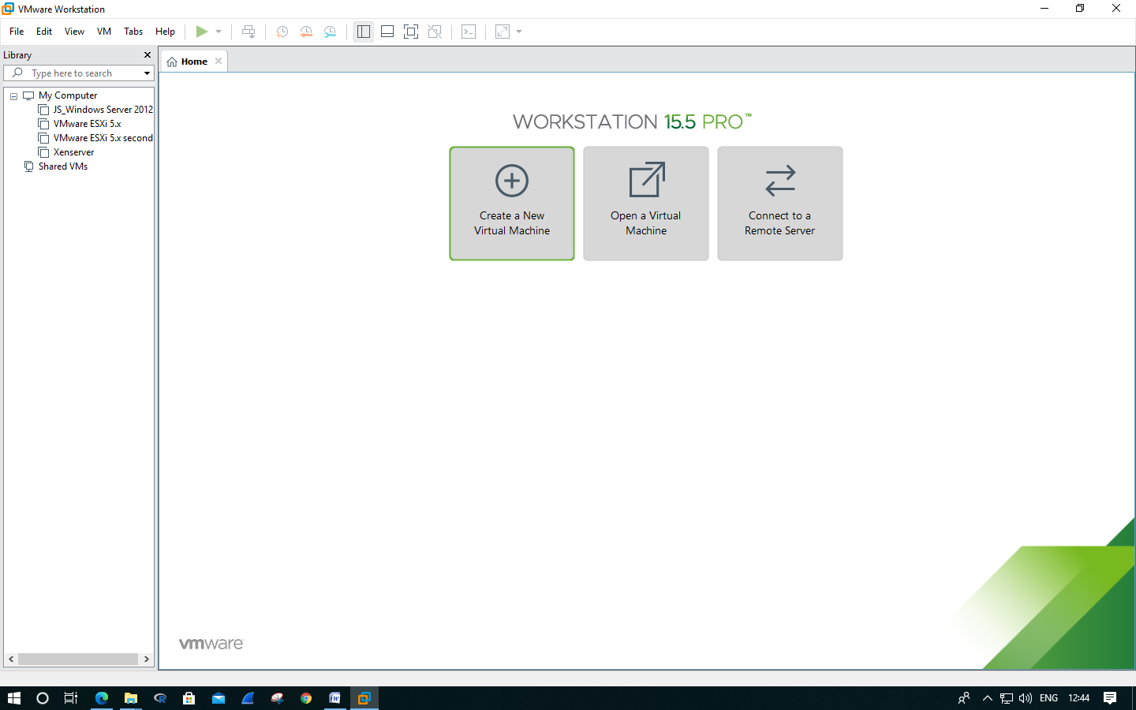

>> In the New Virtual Machine Wizard window select **‘Typical’** as a type of configuration of virtual machine and click on **Next**.

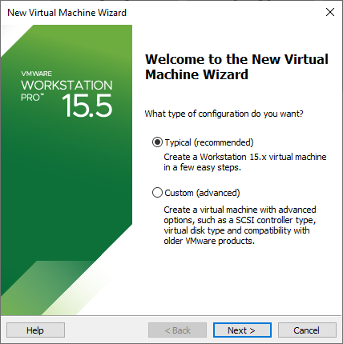

>> Then select **‘Installer disk image file (iso):’**  option and browse for **‘Windows Server iso file’** and then click on **Next.**

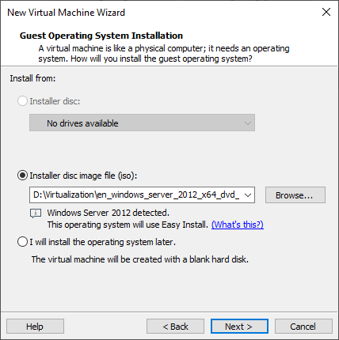

>> In the next tabs

keep the options as default and click on **Next.**

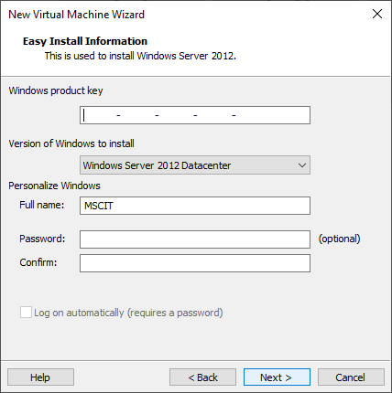

>> Enter a name for your Virtual Machine, and then click on **Next.**

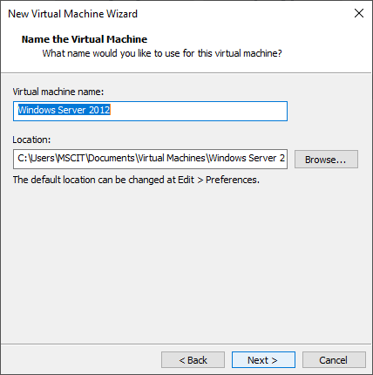

>> In the next tab specify **‘Maximum disk size (GB): as 90GB’** and select **‘Store Virtual Disk as a single file’** option.

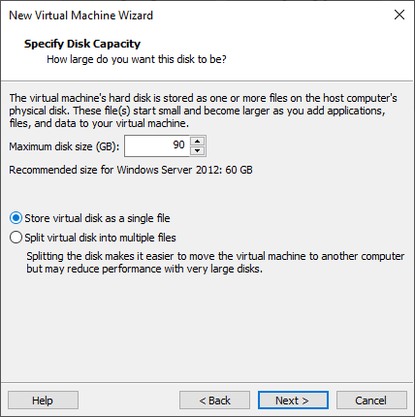

>> In the next tab select **‘Customize Hardware’** option.

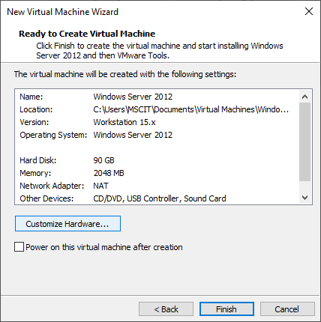

>> In that specify the **memory as 4GB**, and click on **Close.**

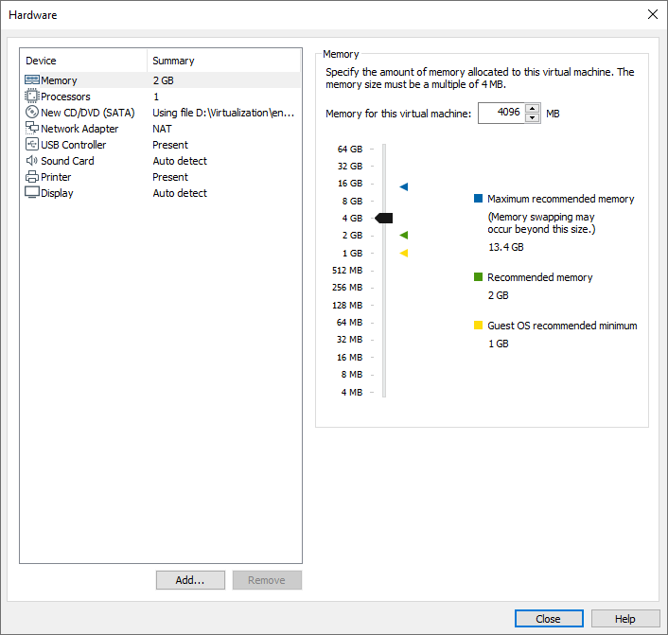

>> And then click on **Finish.**

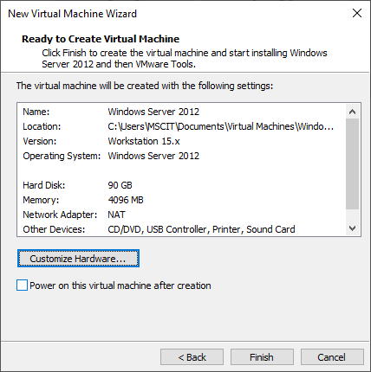

>> Our Virtual Machine will be created.

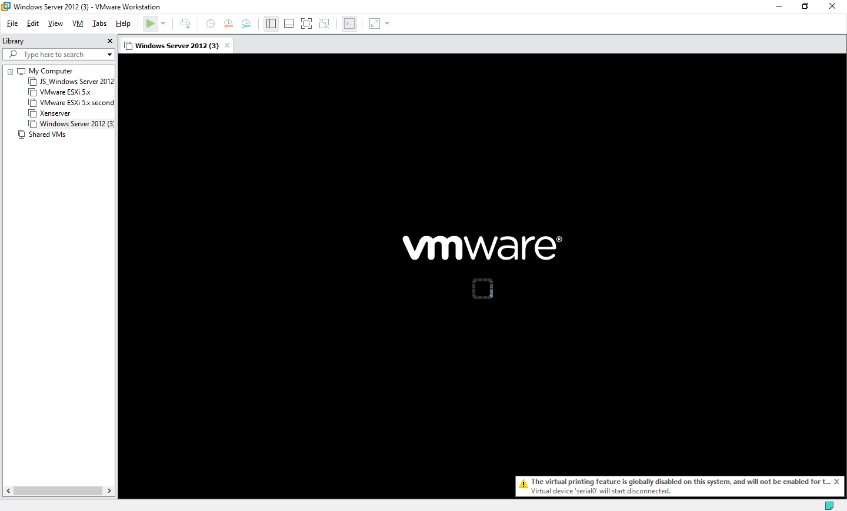

>> Click on **‘Power on the Virtual Machine’**.

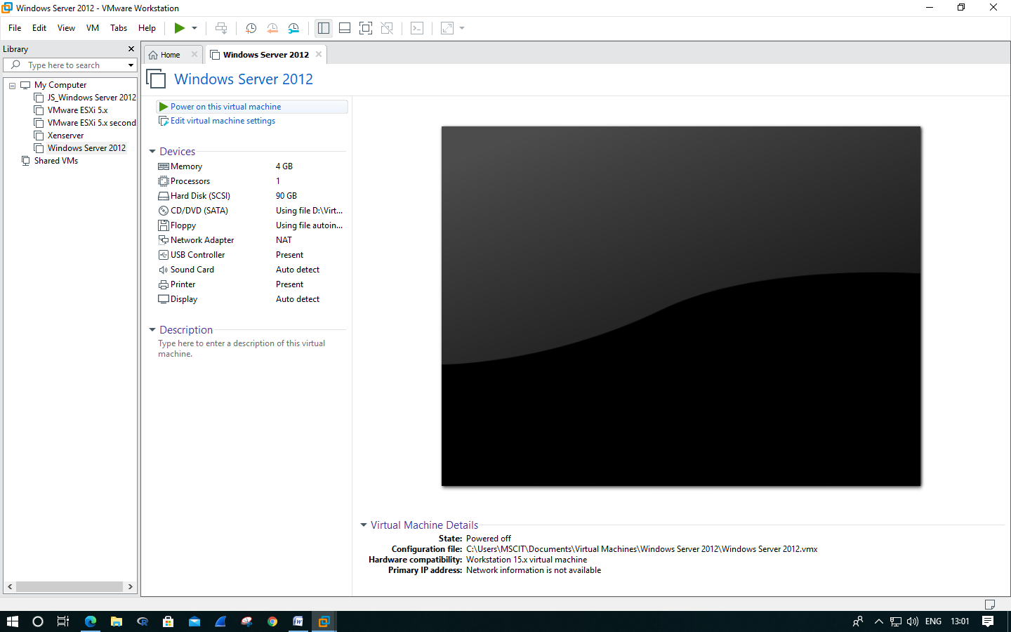

>> Next screens will be displayed to us after powering on the virtual machine.

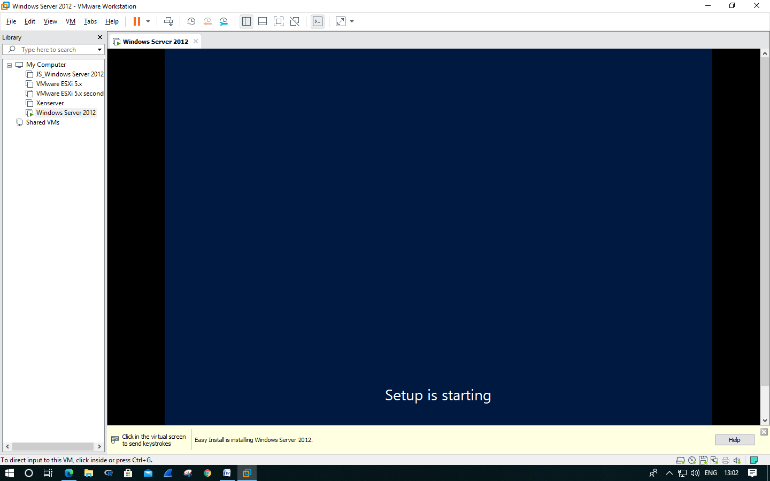

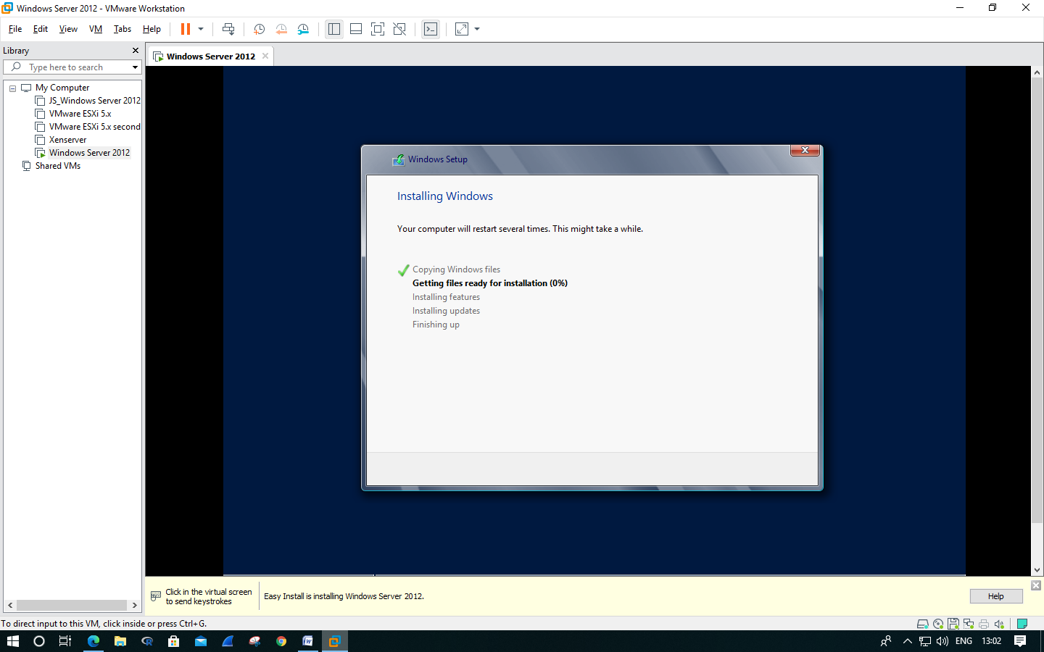

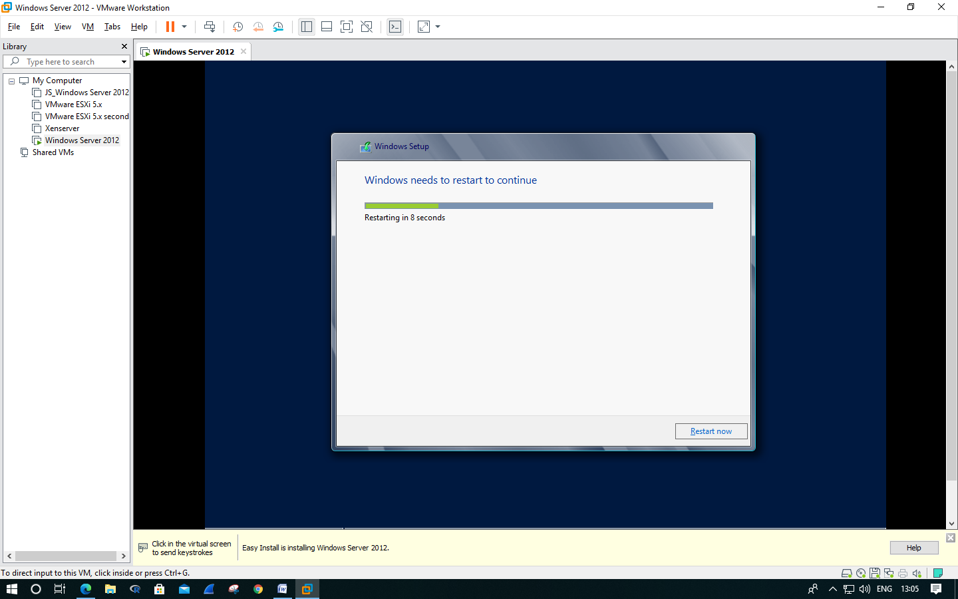

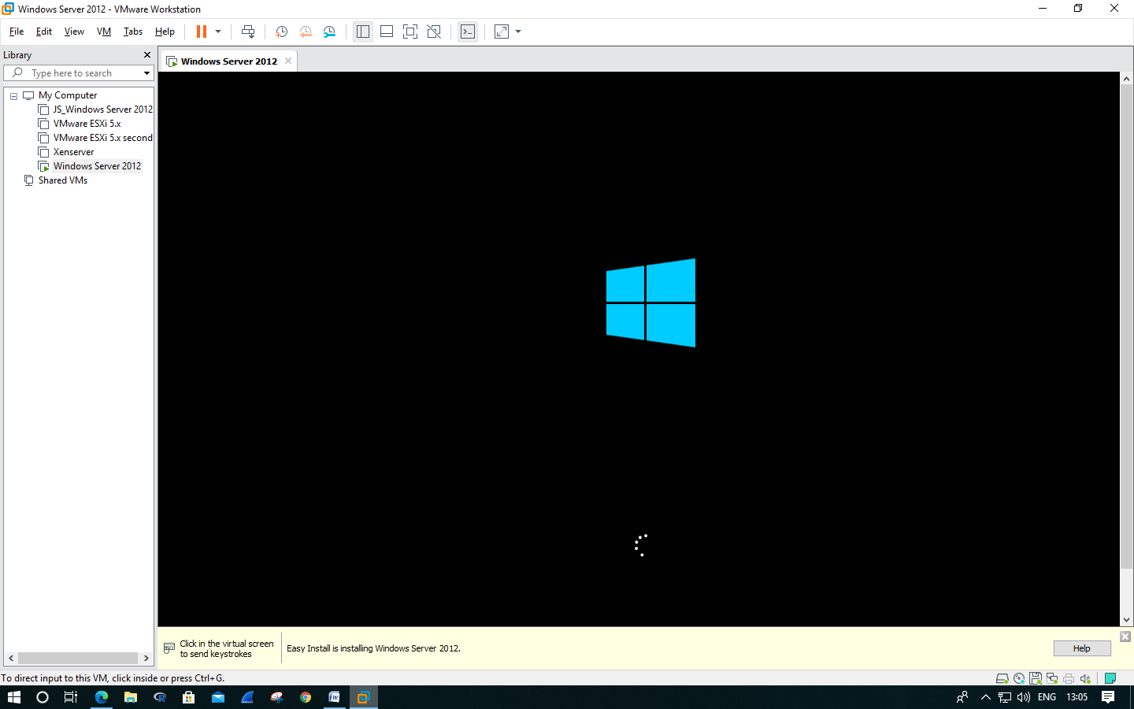

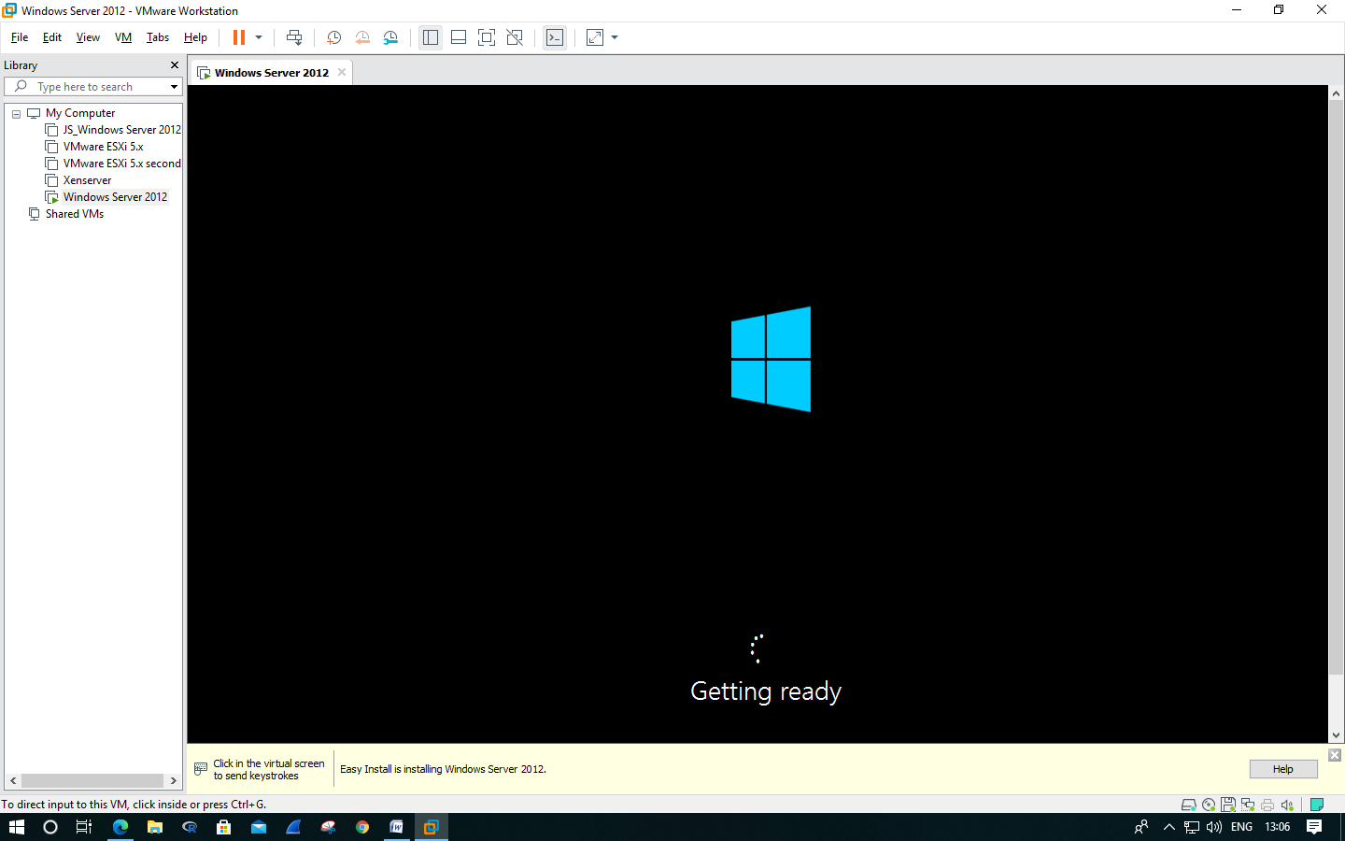

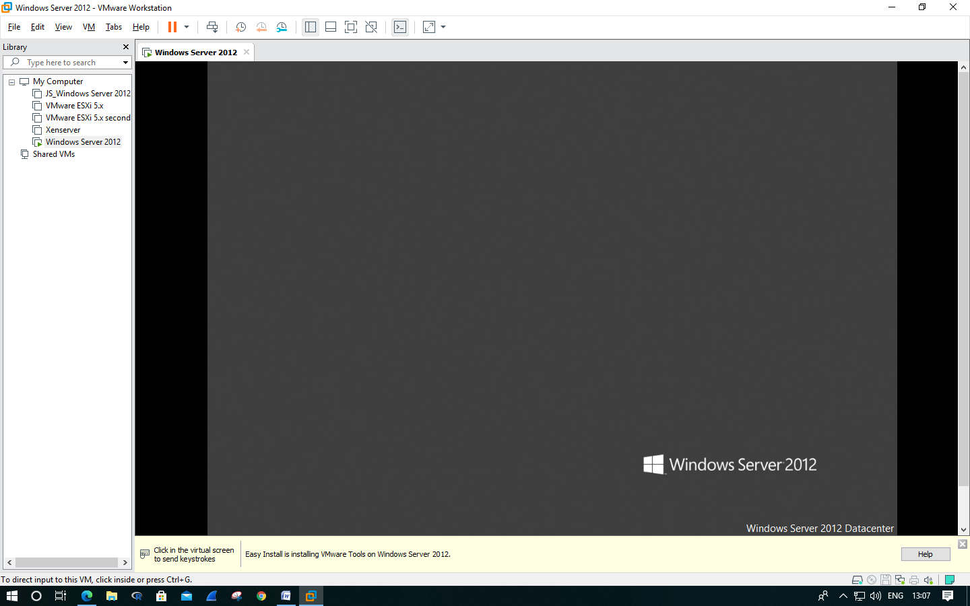

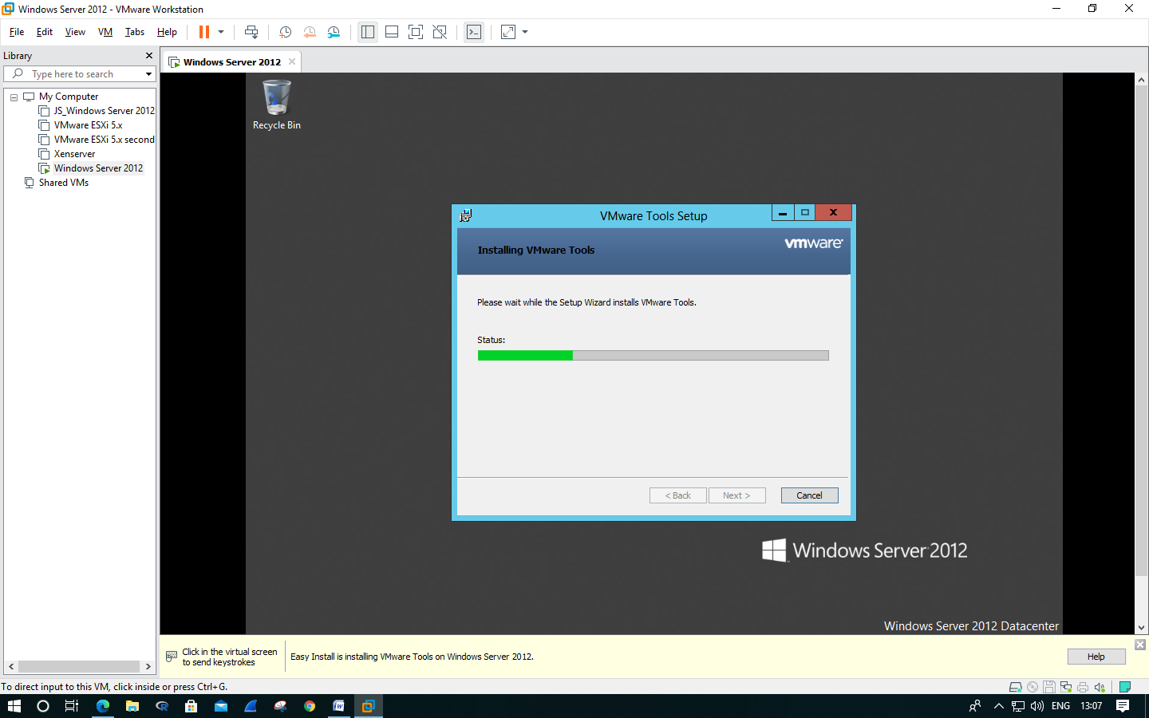

>> Click on **‘Yes’**.

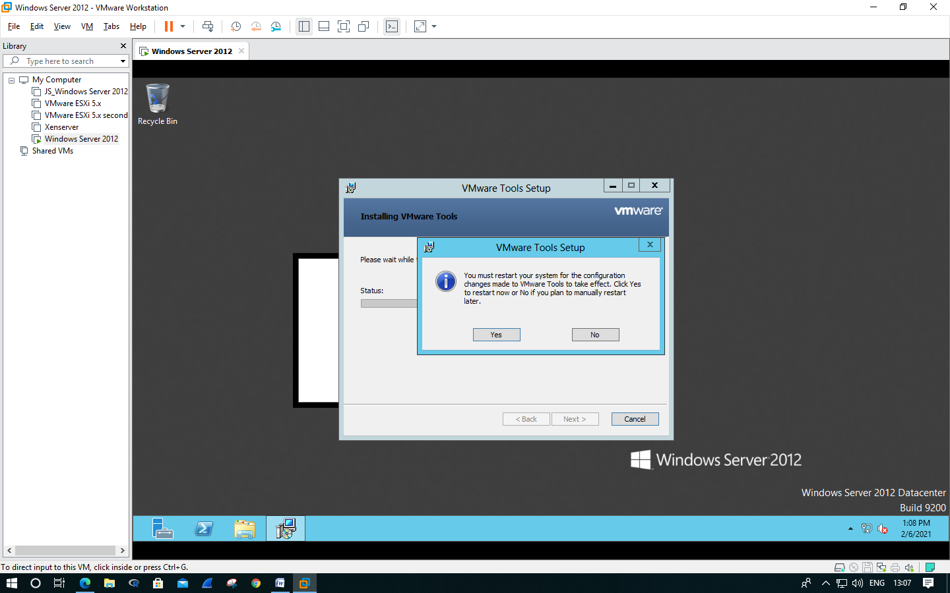

>> Following window will appear. Click on **‘VM’ >> ‘Send Ctrl+Alt+Del’**. And switch the user, Select **‘Administrator’.**

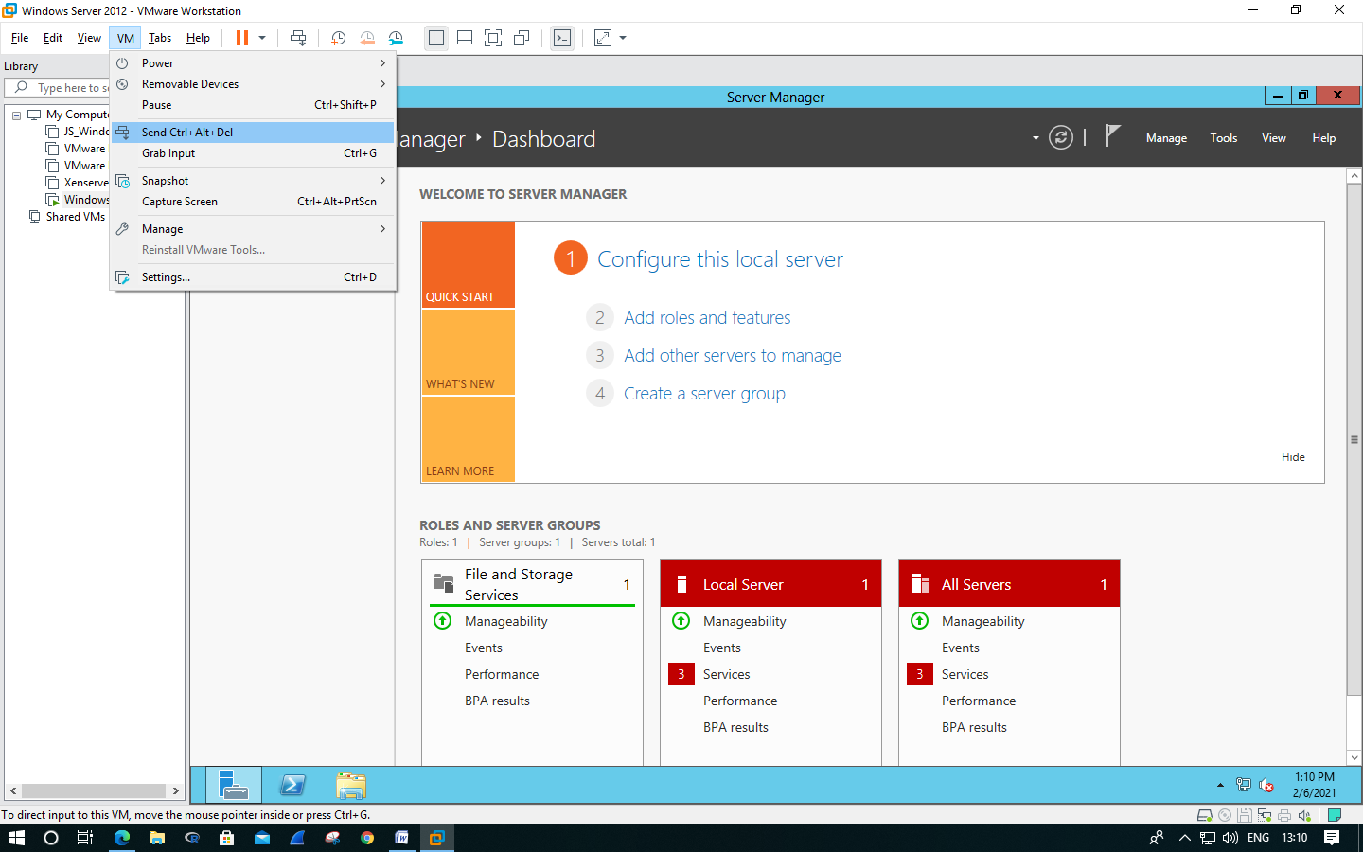

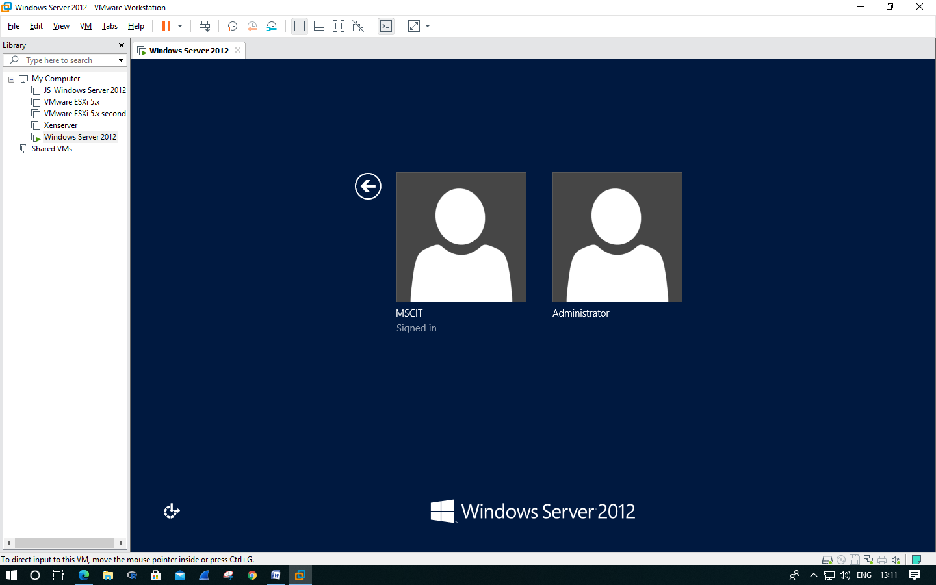

>> Enter a password that you want.

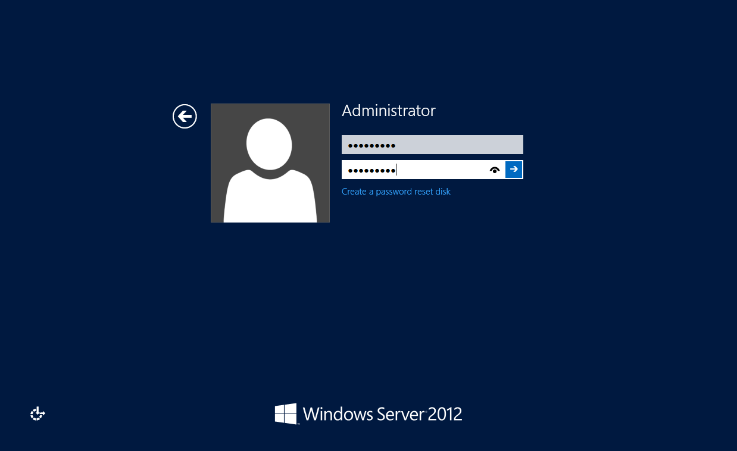

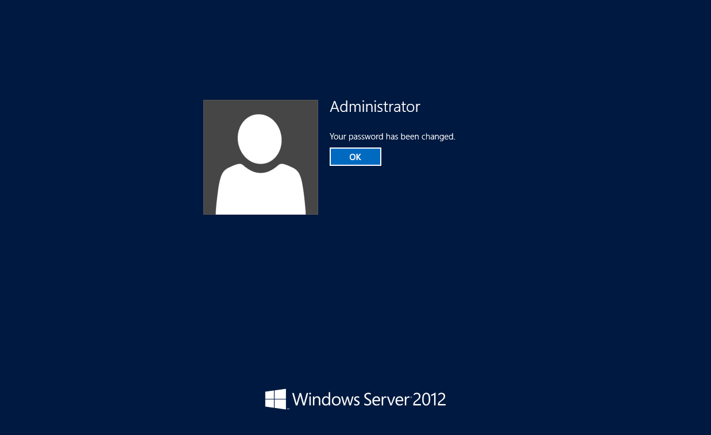

>> Click on **‘Manage’ >> ‘Add Roles and Features’.**

**>> Add roles and Features wizard** will appear.

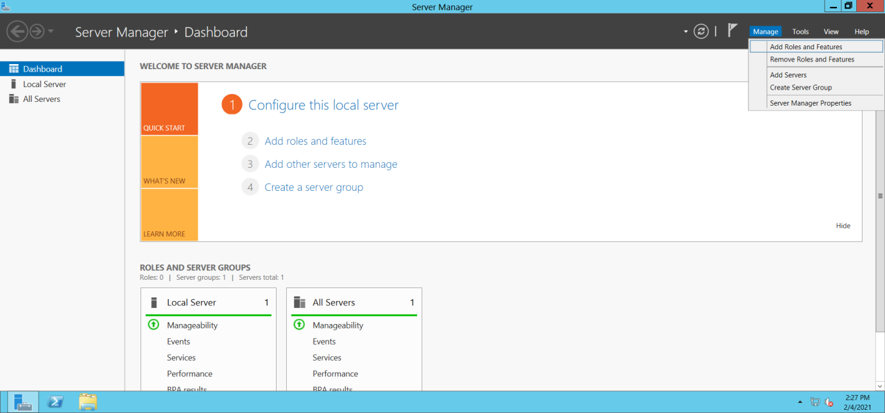

>> Click on **Next.**

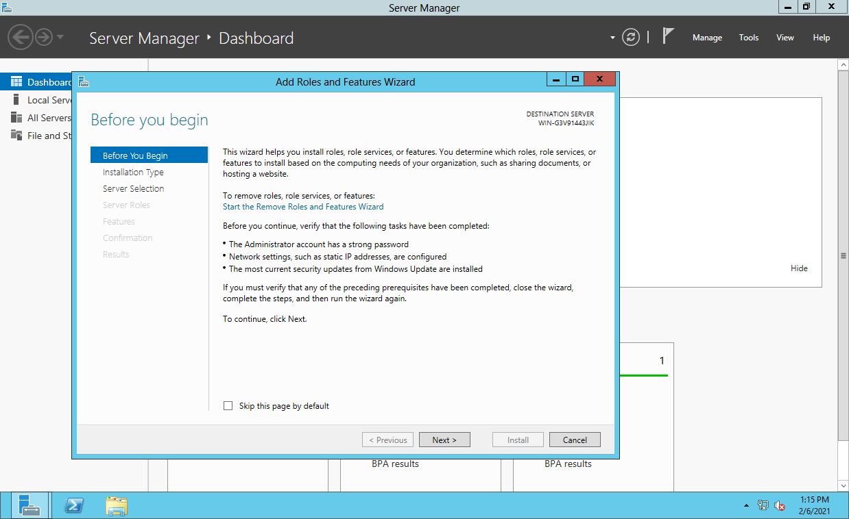

>> Select **Role-based or feature-based installation,** and then click on  **Next.**

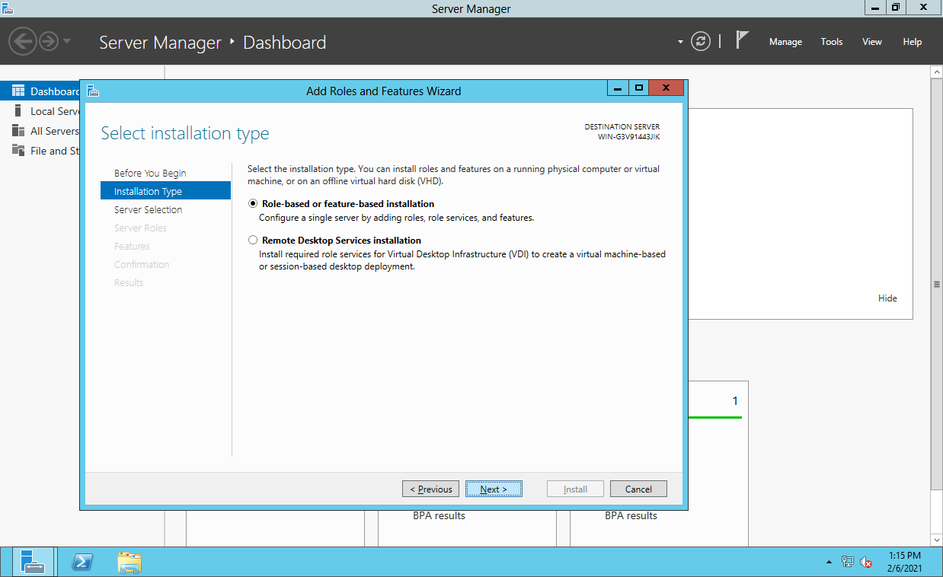

>> Select **‘Select a server from the server pool’** and select the server from the **Server Pool.** Click on **Next.**

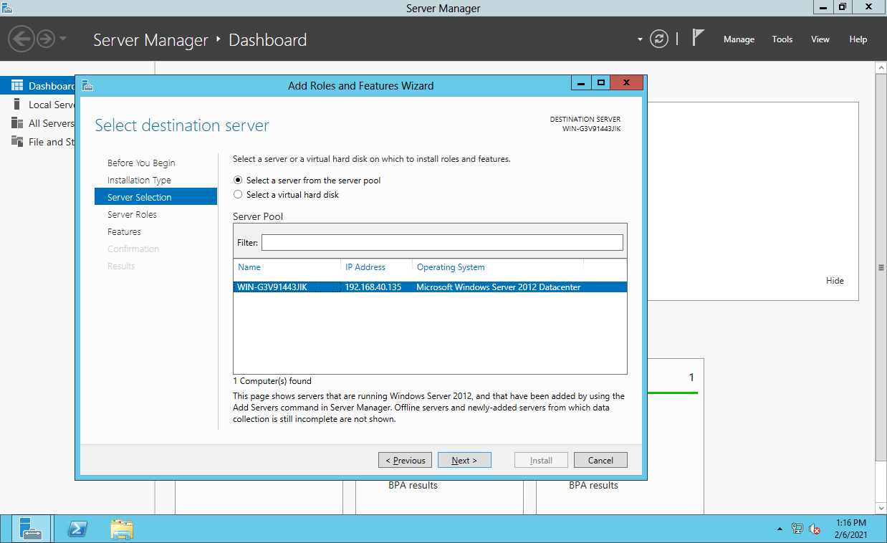

>> Add the following server roles, and click on **Next.**

* **Active Directory Domain Service.**
* **DHCP Server**
* **DNS Server**

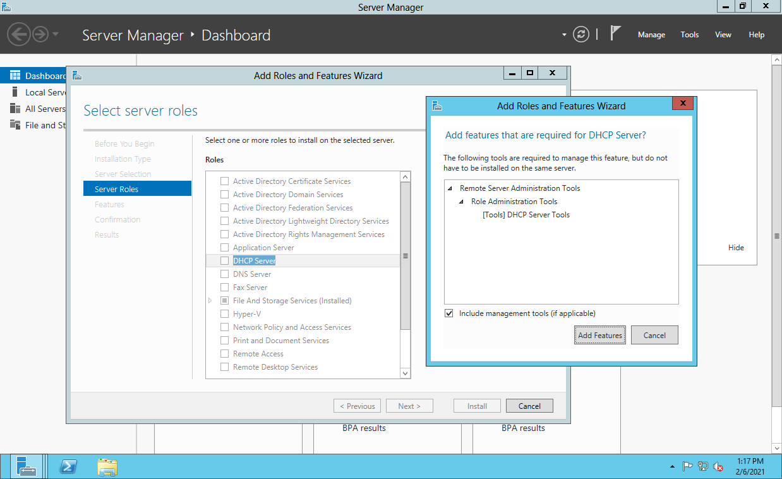

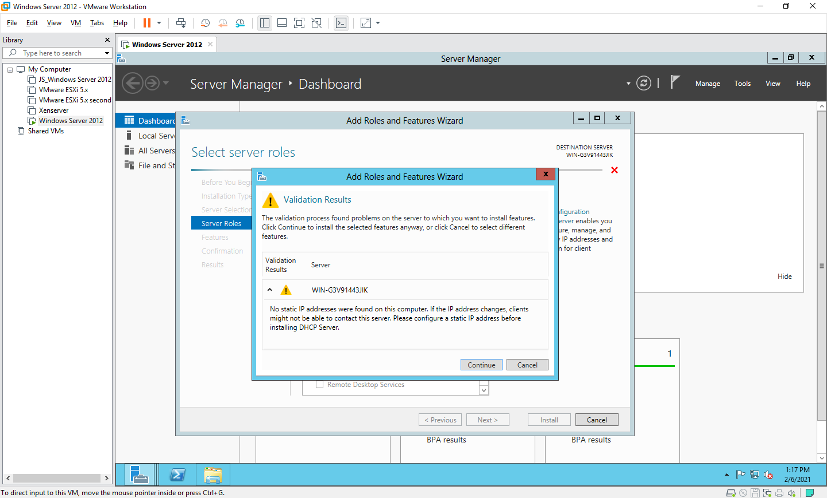

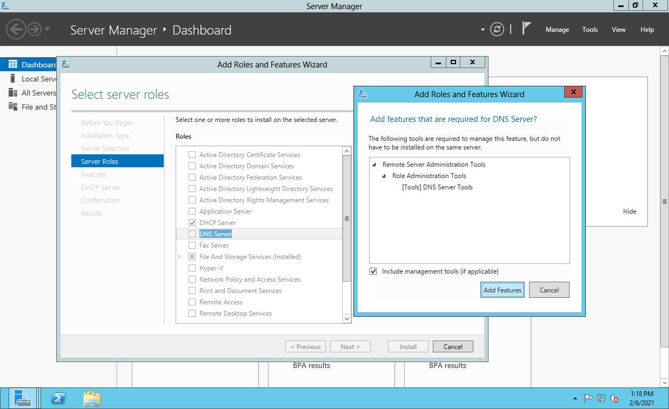

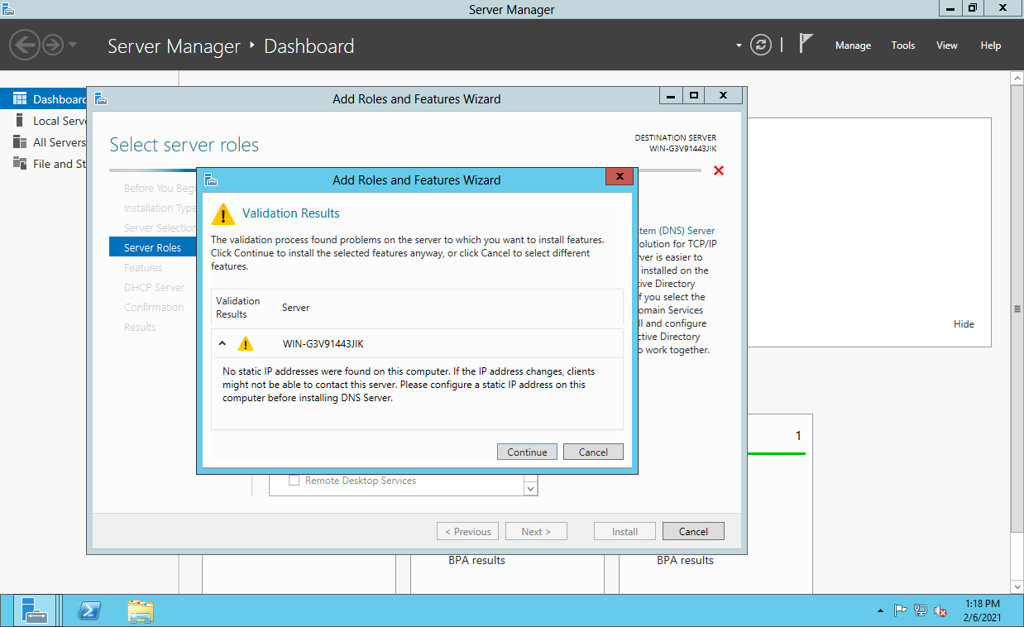

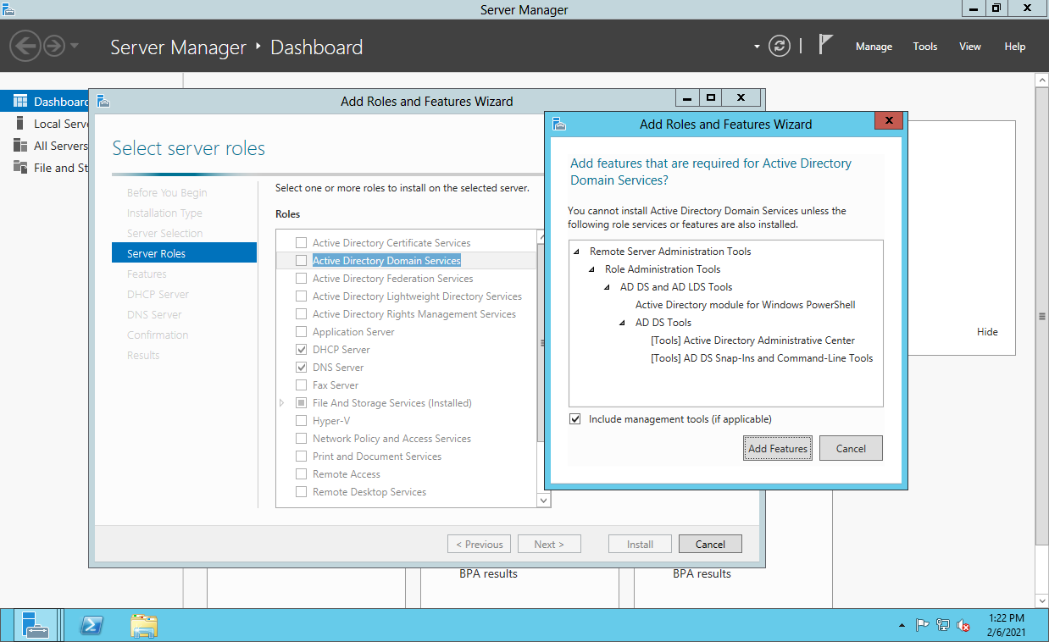



>> Under Features tick the following options and click on **Next.**

* **Failover Clustering**
* **Group Policy Management**
* **.NET Framework 3.5 Features**

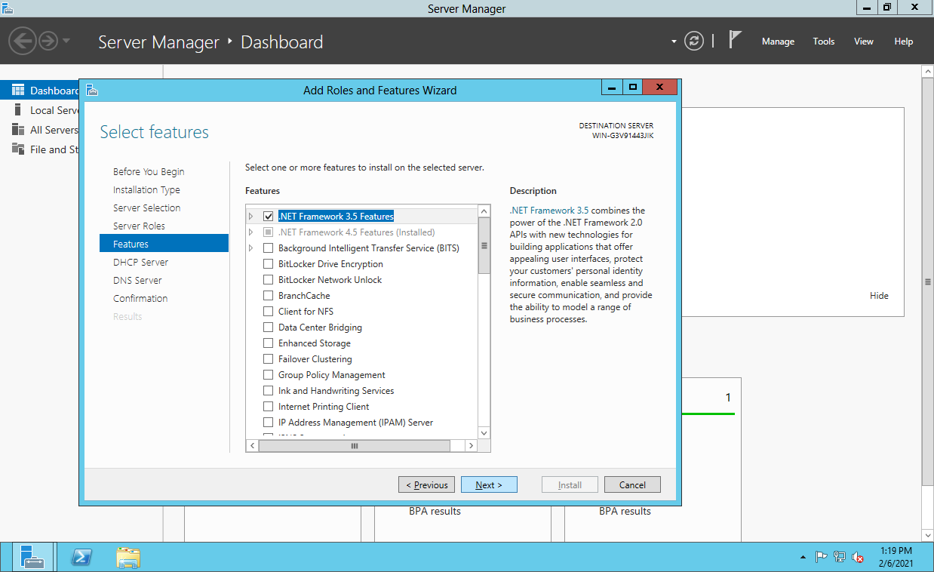

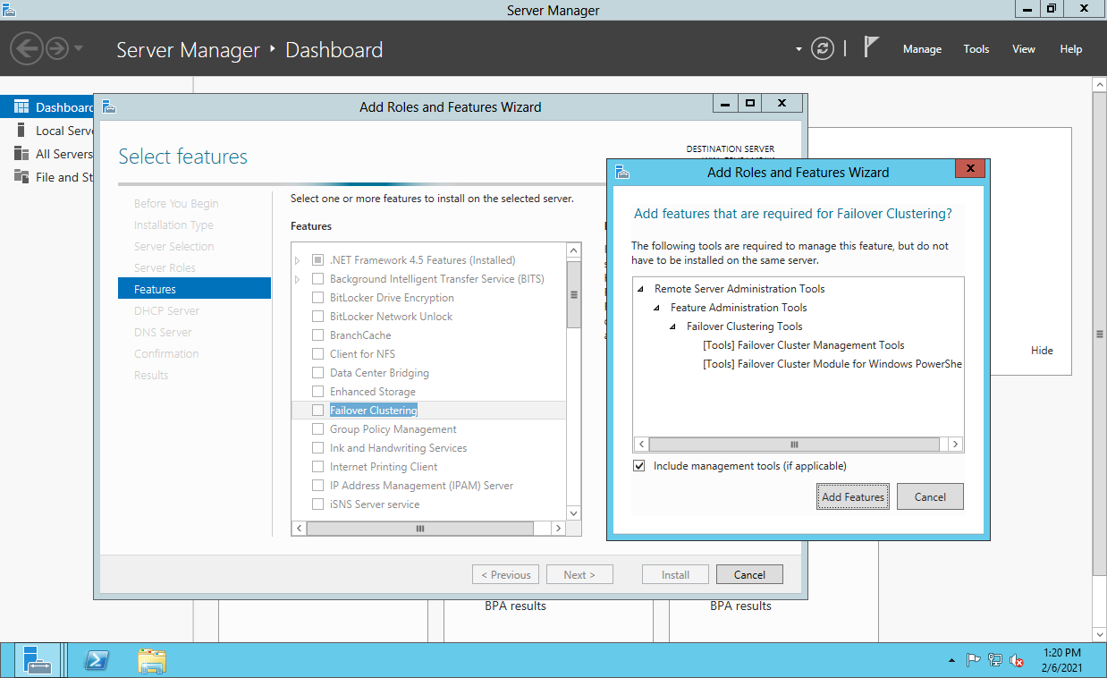

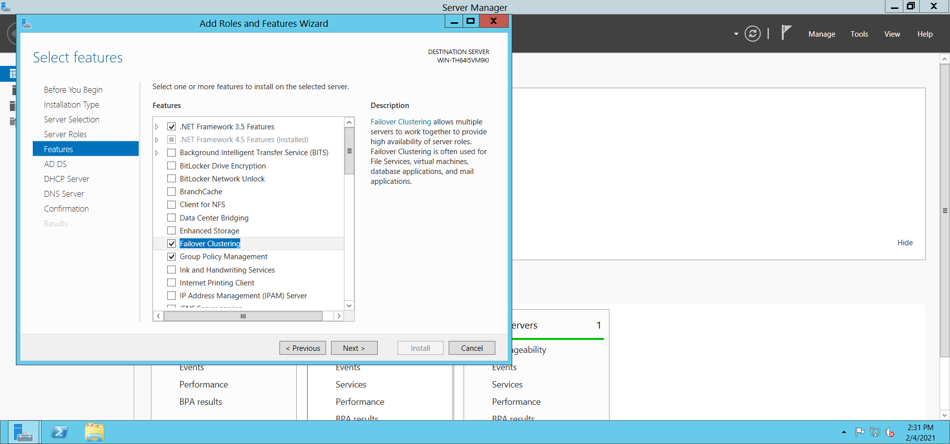

>> Click on **Next.**

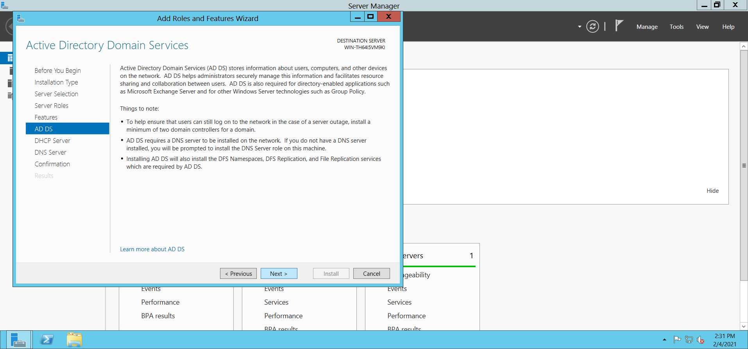

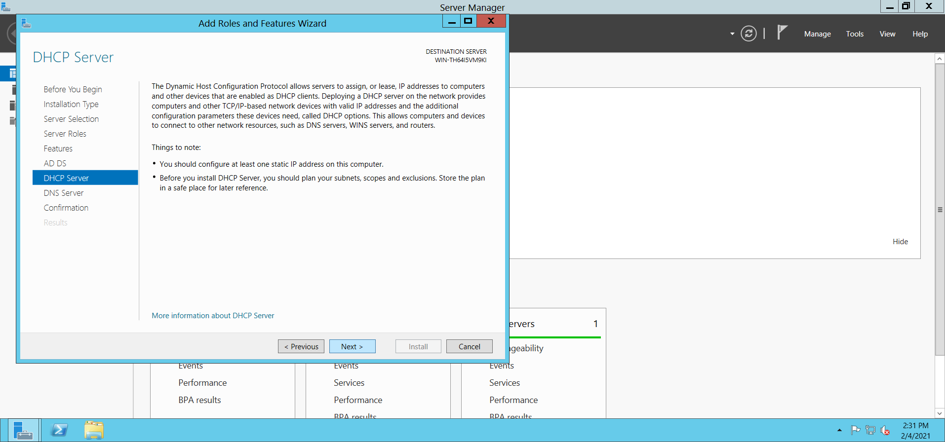

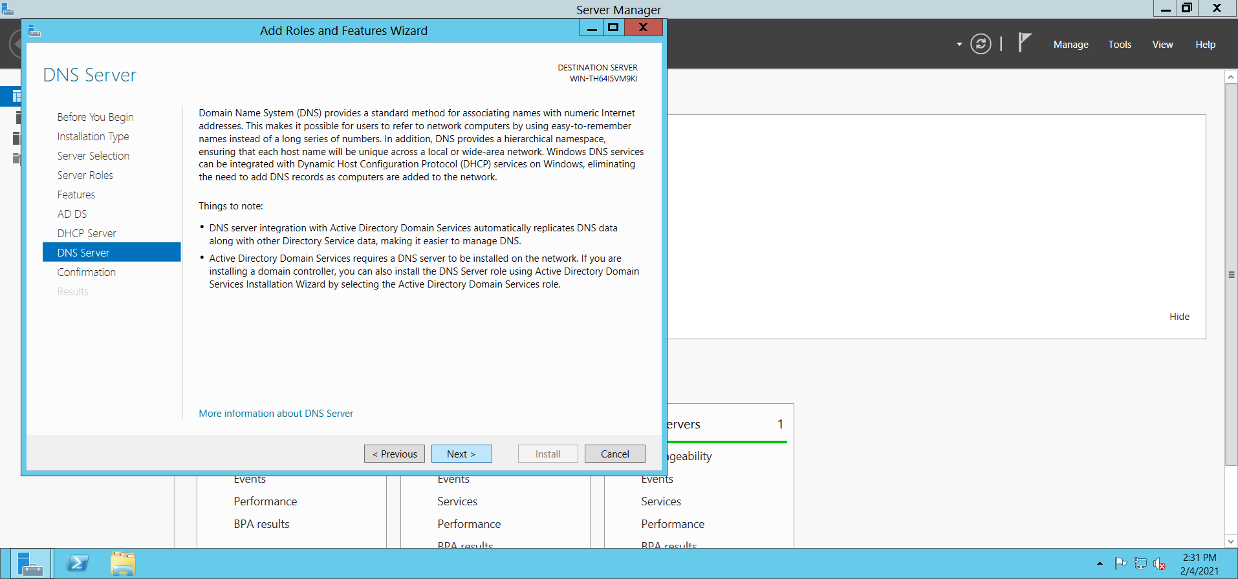

>> Click on **Next.**

>>Here we need to **‘Specify an alternate source path’** for files.

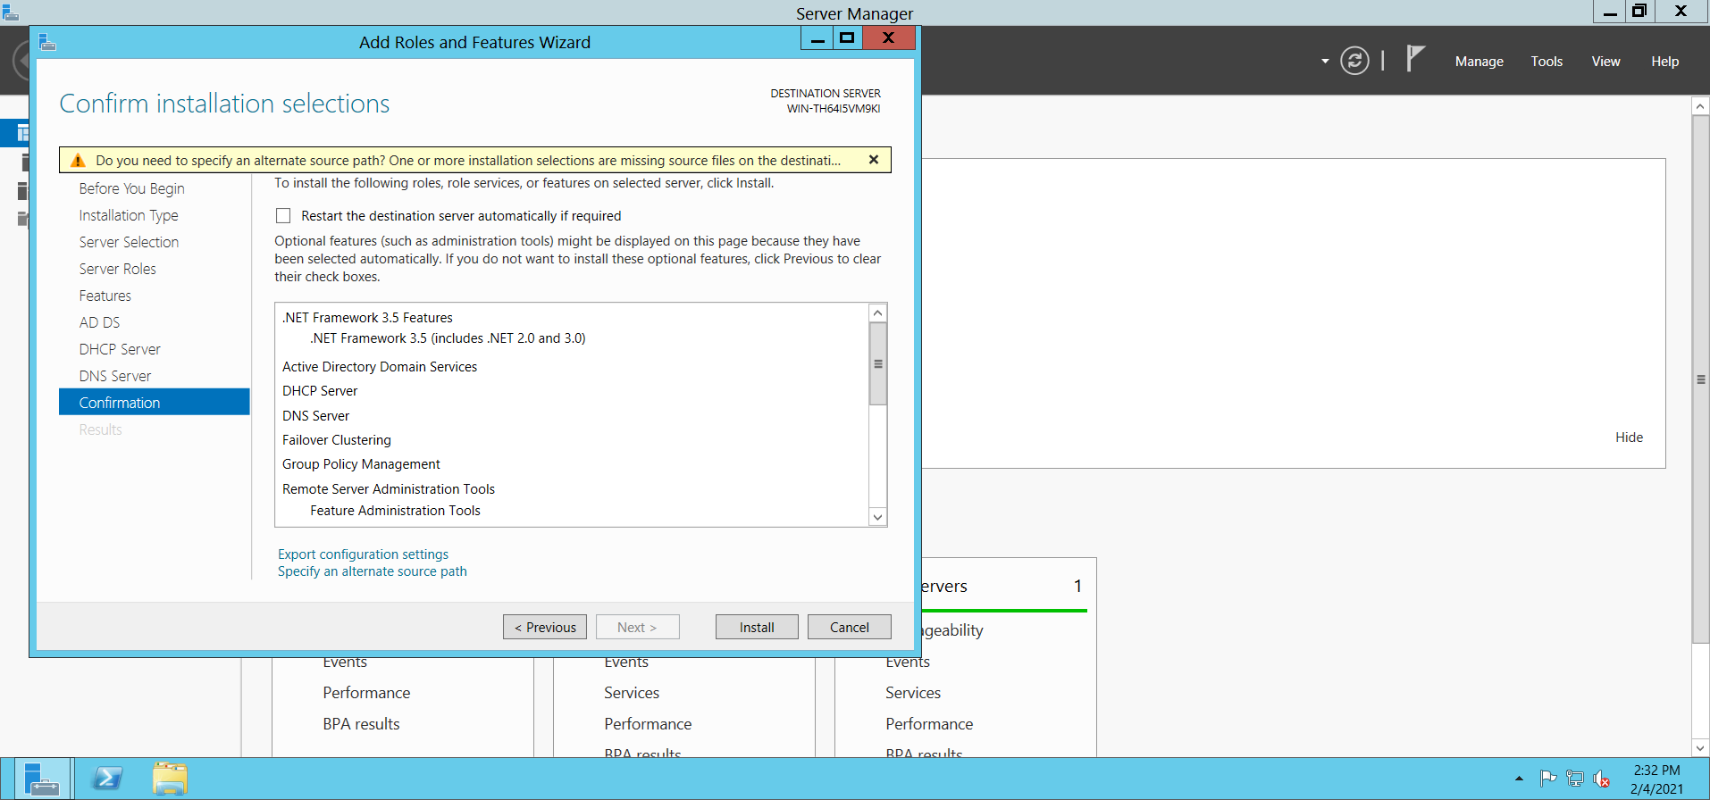

>> To specify an alternate source path click on **VM >> Removable Devices >> CD/DVD (SATA) >> Connect.**

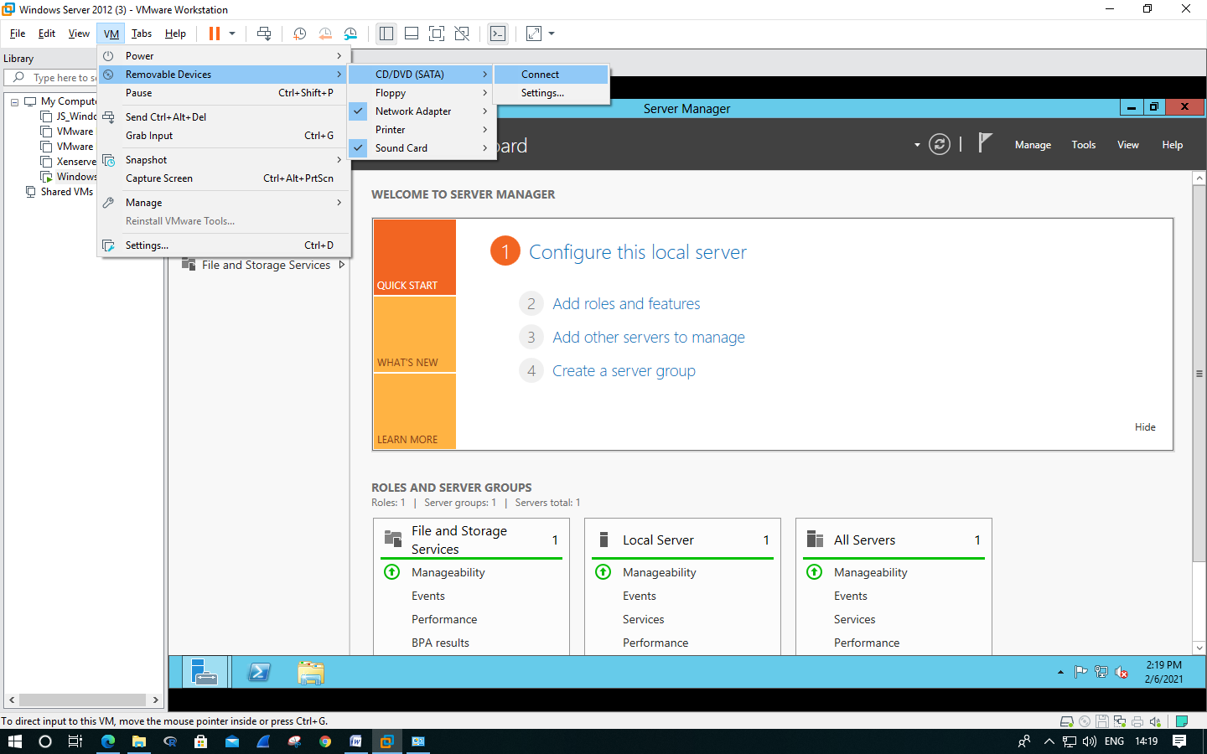

>> Tap on the pop-up in the corner.

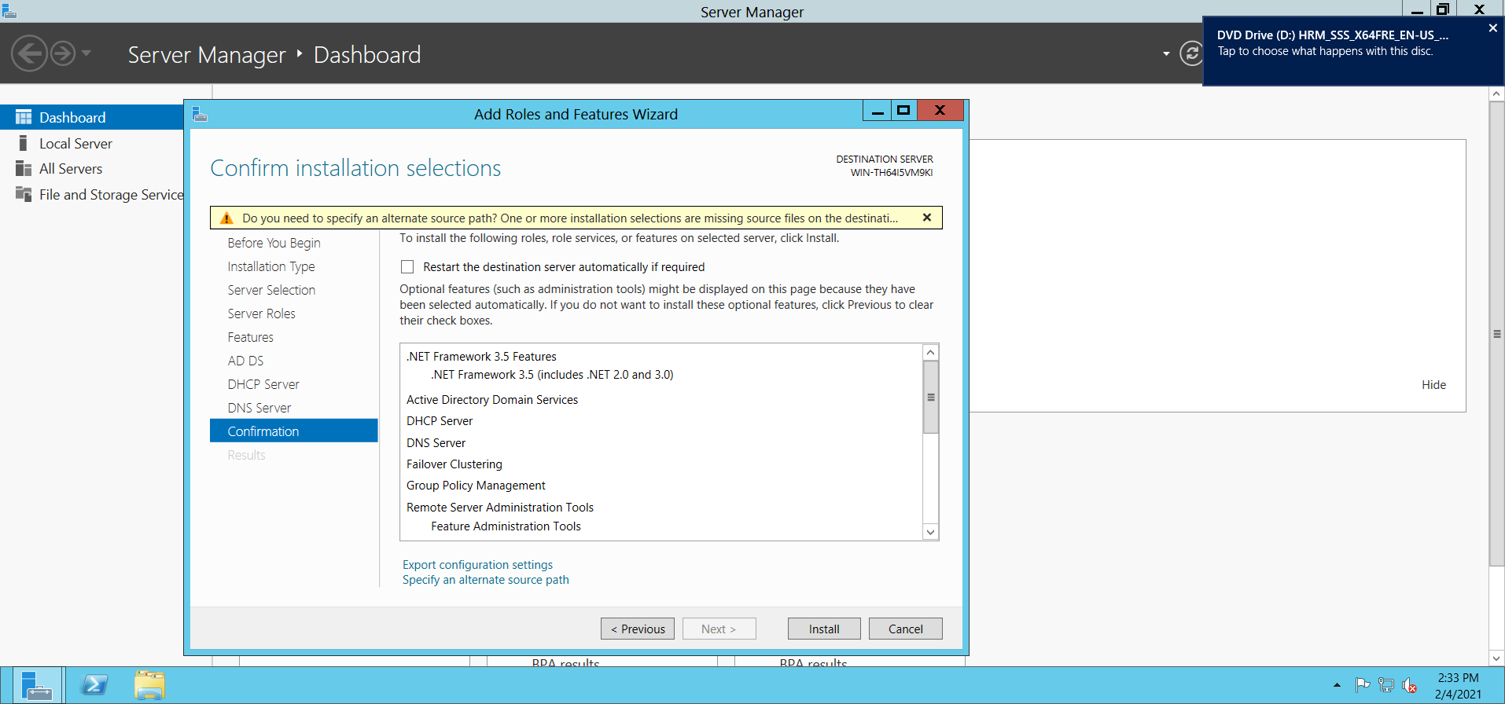

>> Select **‘Open folder to View Files’.**

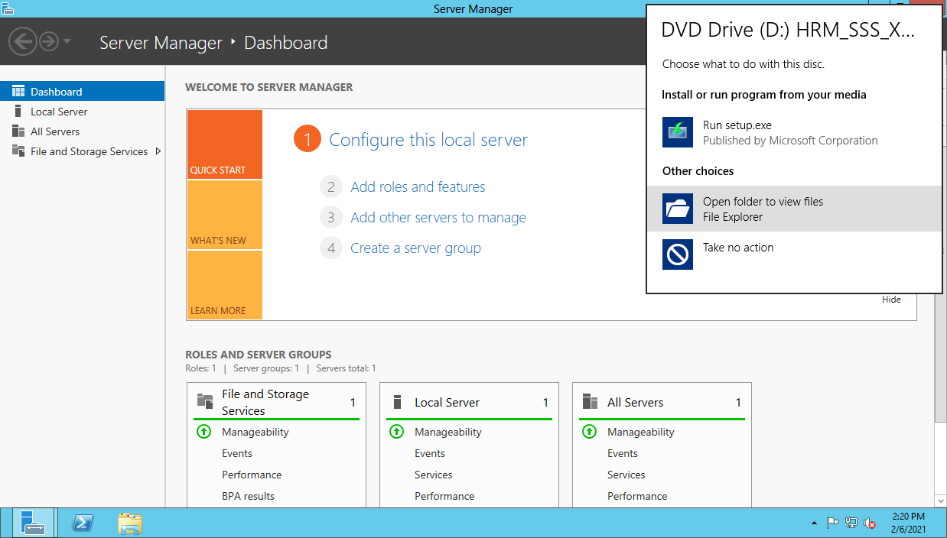

>> Go to the path : **D:\sources\sxs.** Copy this path. And close the window.

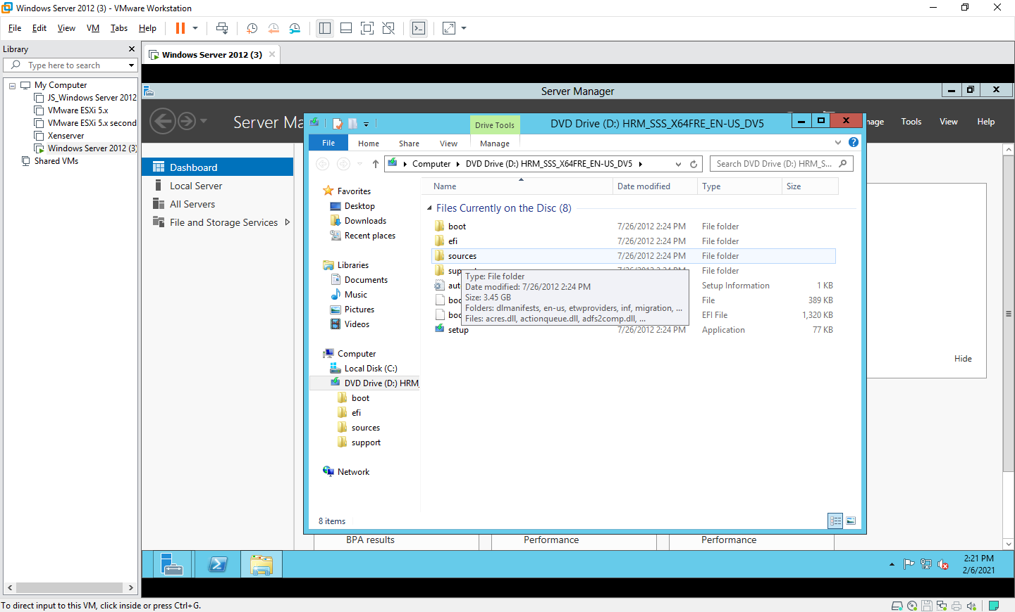

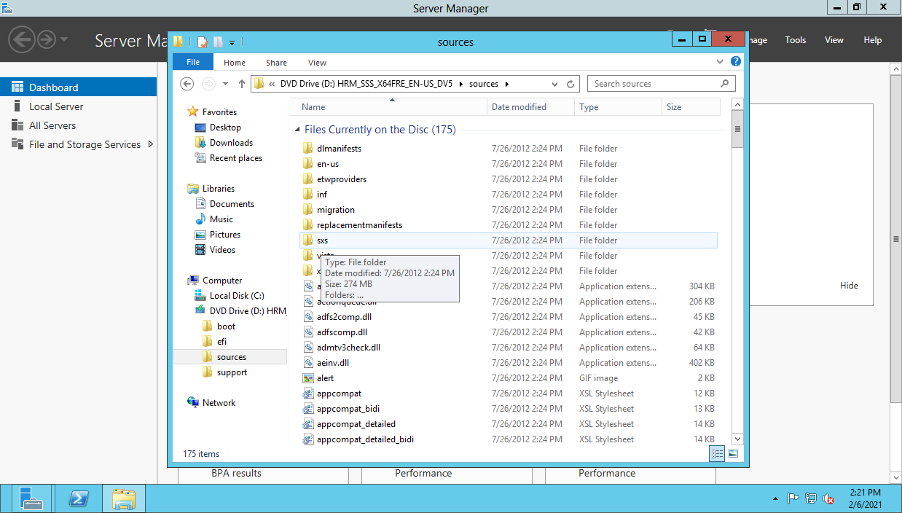

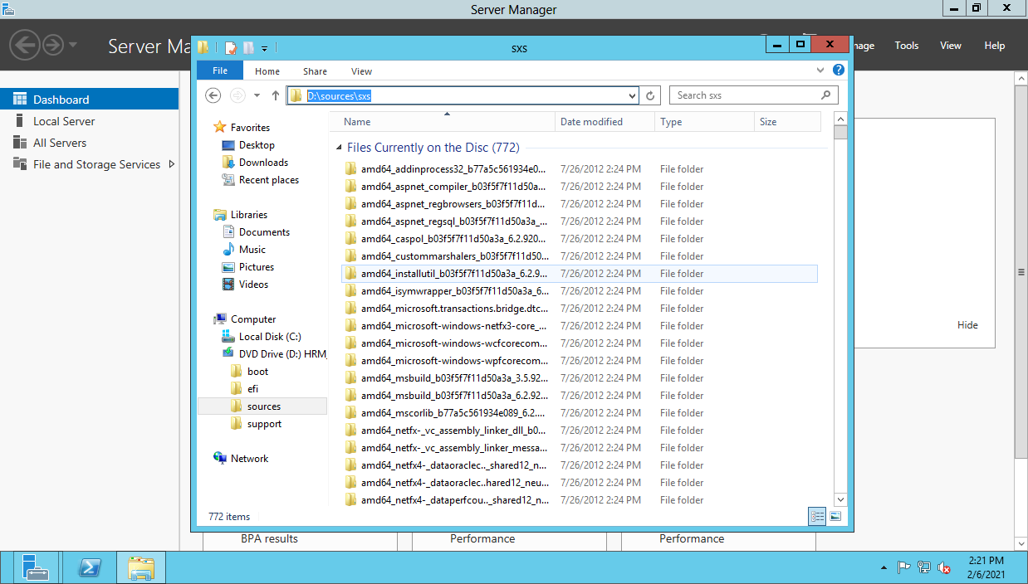

>> Now, click on **‘Specify an alternate source path’**, paste the path in the textbox Path: and click on **Ok.**

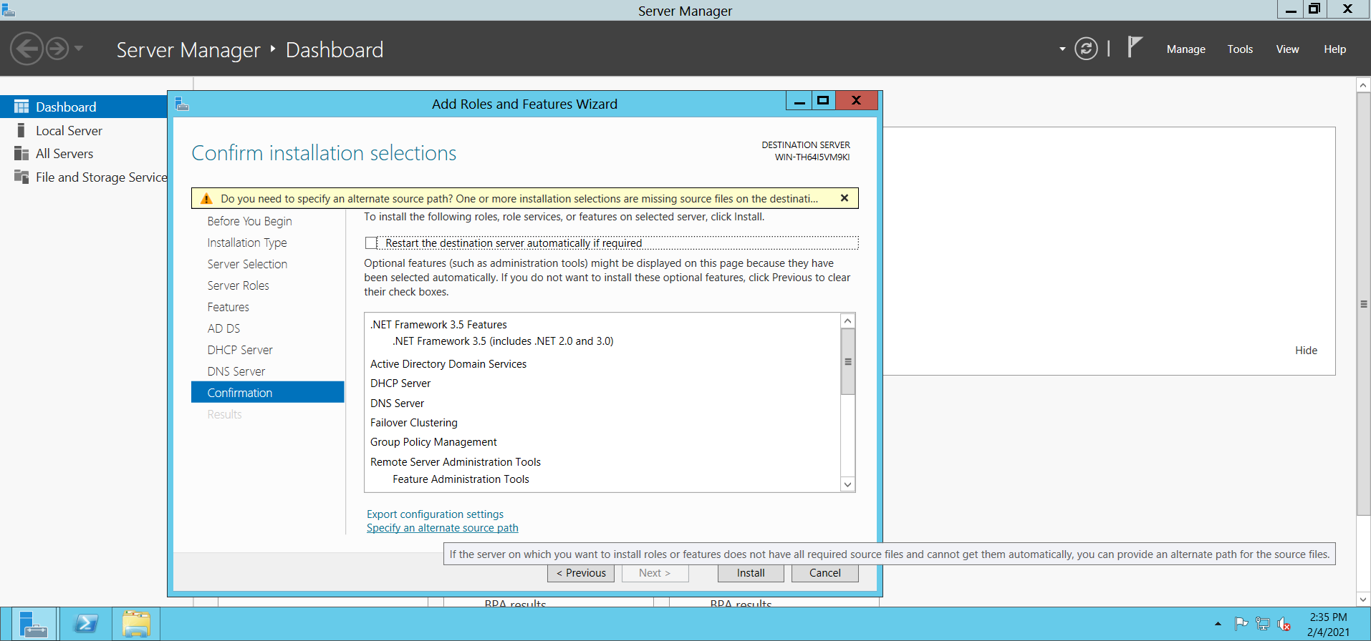

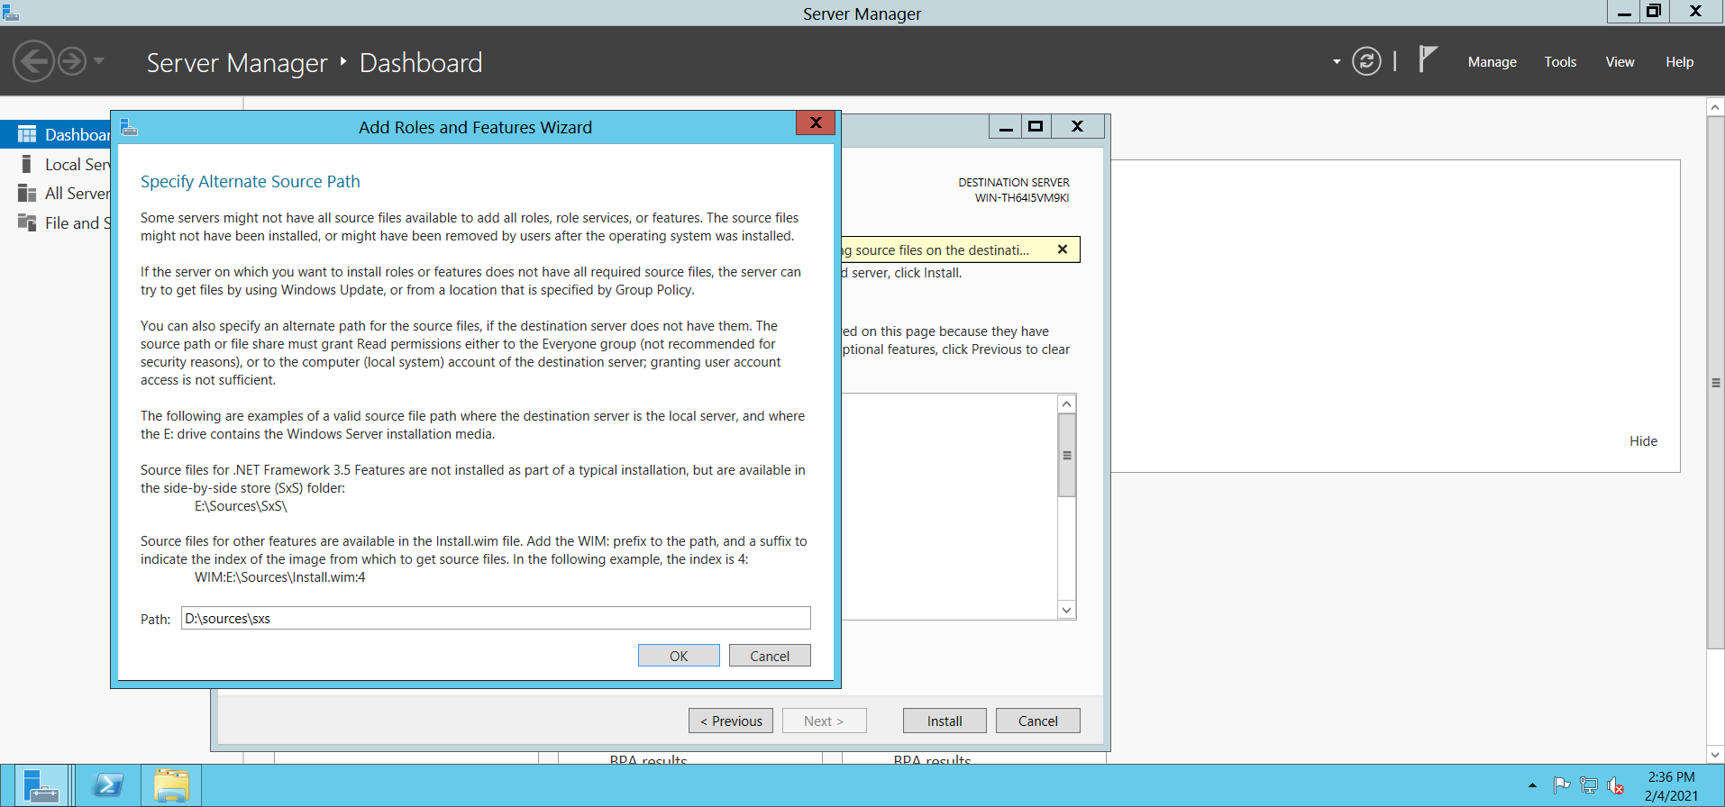

>> Now click on **Install.**

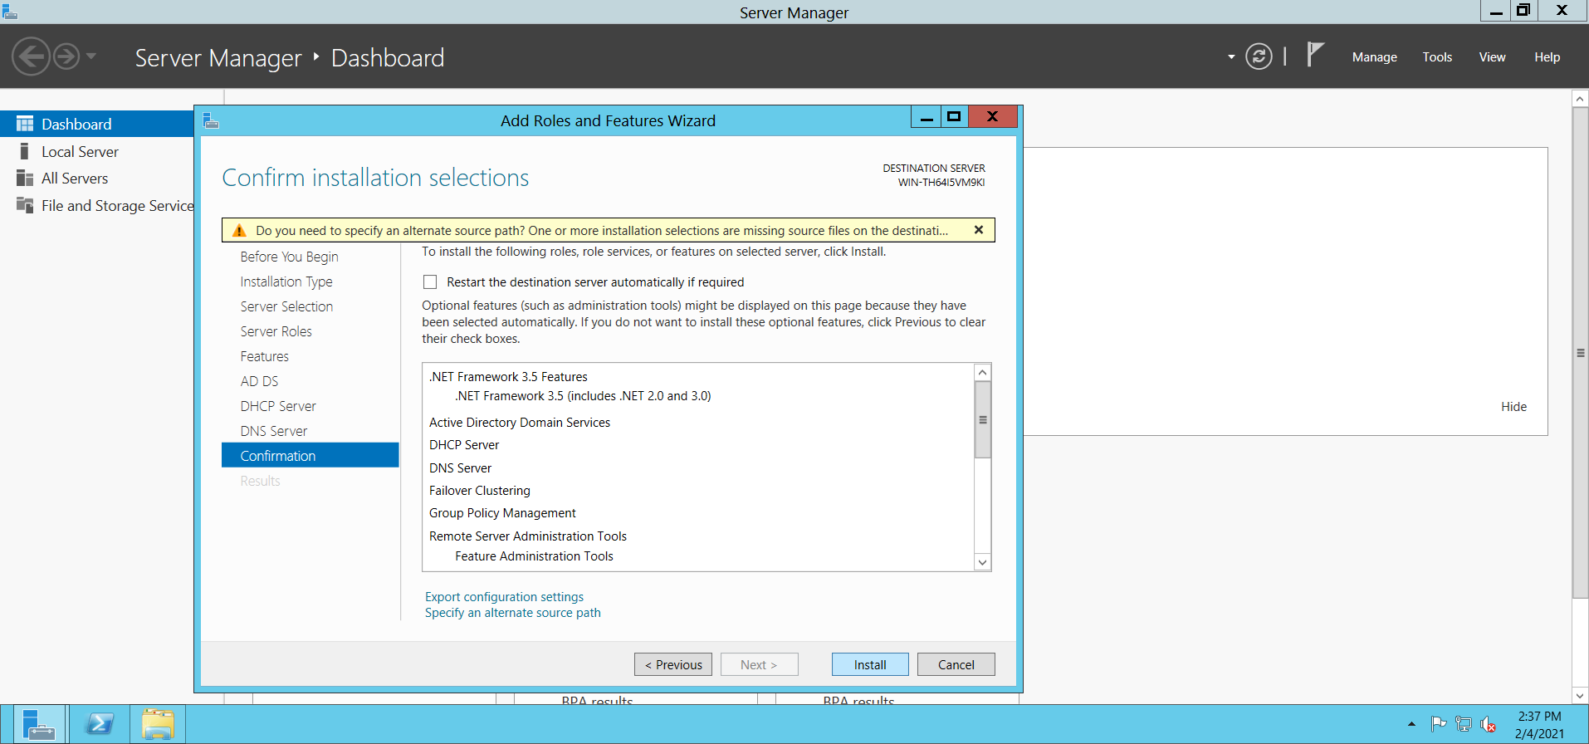

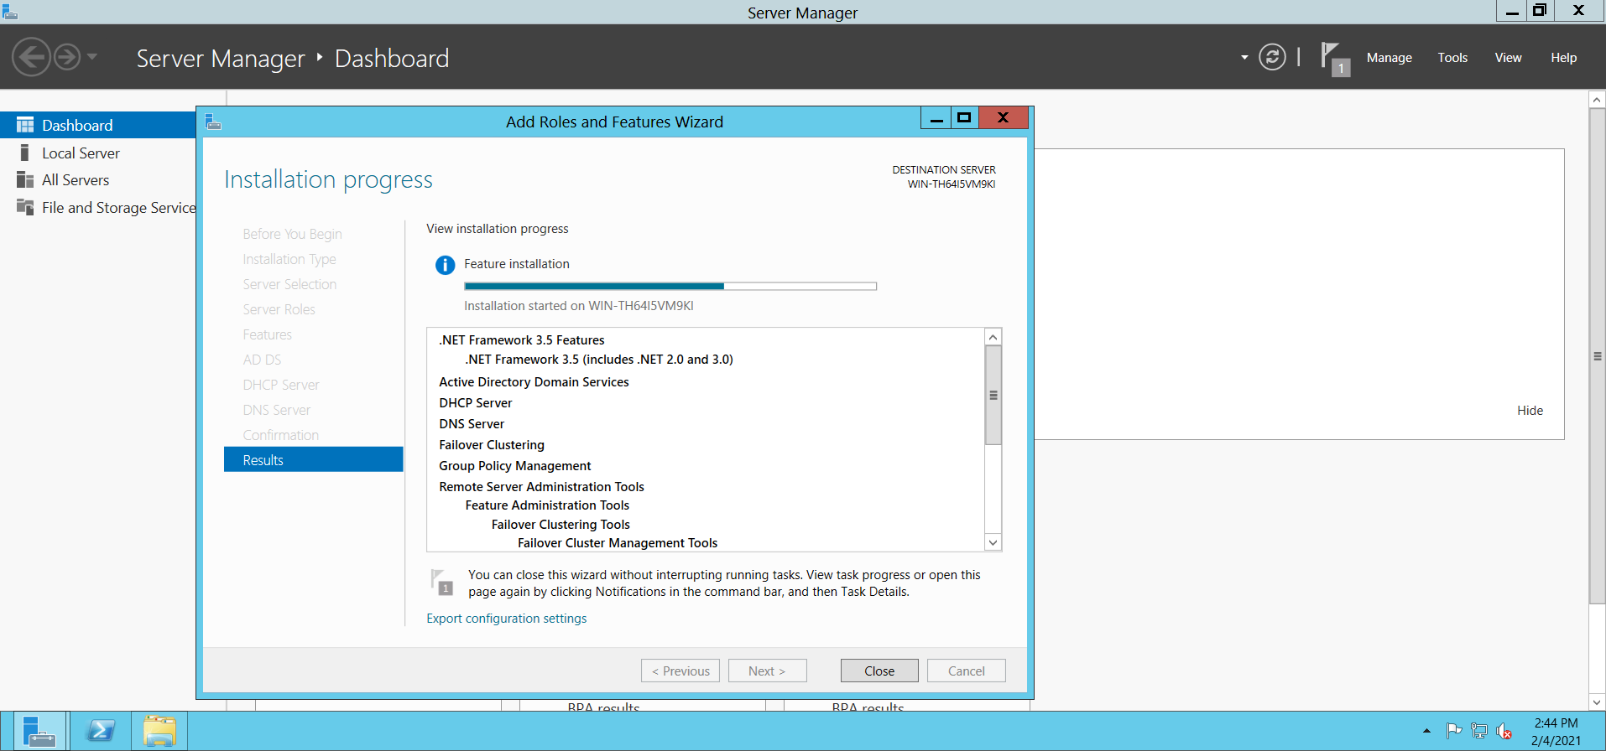

>> Click on Close after installation finishes.

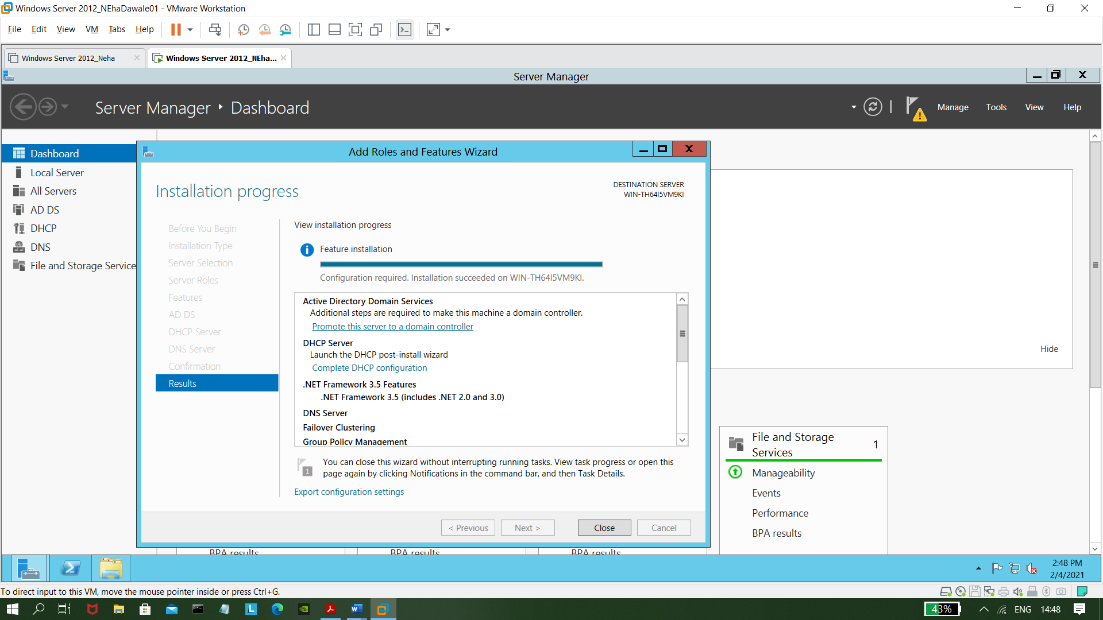

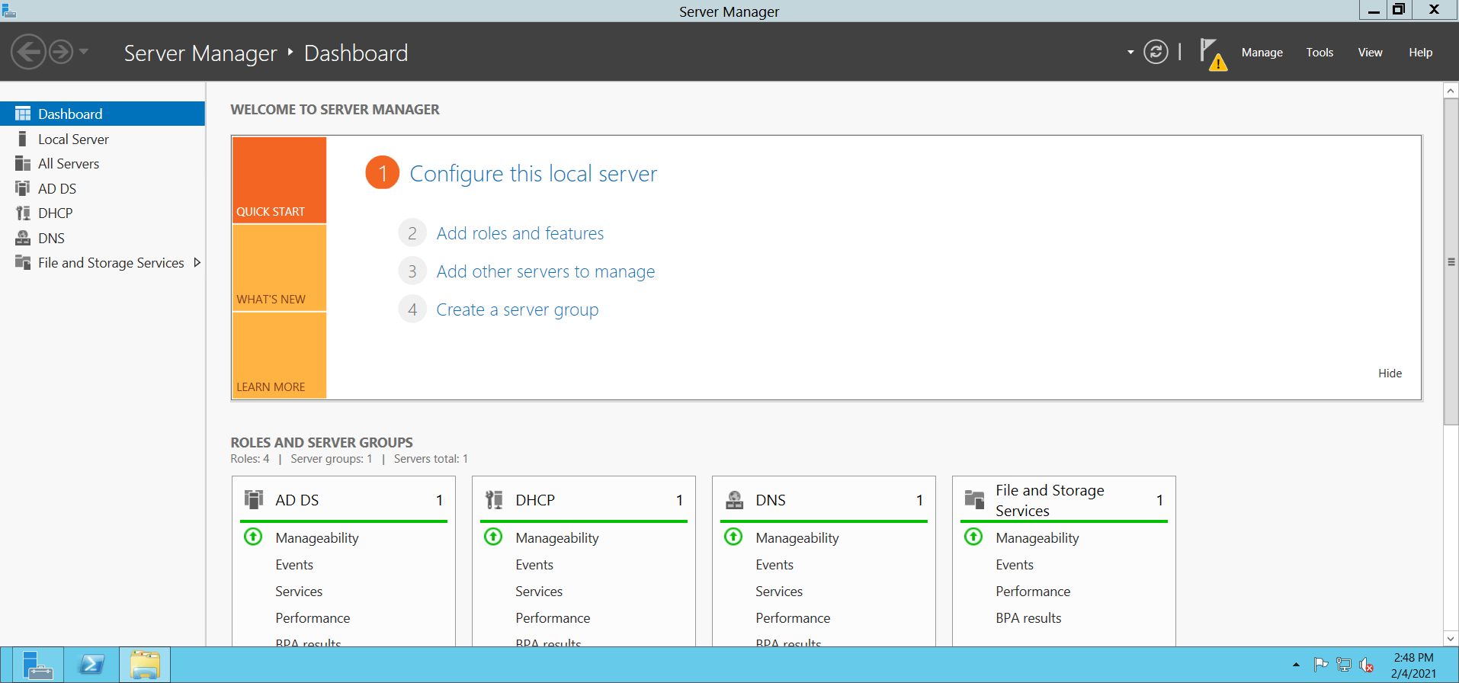

**- Promoting as a domain controller**

>> Now click on **AD DS >> More.**

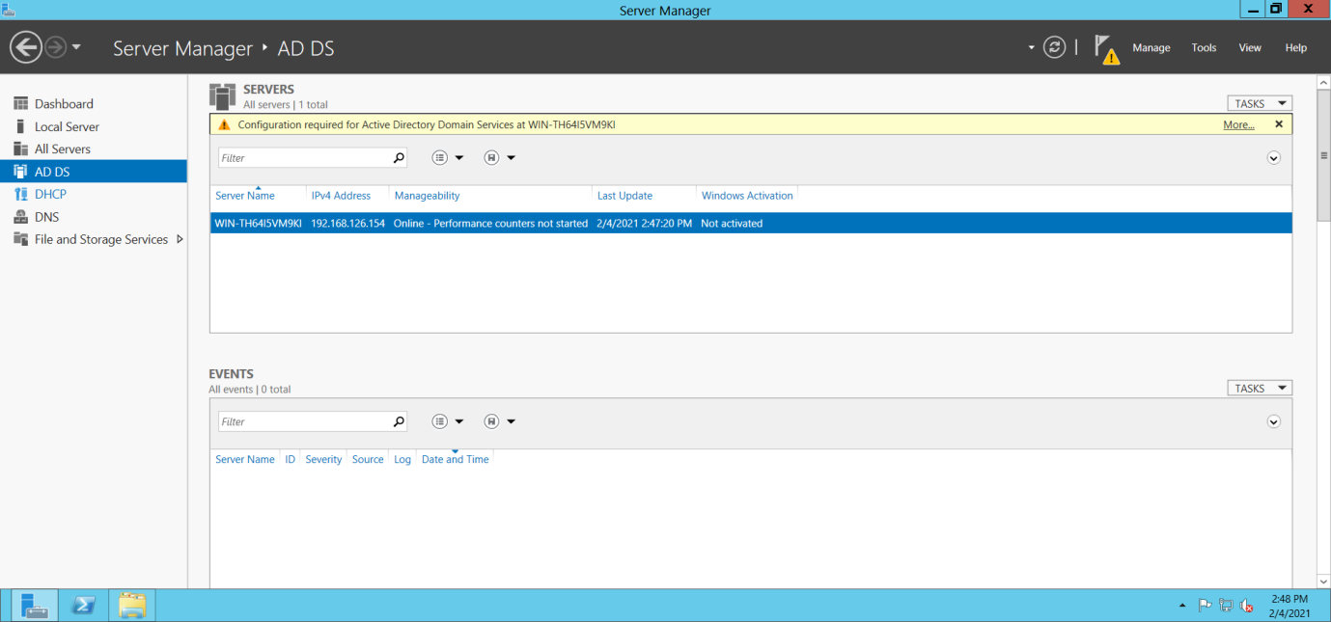

>> Now , Click on **Promote this server to a domain Controller.**

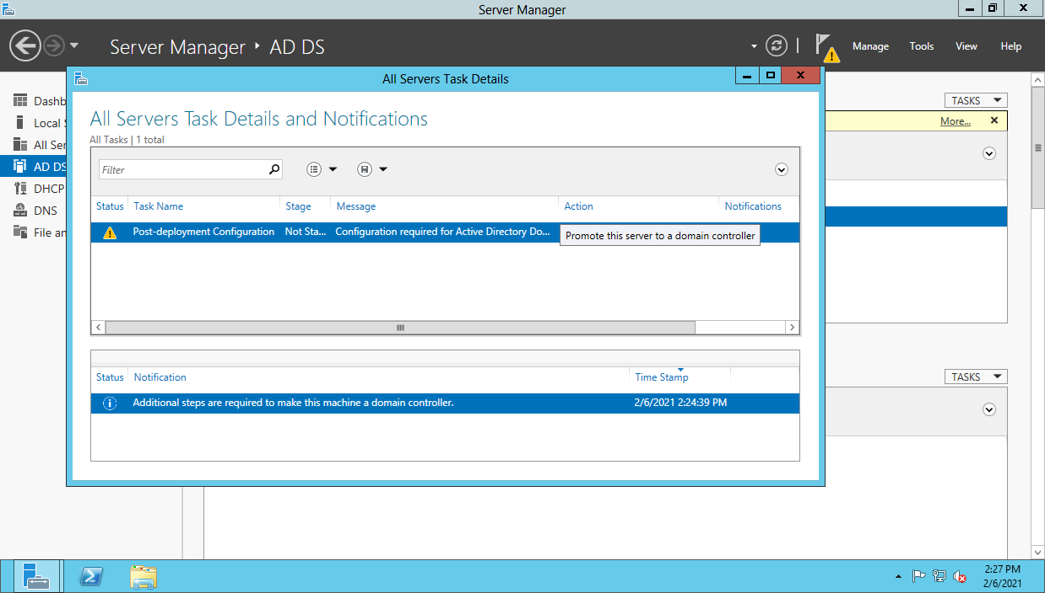

**>>** Select **Add a New Forest.**

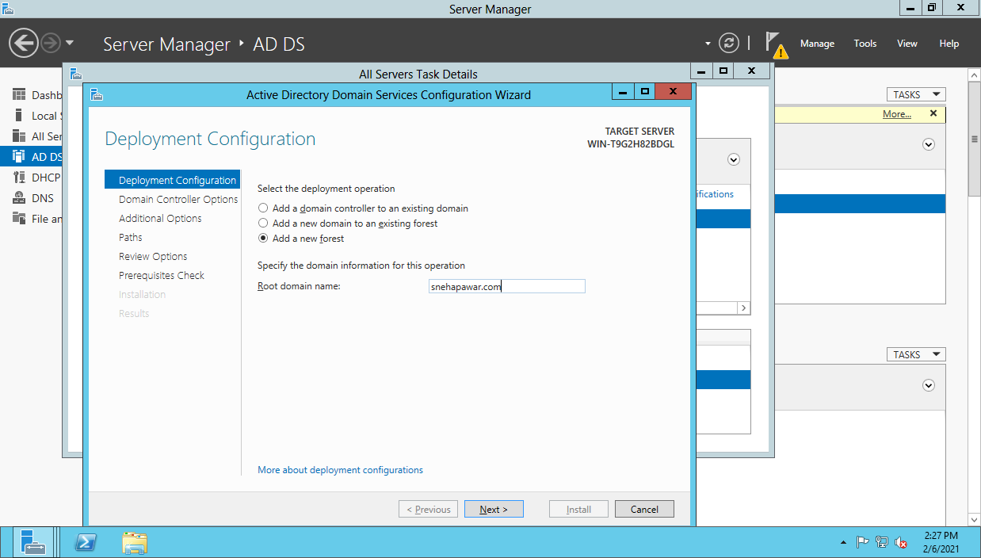

**>>**  Enter a password. And Click on **Next.**

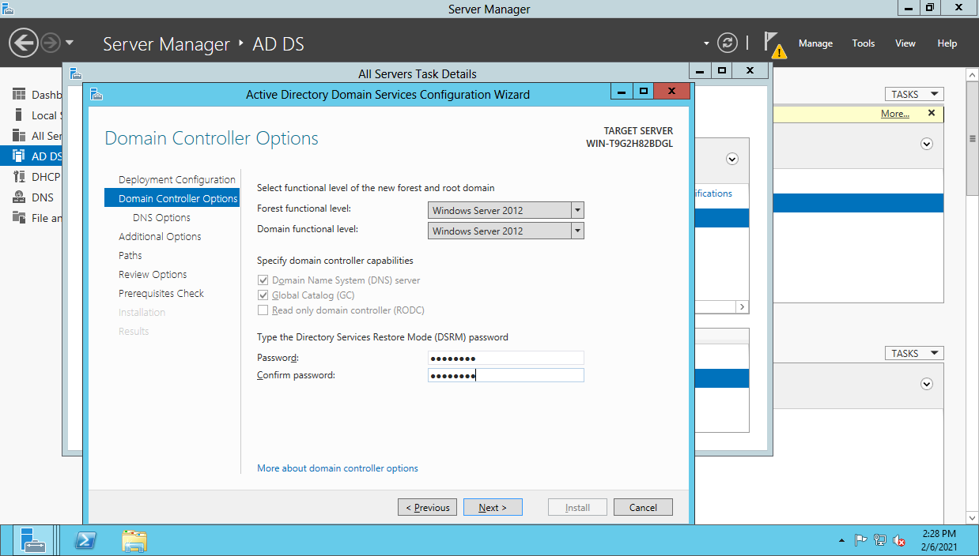

>> Click on **Next.**

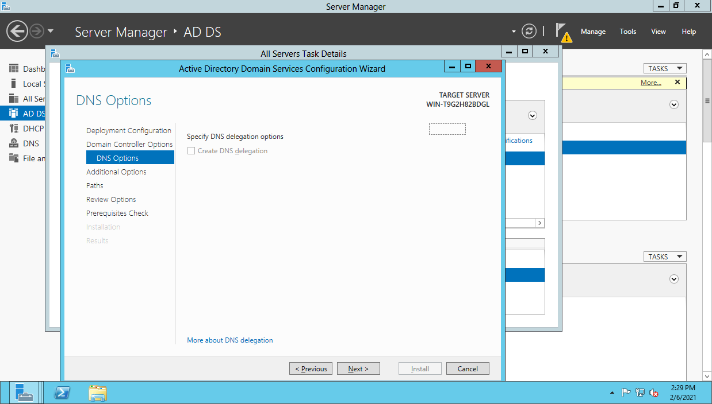

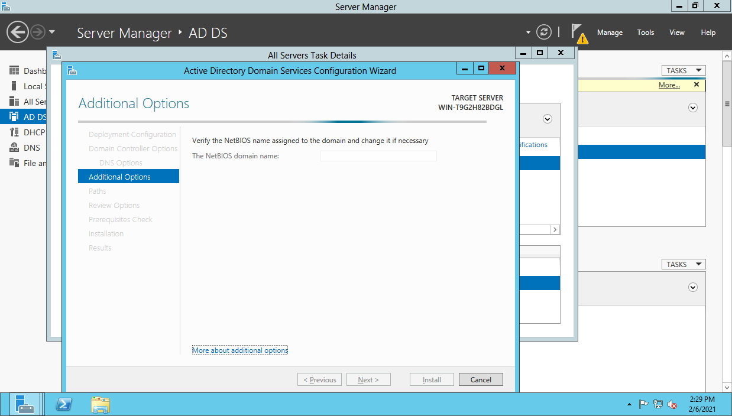

>> Click on **Next.**

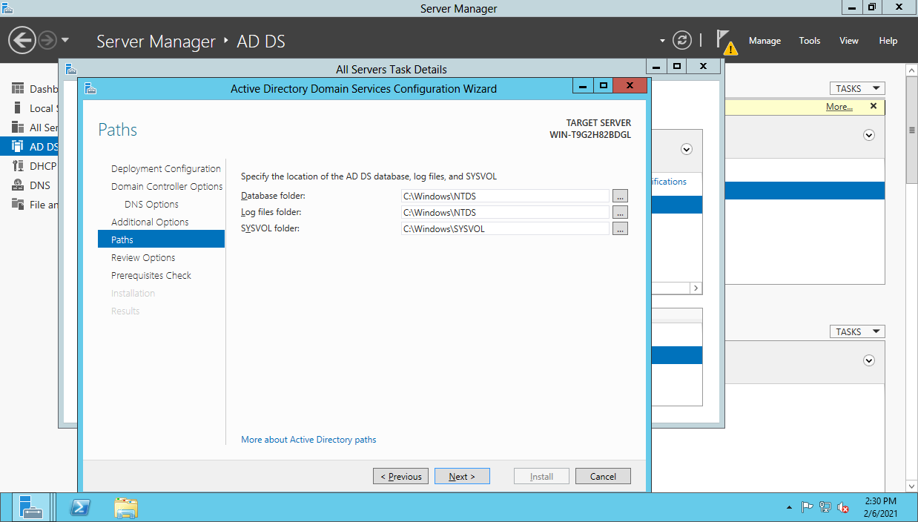

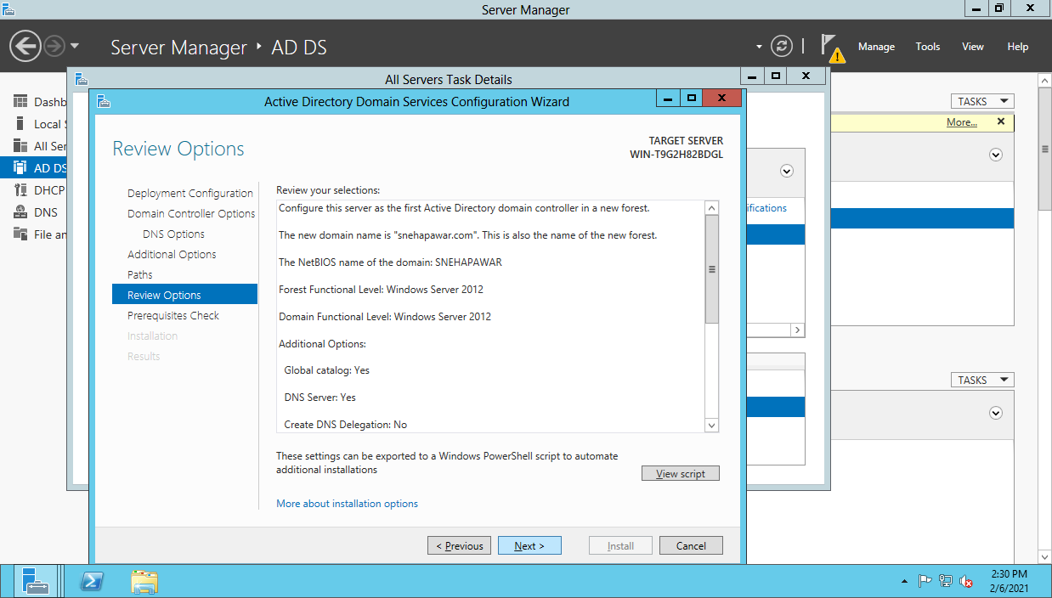

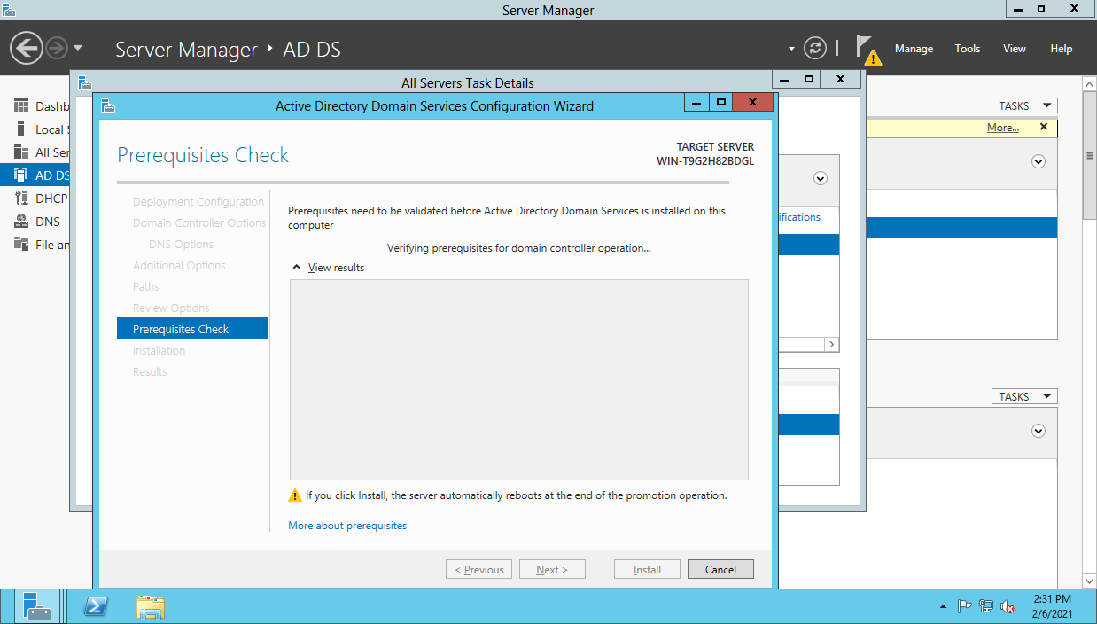

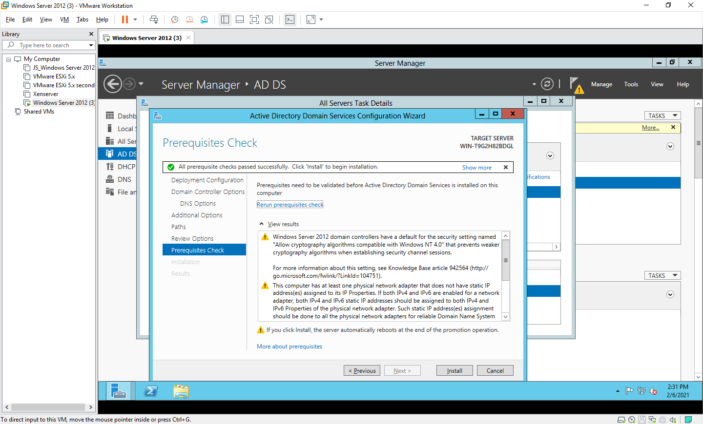

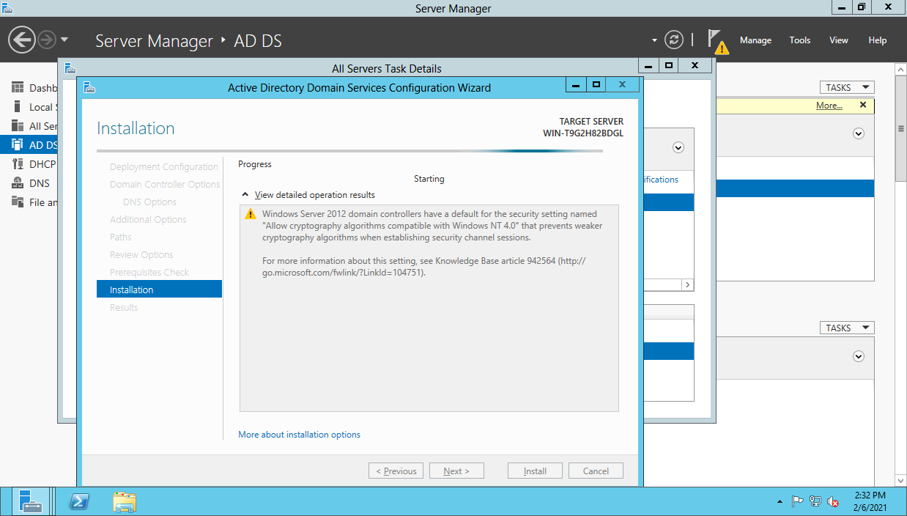

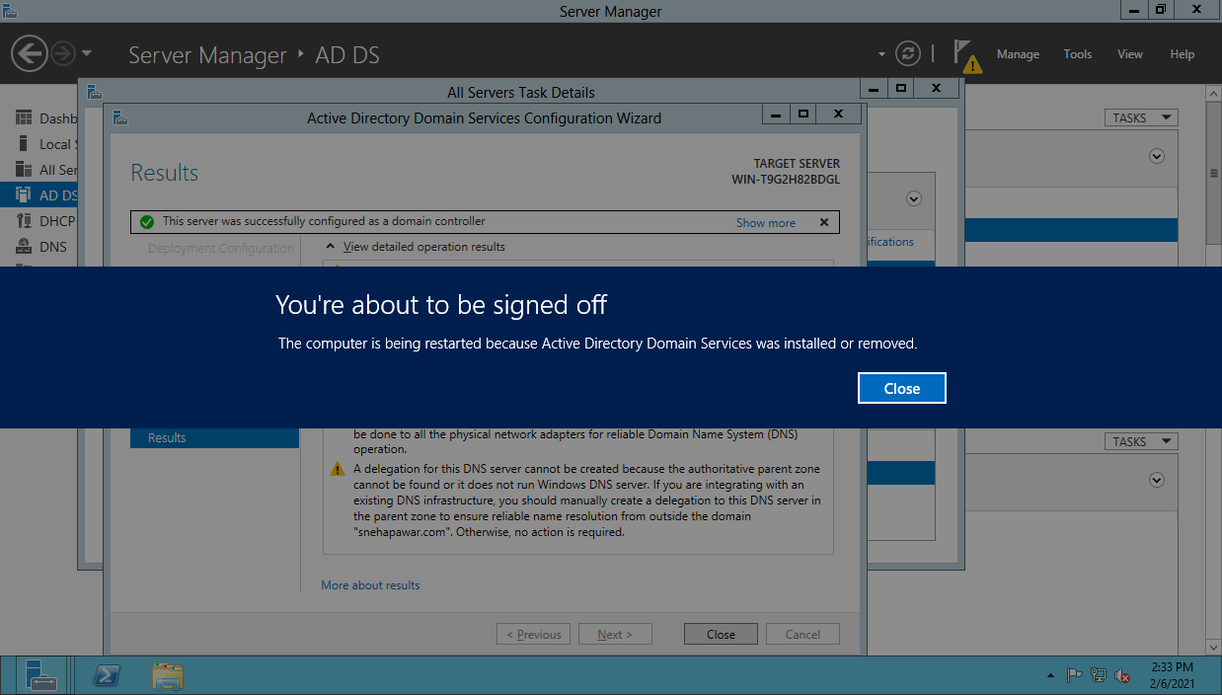

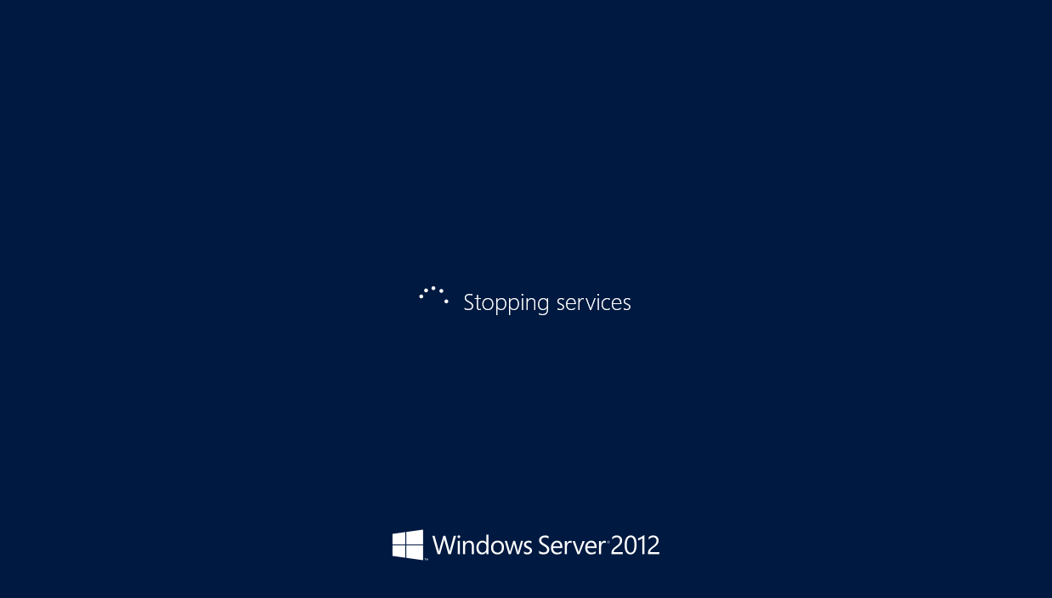

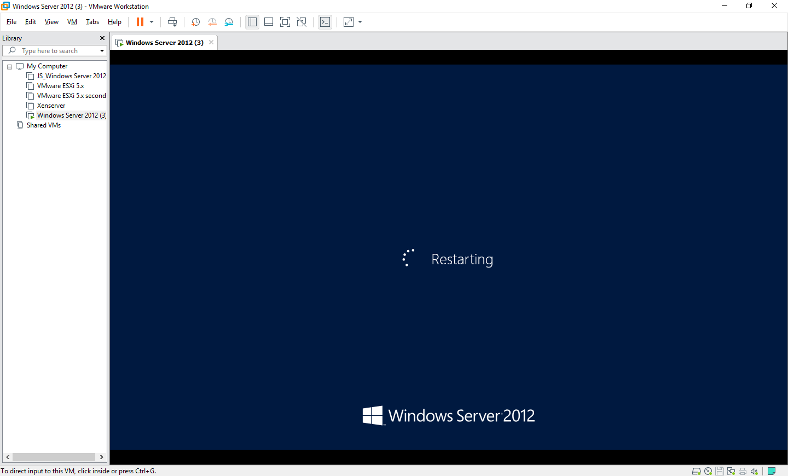

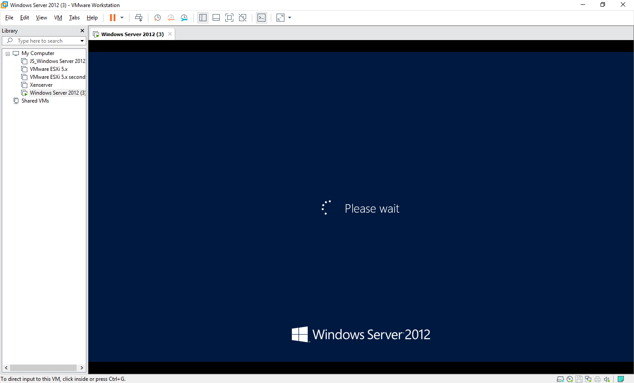

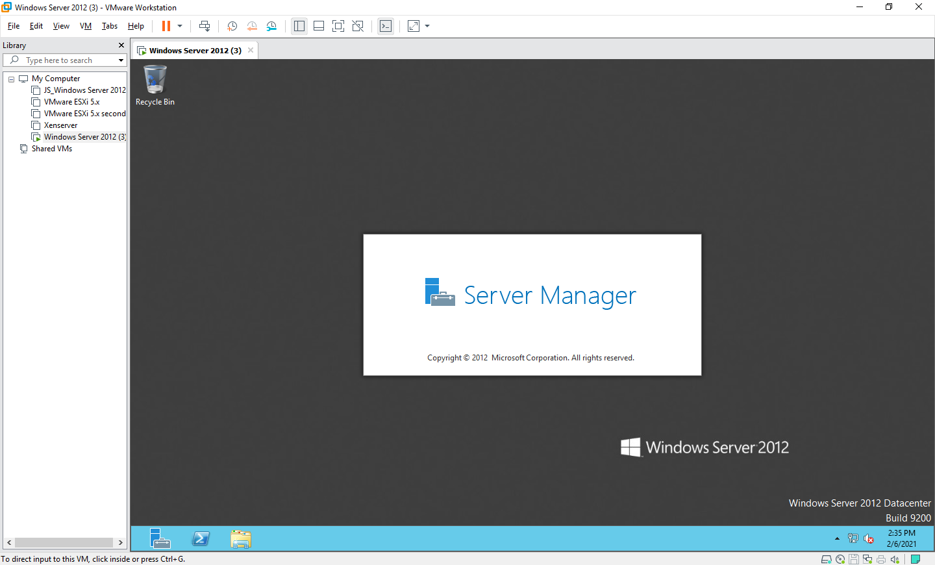

**- Creating a Failover Cluster**

>> Click on **Tools >> Failover cluster Manager**

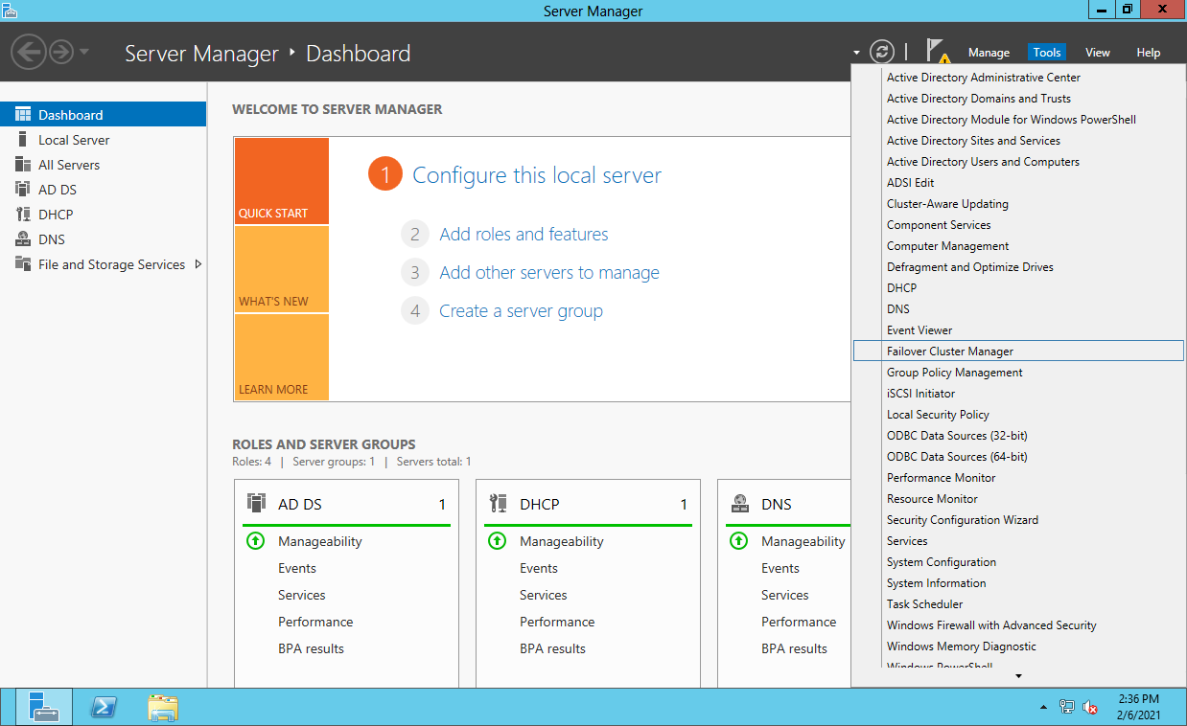

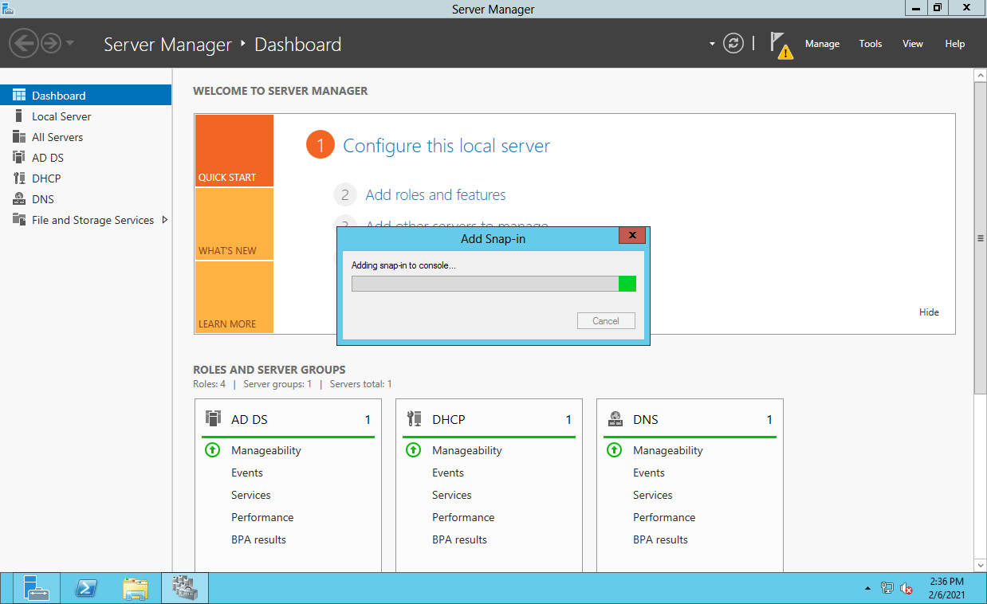

>> Failover Cluster Manager wizards will appear. Click on  **Validate Configuration**, and click on **Next. Validate Configuration Wizard will appear.**

The nodes to be added must be validated prior to add in the cluster.

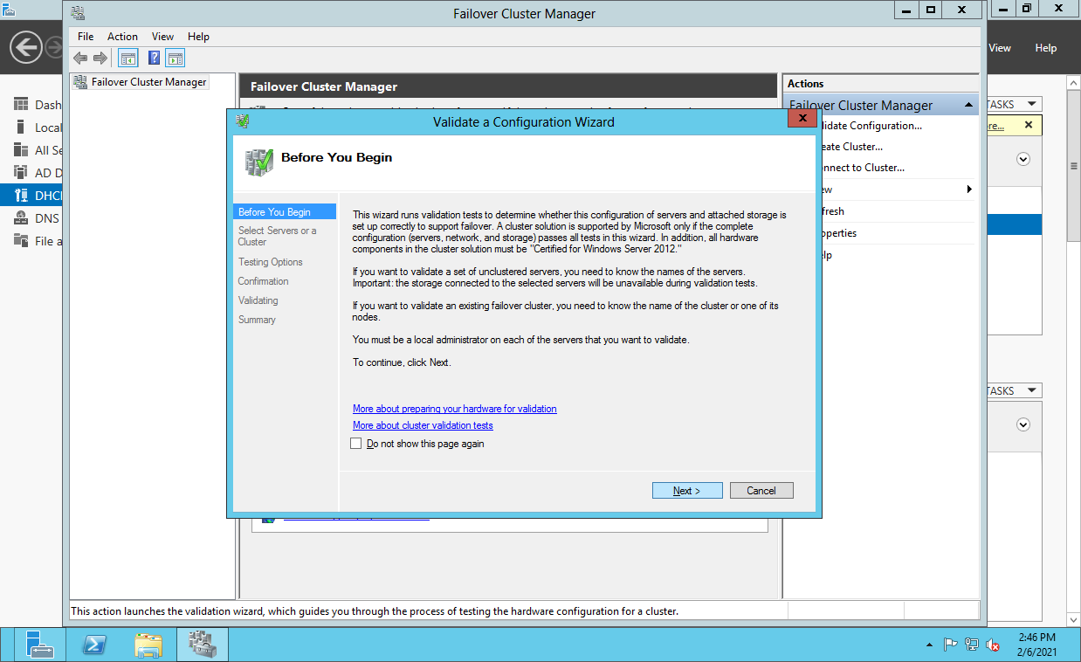

>> Click on **Browse.**

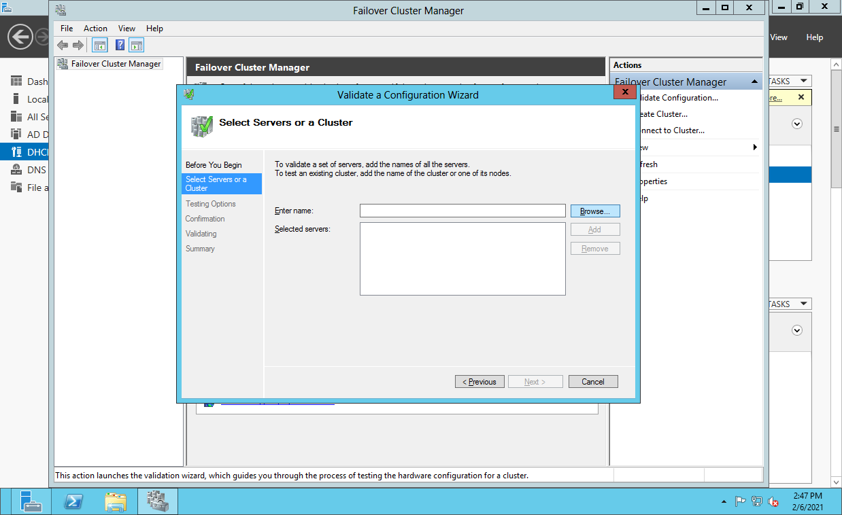

>> CLick on **Advanced.**

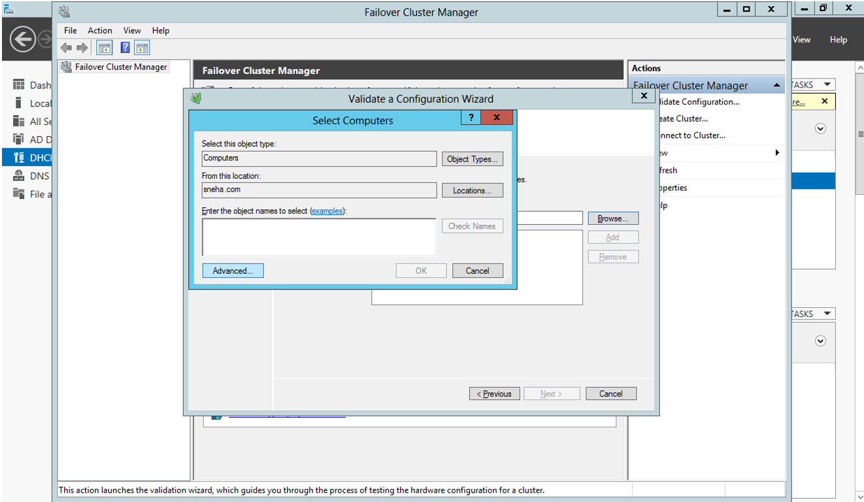

>> Click on **Find Now** to find the domain node.

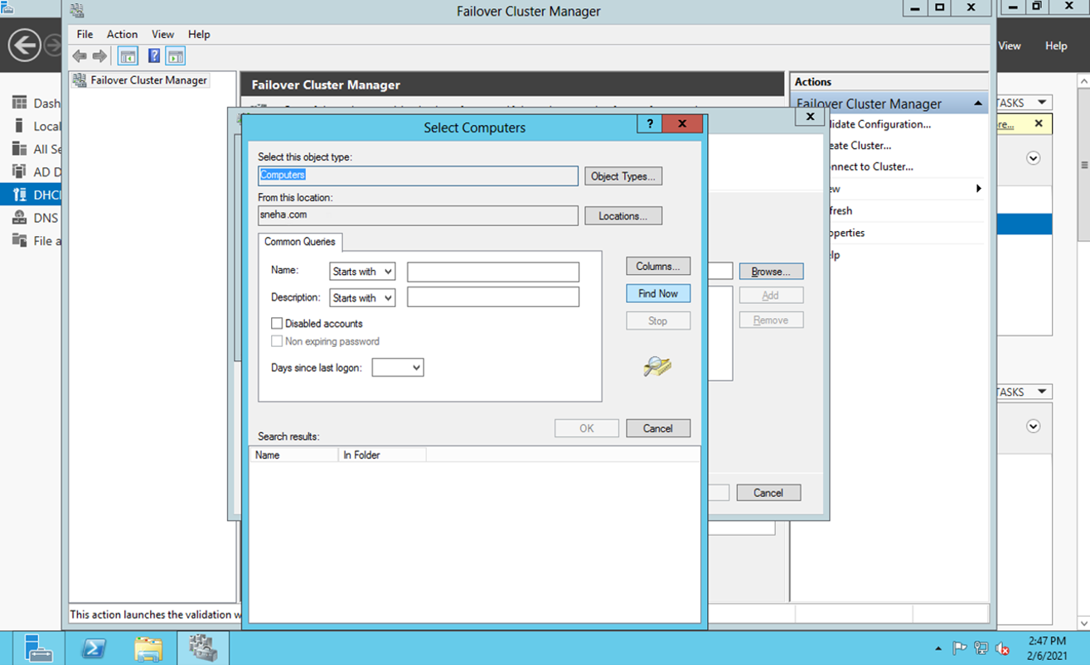

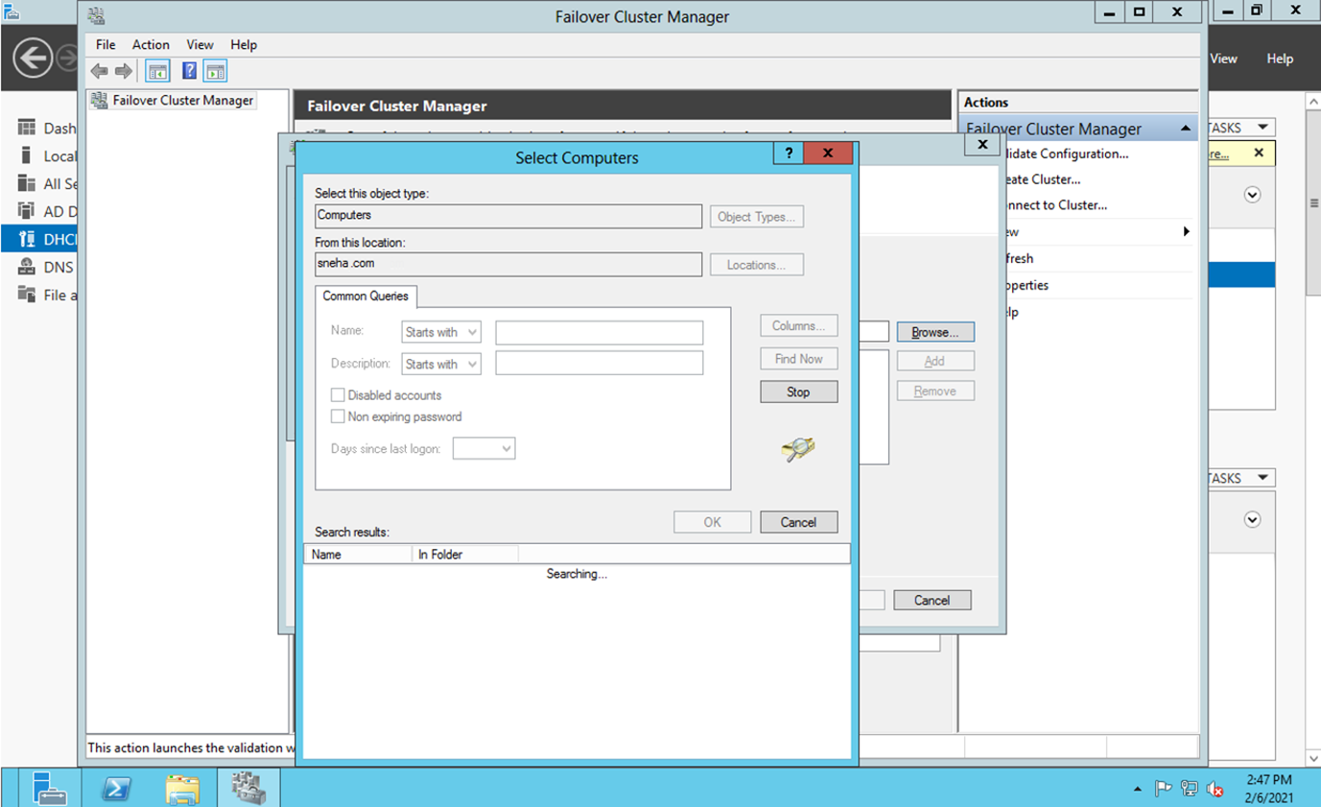

>> Click on the domain that you have created and click on **OK.**

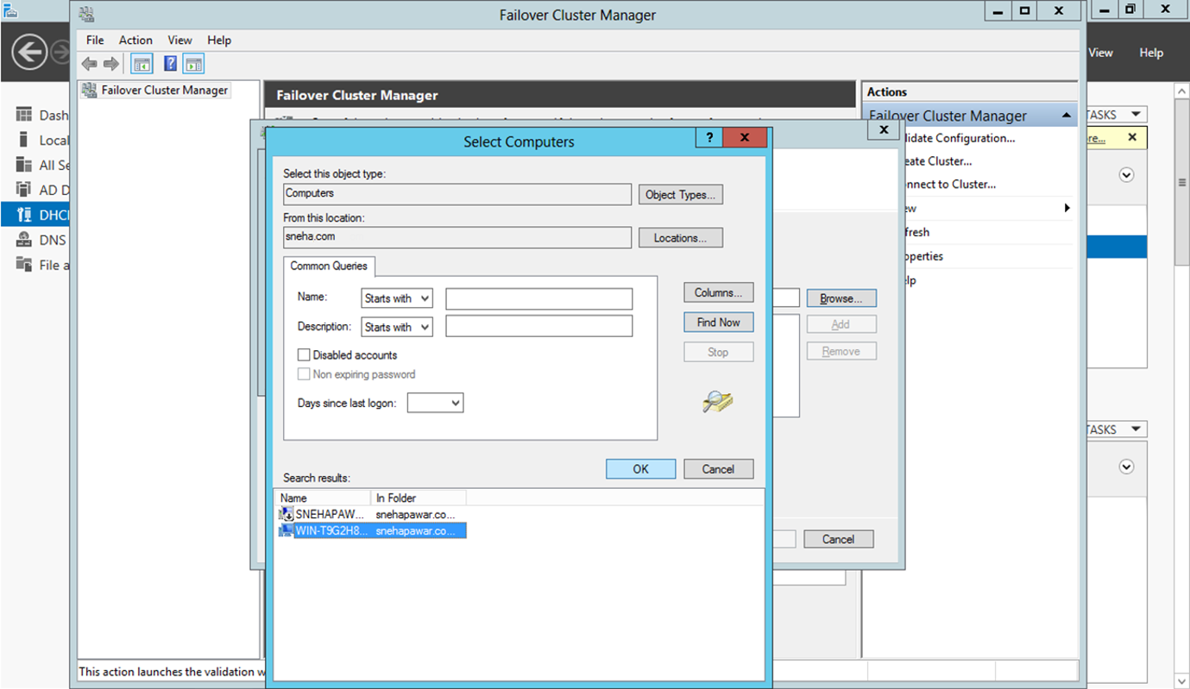

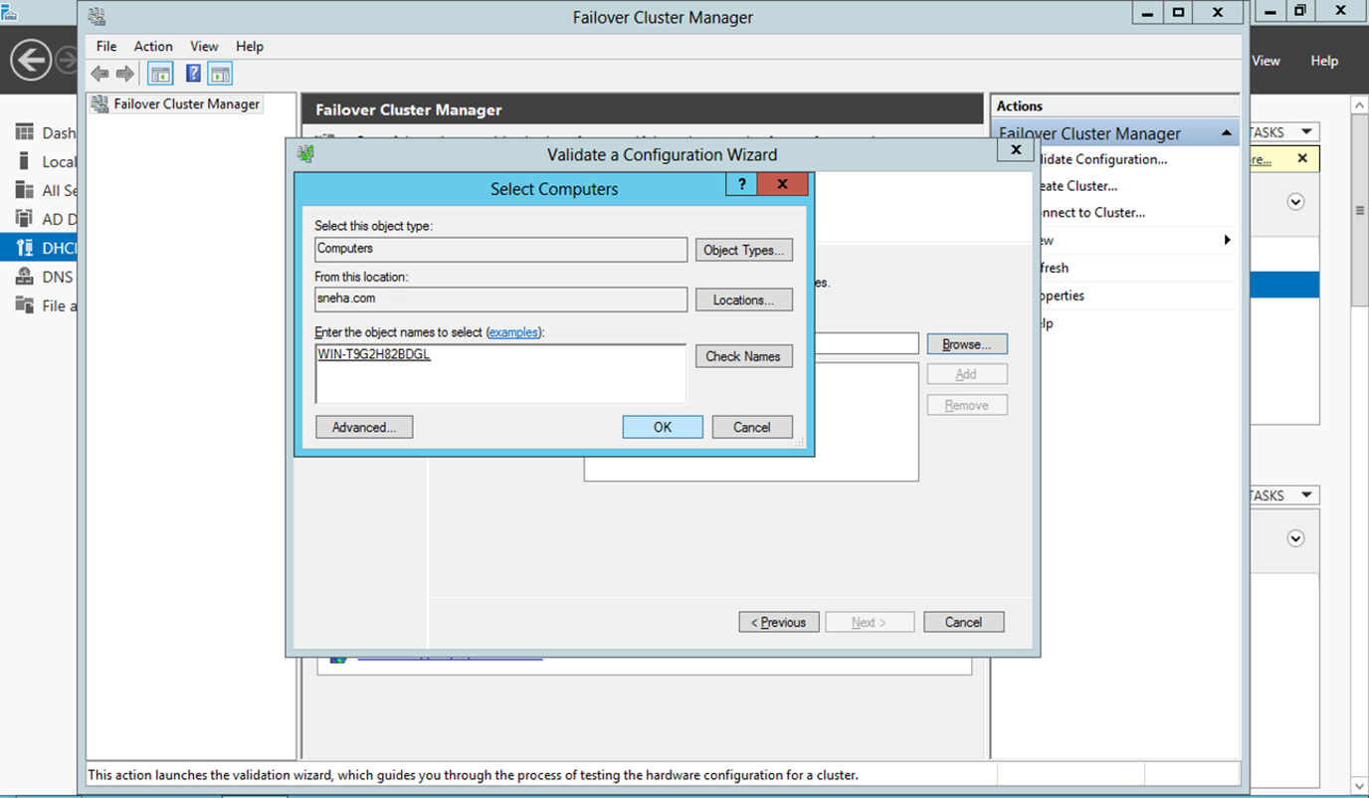

>> Click on  **Next.**

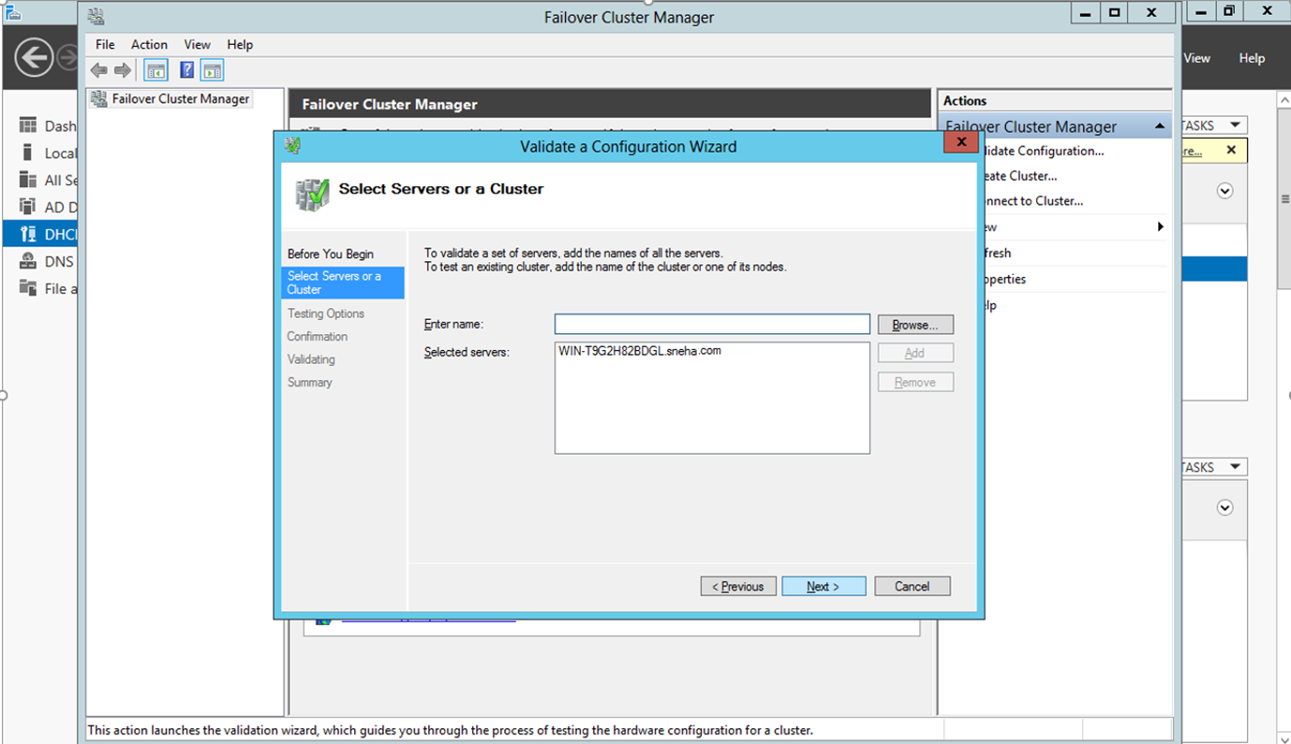

>> Click on **‘Run all Tests Recommended’**. and click on **Next.** It will ask for **confirmation,** click on **Next.**

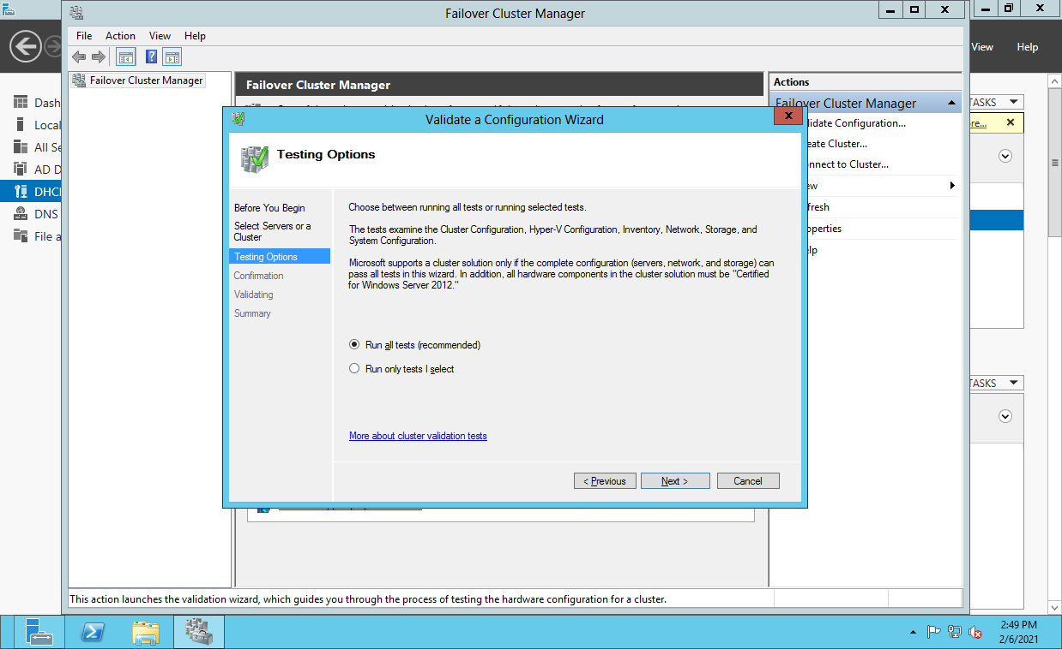

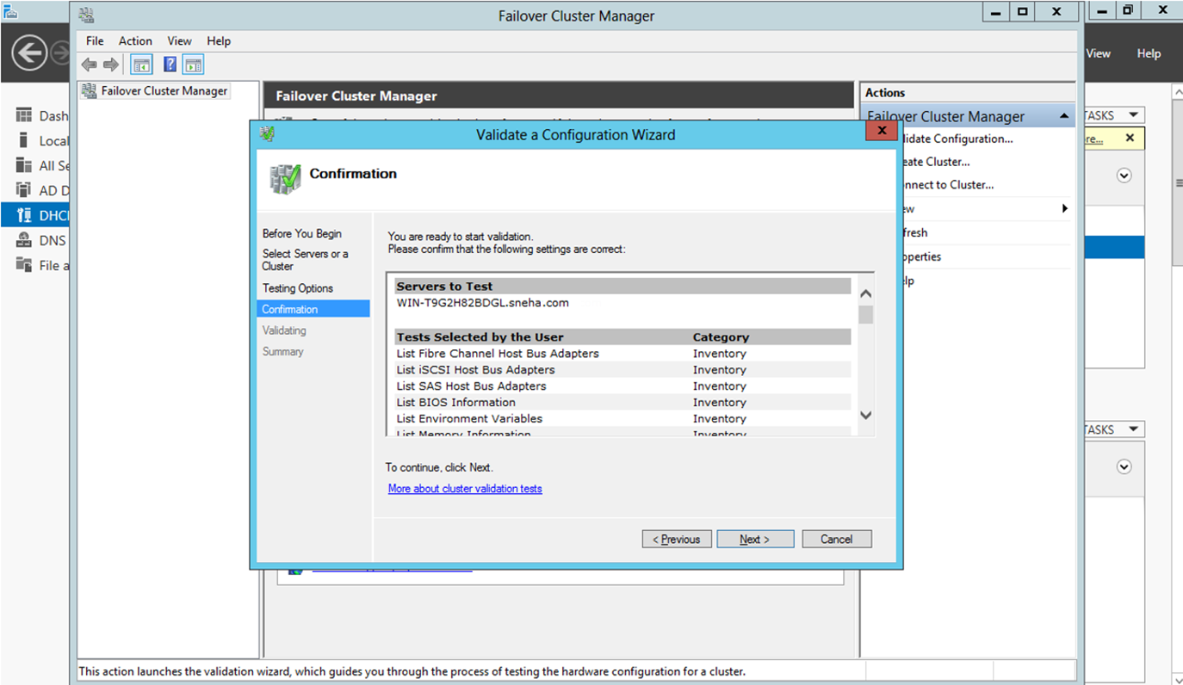

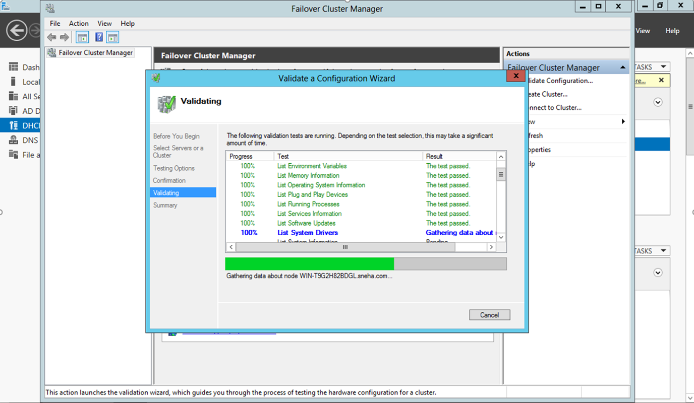

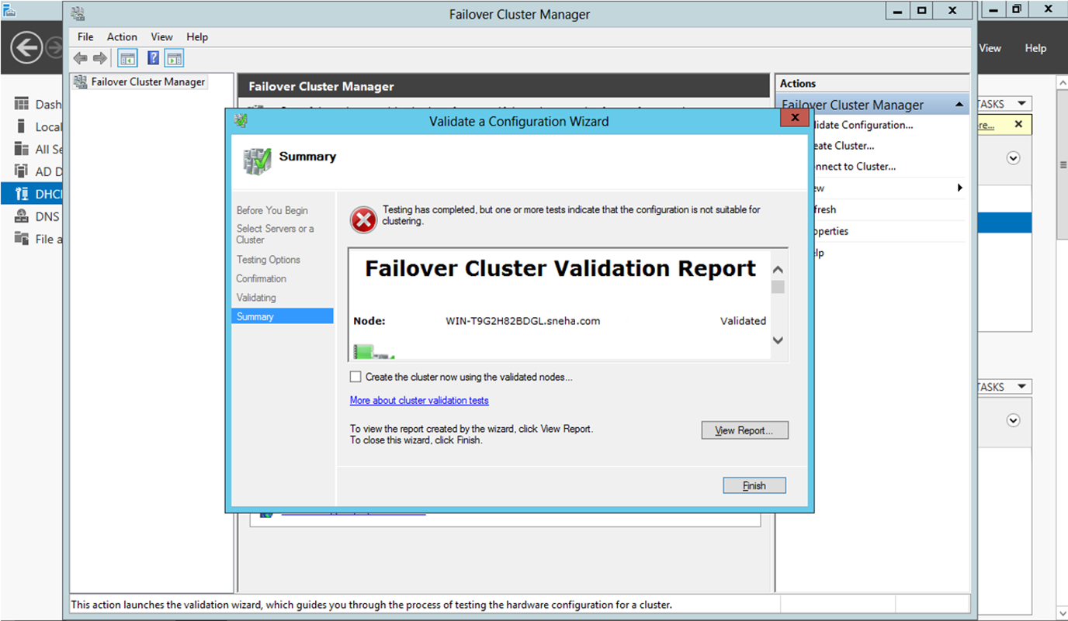

>> After that click on **Create Cluster**. Create cluster wizard will open.

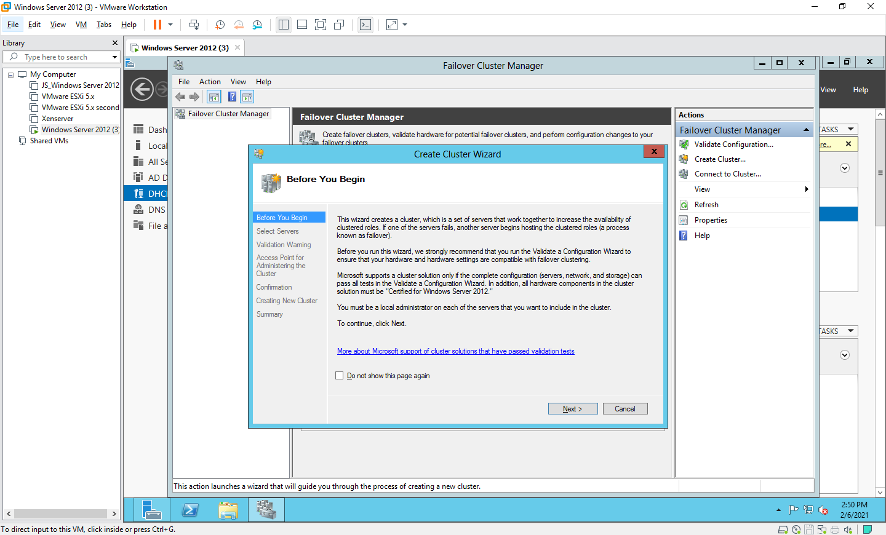

>> Here Specify the cluster name and browse for the domain node that we have created.

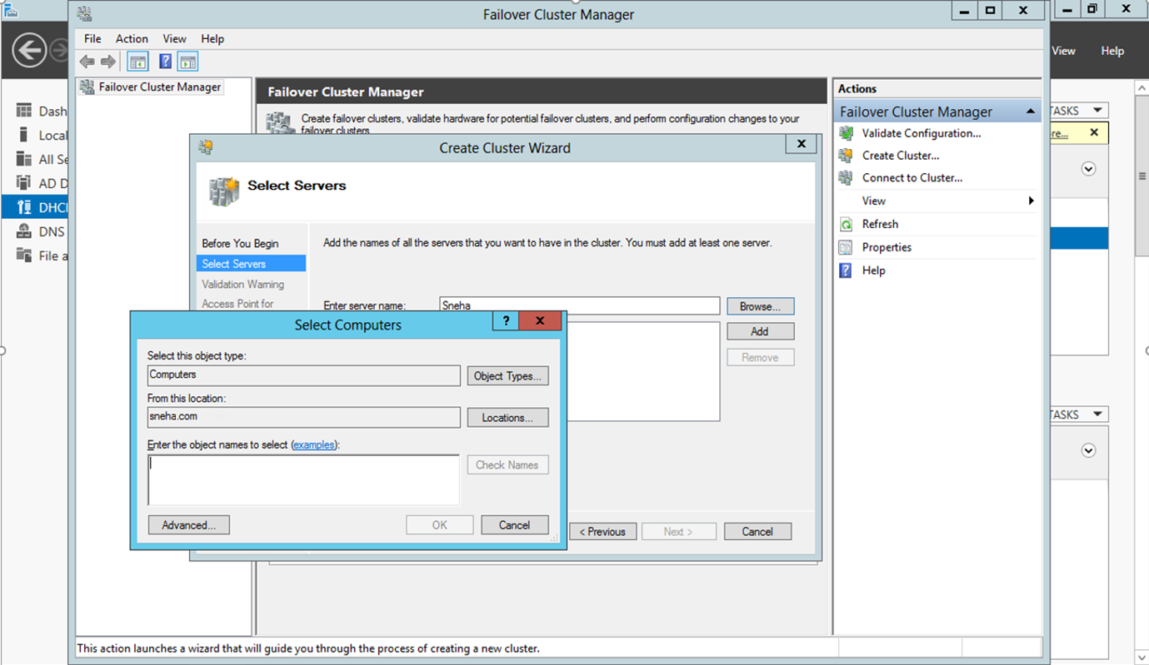

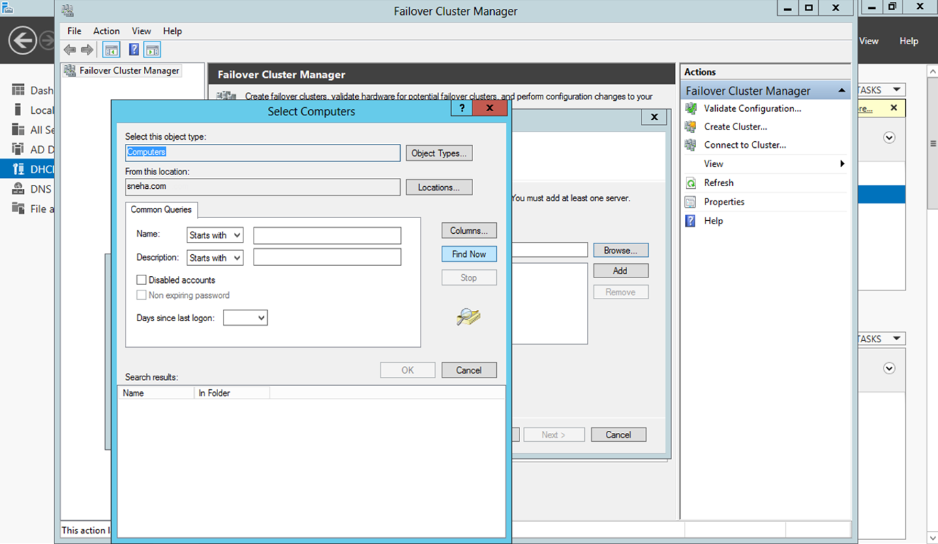

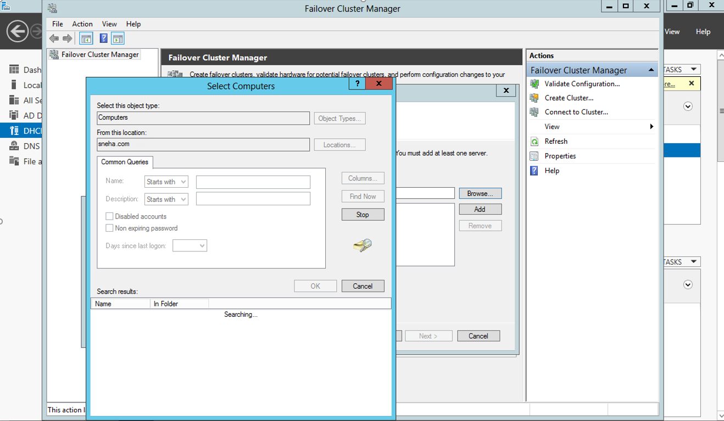

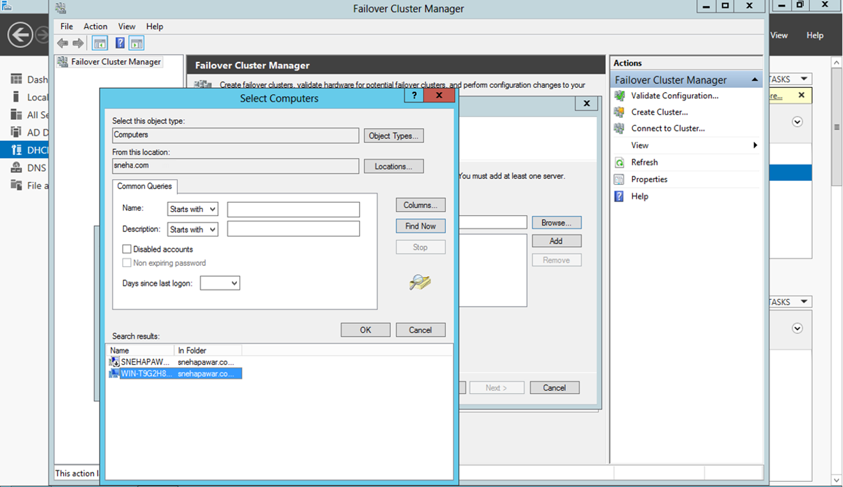

>> Click on **OK.**

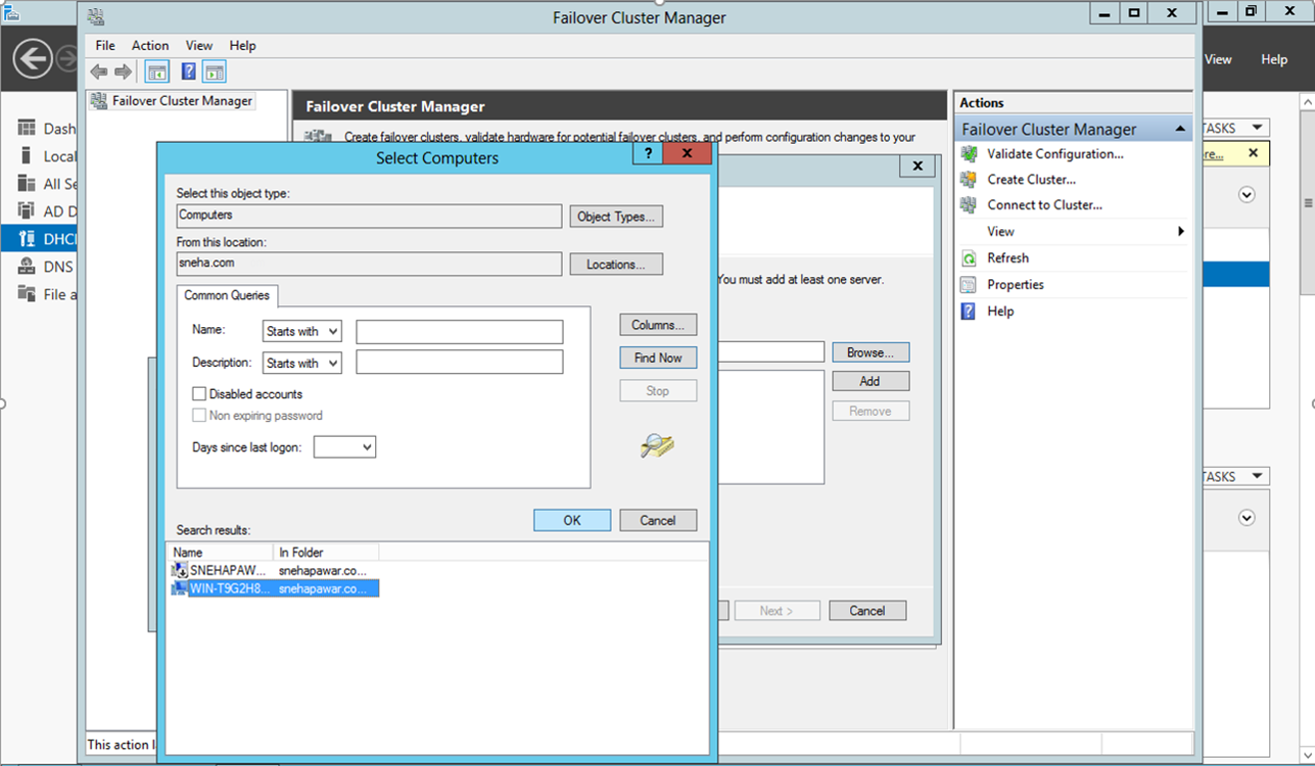

>> click on **Next.**

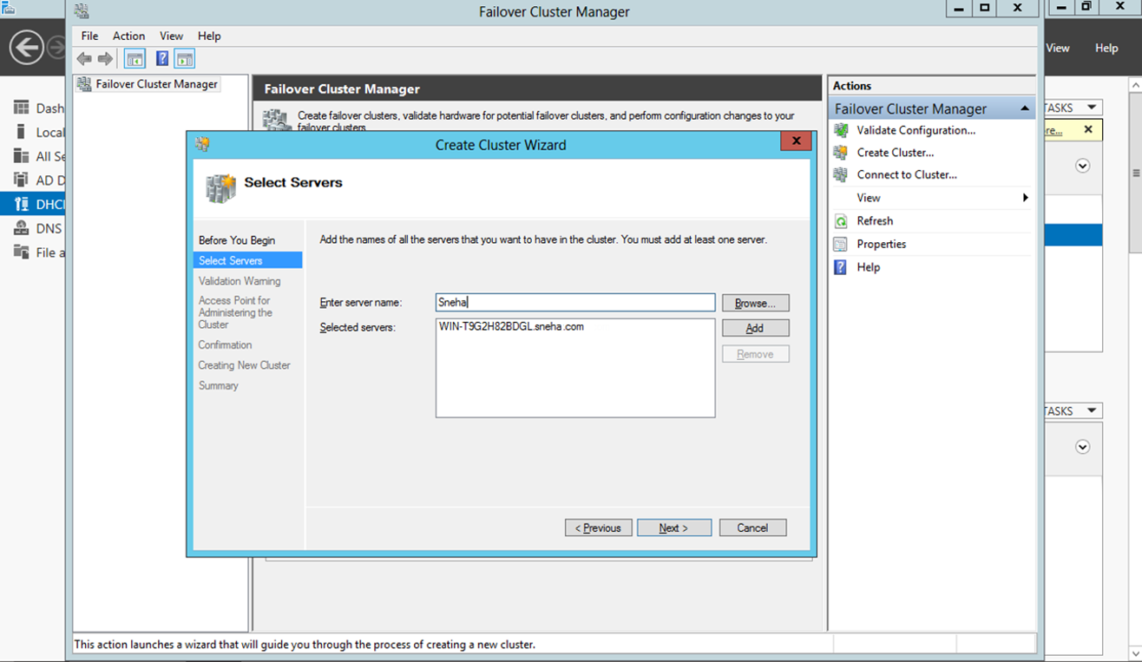

>> In Validation Warning select **No**.

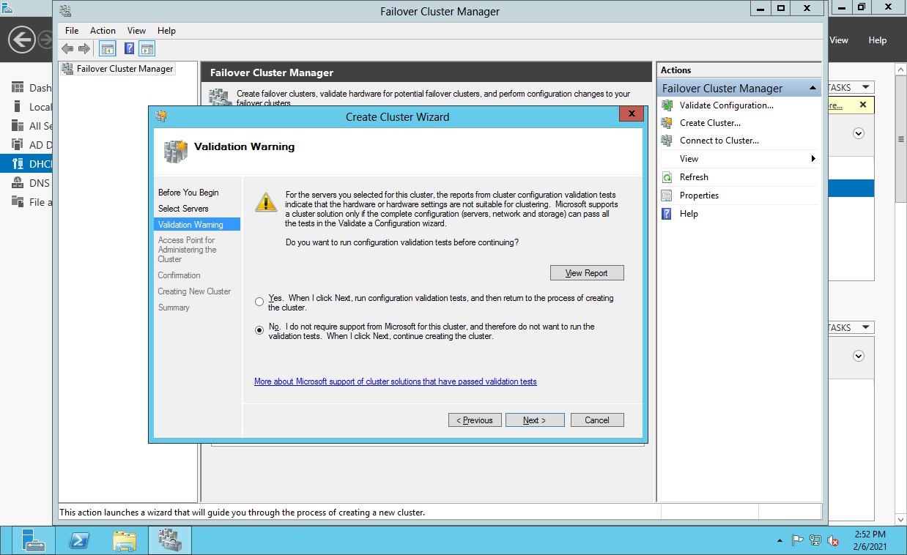

>> Specify the cluster name and click on **Next**.

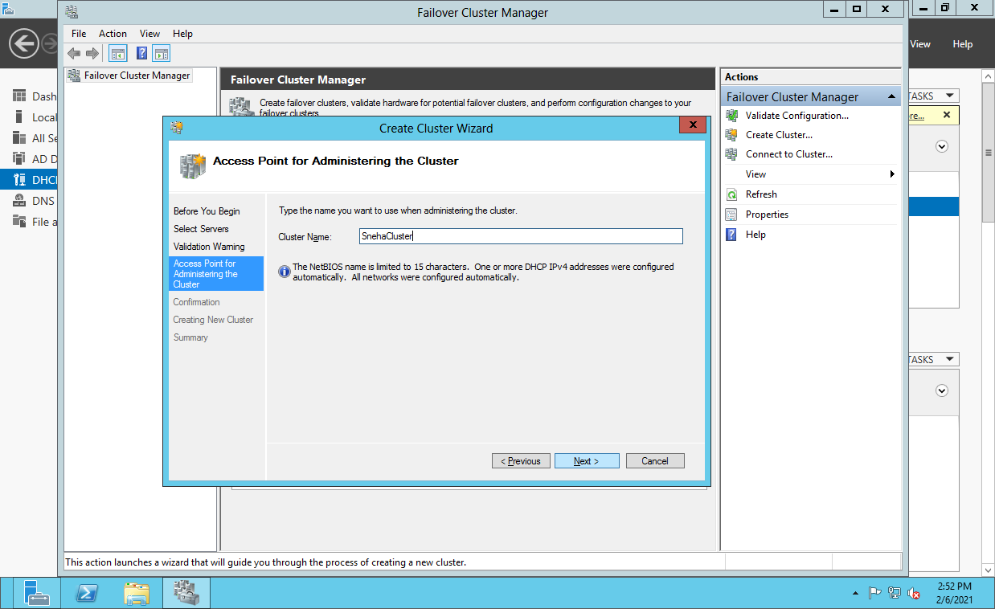

>> click on **Next.**

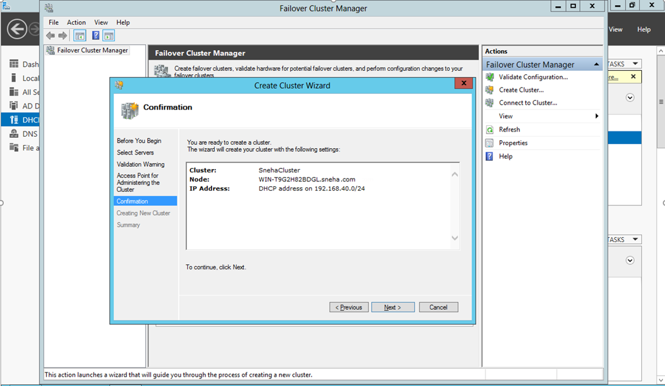

>> Click on **Finish**.

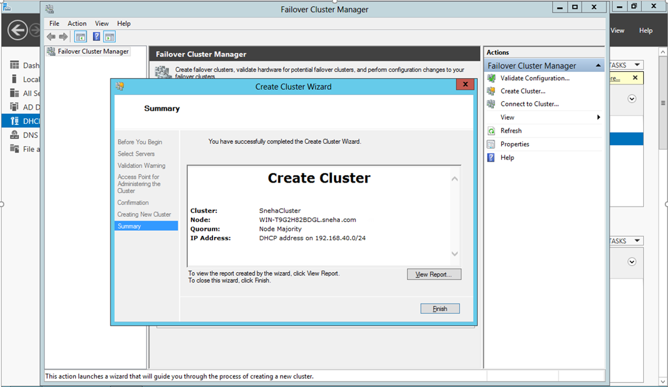

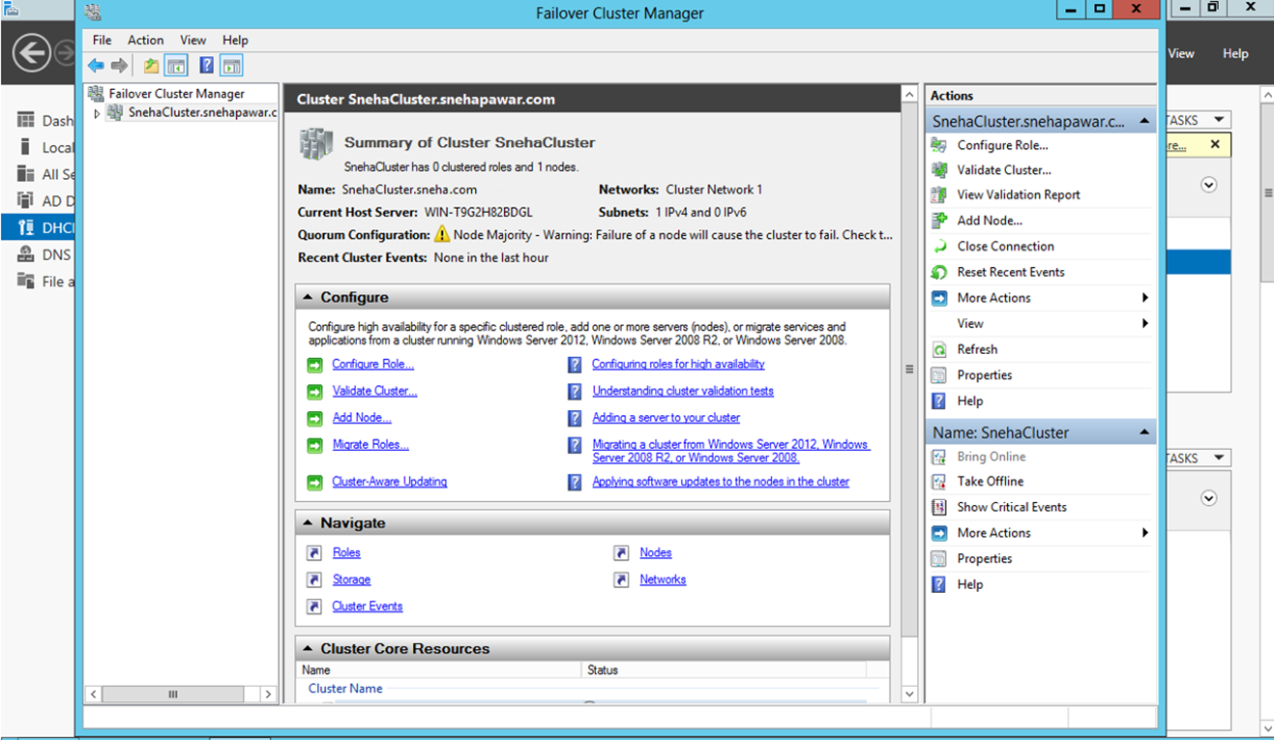

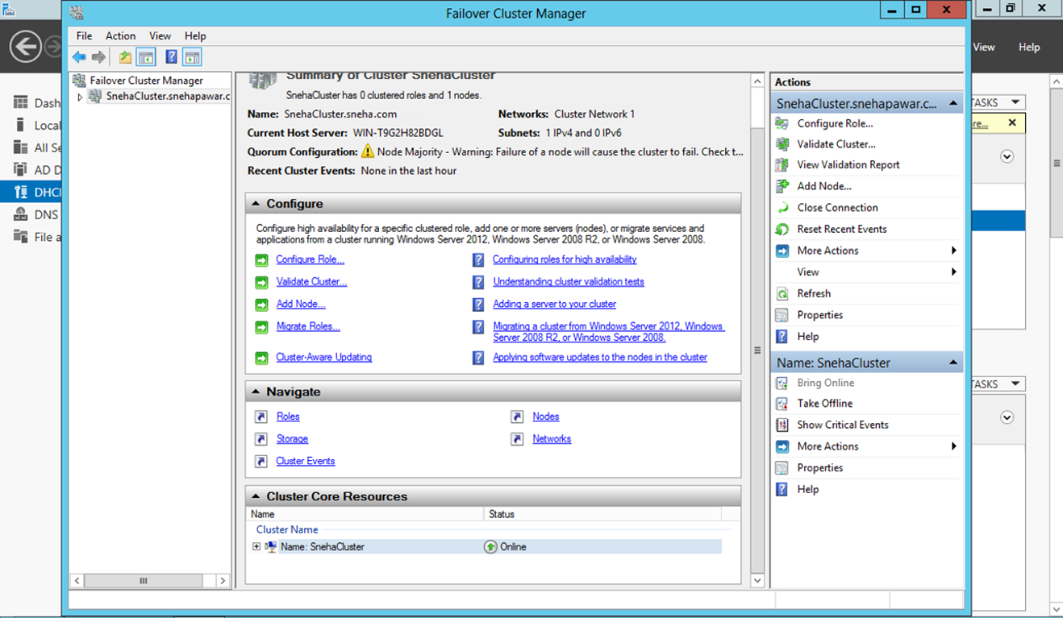

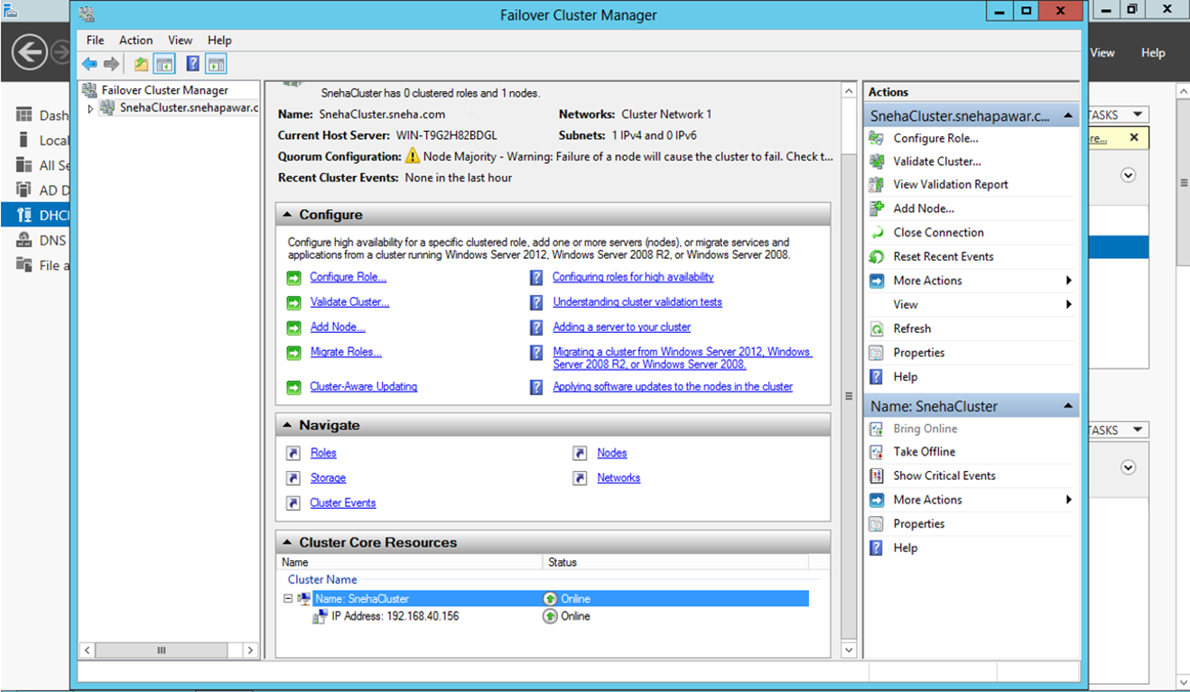

**PRACTICAL: 2**

**Developing application for Windows Azure .**

**Softwares Required :-**

* **Microsoft Visual Studio 2010 Professional**
* **Windows Azure SDK**
* **Windows Azure Tools for Microsoft Visual Studio 2010**

**Steps:**

>> To develop an application for Windows Azure on Visual Studio install the **“Microsoft Azure SDK for .NET(VS 2010) - 2.8.2.1”**.

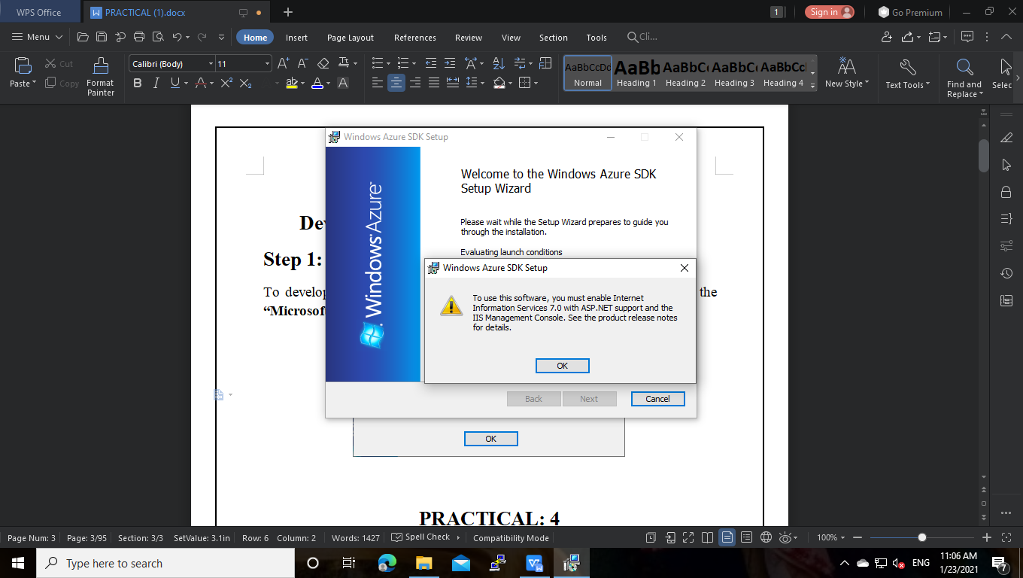

**>> While installing this we will get the above popup.**

>> We need to enable internet information services with ASP.NET support and the IIS Management Console.

IIS stands for Internet Information Services or internet Information Server also known as Windows Web Server is available on most versions of Microsoft Windows operating systems and takes second place in overall usage behind Apache HTTP Server on the internet.

IIS is a web server package designed for windows server. It is used for hosting websites and other content on the web.

**Enabling IIS and required IIS components on Windows 10.**

**>>** Open **Control Panel** and click  **Programs and Features > Turn Windows features on or off.**

**>> Enable internet information services.**

**>>**  Expand the **Internet Information Services** feature and verify that the web server components listed in the next section are enabled.

**>>** Click **OK.**

**Required IIS Components :**

The IIS components listed below satisfy the minimum requirements. If other IIS components are enabled, they do not need to be removed.

* Web Manager Tools

- IIS 6 Management Compatibility

- IIS Metabase and IIS 6 configuration compatibility

- IIS Management Console

- IIS Management Scripts and Tools

- IIS Management Service

* World Wide Web Services

- Application Development Features

- .NET Extensibility 4.5

- ASP.NET 4.5

- ISAPI Extensions

- ISAPI Filters

- WebSocket Protocol

- Common HTTP Features

- Default Document

- Static Content

- Security

-Basic Authentication

- Request Filtering

- Windows Authentication

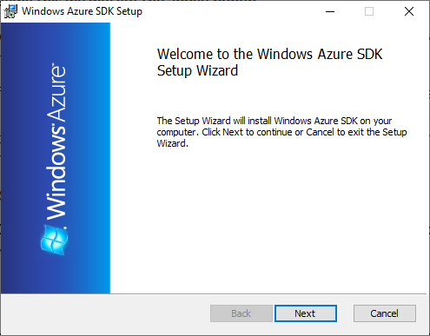

>> Accept the license agreement and click on **Next**.

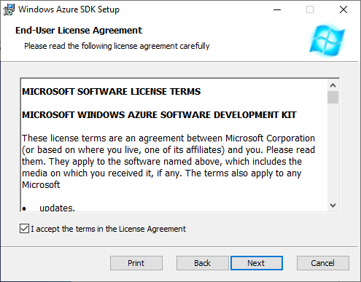

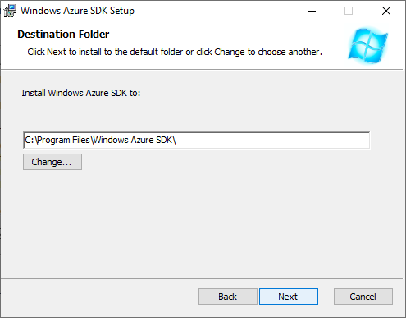

>> Click on **Install**.

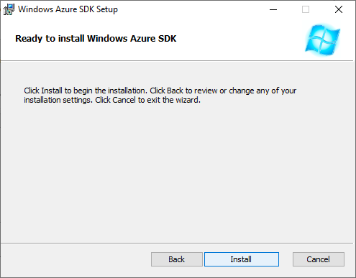

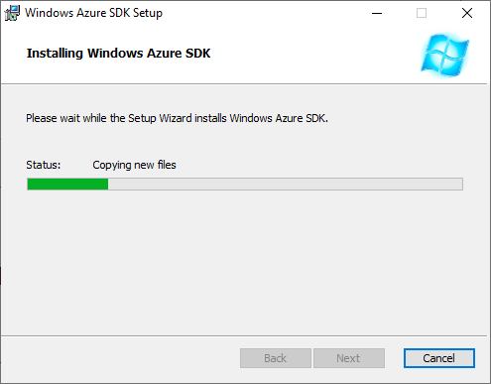

>> Click on **Finish**.

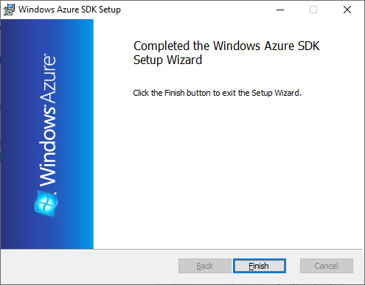

>> Now, Install the **“Microsoft Visual Studio 2010”**.

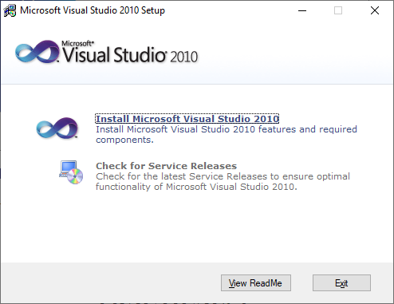

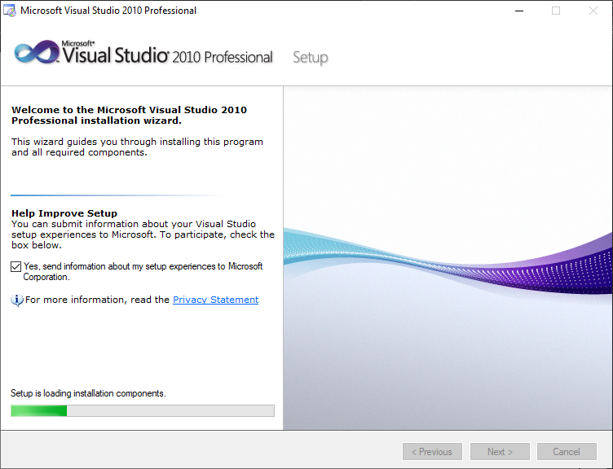

>> Now, Click on **Next.**

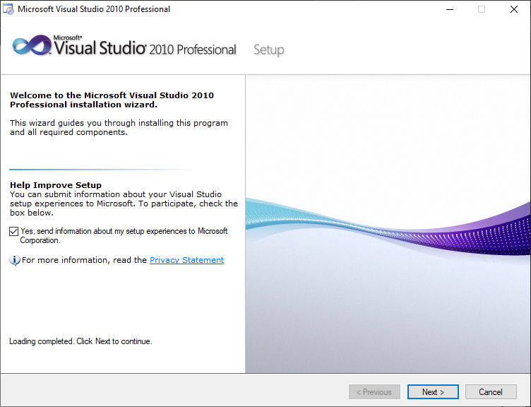

>> Click on **Next**.

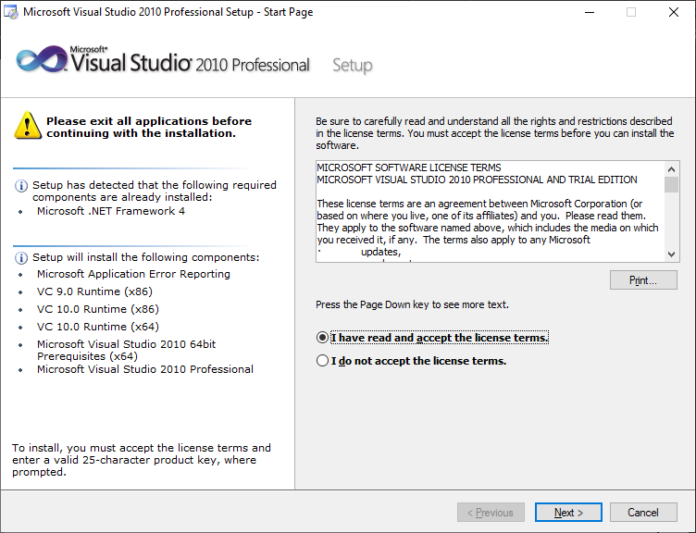

**>> Select Features to Install >> Full.**  and click on **Install**.

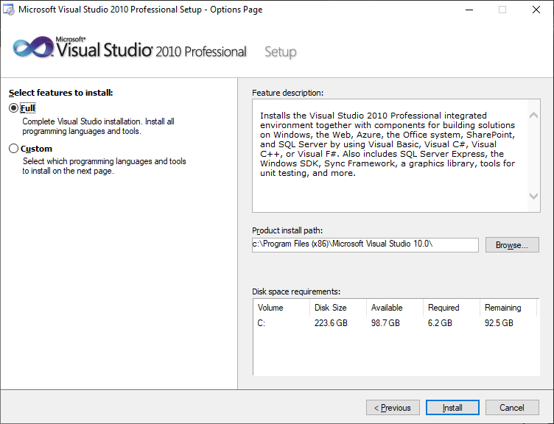

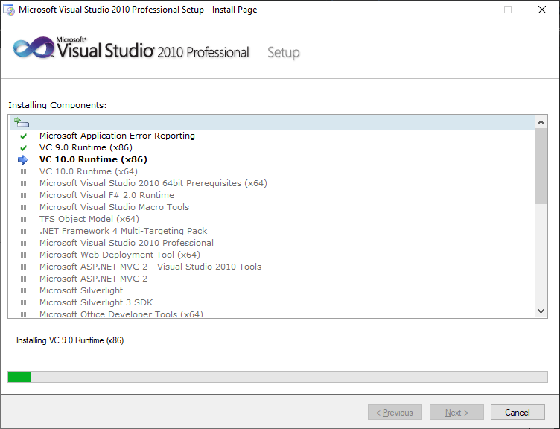

>> Click on **Finish.**

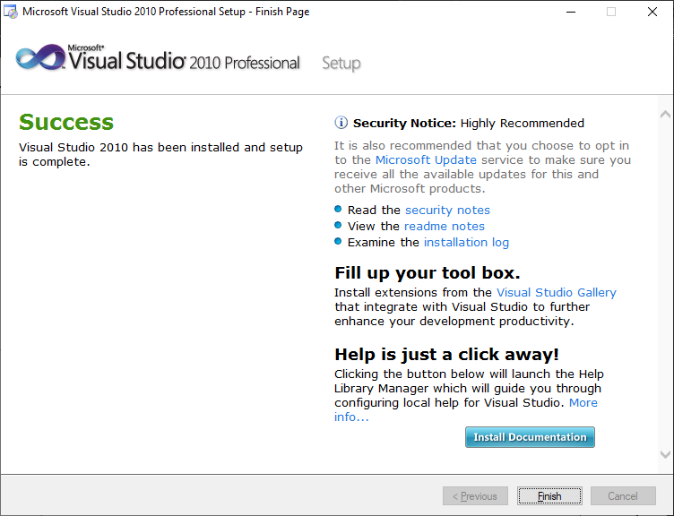

>> Now Install Windows Azure Tools for Microsoft Visual Studio 2010(VSCloudServices) application. Without this we can’t create cloud based web application in Visual Studio.

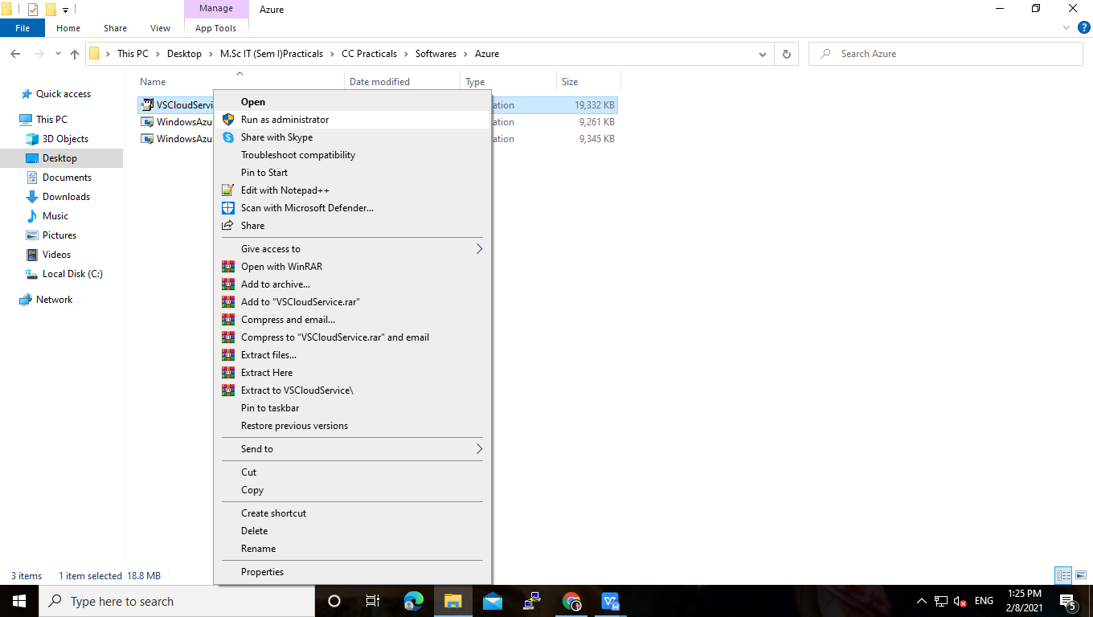

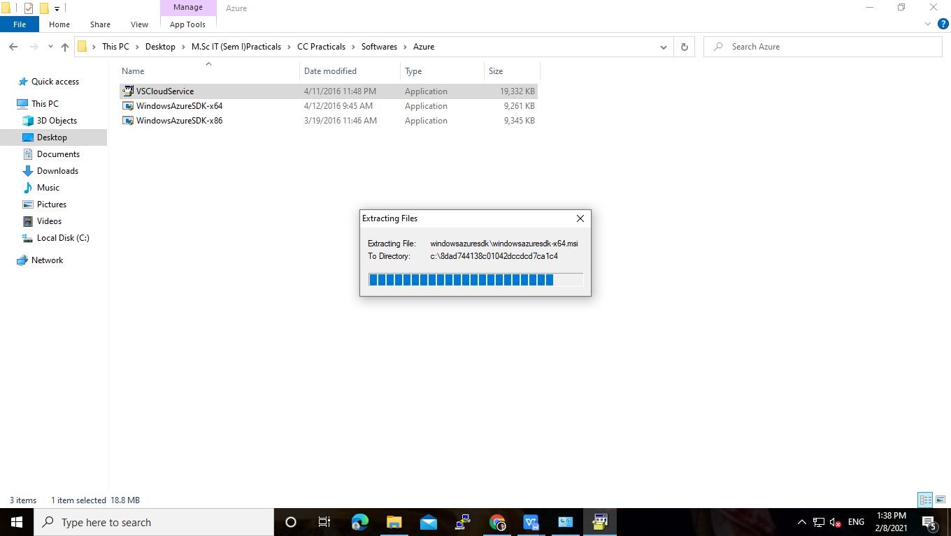

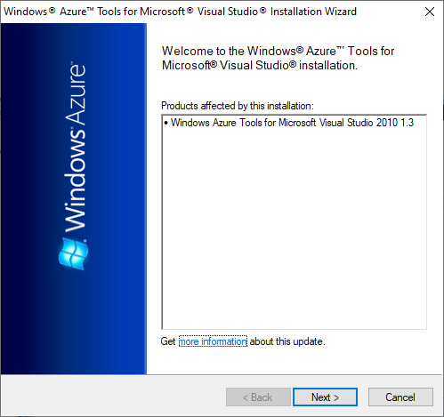

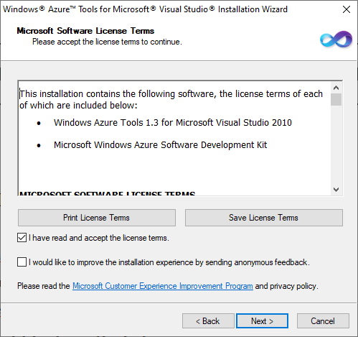

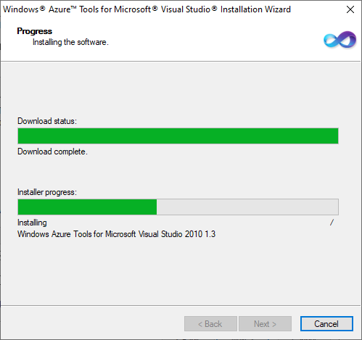

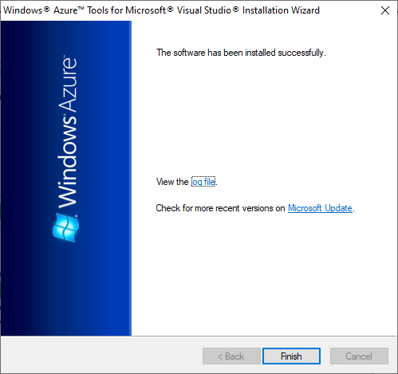

>> Now, **Run the visual studio as an Administrator.**

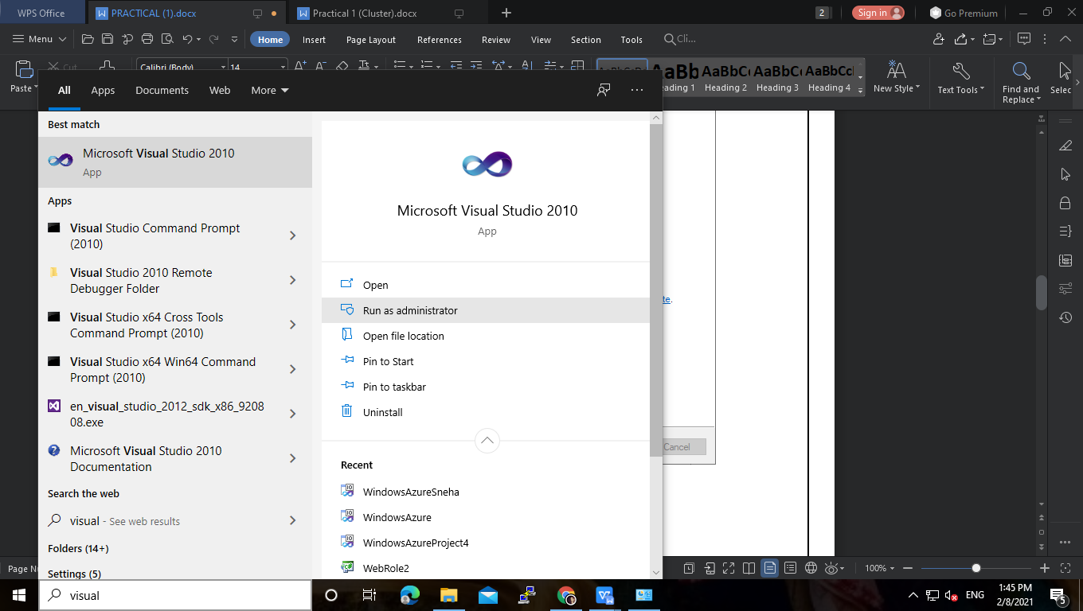

>> Click on **File >> New >> Project.**

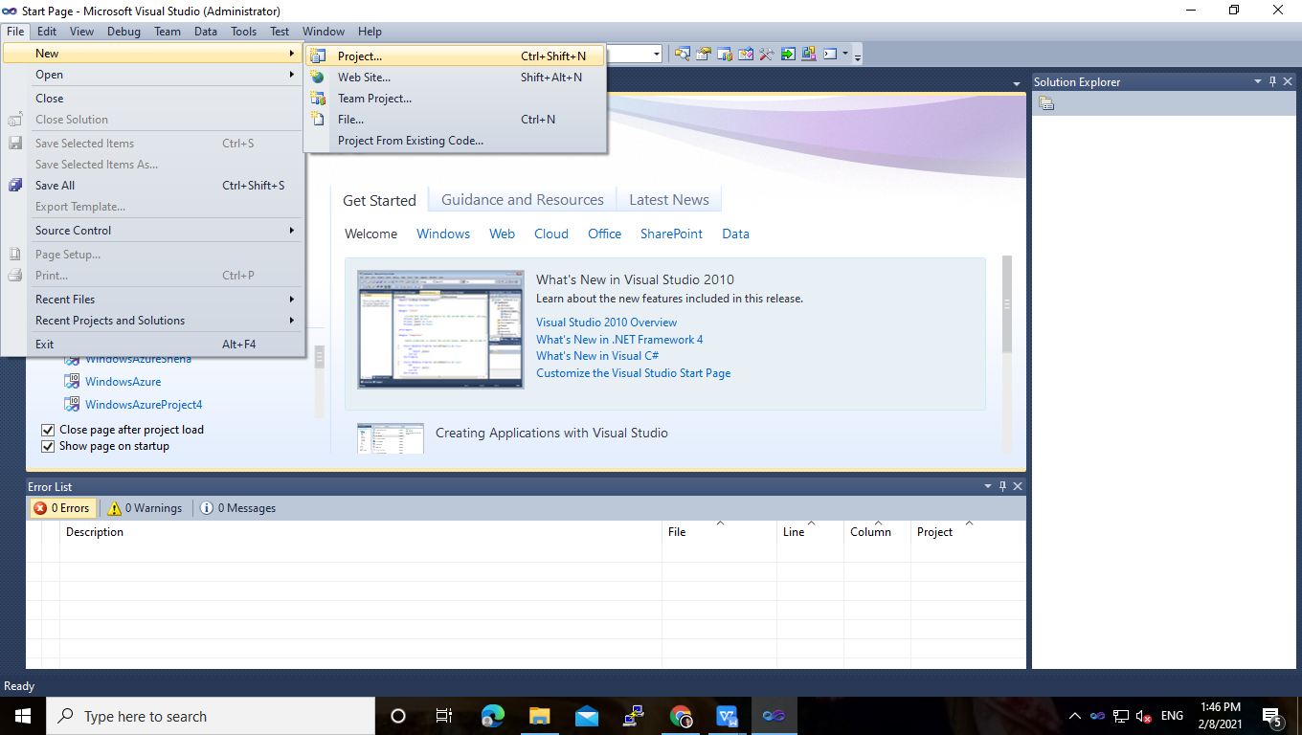

>> Click on  **Cloud.** Enter the name for project. Click on **Ok.**

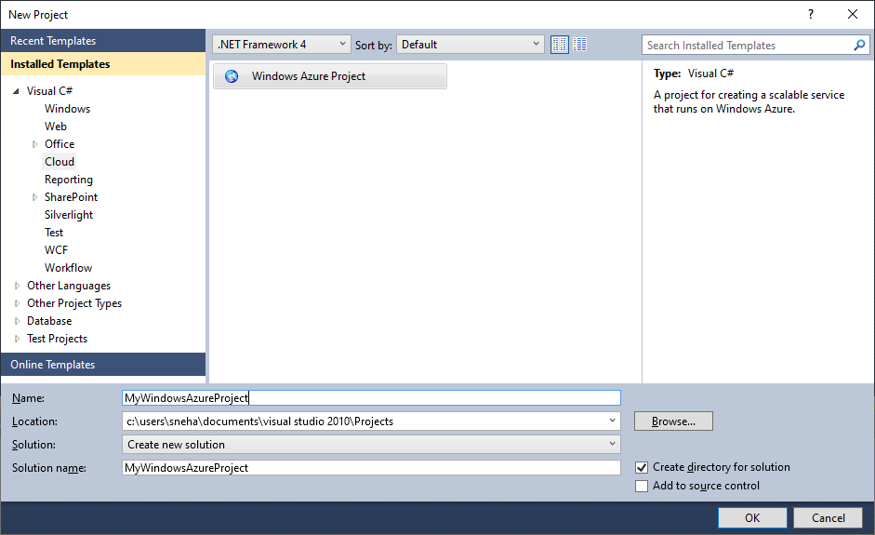

>> **New Windows Azure Project** window will open. In that we have to add **ASP.NET Web Role** under **Visual C#** and click on **OK.**

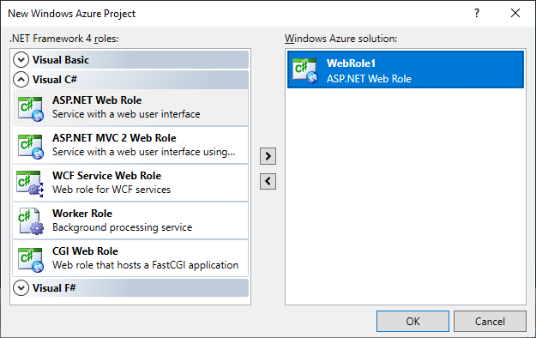

>> Now , we will get to see project hierarchy and sample generated code.

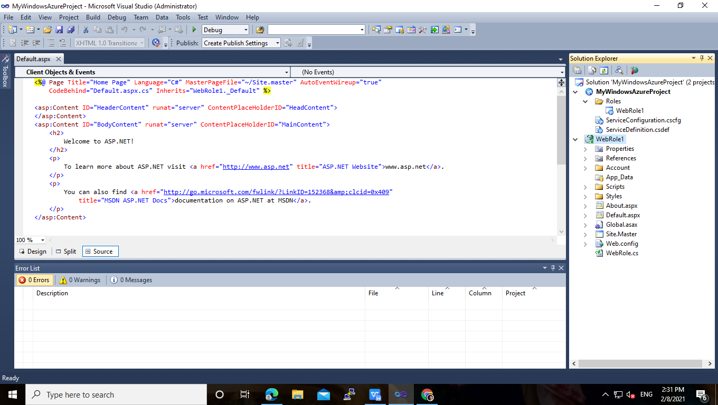

>> Right click on **WebRole1 >> Add >> New Item.**

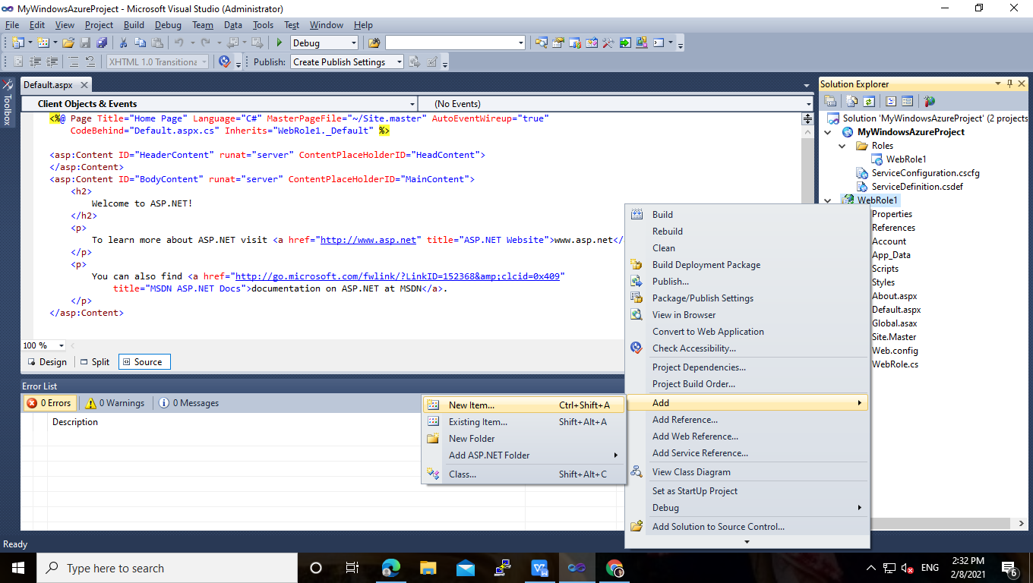

>> Select **Web Form,** give name to a webform, and click on **Add.**

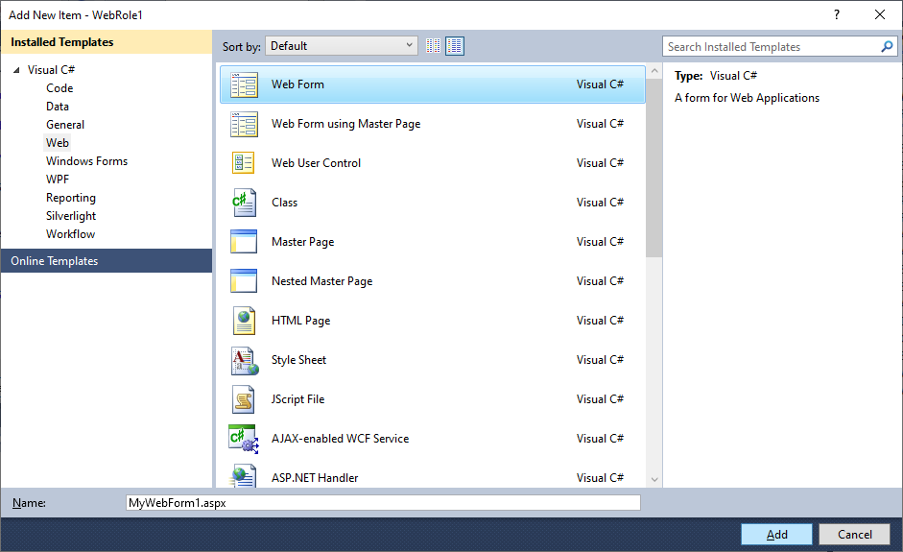

>> Design web form as you want.

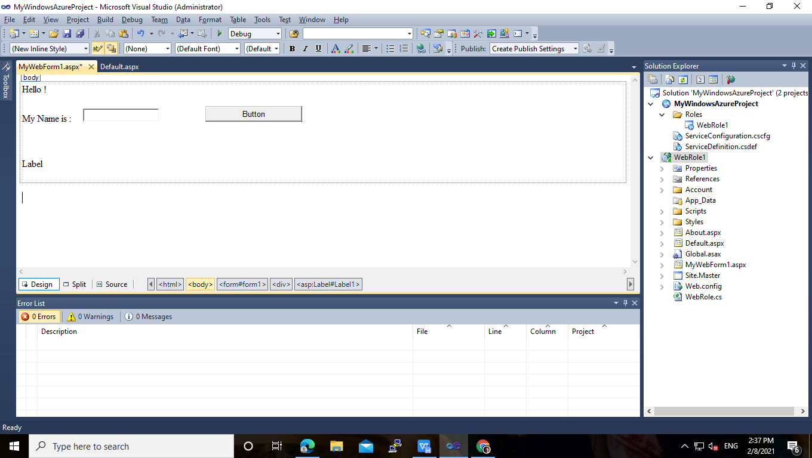

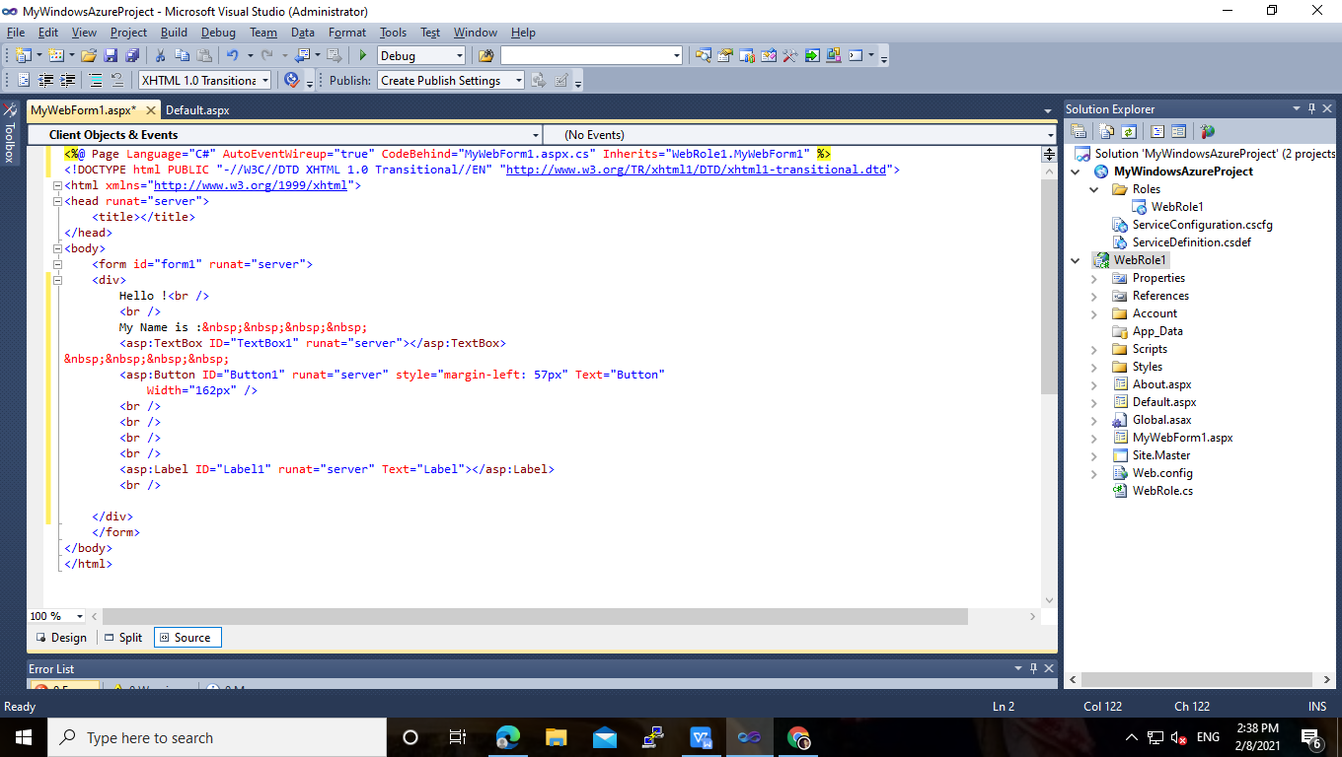

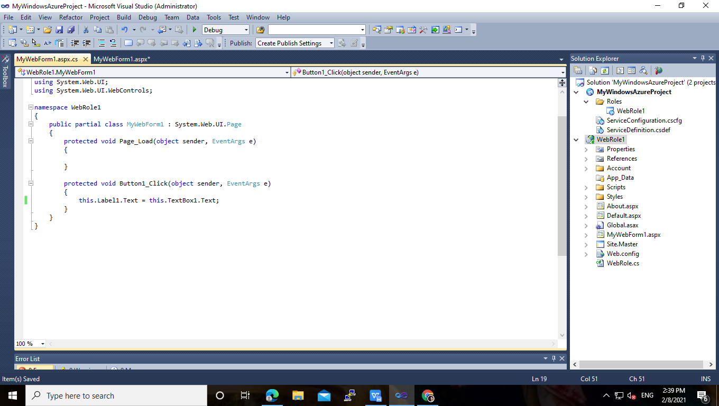

>> Right click on **WebRole1 >>** go to  **Properties.**

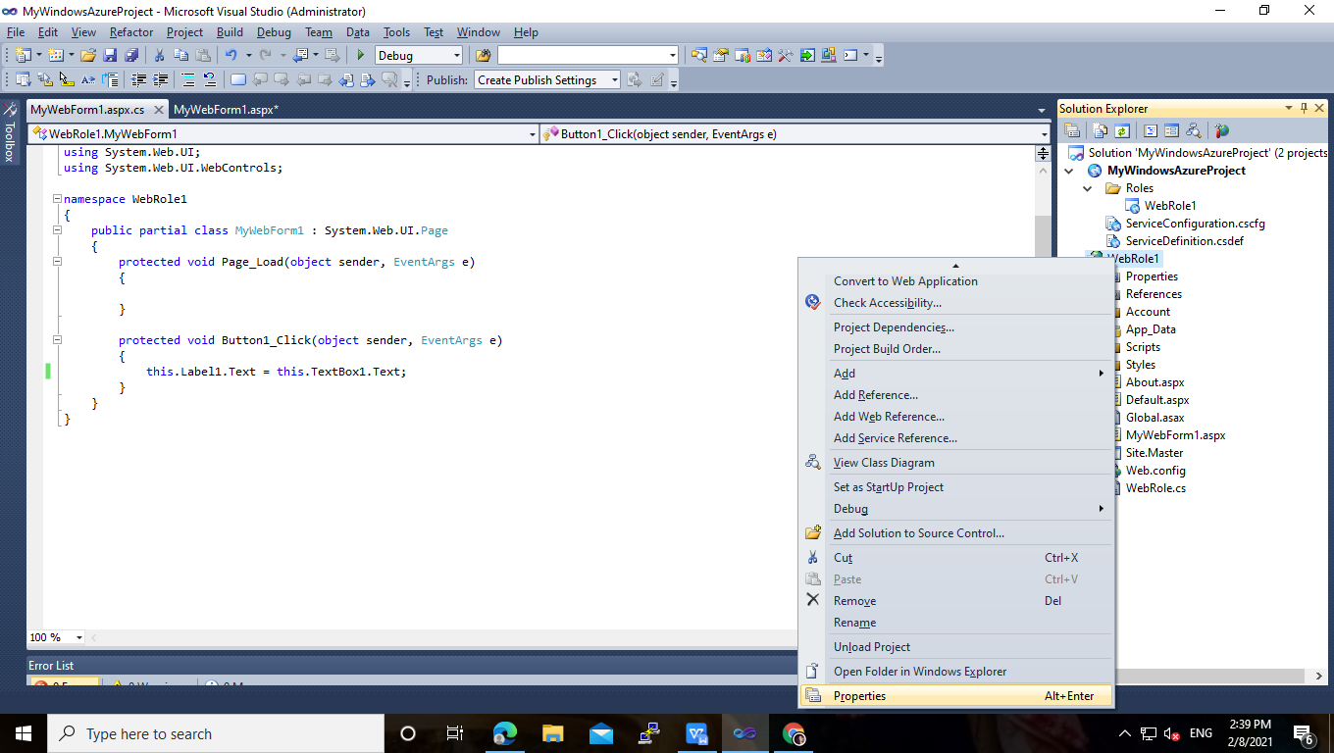

>> under W**eb** tab select **‘Use Local IIS Web server’** and you can change the name of web role. And Click on **‘Create Virtual Directory’.**

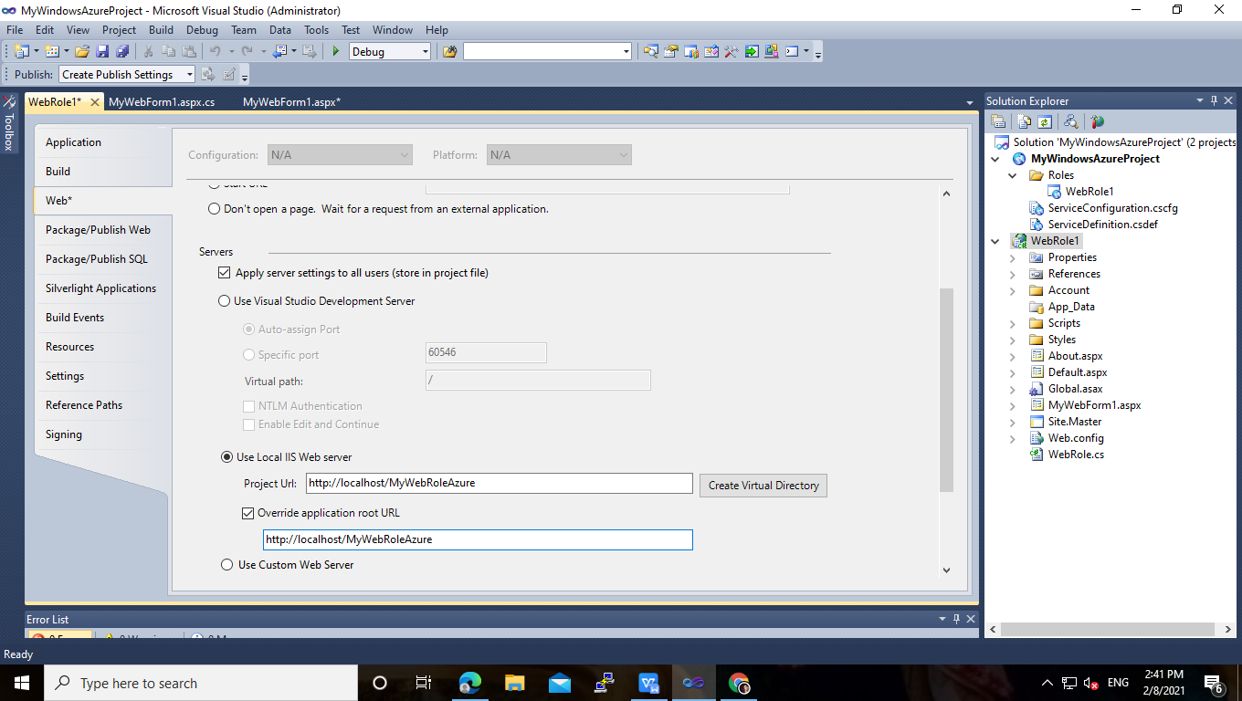

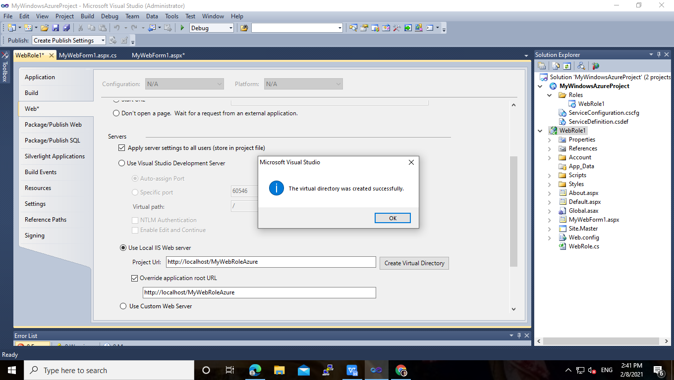

>> Now click on **Debug >> Start Debugging.**

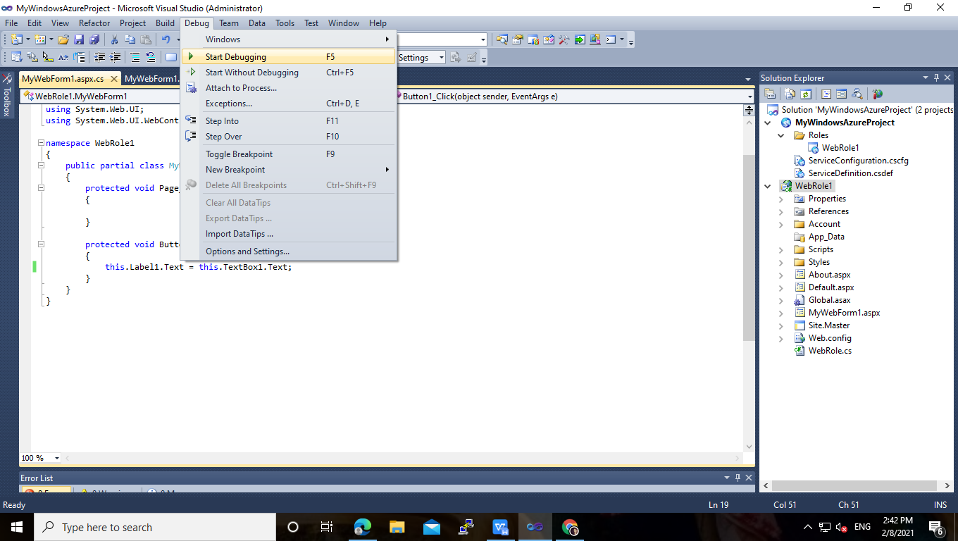

**>> OUTPUT :**

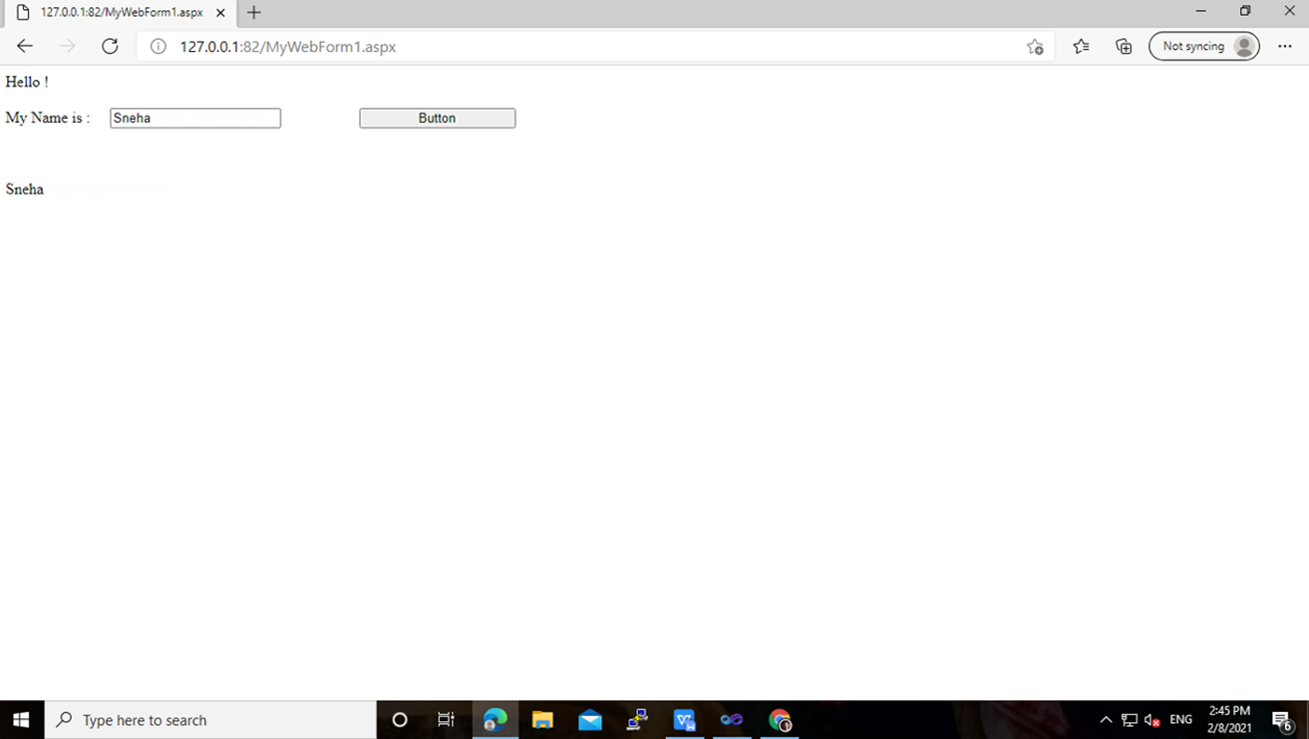

>> Similarly you can implement web applications for windows Azure.

**>> Here I have created Simple calculator Application.**

**CalculatorWebform.aspx**

<%@ Page Language="C#" AutoEventWireup="true" CodeBehind="CalculatorWebForm.aspx.cs" Inherits="WebRole1.CalculatorWebForm" %>

<!DOCTYPE html PUBLIC "-//W3C//DTD XHTML 1.0 Transitional//EN" "http://www.w3.org/TR/xhtml1/DTD/xhtml1-transitional.dtd">

<html xmlns="http://www.w3.org/1999/xhtml">

<head runat="server">

<title></title>

</head>

<body>

<form id="form1" runat="server">

<div>

Number 1 :&nbsp;&nbsp;&nbsp;

<asp:TextBox ID="TextBox1" runat="server" style="margin-left: 0px"></asp:TextBox>

<br />

<br />

Number 2:&nbsp;&nbsp;&nbsp;

<asp:TextBox ID="TextBox2" runat="server"></asp:TextBox>

<br />

<br />

Result&nbsp;&nbsp;&nbsp; :&nbsp;&nbsp;&nbsp;&nbsp;&nbsp;

<asp:TextBox ID="TextBox3" runat="server"></asp:TextBox>

<br />

<br />

<asp:Button ID="btnsum" runat="server" onclick="btnsum_Click" Text="+"

Width="119px" />

<asp:Button ID="btnminus" runat="server" onclick="btnminus_Click" Text="-"

Width="112px" />

<asp:Button ID="btnmul" runat="server" onclick="btnmul_Click" Text="*"

Width="158px" />

<asp:Button ID="btndiv" runat="server" onclick="btndiv_Click"

style="margin-left: 0px" Text="/" Width="160px" />

<br />

<br />

<br />

<br />

<asp:Button ID="Button2" runat="server" onclick="Button2_Click"

style="margin-left: 105px" Text="Clear" Width="168px" />

<br />

</div>

</form>

</body>

</html>

**CalculatorWebform.aspx.cs**

using System;

using System.Collections.Generic;

using System.Linq;

using System.Web;

using System.Web.UI;

using System.Web.UI.WebControls;

namespace WebRole1

{

public partial class CalculatorWebForm : System.Web.UI.Page

{

protected void Button2_Click(object sender, EventArgs e)

{

TextBox1.Text = "";

TextBox2.Text = "";

TextBox3.Text = "";

}

protected void btnsum_Click(object sender, EventArgs e)

{

int sum = Int32.Parse(TextBox1.Text) + Int32.Parse(TextBox2.Text);

TextBox3.Text = Convert.ToString(sum);

}

protected void btnminus_Click(object sender, EventArgs e)

{

int minus = Int32.Parse(TextBox1.Text) - Int32.Parse(TextBox2.Text);

TextBox3.Text = Convert.ToString(minus);

}

protected void btnmul_Click(object sender, EventArgs e)

{

int multiply = Int32.Parse(TextBox1.Text) * Int32.Parse(TextBox2.Text);

TextBox3.Text = Convert.ToString(multiply);

}

protected void btndiv_Click(object sender, EventArgs e)

{

int division = Int32.Parse(TextBox1.Text) / Int32.Parse(TextBox2.Text);

TextBox3.Text = Convert.ToString(division);

}

}

}

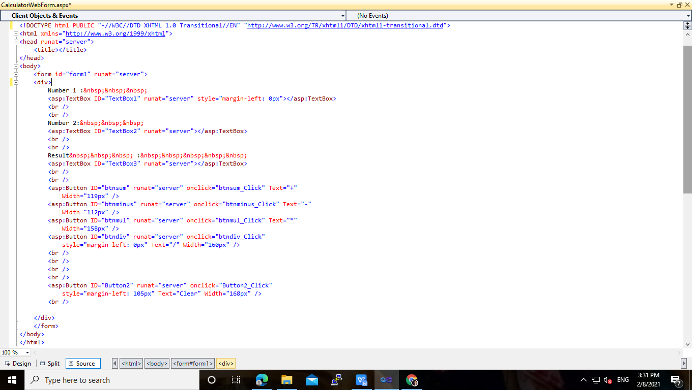

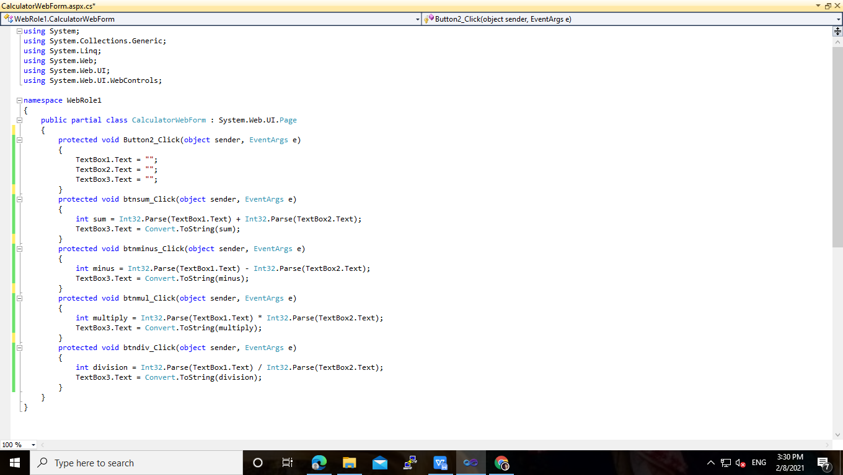

OUTPUT :

On Click on Addition Button.

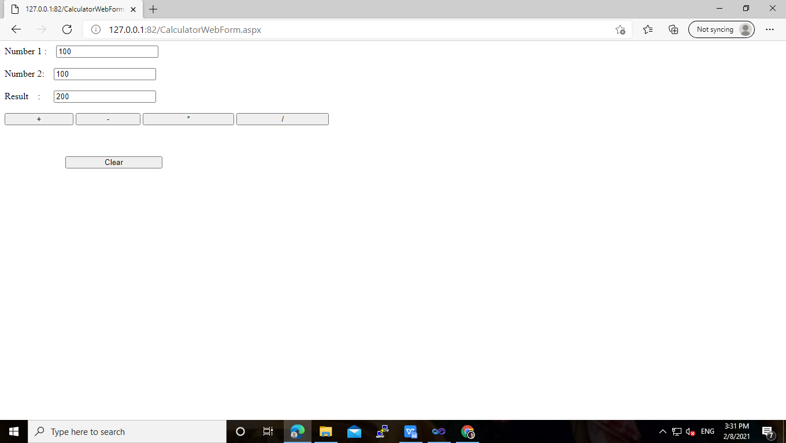

On Click on Multiplication Button.

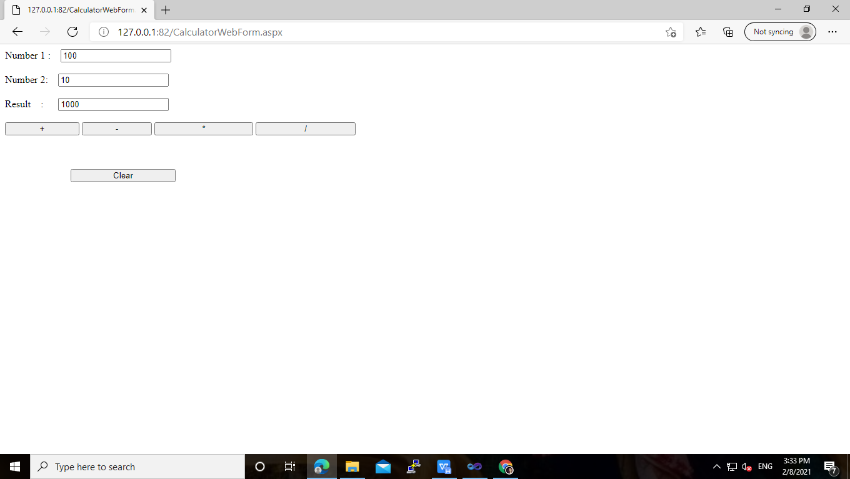

**PRACTICAL: 3**

**Implementing private cloud with XenServer.**

**Softwares Required :-**

* **VMware Workstation 15.5 PRO**
* [**XenServer-6.2.0-install-cd.iso**](http://download.wx.51idc.com:8000/%B2%D9%D7%F7%CF%B5%CD%B3/Xenserver/XenServer-6.2.0-install-cd.iso)
* **XenCenter_6.2_en.msi**

**Download files from the link:**

<http://download.wx.51idc.com:8000/%b2%d9%d7%f7%cf%b5%cd%b3/Xenserver/>

__________________________________________________

**What is XenServer & XenCenter?**

Citrix XenServer is a server virtualization platform that enables users to host, deploy, and manage virtual machines. XenCenter is a system that enables users to install and manage XenServer environments via a user interface.

>> Open VMware Workstation – And select Create a New Virtual Machine.

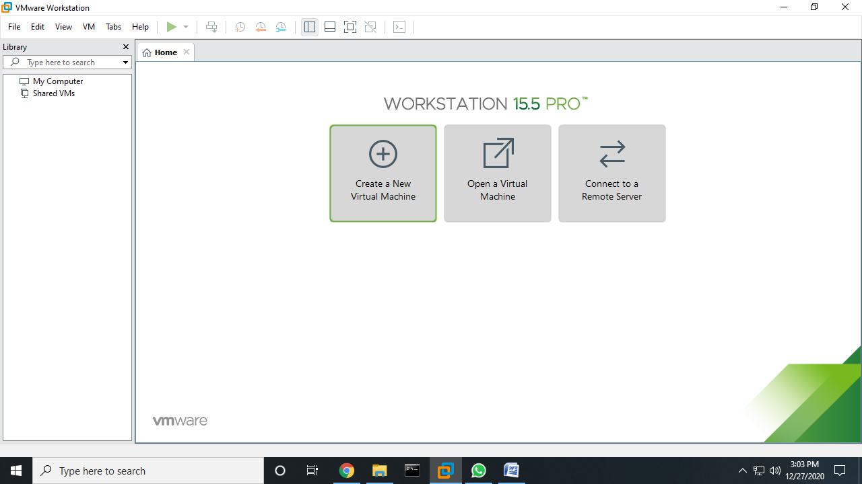

>> Select typical and then click Next.

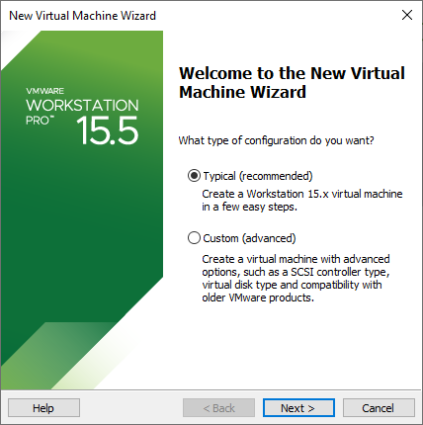

>> Select Installer disc_image file (ISO). Click Browse – XenServer Iso File – For Example **“C:\Users\CHINU\Desktop\Sneha\ XenServer-6.2.0-install-cd.iso”** And click on next.

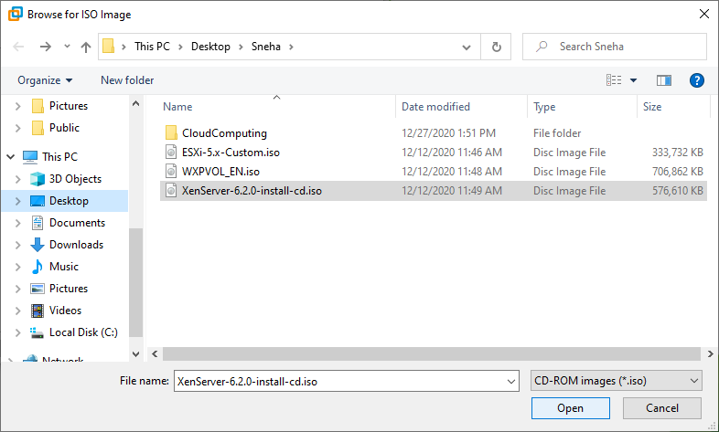

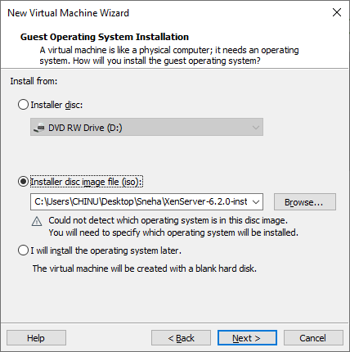

>> Select Guest Operating System as Linux. Select version as Ubuntu. Click next.

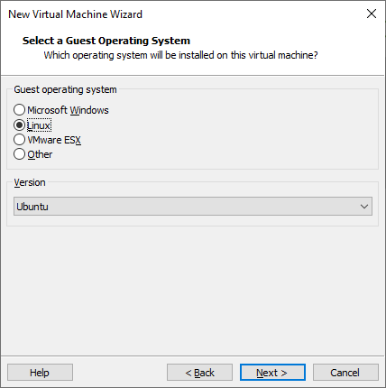

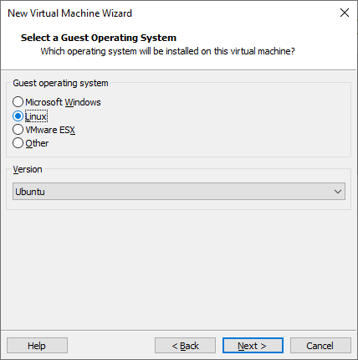

>> Give Virtual machine a name as “XenServerPractical” and click on next.

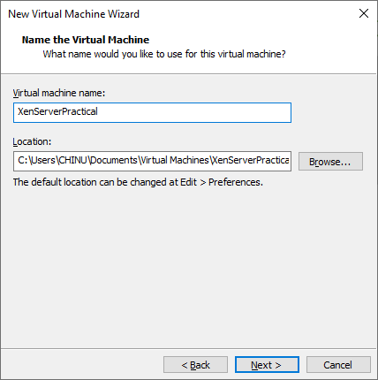

>> Change maximum disk size to 40 GB and check – Store virtual disk as a single file.

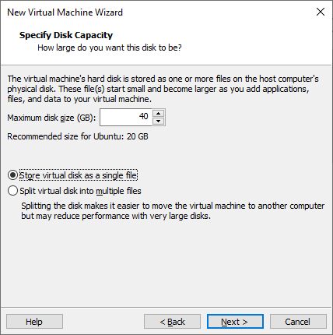

>> Click on **Customize hardware option**

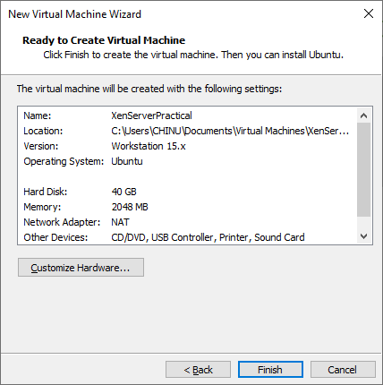

>> Change – Memory for this virtual machine to 2 GB and click on close button.

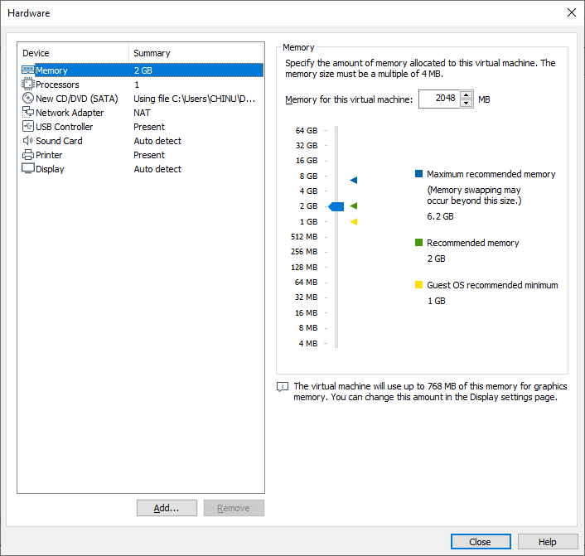

>> Click on processor and select Virtualized Intel VT-x/ EPT or AMD-V/RVI. And then close

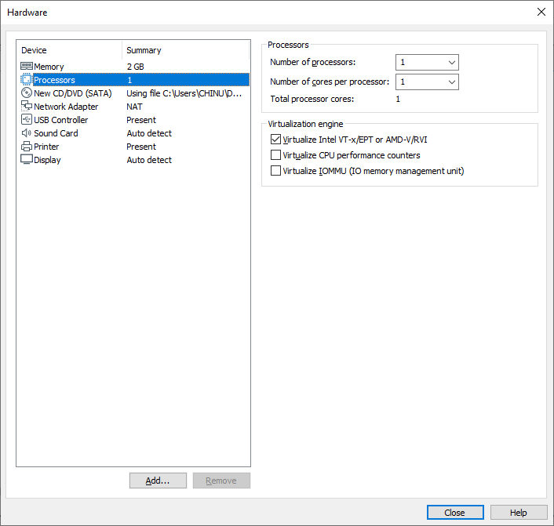

>> Click on Finish.

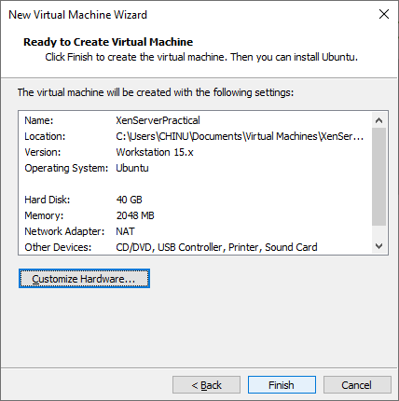

>> Now power on newly created virtual machine –

>> Now select US and click on Ok.

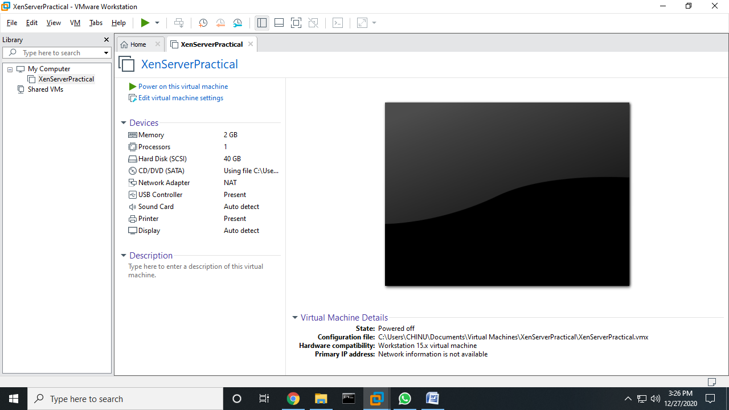

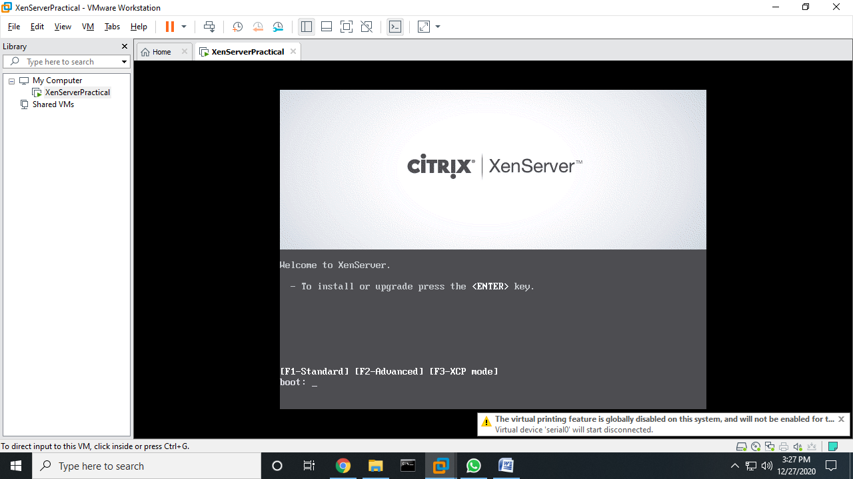

>> Click on Ok.

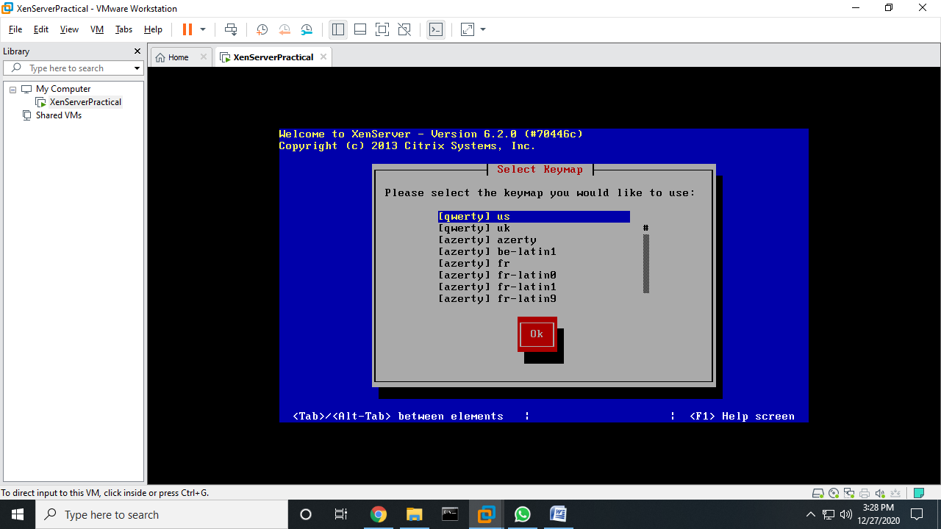

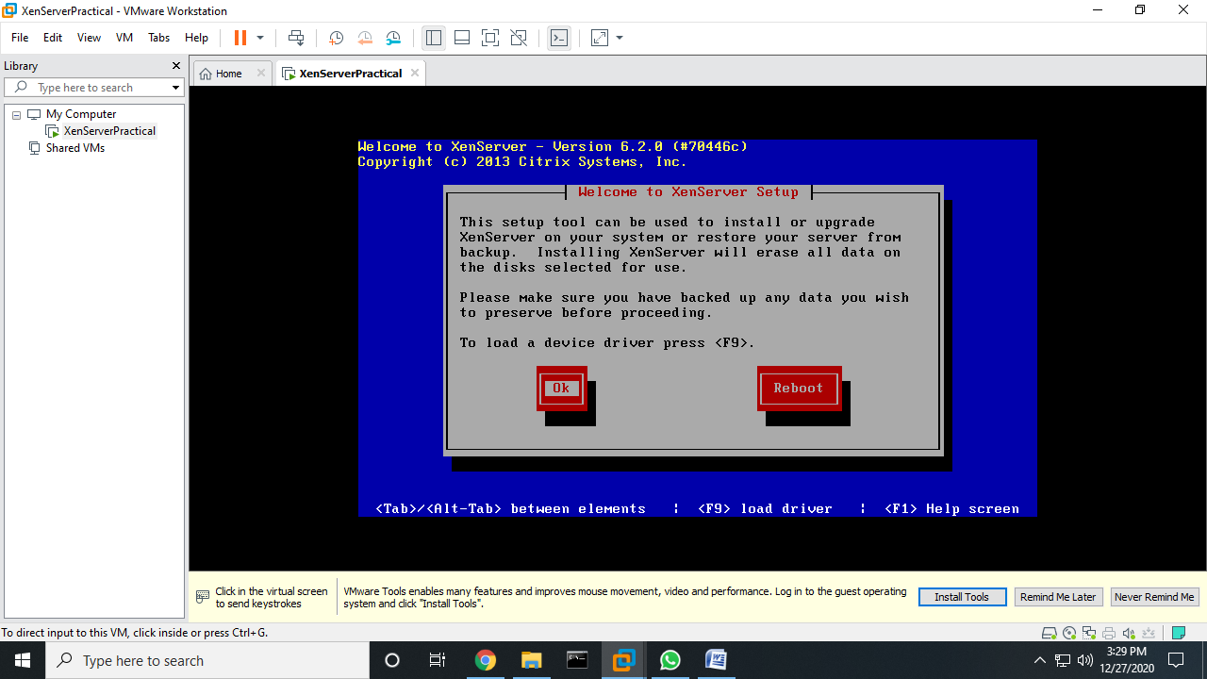

>> Click on Accept Eula.

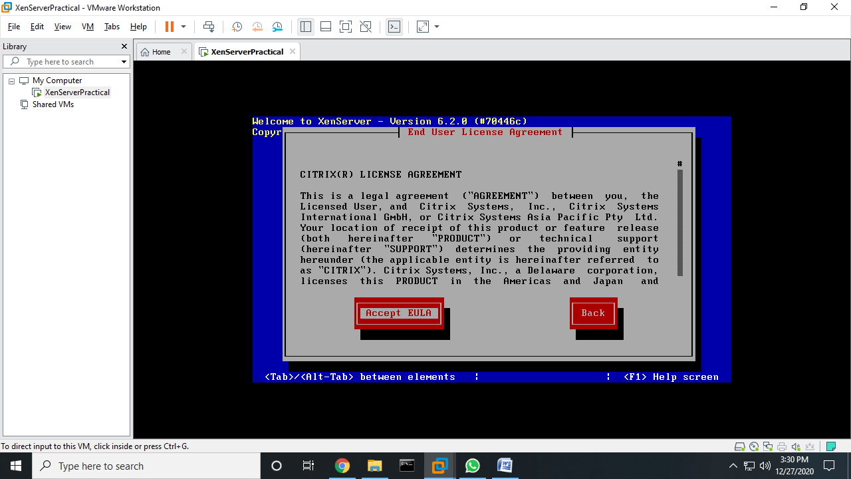

>> Click on Ok.

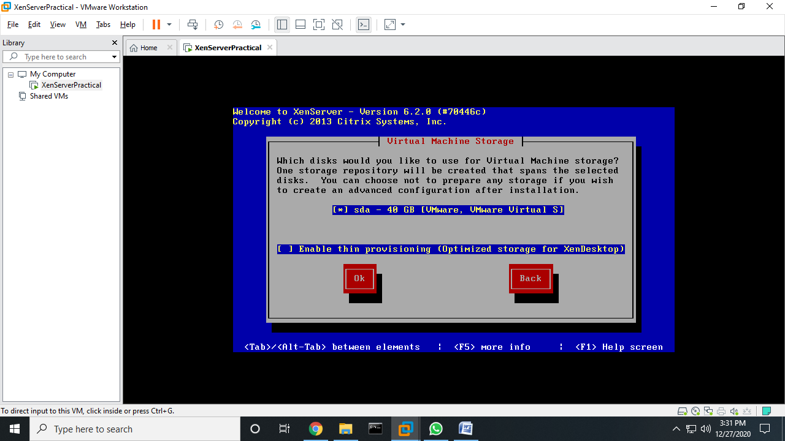

>> Select Local media and click Ok.

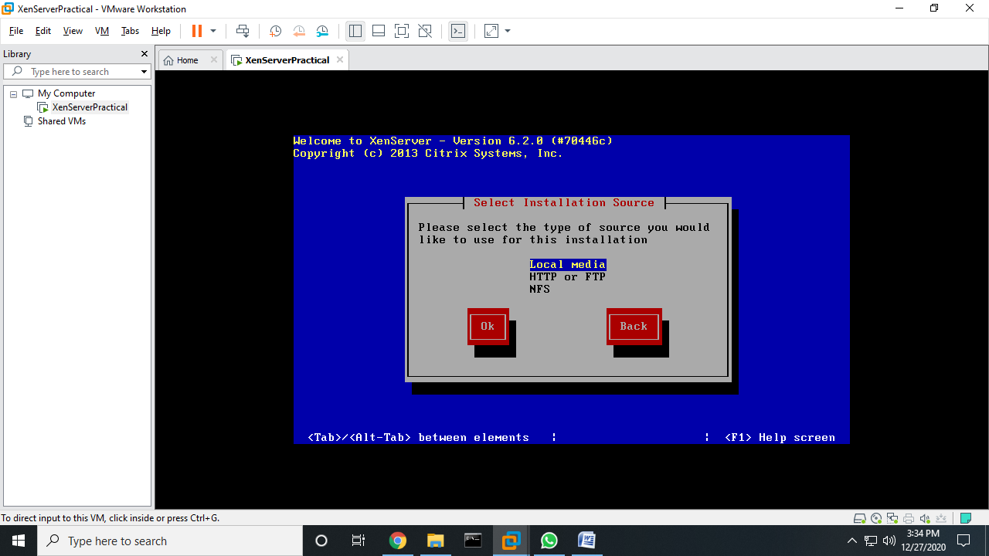

>> Click No.

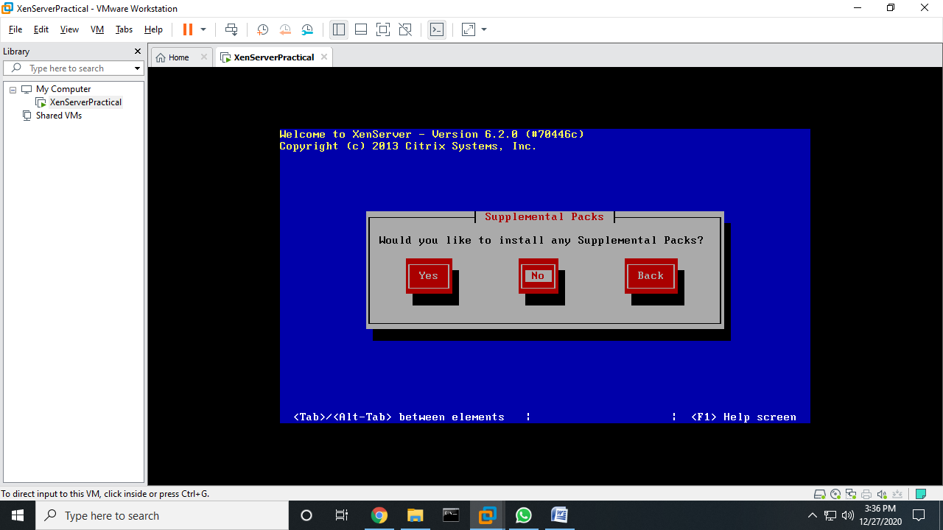

>> Select **Verify Installation Source.** Click Ok.

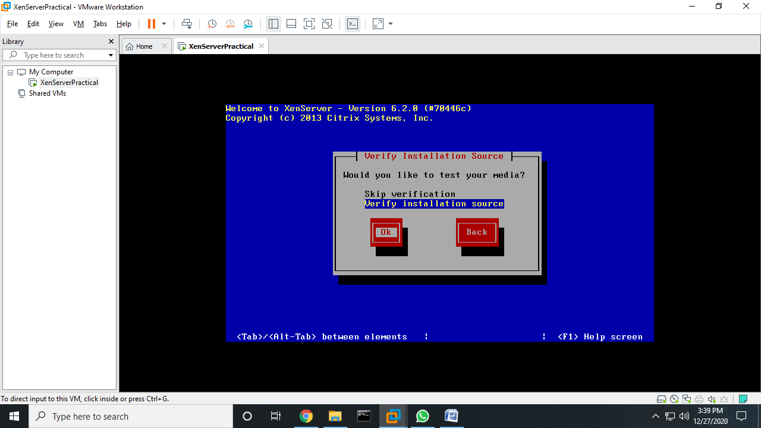

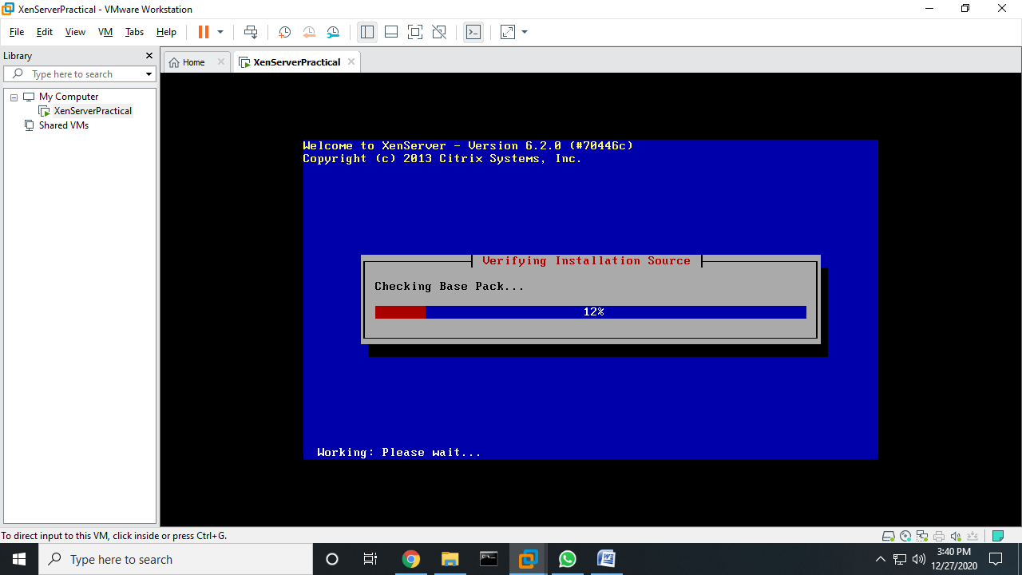

>> Click Ok.

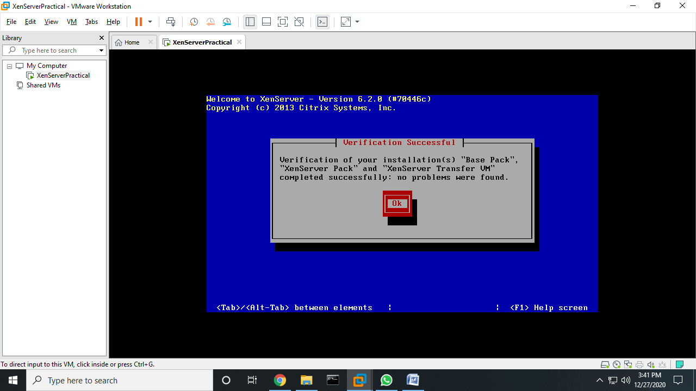

>> Enter **Password: root123**  and click on Ok.

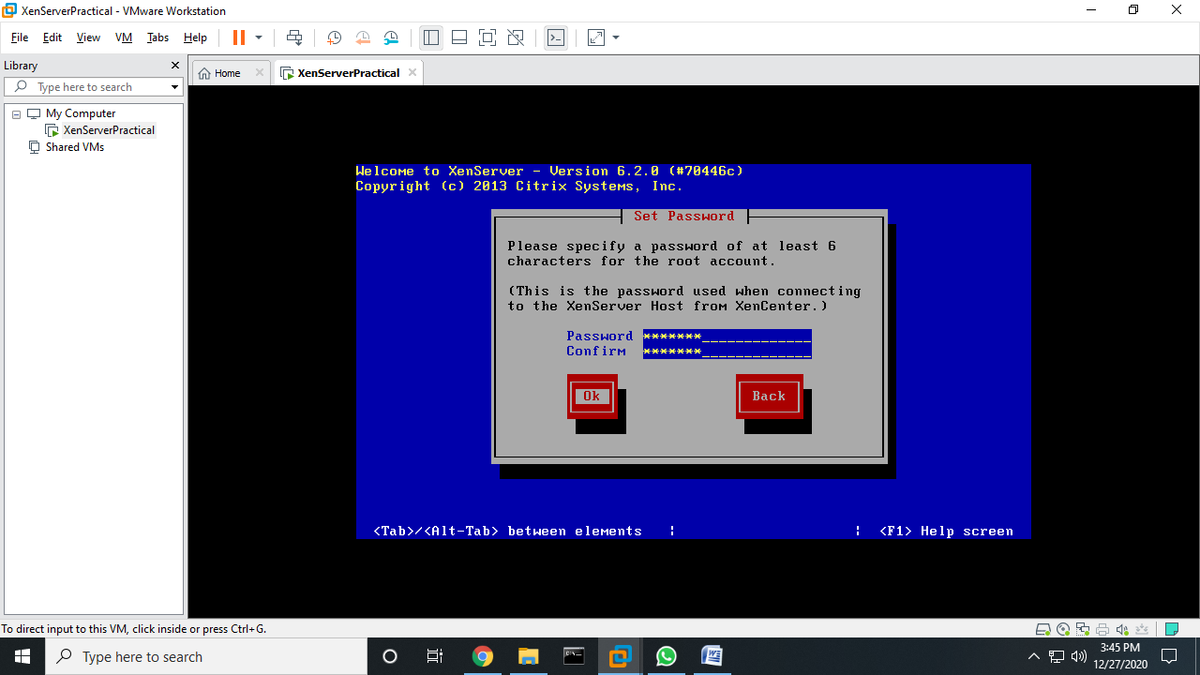

>> Select **Automatic Configuration (DHCP)** and Click **OK.**

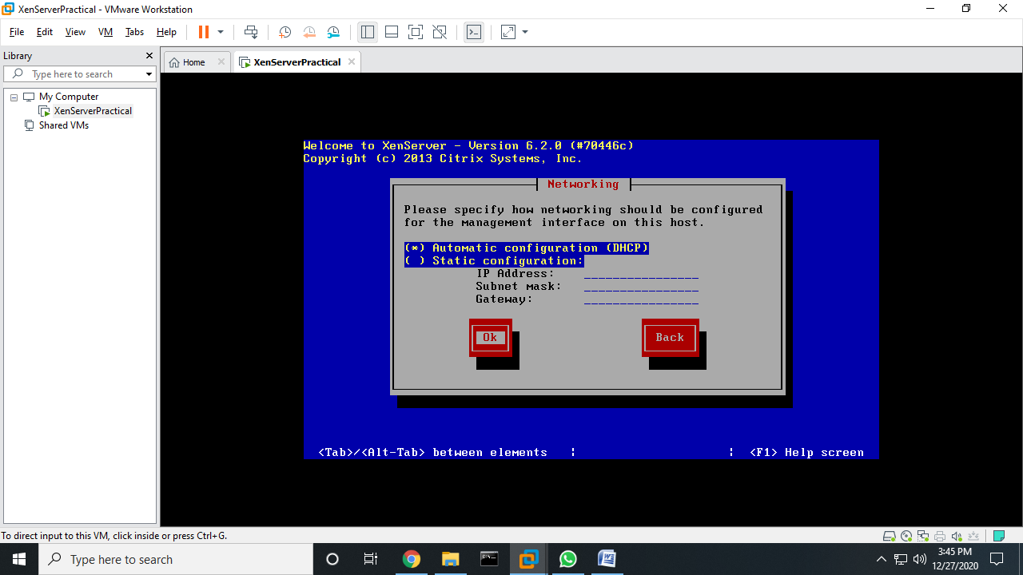

>> Select **Automatically set via (DHCP)** and Click **OK.**

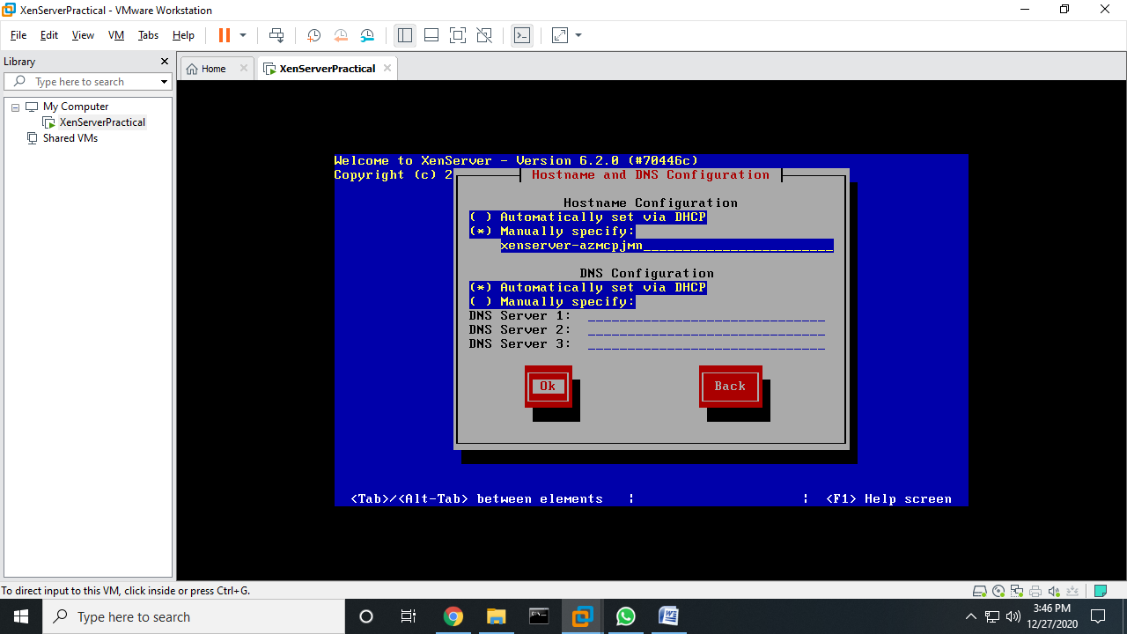

>> Select **Asia** and click **OK.**

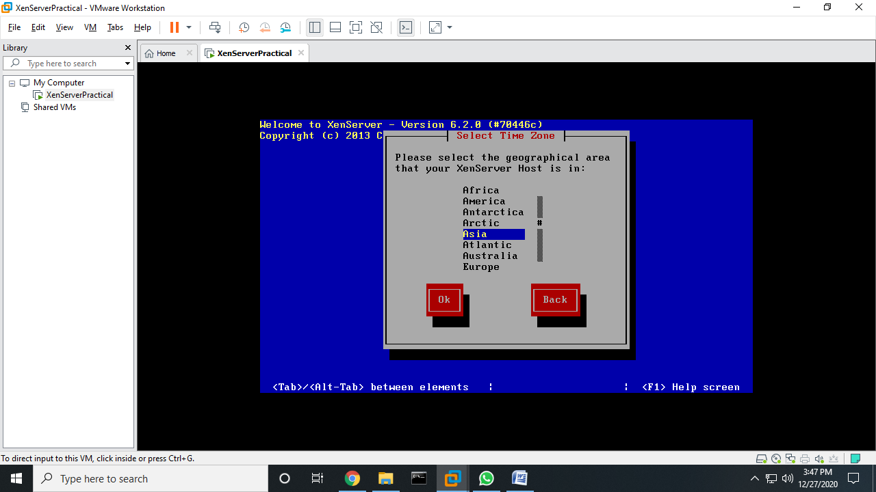

>> Select **Calcutta** and Click **OK.**

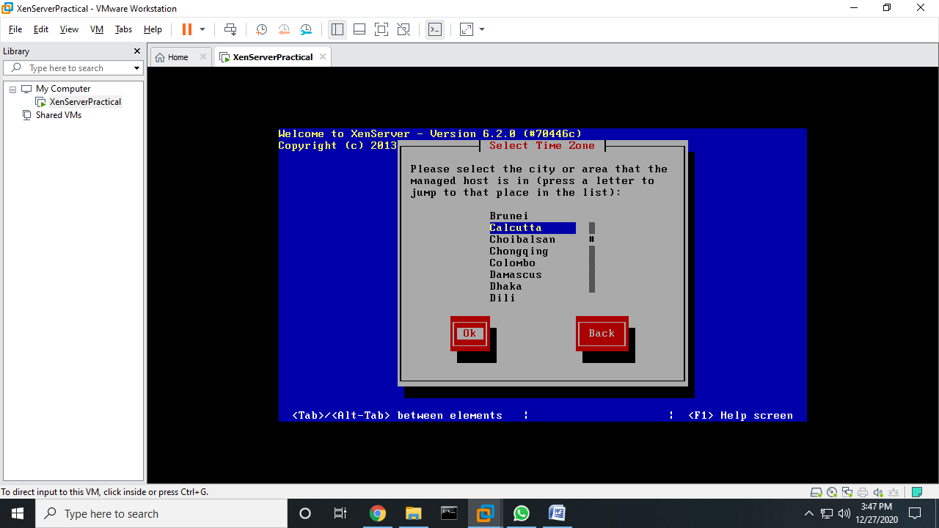

>> Select **Using NTP** and Click **OK.**

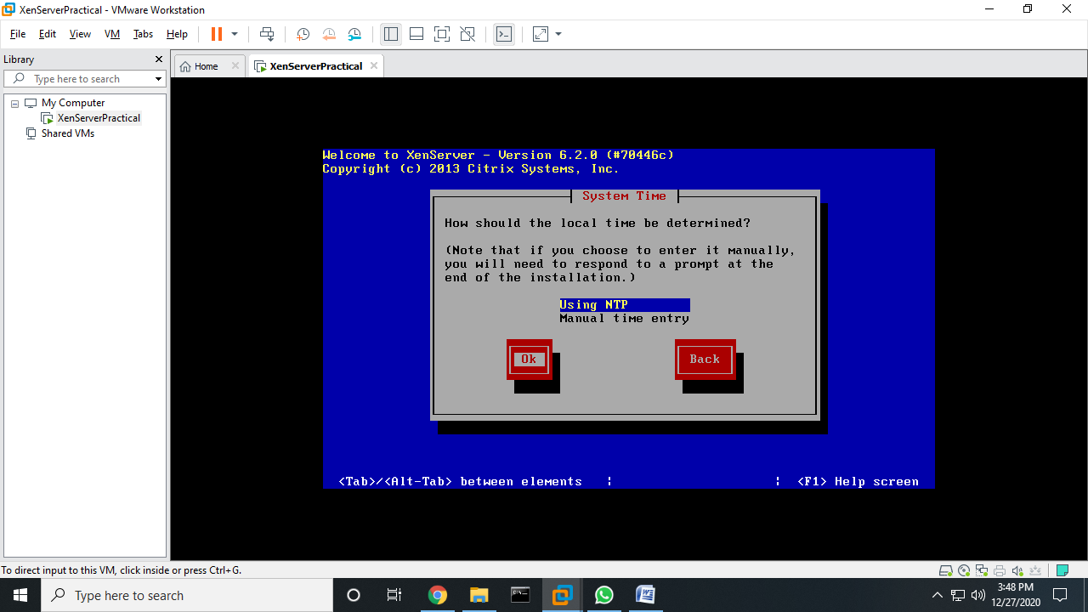

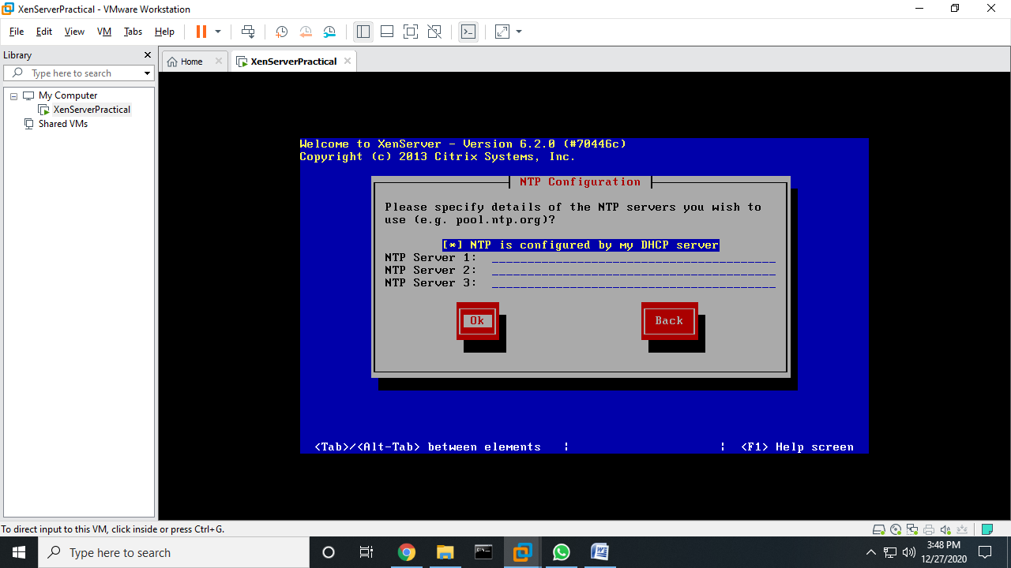

>> Click **Install XenServer.**

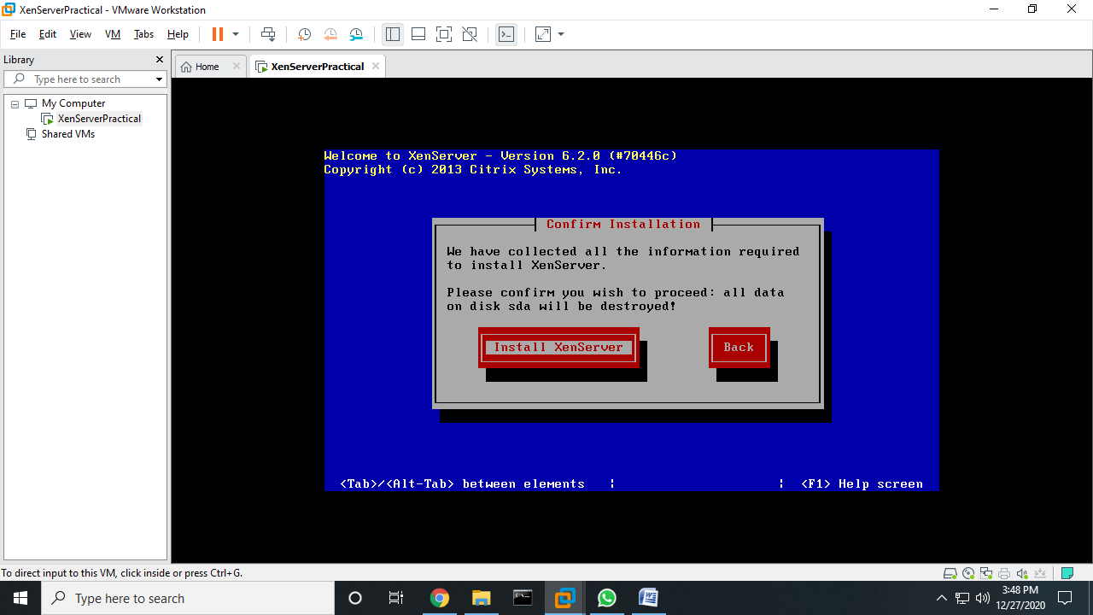

>> Wait a while till it is installing.

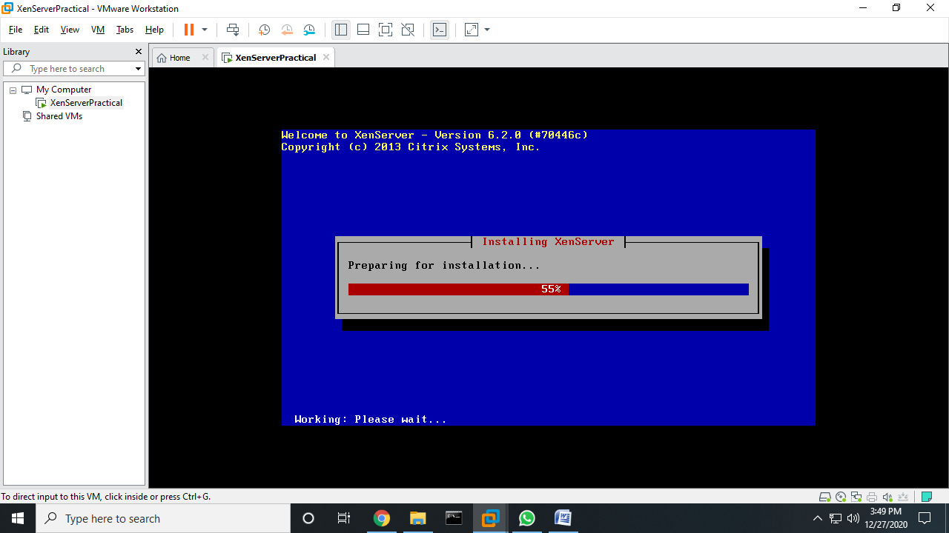

>> Click **OK** to **Reboot.**

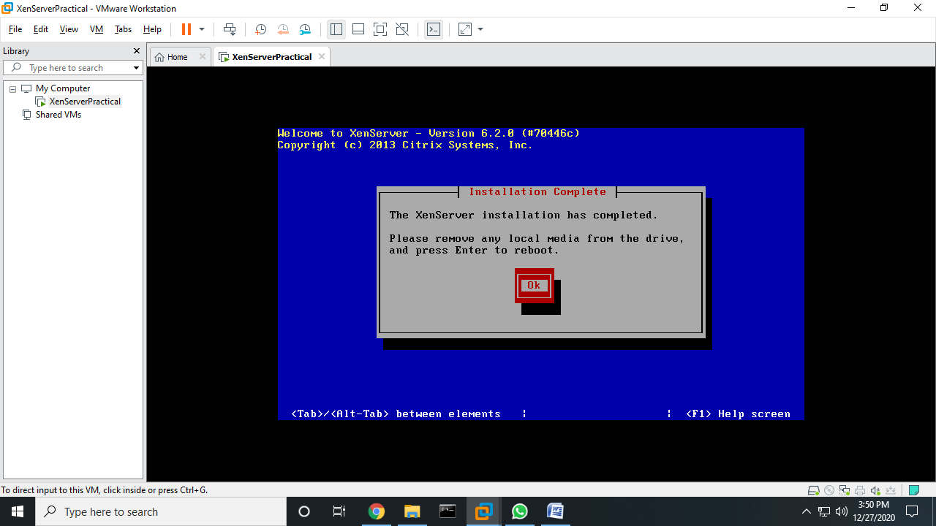

**>> XenServer** is loading.

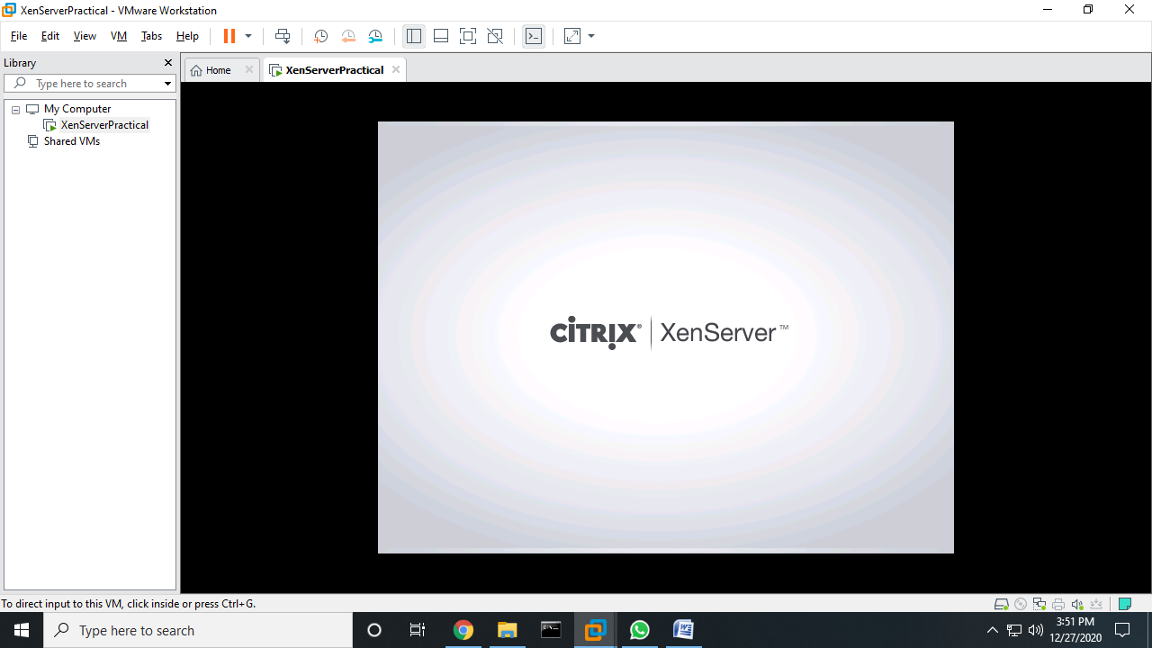

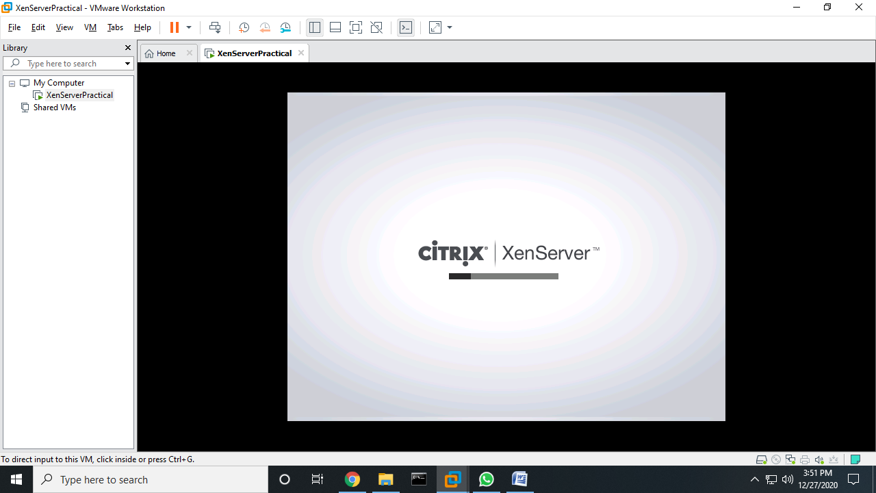

>> Note down the IP Address “ 192.168.32.130” ping it from command prompt to verify connection.

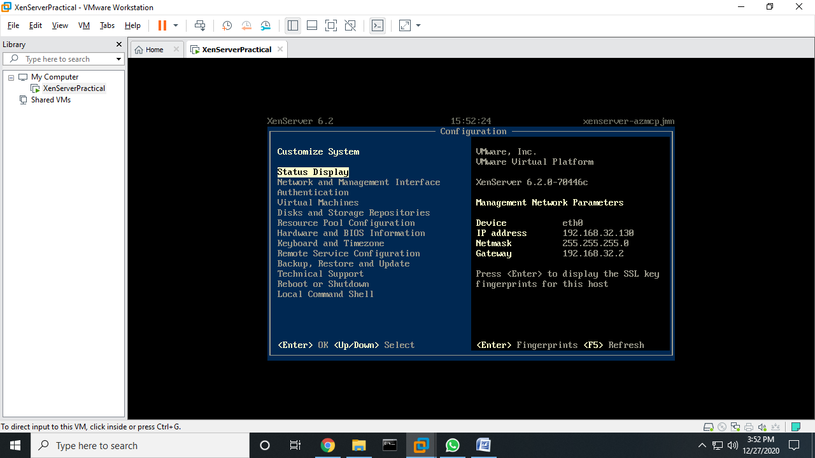

>> The ping details from command prompt.

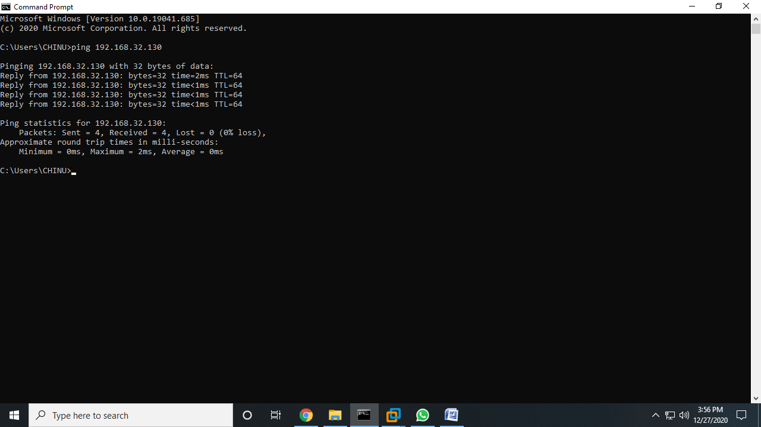

>> Now install Citrix App if not installed (i.e. Citrix XenCenter). Click Next.

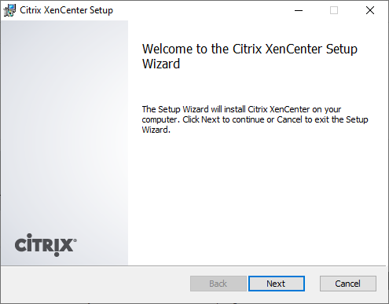

>> Browse the desired folder and click Next.

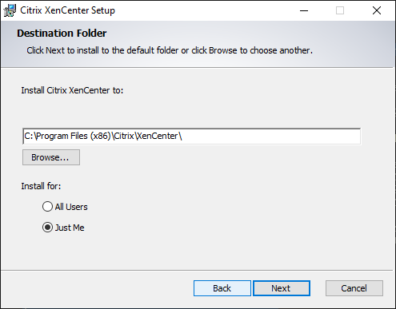

>> Click **Install.**

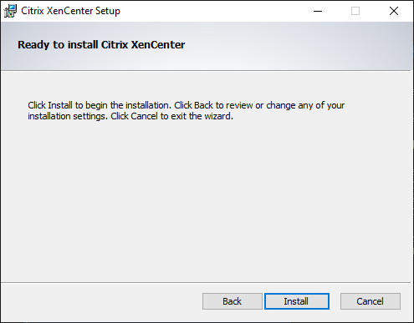

>> Wait a while till it gets installed.

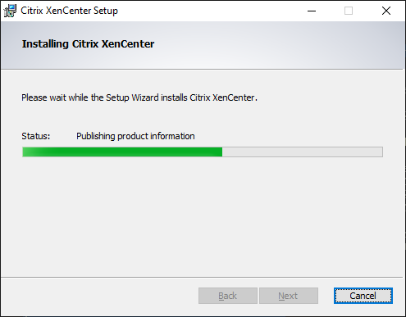

>> Click Finish. Your Citrix XenCenter is Installed Successfully.

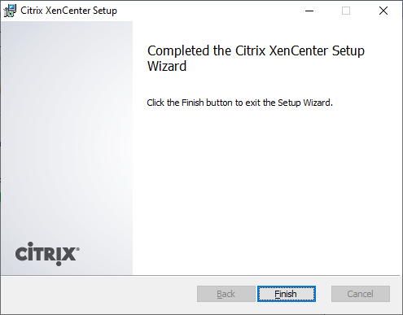

>> Now Open Citrix XenCenter – and Click **Add Server.**

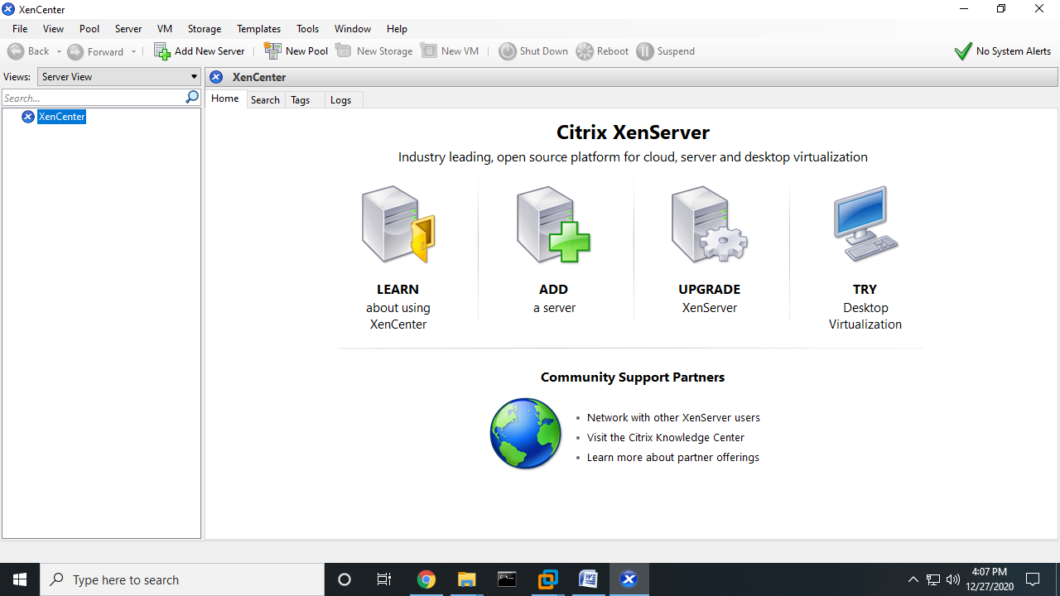

>> Fill the IP address that we have noted down from installation and User name: “**root**” and Password: “**root123**”which we have given during installation and Click **Add.**

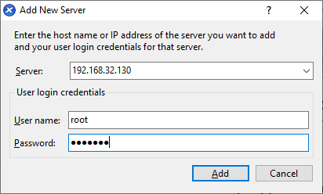

>> Wait until it is loading.

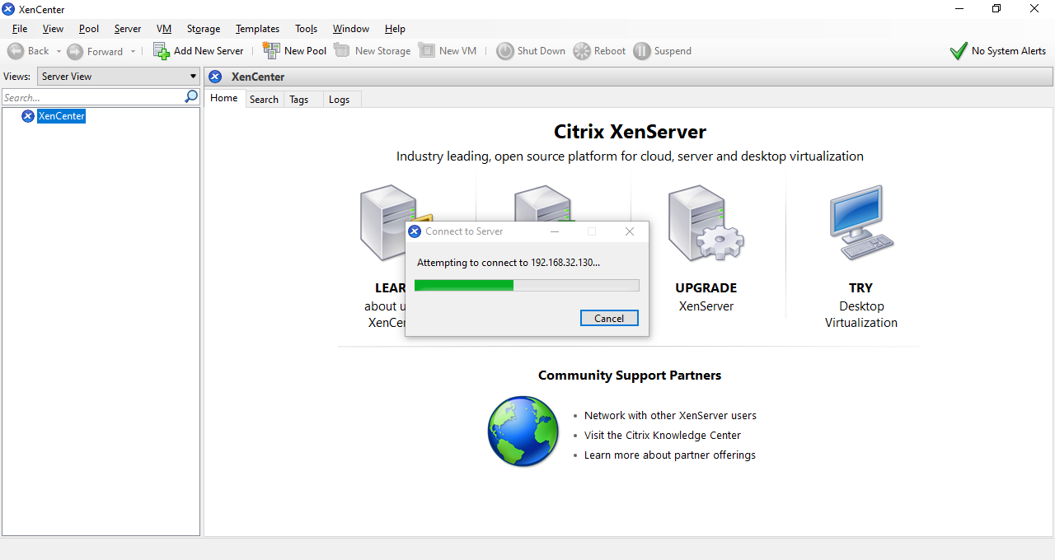

>> Check the **Save and Restore server connection state on startup** and Click **OK.**

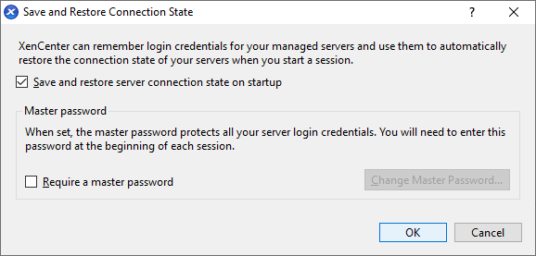

>> Before proceeding further create a New Folder on desktop and add the windows.iso file in that folder.

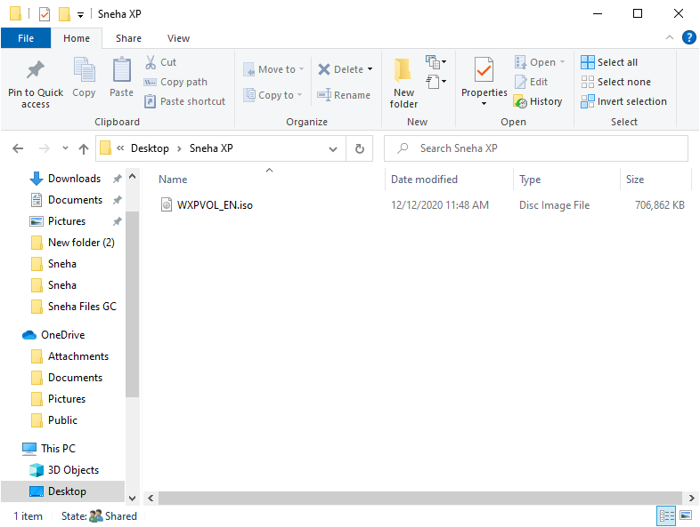

>> Now right Click anywhere in the folder and go to properties.

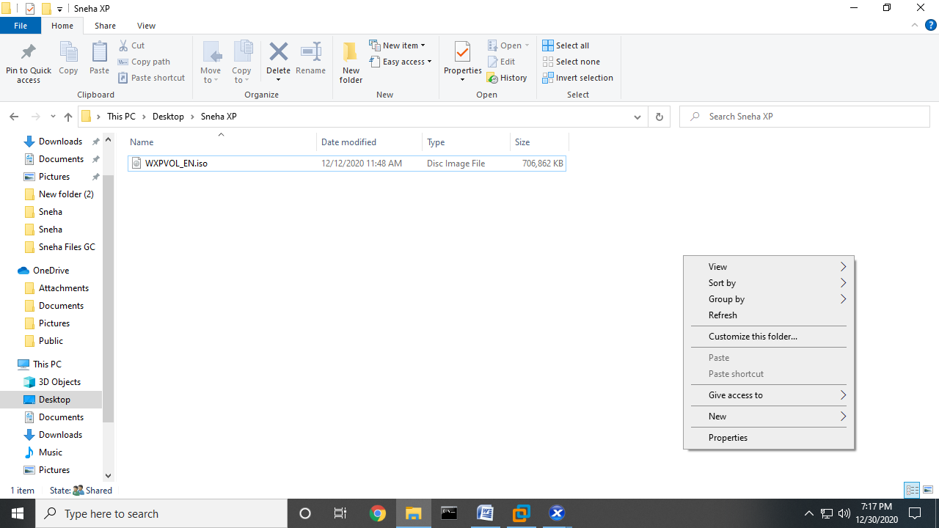

>> In properties go to sharing option and click Advance Sharing and note down the Network path: \\DESKTOP-FTPJ0PJ\Sneha XP

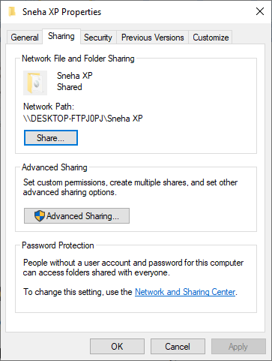

>> Click on ‘Permissions’.

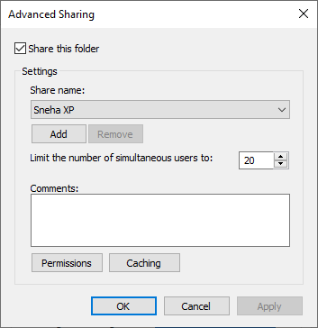

>> Click on Add.

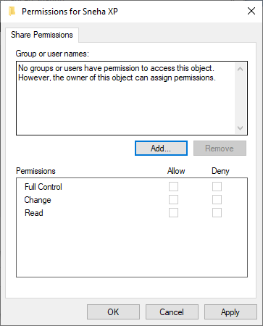

>> Click Advanced.

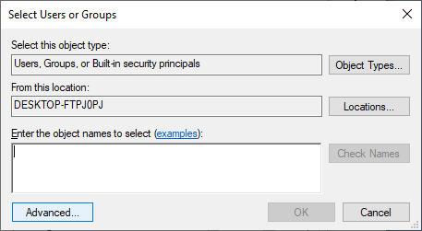

>> Click Find Now and search for Everyone and Select Everyone and Click OK.

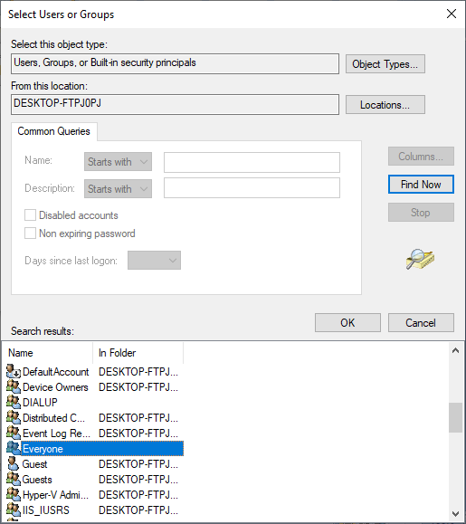

>> Click OK.

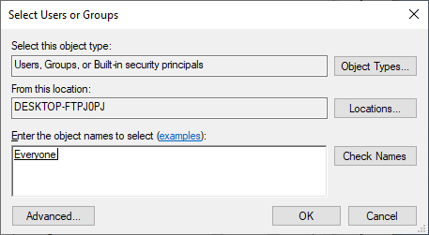

>> Check on full control and Change. Then click Apply and OK

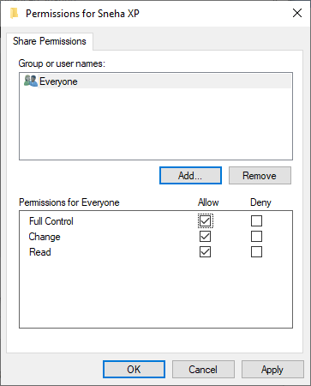

>> Click Apply and OK.

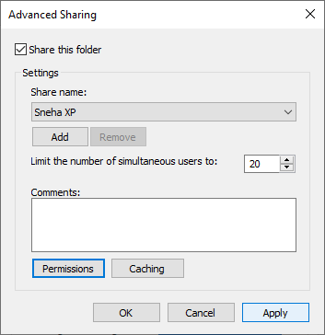

>> Click OK. Now the folder has become Shareable.

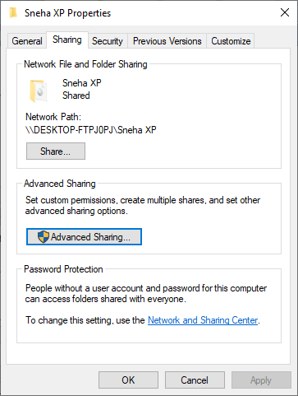

>> Now go to Control Panel and select Programs.

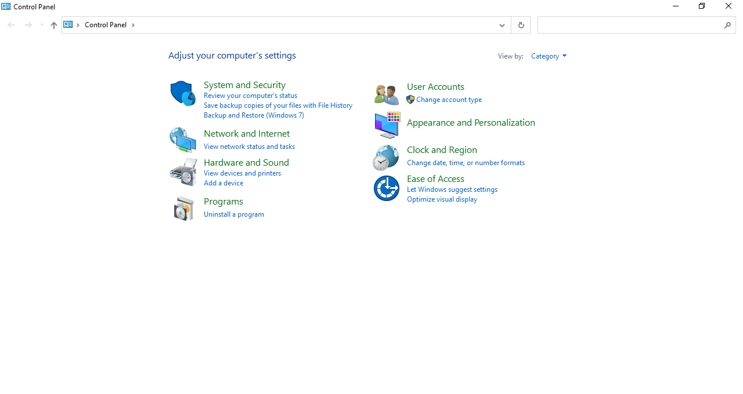

>> Go to Turn Windows features on and off.

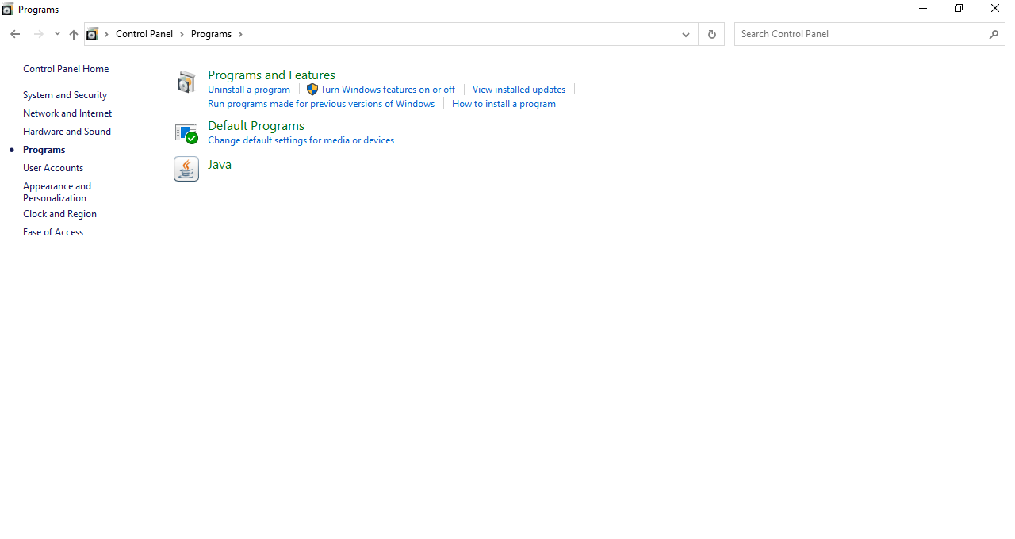

>> Check SMB 1.0/CIFS File Sharing Support and click OK.

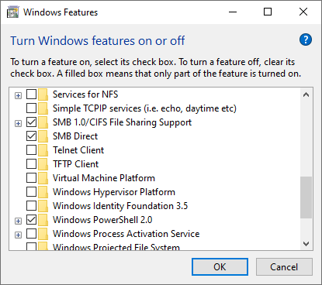

>> Now open XenCenter again and click on **Storage** and **New SR** to create new storage.

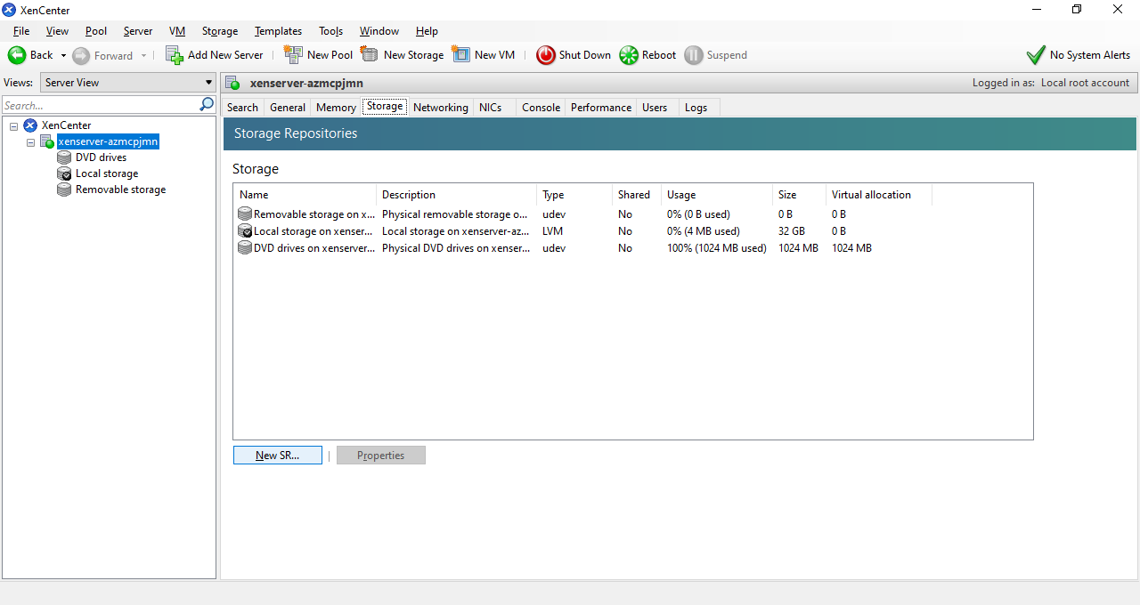

>> Select **Windows File Sharing (CIFS)** and Click Next.

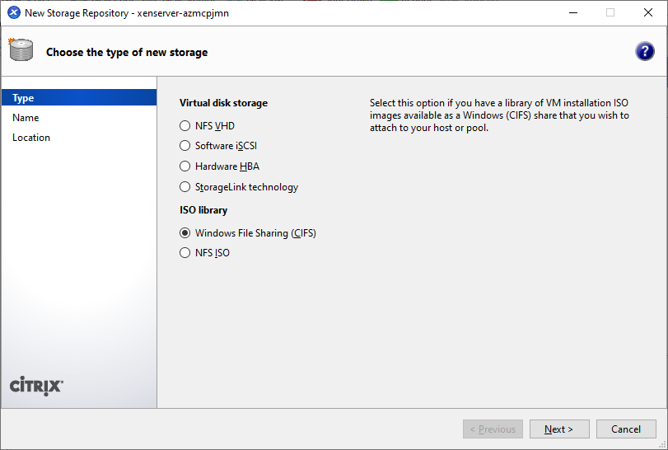

>> Uncheck **Auto generate description** and Click Next.

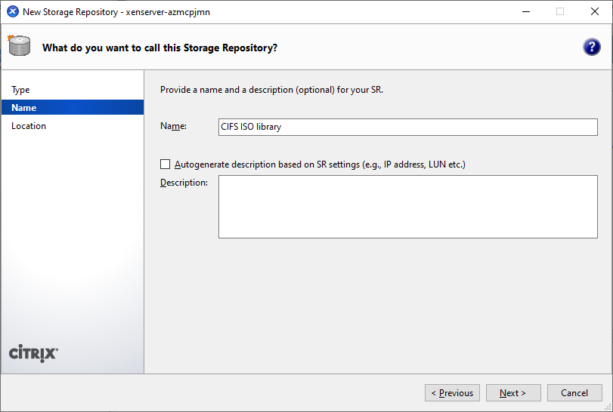

>> Enter the Network Path that we have noted down earlier (Network path: \\DESKTOP-FTPJ0PJ\Sneha XP) and Enter User Name and Password if you have it for login into your pc. (Else if not the it’s Not required).

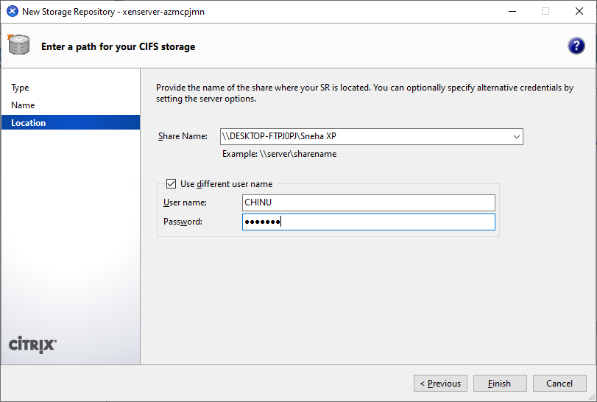

>> You can see that the CIFS ISO library is created.

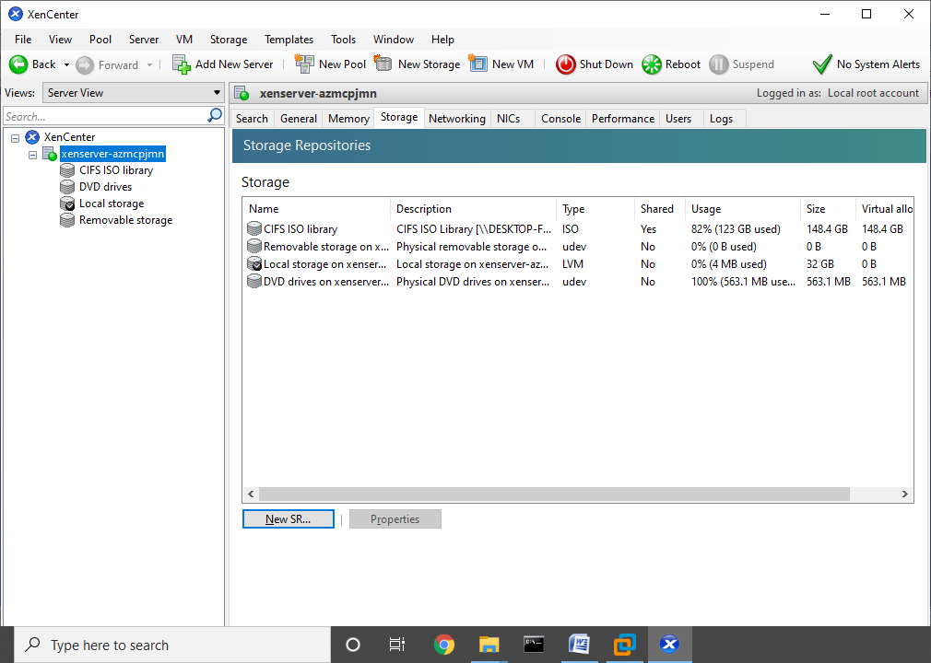

>> Click on New VM and Select Windows XP SP3 and Click Next.

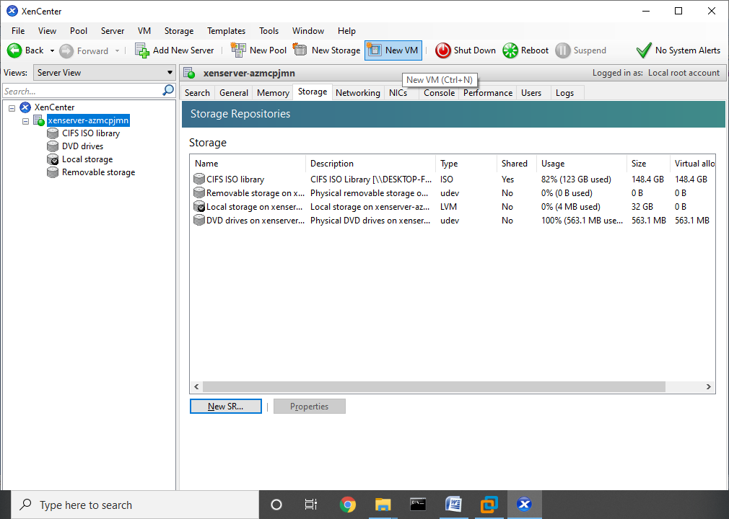

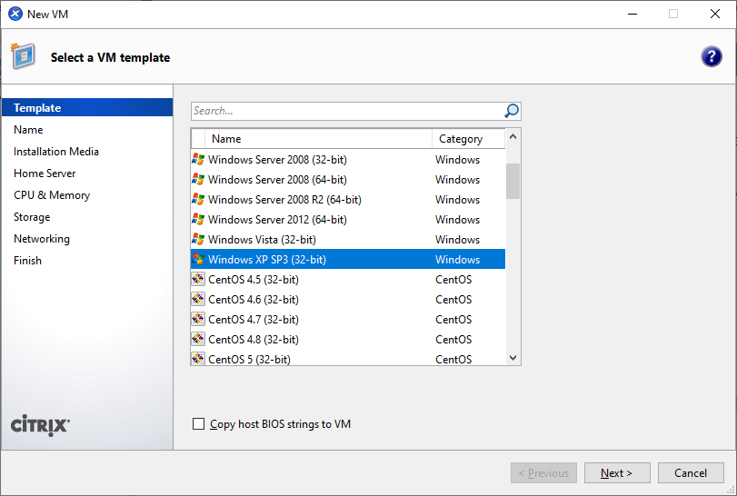

>> Enter name as desired and Click Next.

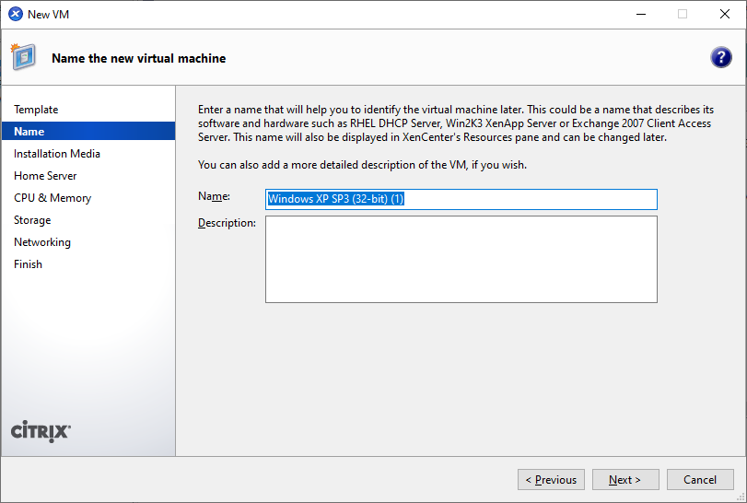

>> Click on drop down List Select the WXPVOL_EN.iso file under CIFS ISO Library.

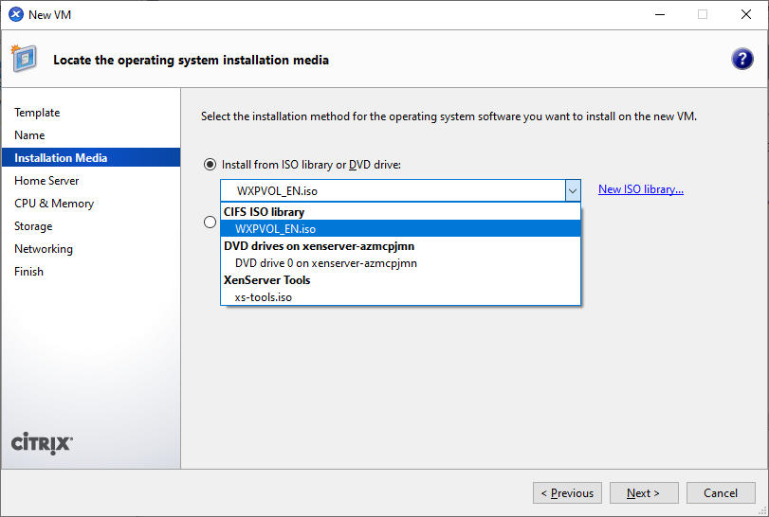

>> Click Next.

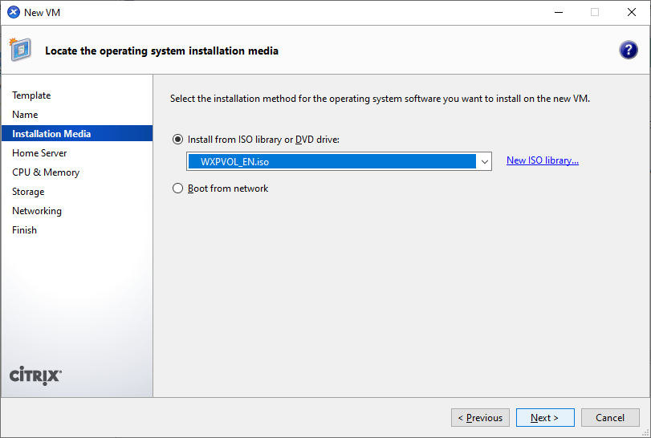

>> Select xenserver-azmcpjmn 1190 MB available (2047 MB total) and click Next.

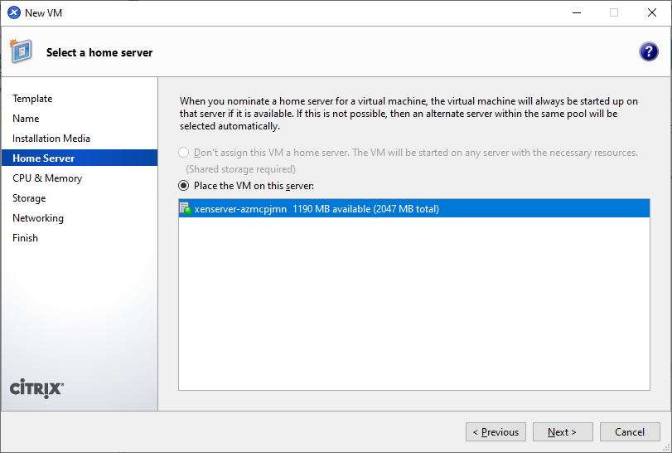

>> Click Next.

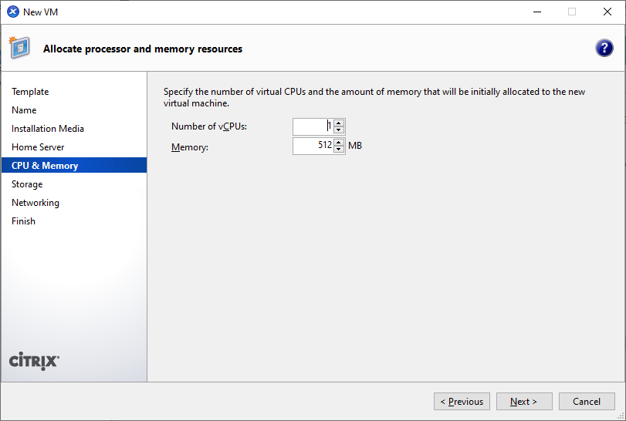

>> Click Next.

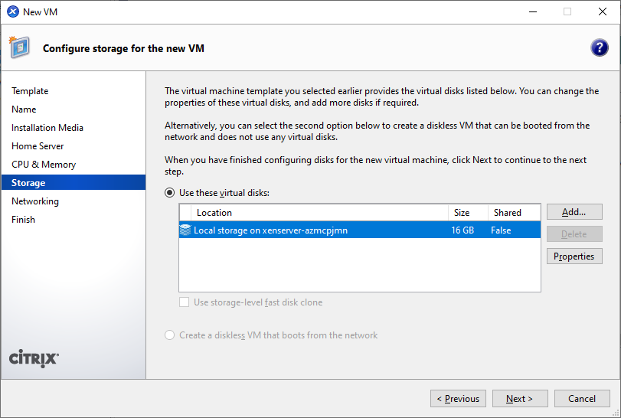

>> Click Next.

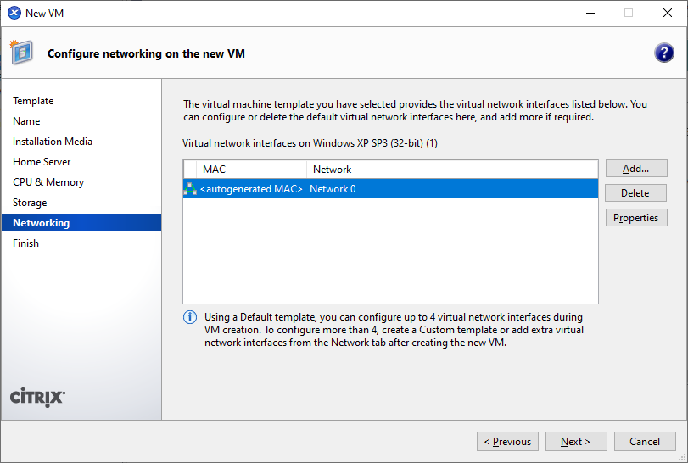

>> Uncheck – Start the new VM and click on Create New VM.

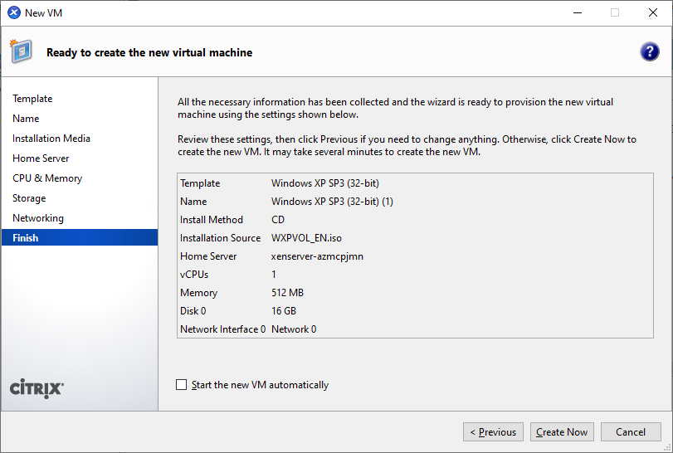

>> Right click on Windows XP SP3 and select Start.

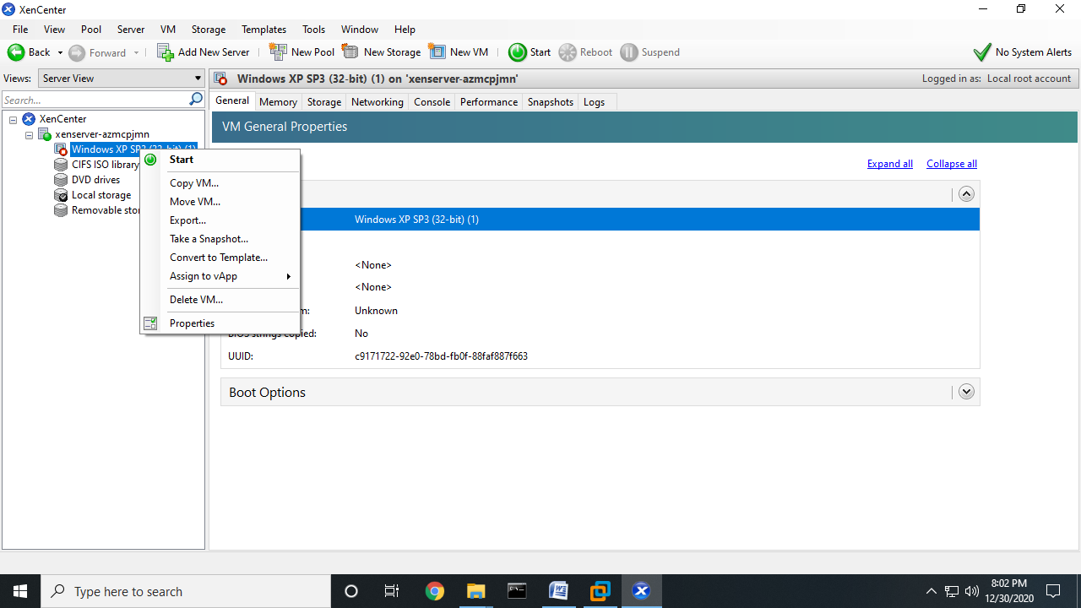

>> Go to Console to see the final Output.

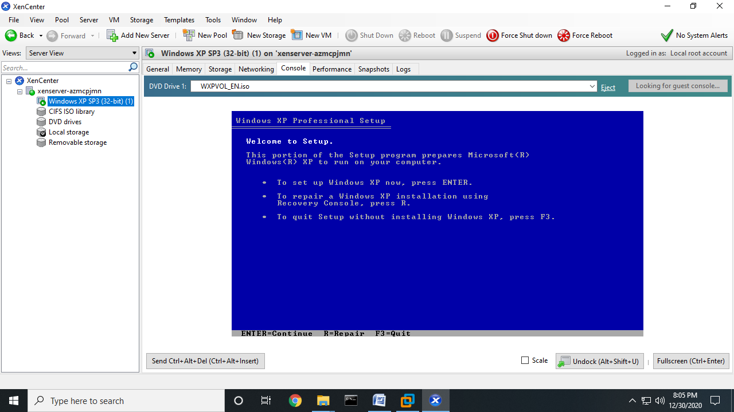

**PRACTICAL: 4**

**Develop application using Google App Engine (GAE)**

**Softwares Required :-**

* **Eclipse IDE for Enterprise Java Developers**
* **Google Cloud Tools for Eclipse**

**Steps:**

>> Download Eclipse IDE for Enterprise java Developers and install.

>> Open Eclipse IDE and **Browse** your **Workspace** and click on it. You can use the default workspace as well.



>> And click on **Launch**.

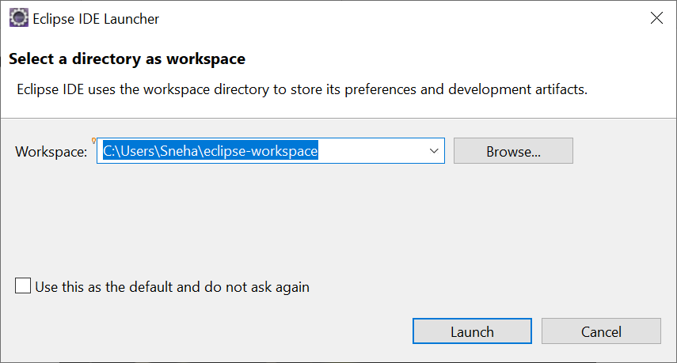



>> Following window will appear.

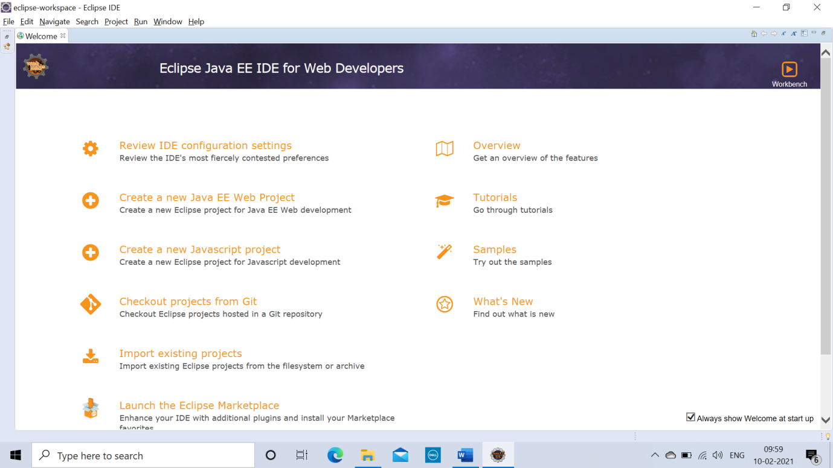

>> Close the Welcome window. And click on **‘Open Perspective’** option in the right corner.

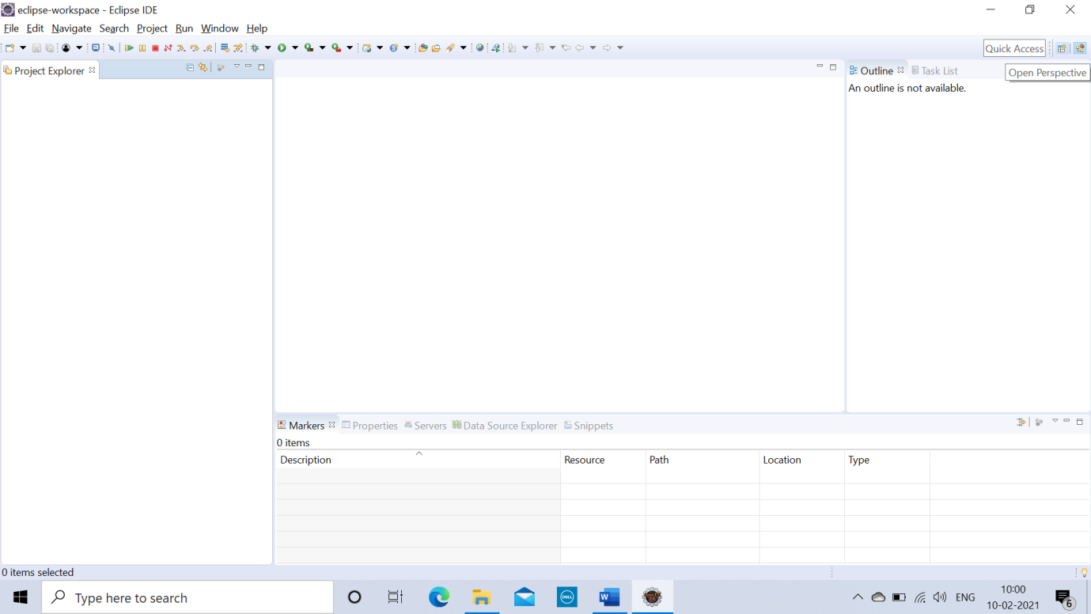

>> Choose **‘Java EE (Default)’**. And click on **Open.**

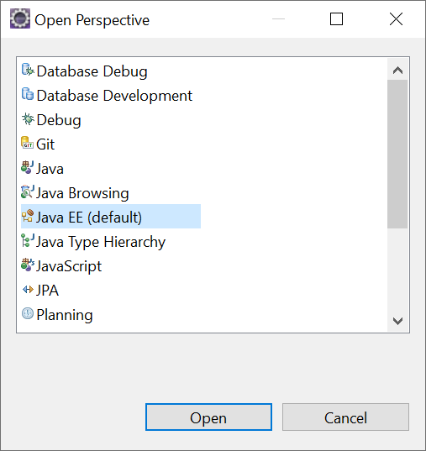

>> Now click on **‘Help’** and choose **‘Eclipse Marketplace’** option.

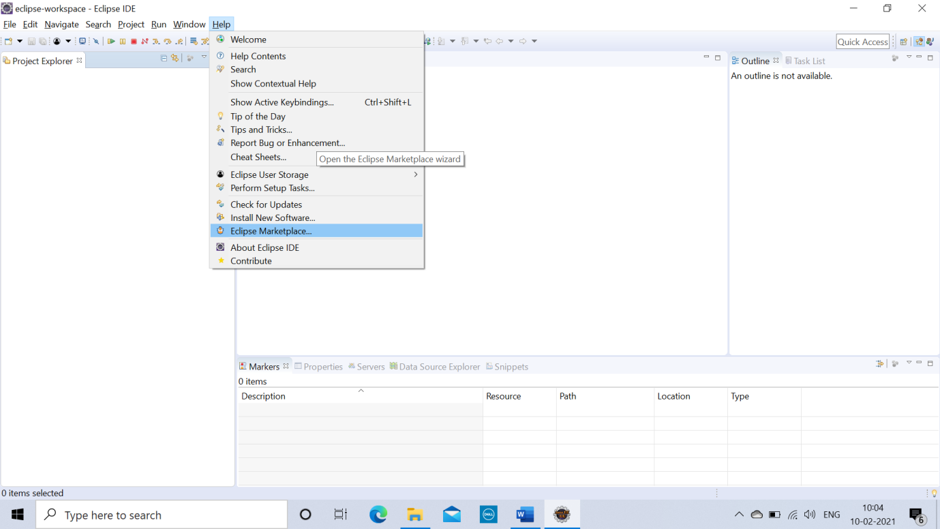

>> In **Find Search Box** Search for **‘Google Cloud Tools For Eclipse’**. And click on **Install.**

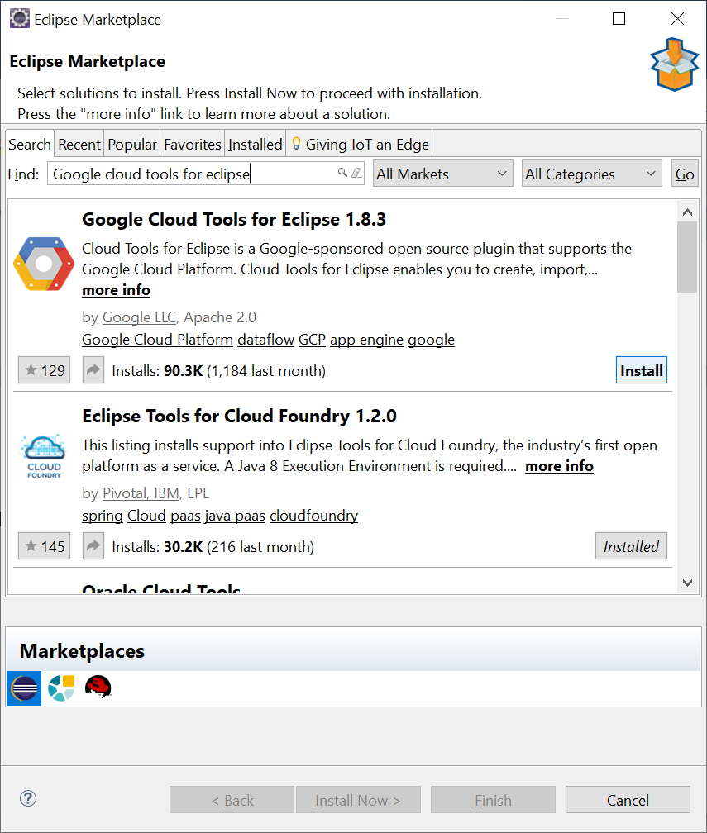

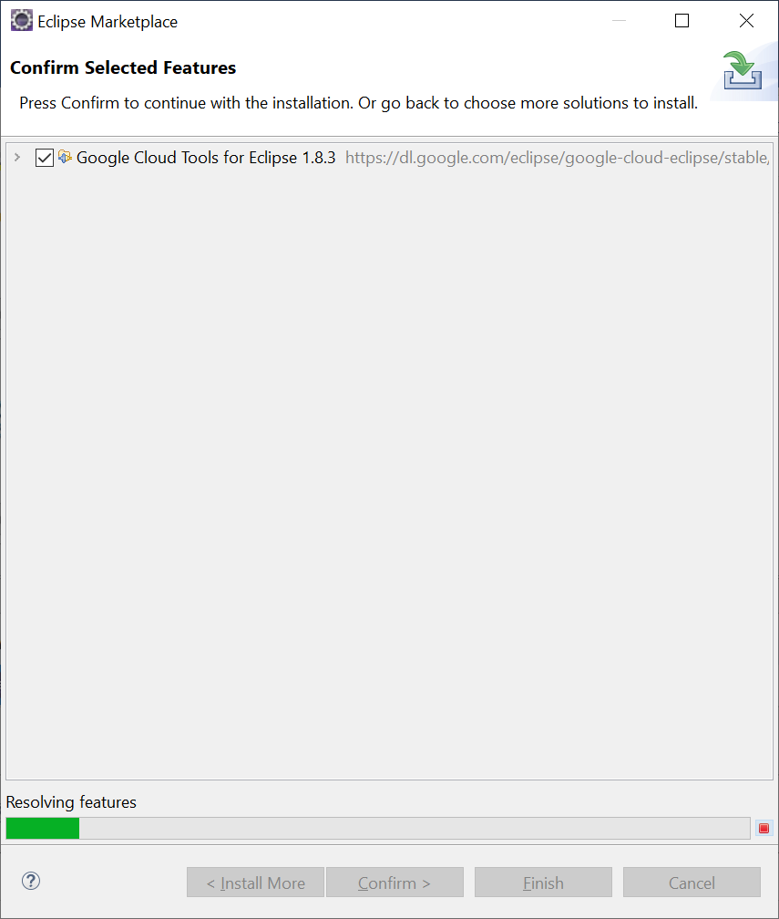

>> Click on **Confirm.**

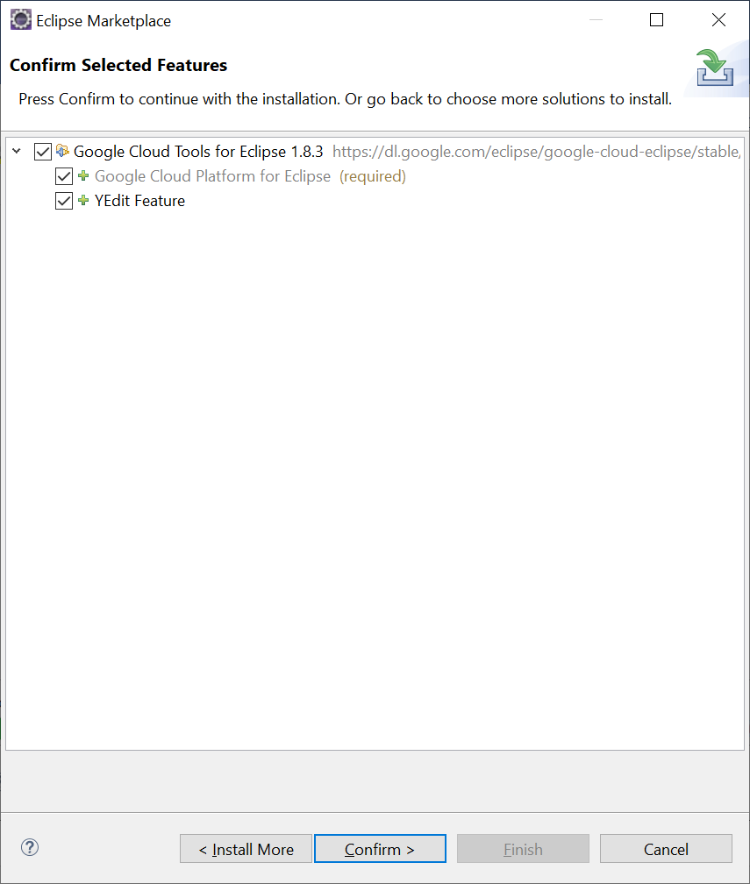

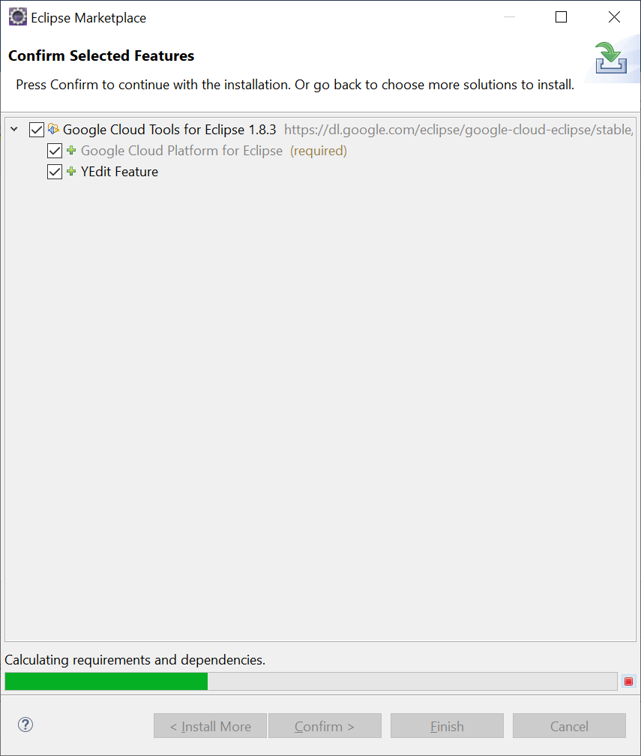

>> Accept the terms of the license agreement. And click on **Finish.**

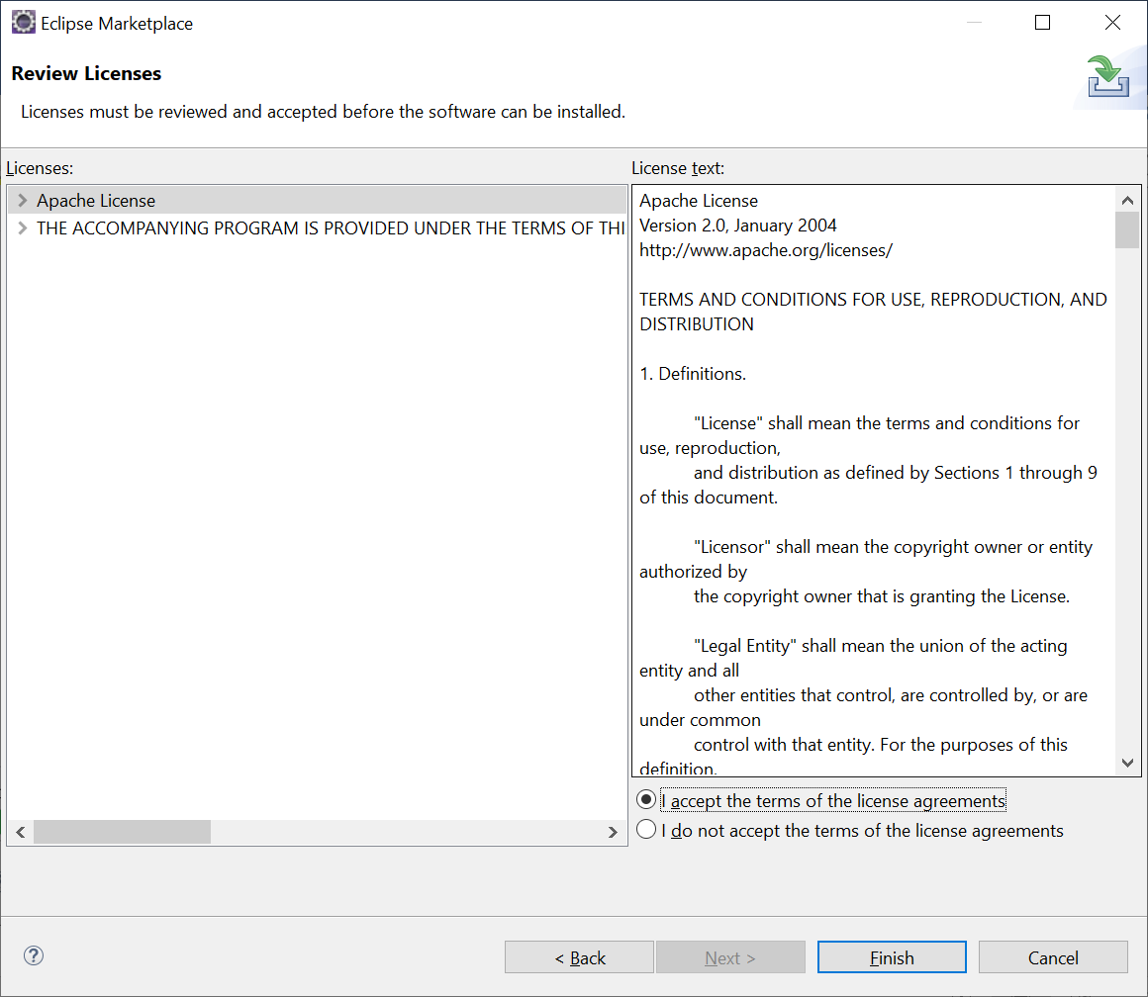

>> Software will start to install. You will get to see it in the right side bottom corner.

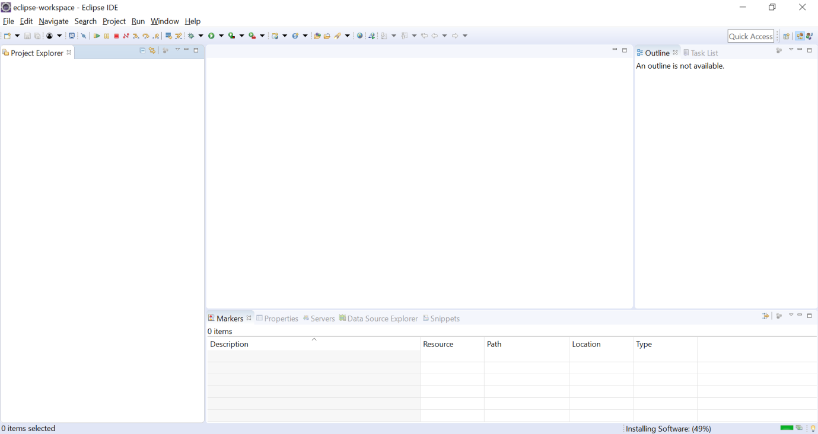

>> Now , restart the Eclipse IDE. After restarting you will get to see the **‘Google Cloud Platform’** option in the menu bar.

>> And also at the right side bottom corner we will get to see **‘Configuring Google Cloud SDK’.** Let that be complete.

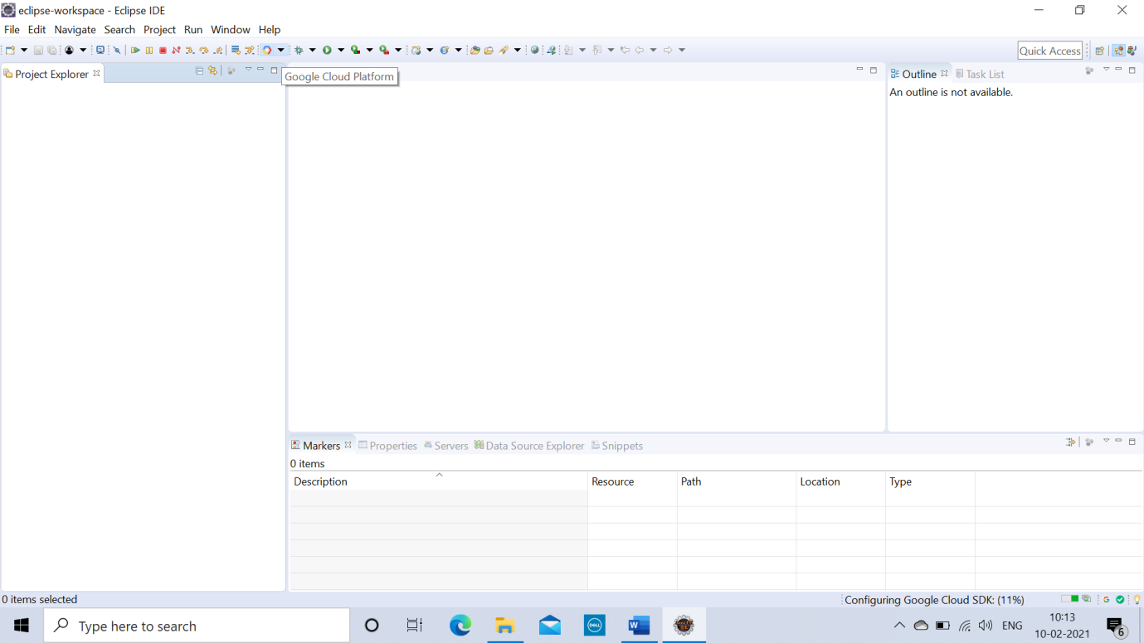

>> Now click on **File >> New >> Other.**

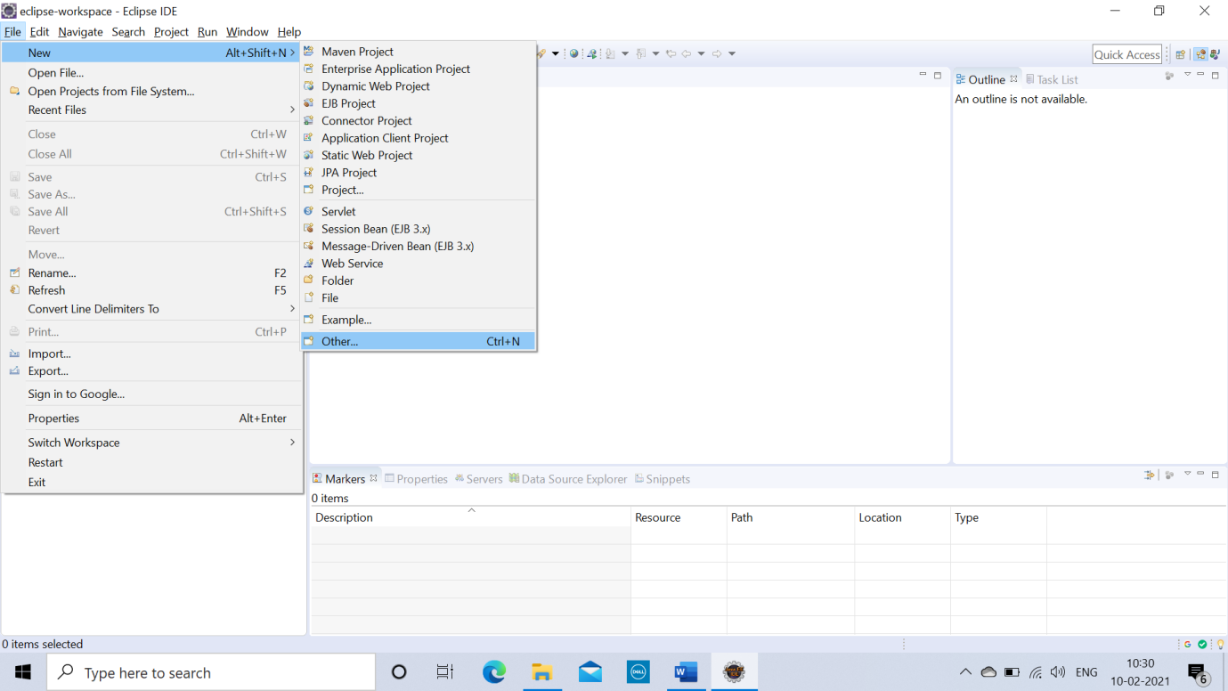

>> Search **‘Google’** and select **‘Google App Engine Standard Java Project’**. And click on **Next.**

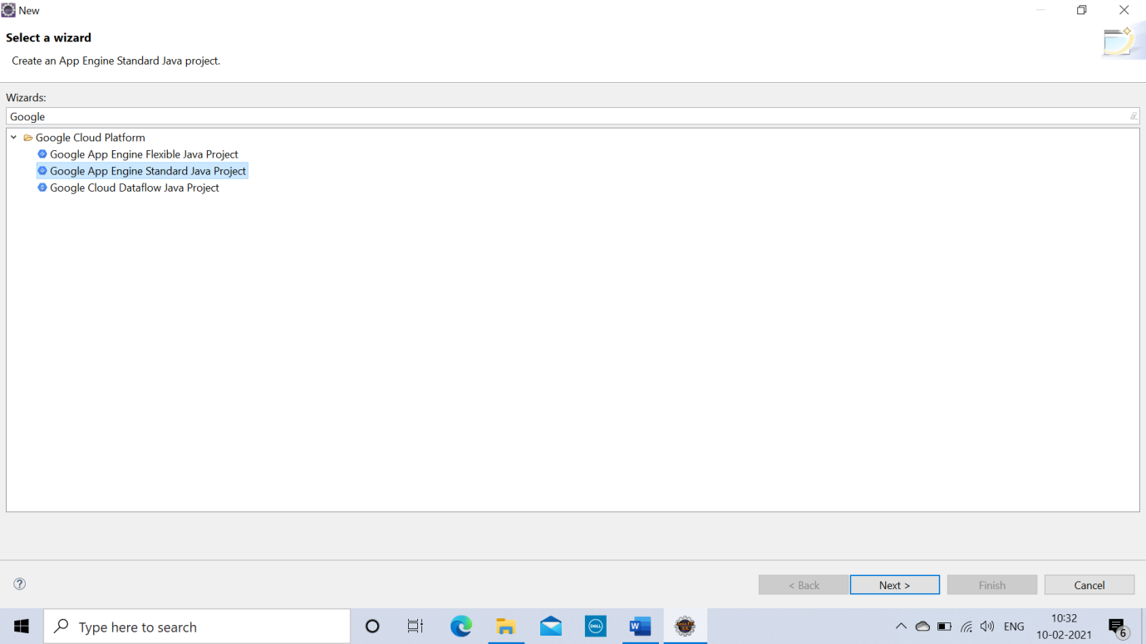

>> Enter **Project Name** and **Package Name.** Click on **Next**, and then click on **Finish.**

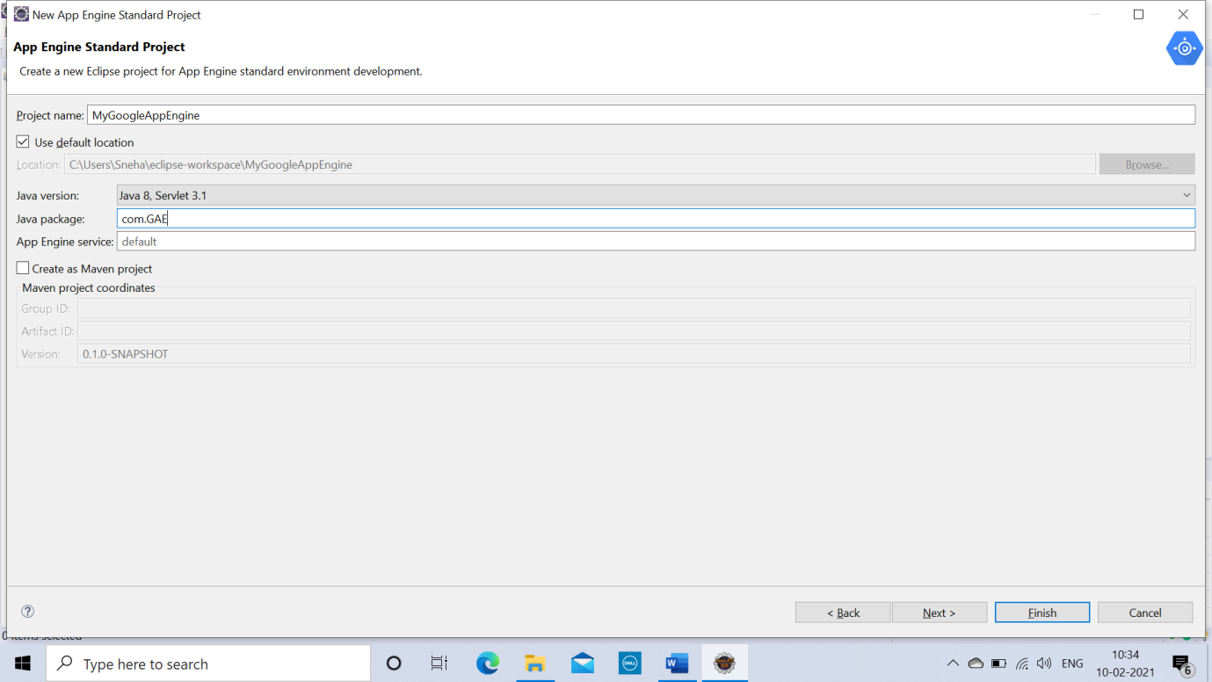

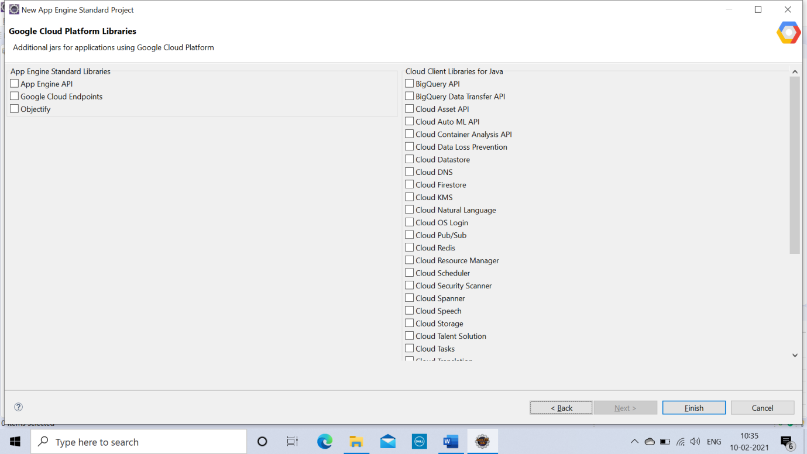

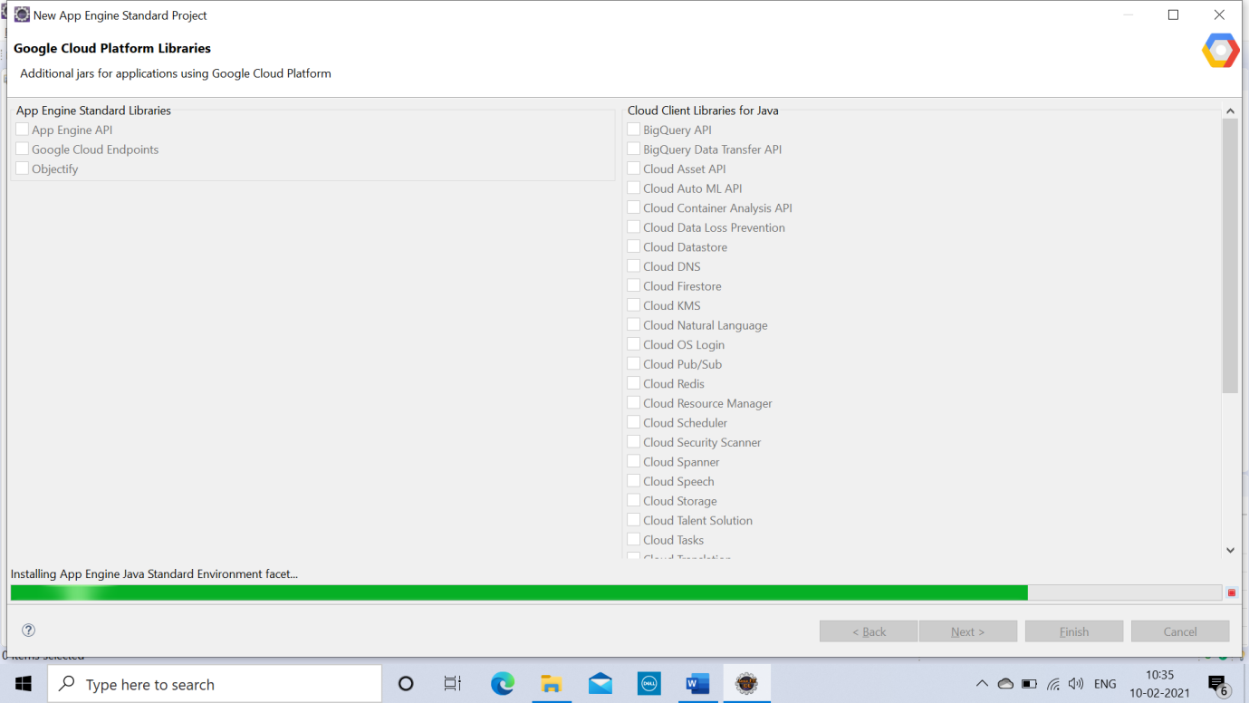

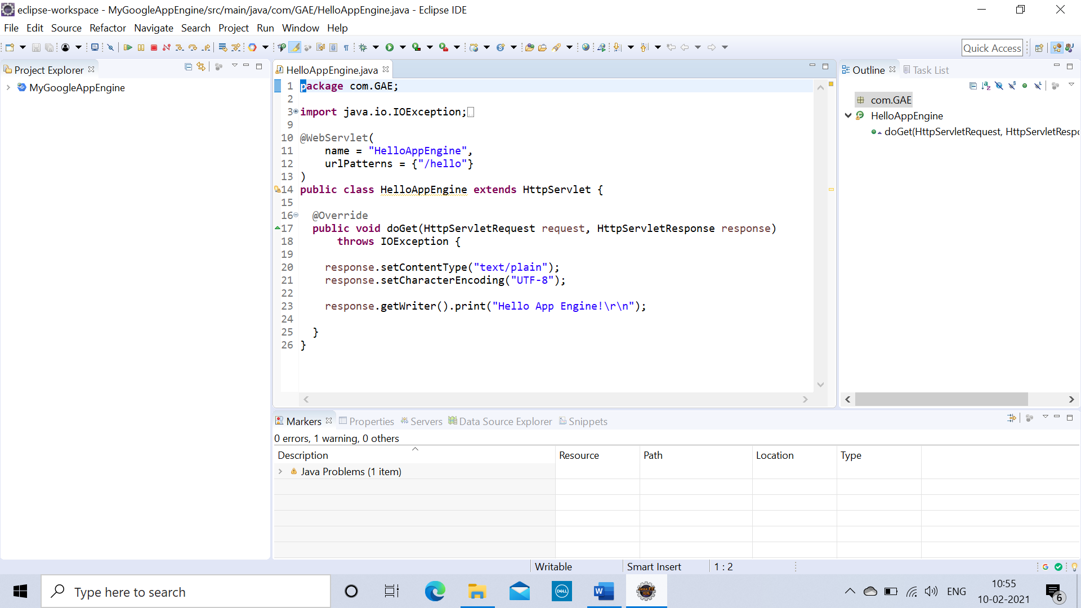

>> Open project hierarchy. Edit the files as required (Unedited file too can be used, Here the editing is done to ‘What should be displayed on the browser’ as an output). Save the file.

**HelloAppEngine.java**

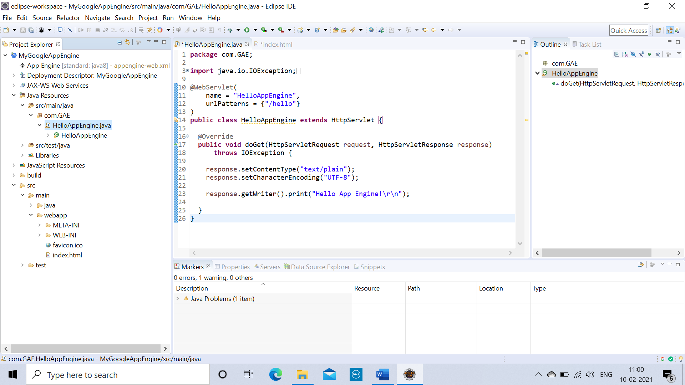

**Index.html**

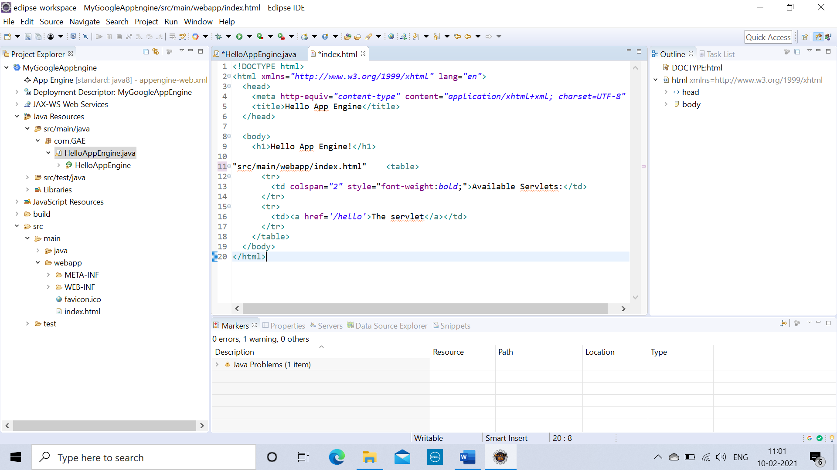

>> To configure the **‘App Engine Standard Server’**, Click on the link to create a new server under **Server** tab.

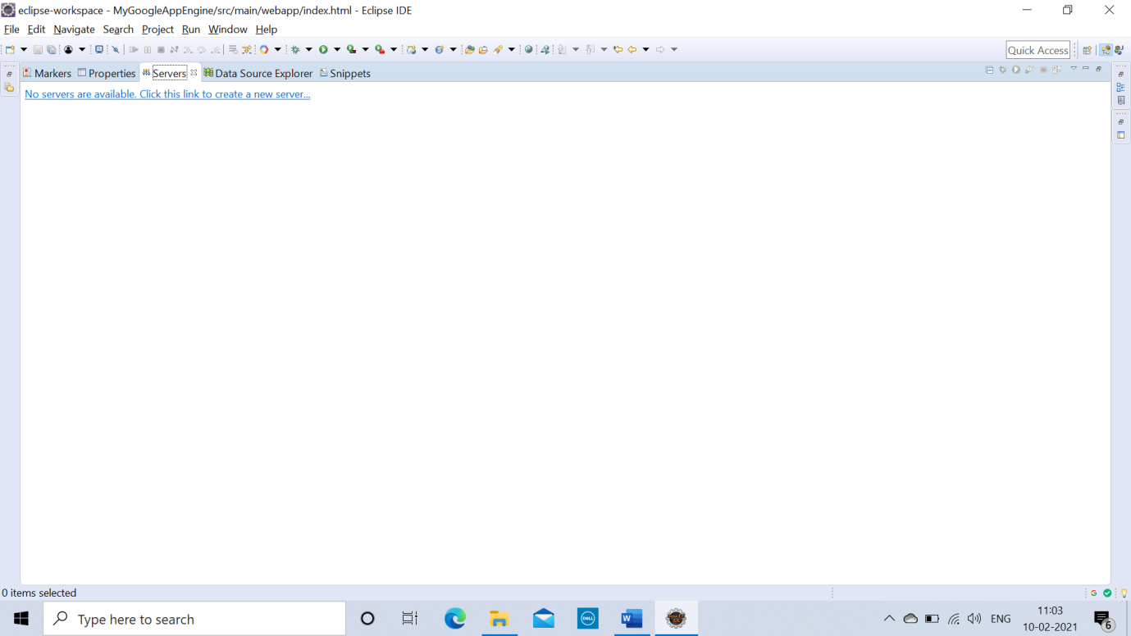

>> Click on **Next.**

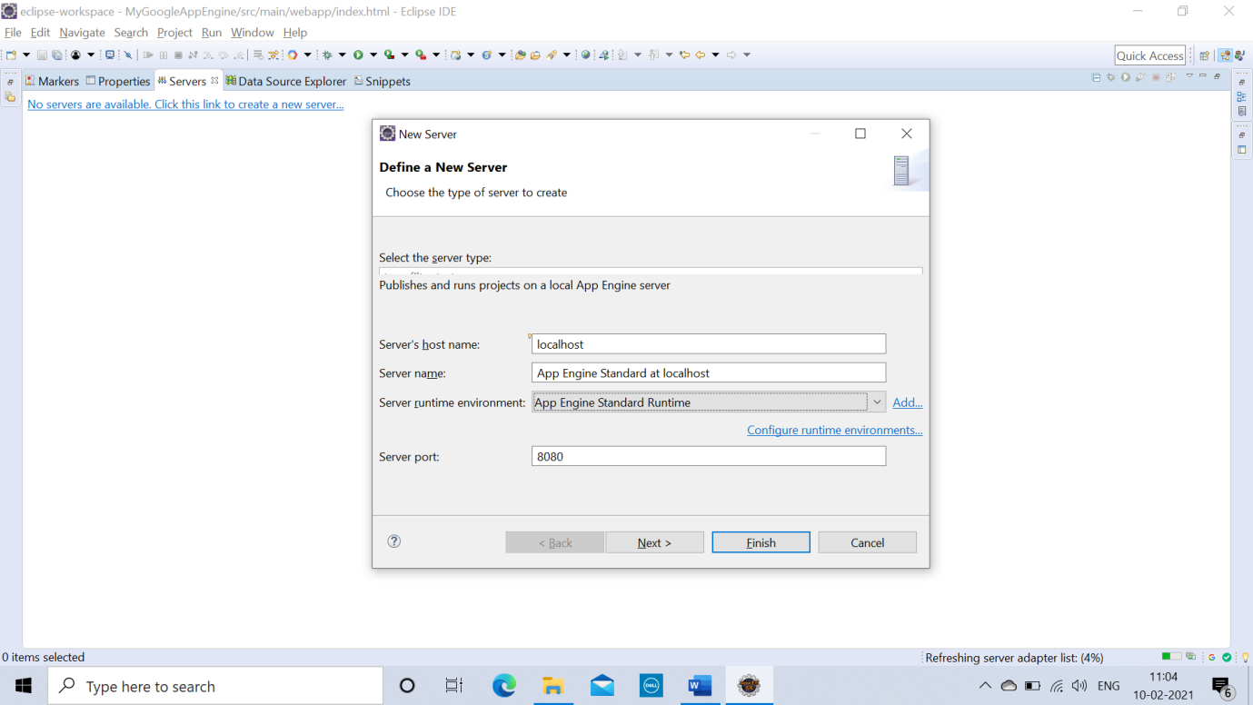

>> Click on **‘Add all’**, and then click on **Finish.**

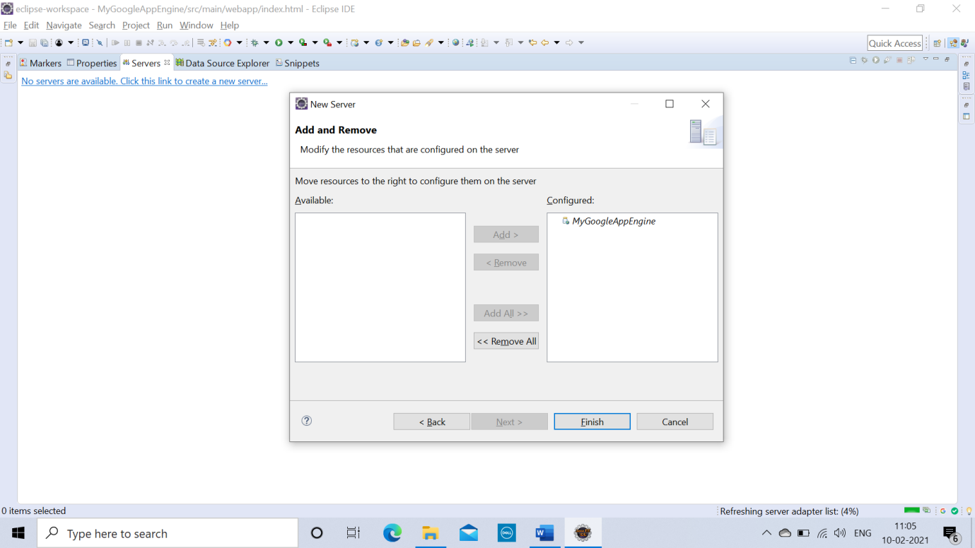

>> Now click on **Run as** >> **App Engine**

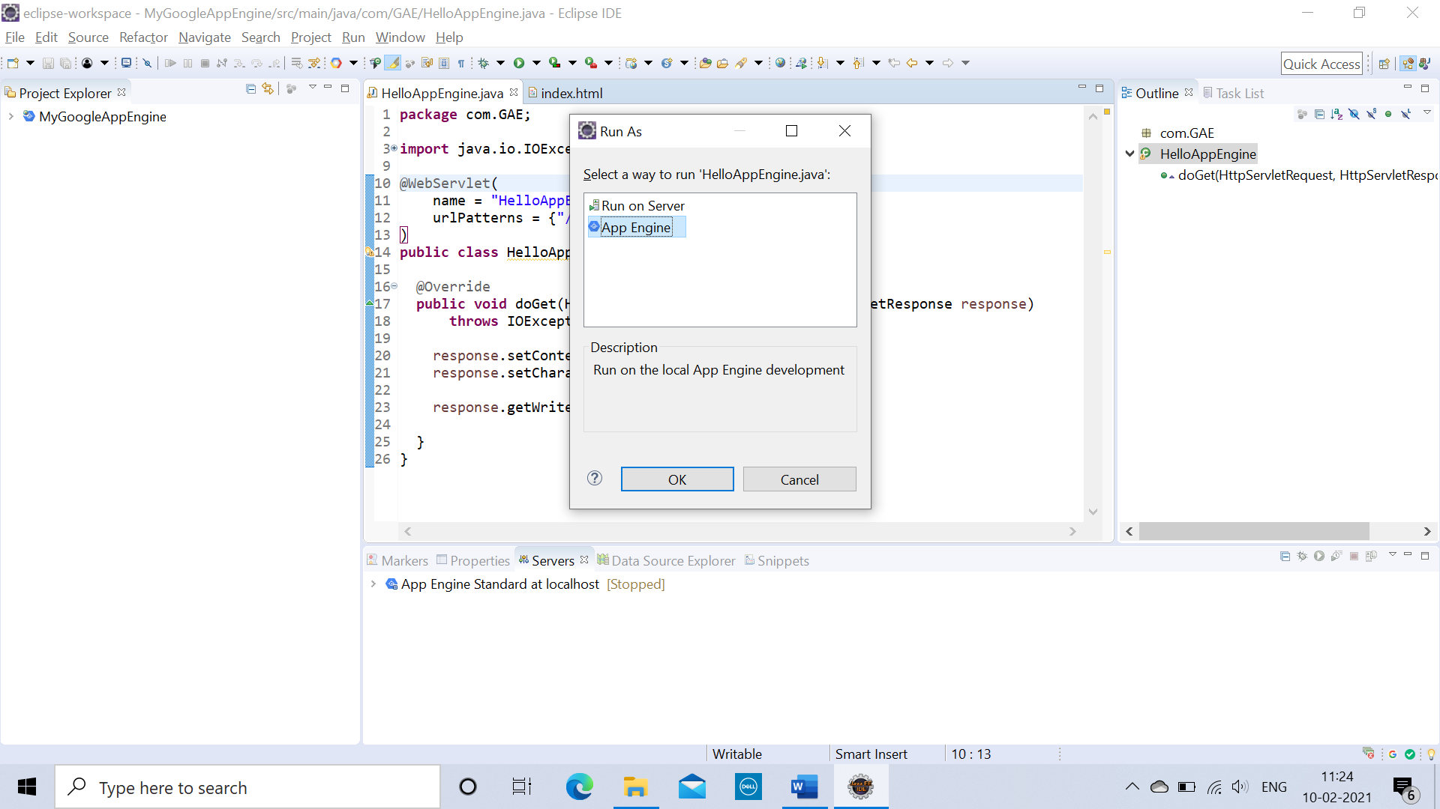

**OUTPUT:**

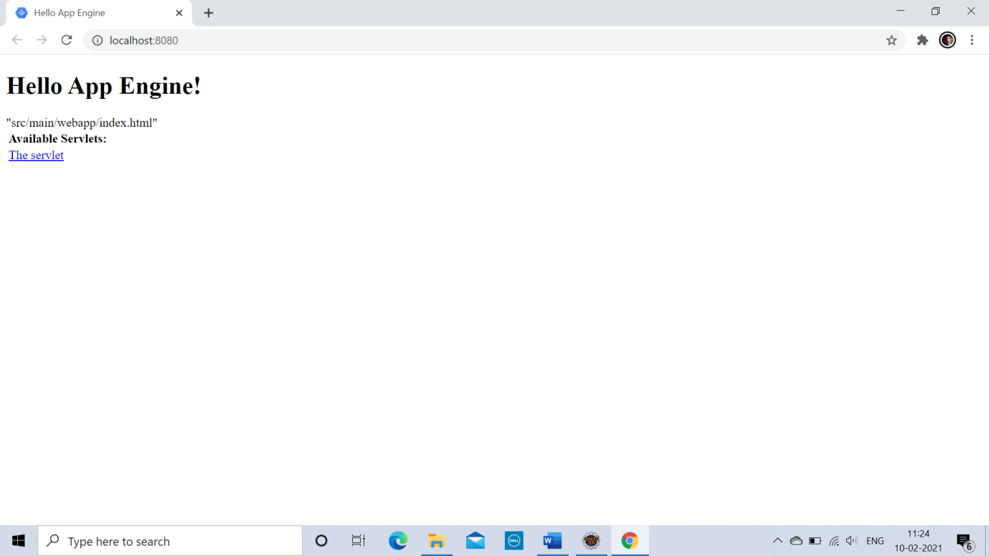

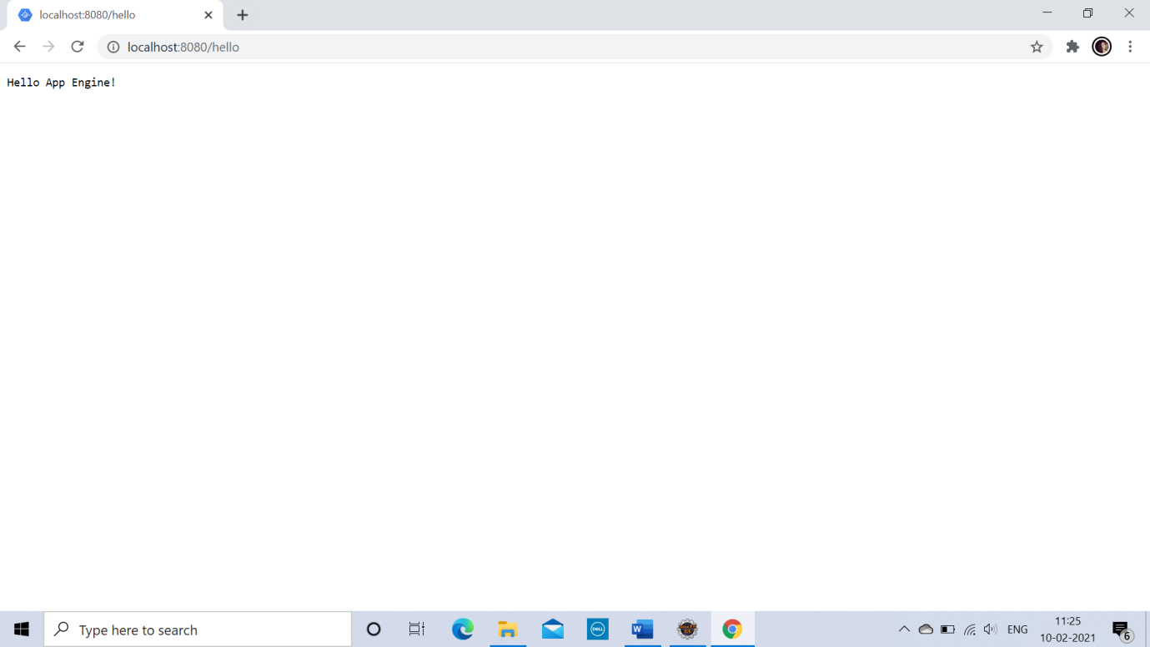

**>> Similarly you can create web applictions with the help of Google App Engine.**

**>> Here I have created simple login form.**

**LoginPage.java**

**package** com.LoginForm;

**import** java.io.IOException;

**import** java.io.PrintWriter;

**import** javax.servlet.ServletException;

**import** javax.servlet.http.HttpServlet;

**import** javax.servlet.http.HttpServletRequest;

**import** javax.servlet.http.HttpServletResponse;

**public** **class** LoginPage **extends** HttpServlet

{

**protected** **void** doPost(HttpServletRequest req,HttpServletResponse res) **throws** ServletException , IOException

{

PrintWriter out =res.getWriter();

String uname = req.getParameter("myusername");

String upass = req.getParameter("mypassword");

**if**(uname.equals("snehapawar") && upass.equals("Sneha@123"))

{

out.println("Login Successful !");

}

**else**

{

out.println("Please Enter Correct Username and Password.");

}

}

}

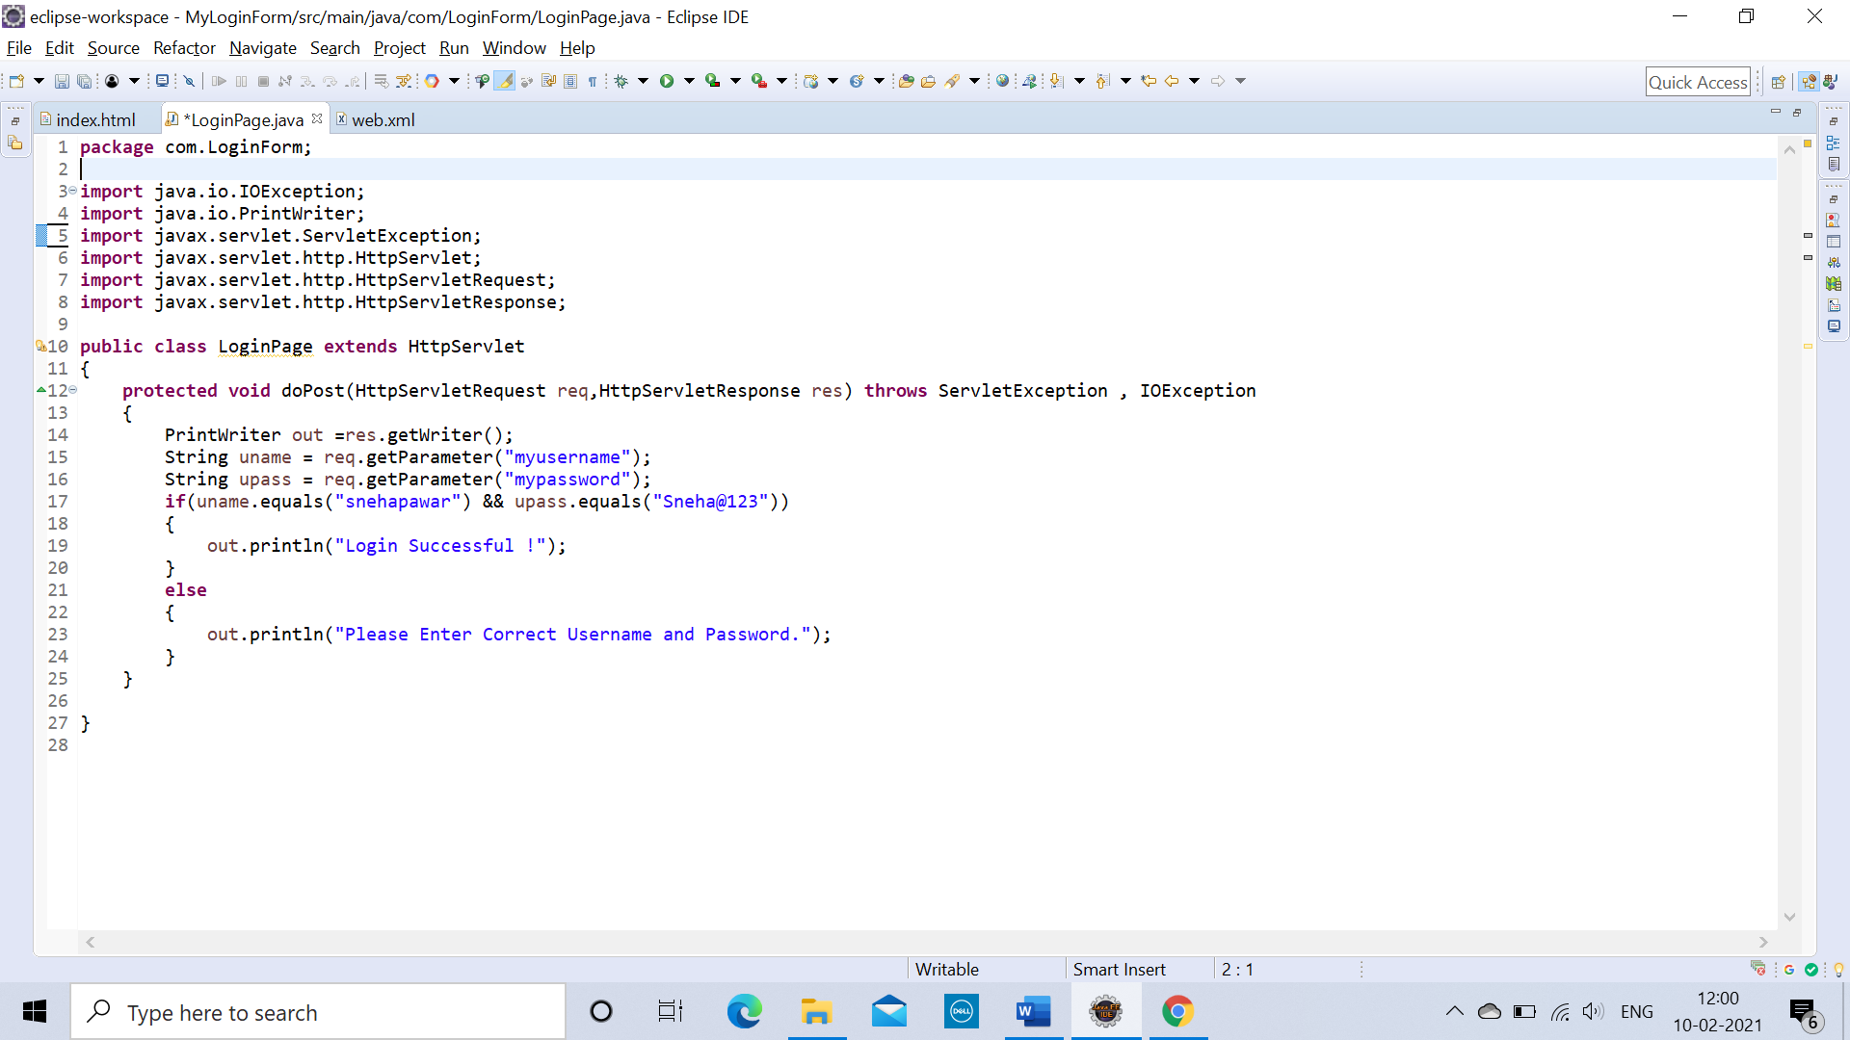

**index.html**

<!DOCTYPE html>

<html xmlns=*"http://www.w3.org/1999/xhtml"* lang=*"en"*>

<head>

<meta http-equiv=*"content-type"* content=*"application/xhtml+xml; charset=UTF-8"* />

<title>Hello App Engine</title>

</head>

<title>Login Form</title>

<body>

<form action=*"logindemo"* method=*"post"*>

USERNAME : <input type=*"text"* name=*"myusername"*/><br>

PASSWORD : <input type=*"password"* name=*"mypassword"*/><br><br>

<input type=*"submit"* value=*"Login"*/><br><br>

<input type=*"reset"* value=*"Clear"*/><br>

</form>

</body>

</html>

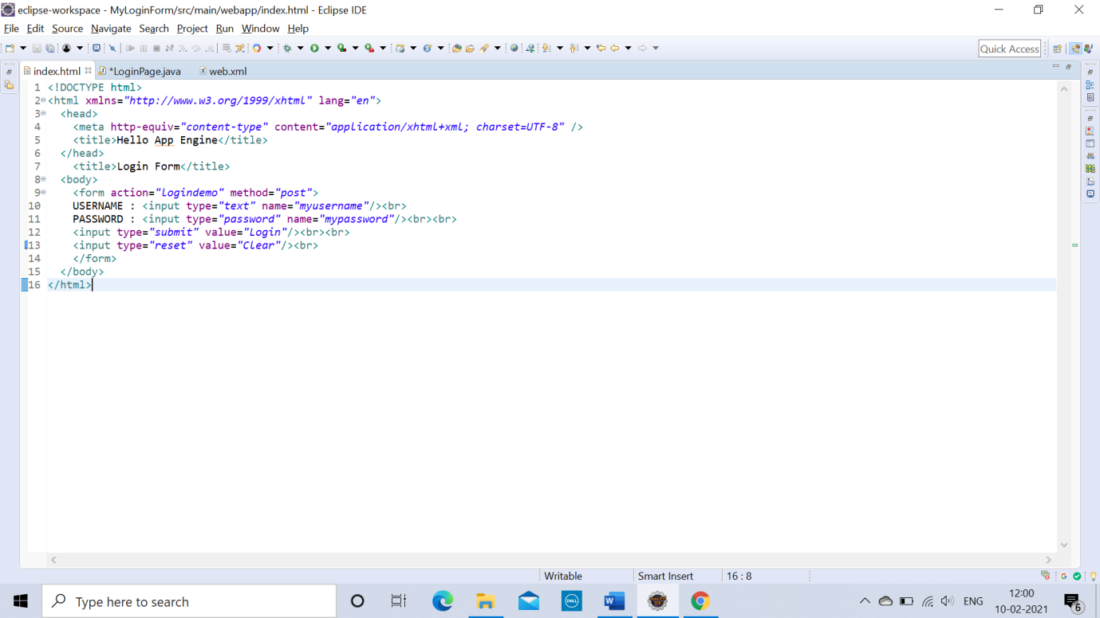

**web.xml**

<?xml version=*"1.0"* encoding=*"utf-8"*?>

<web-app xmlns=*"http://xmlns.jcp.org/xml/ns/javaee"*

xmlns:xsi=*"http://www.w3.org/2001/XMLSchema-instance"*

xsi:schemaLocation=*"http://xmlns.jcp.org/xml/ns/javaee http://xmlns.jcp.org/xml/ns/javaee/web-app_3_1.xsd"*

version=*"3.1"*>

<servlet>

<servlet-name>loginservlet</servlet-name>

<servlet-class>com.LoginForm.LoginPage</servlet-class>

</servlet>

<servlet-mapping>

<servlet-name>loginservlet</servlet-name>

<url-pattern>/logindemo</url-pattern>

</servlet-mapping>

</web-app>

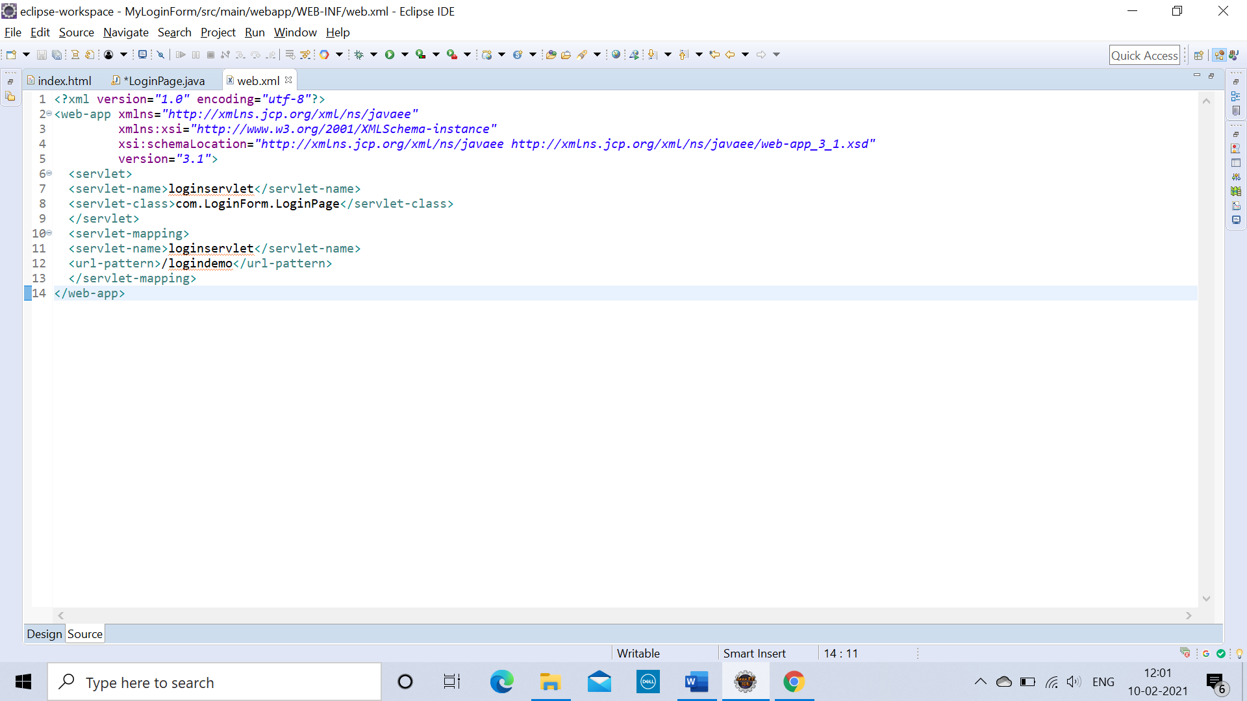

**OUTPUT :**

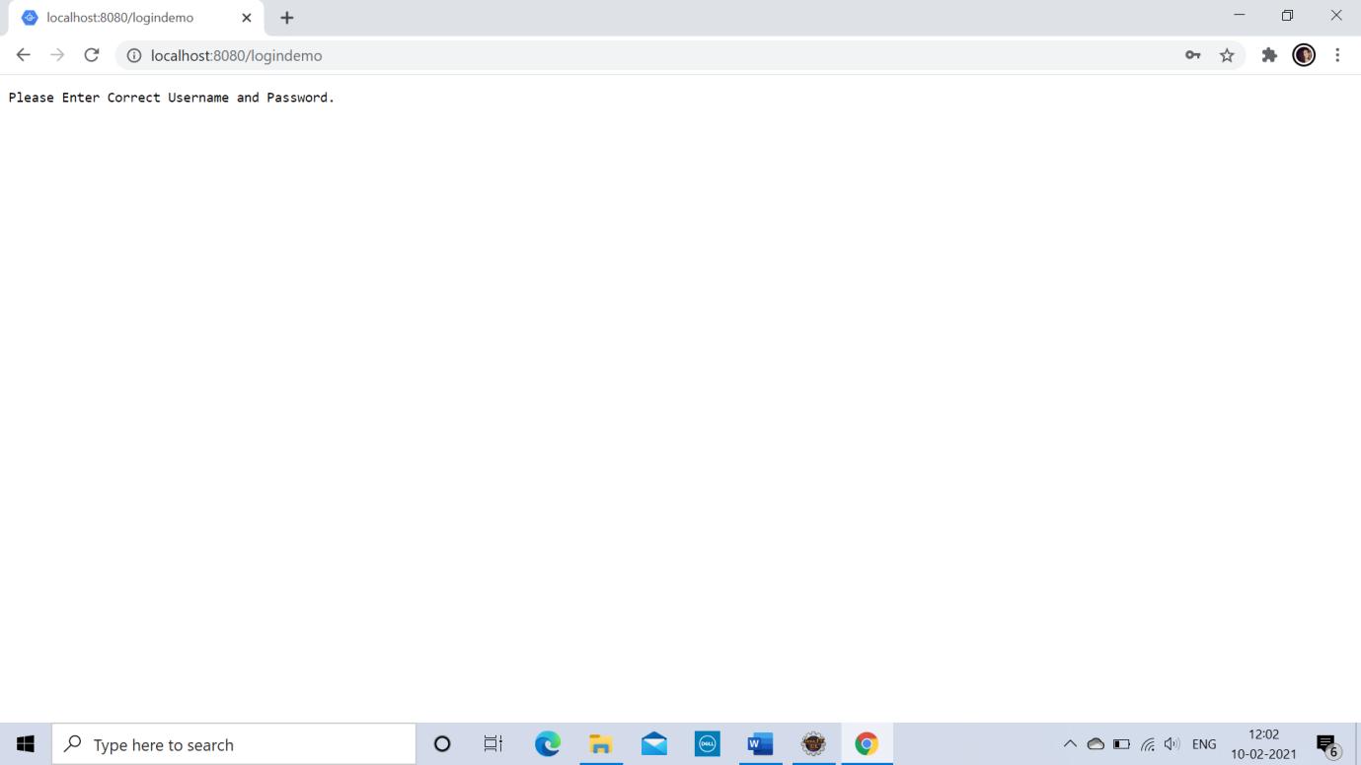

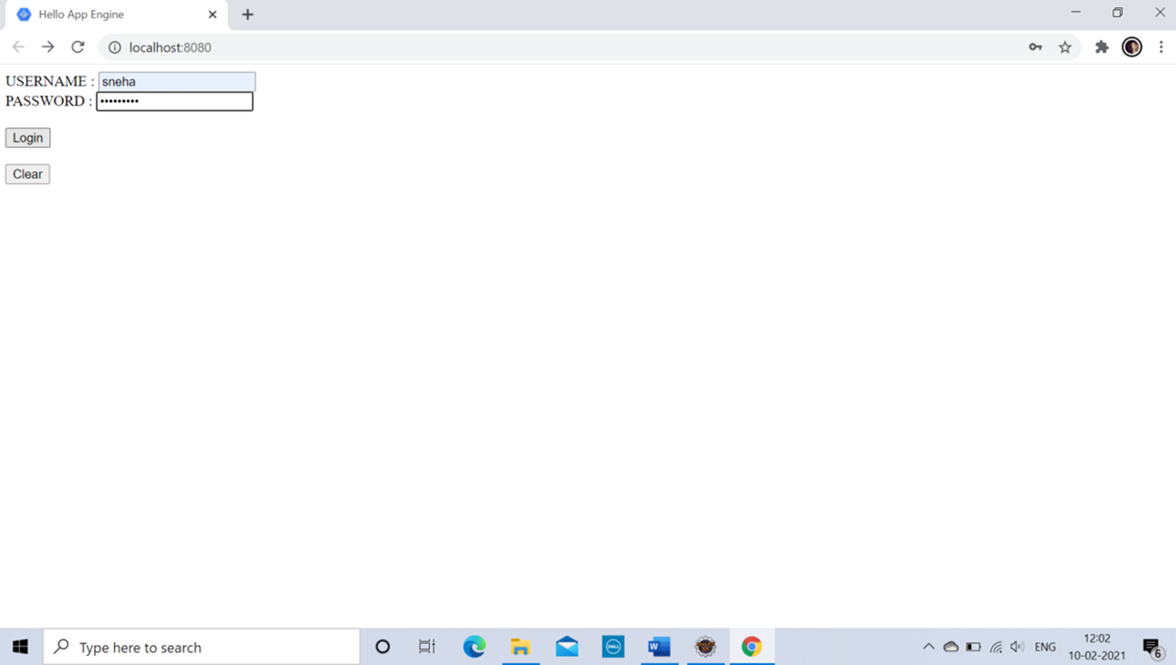

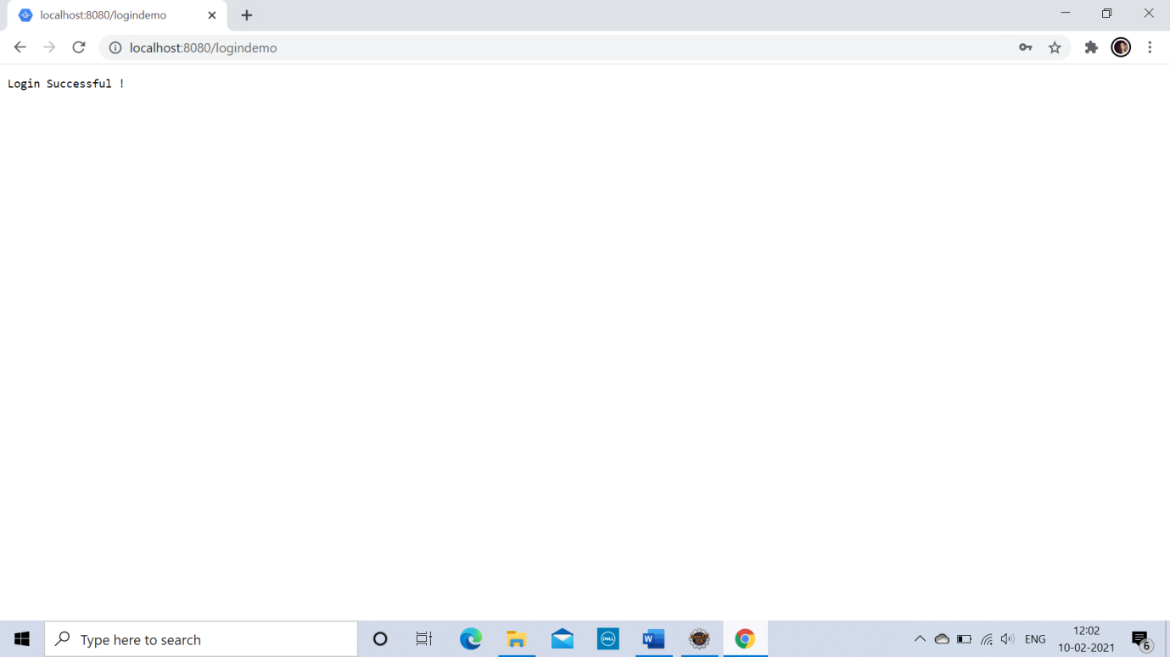

**PRACTICAL: 5**

**IMPLEMENT ESXi SERVER**

**Softwares Required :**

* **VMware Workstation 15.5 PRO**
* **VMware ESXi-5.x-Custom.iso file**
* **vSphere Client**
* **Windows XP iso file**

**What is VMWare ESXi :**

VMWare ESXi is just an OS that sits on your hardware and give you the power to virtualize your hardware resources eg, CPU, RAM etc.

**What is VMWare vSphere Client :**

The VMWare vSphere Client is a web based application that connects to the vCenter Server so IT administrators can manage installations and handle inventory objects in a vSphere deployment.

**Steps:**

>> Open VMware Workstation and select Create a New Virtual Machine.

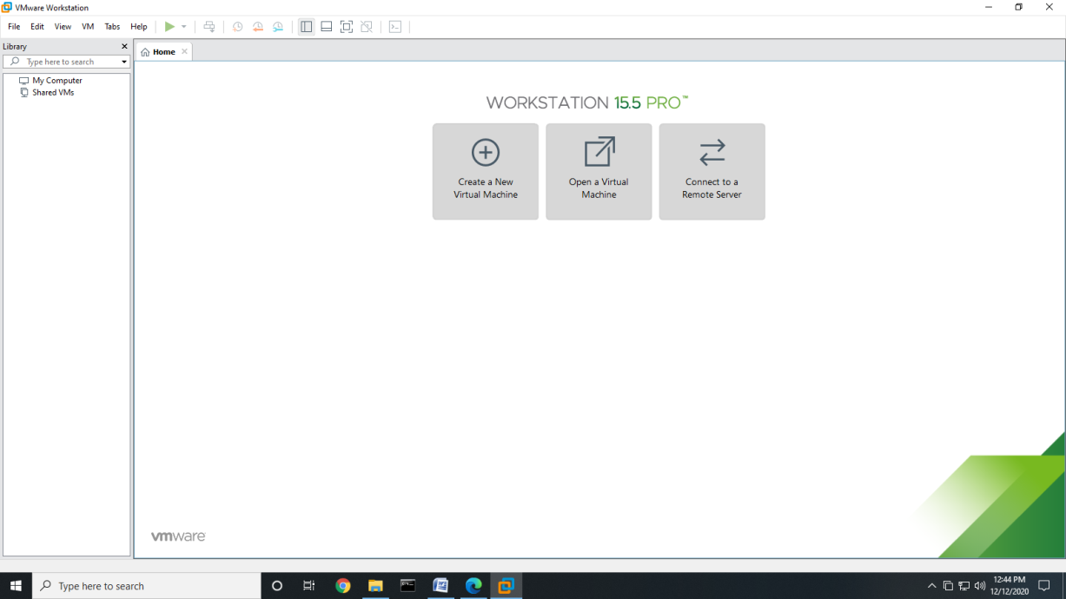

>> Select Typical and click “**Next”.**

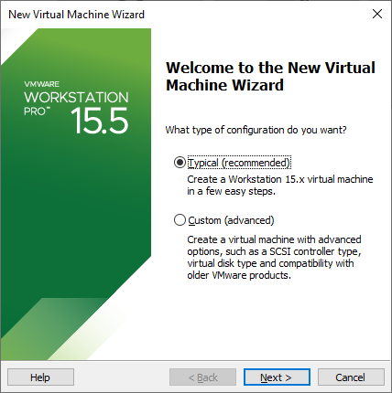

>> Select Installer disc_image file(ISO). Click Browse>>ESXi 5.xCustom.iso (Iso File)>>For Example “**C:\Users\CHINU\Desktop\Sneha\ESXi-5.x-Custom.iso**” And click “**NEXT**”.

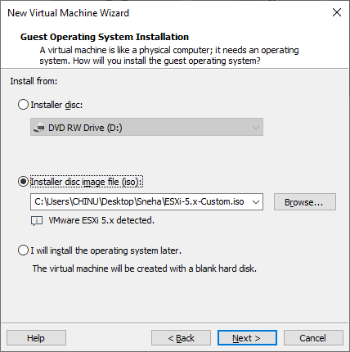

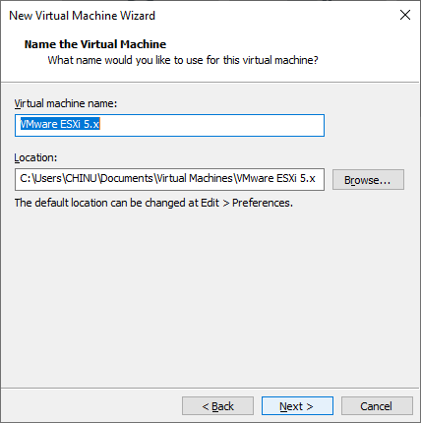

>> Choose “**Store virtual disk as a single file**” and Keep the memory size as 60GB. Click “**NEXT**”.

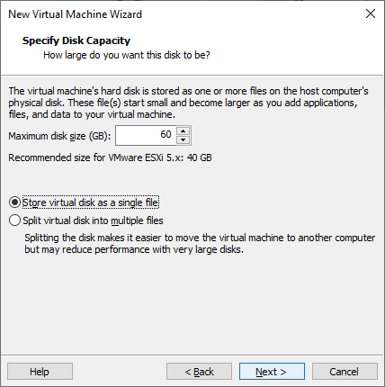

>> Click on Memory under Devices on the right side and make it to **4GB**. Power on the virtual machine by clicking check box “**Power on this virtual machine**”. Click on Processor and select **Virtualize Intel VT-x**.

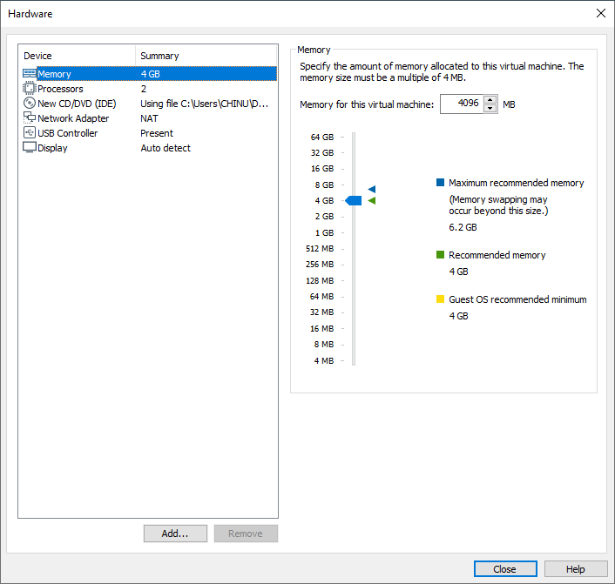

>> Click on “**Finish**” button.

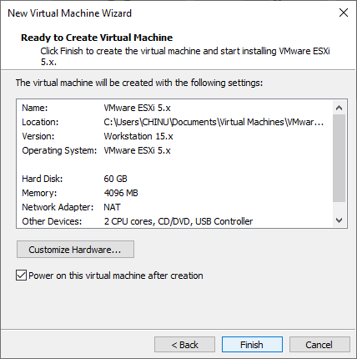

>> Wait until it boots automatically.

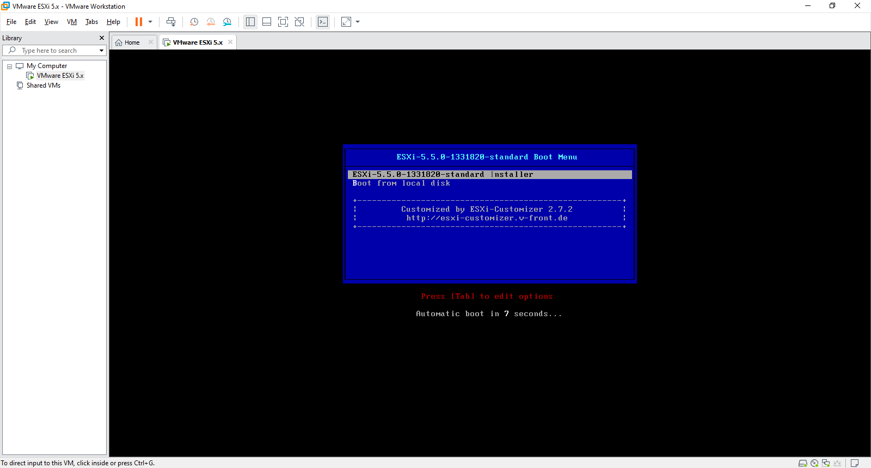

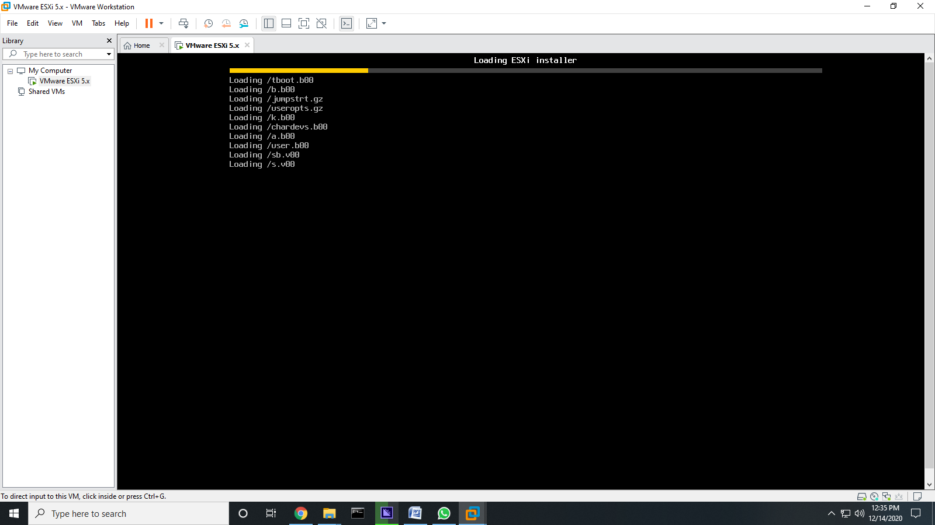

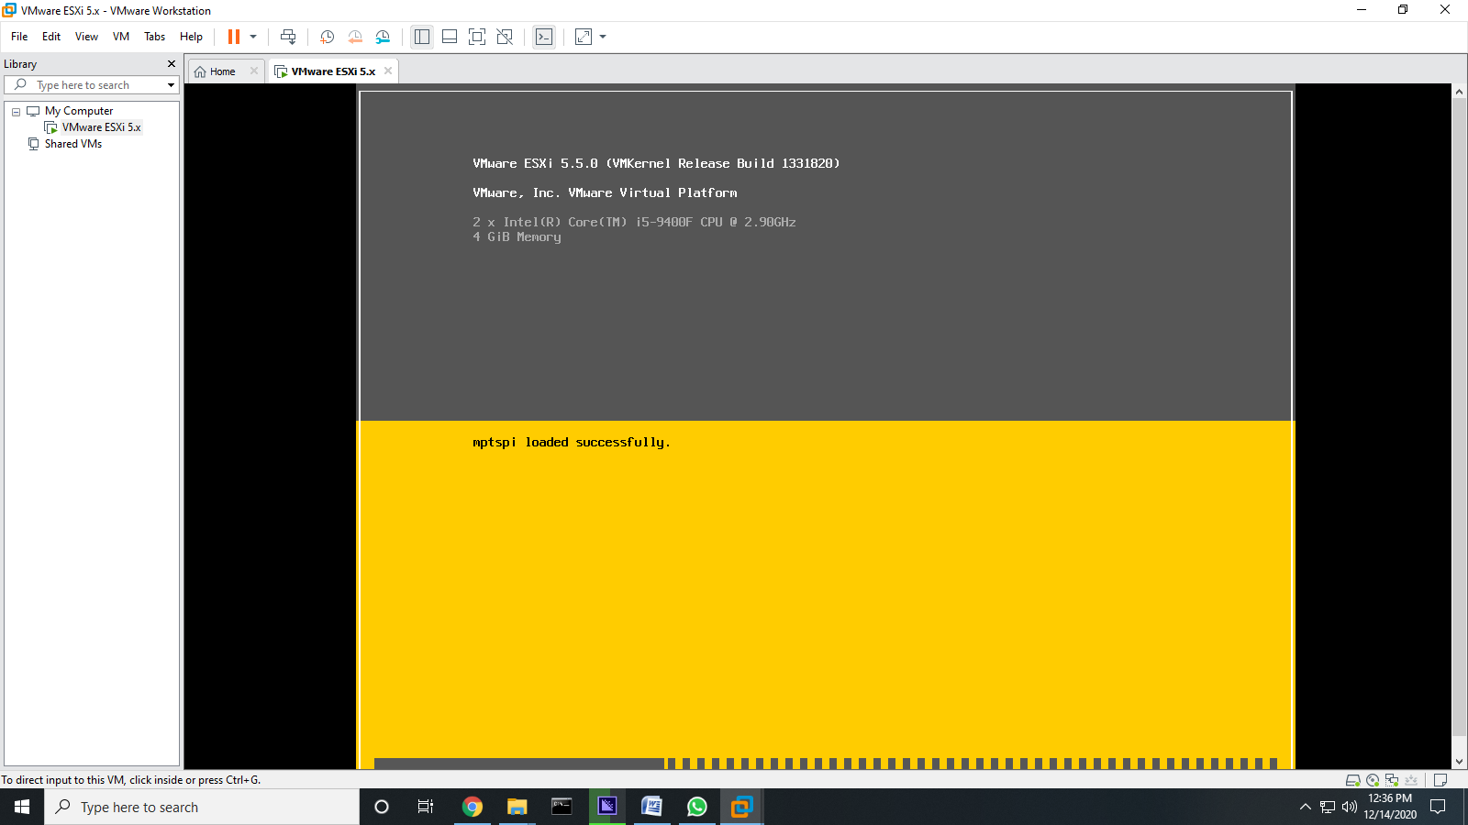

>> Press Enter to Continue.

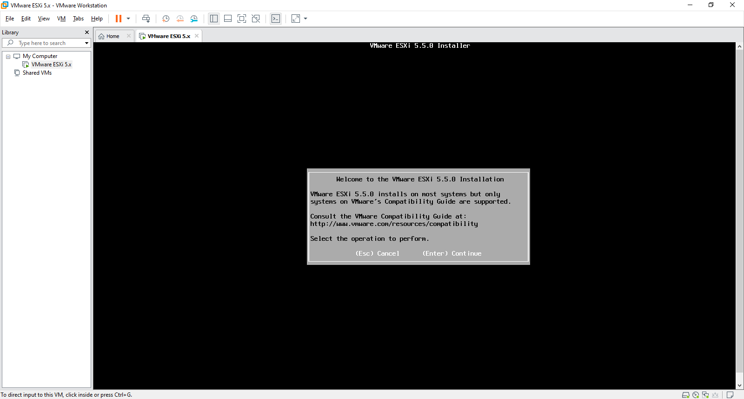

>> Press Function key 11 (F11) to Accept and Continue.

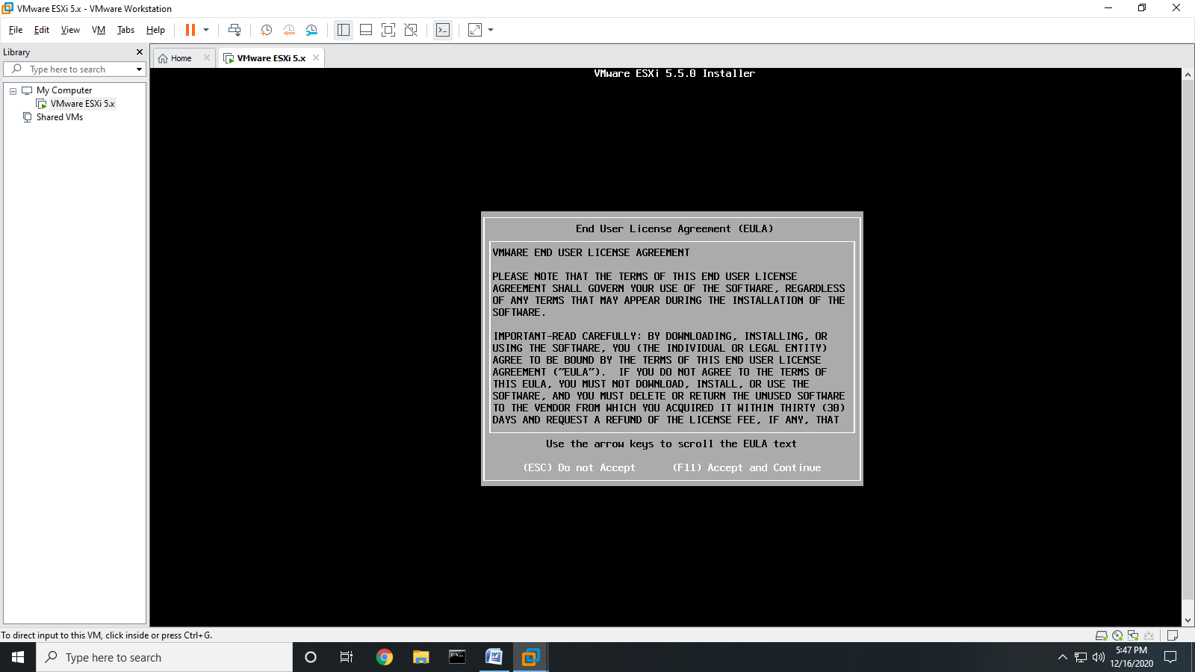

>> Wait until finish scanning.

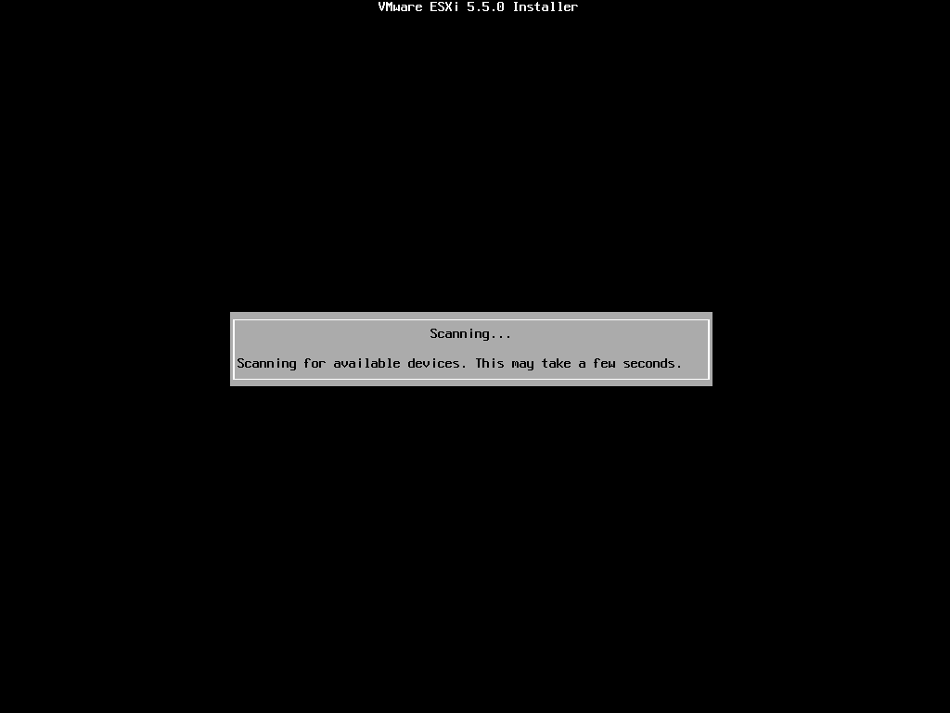

>> Press Enter to Continue.

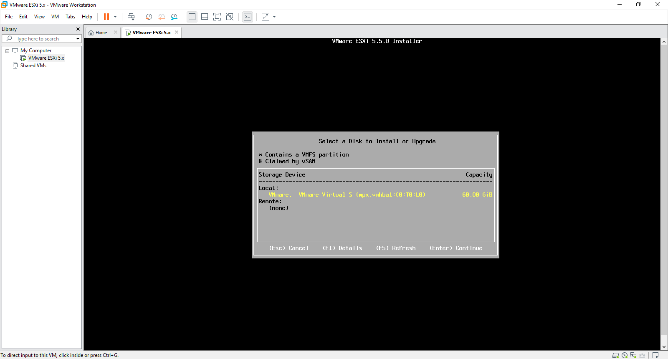

>> Select “**US Default”** and press “**Enter”.**

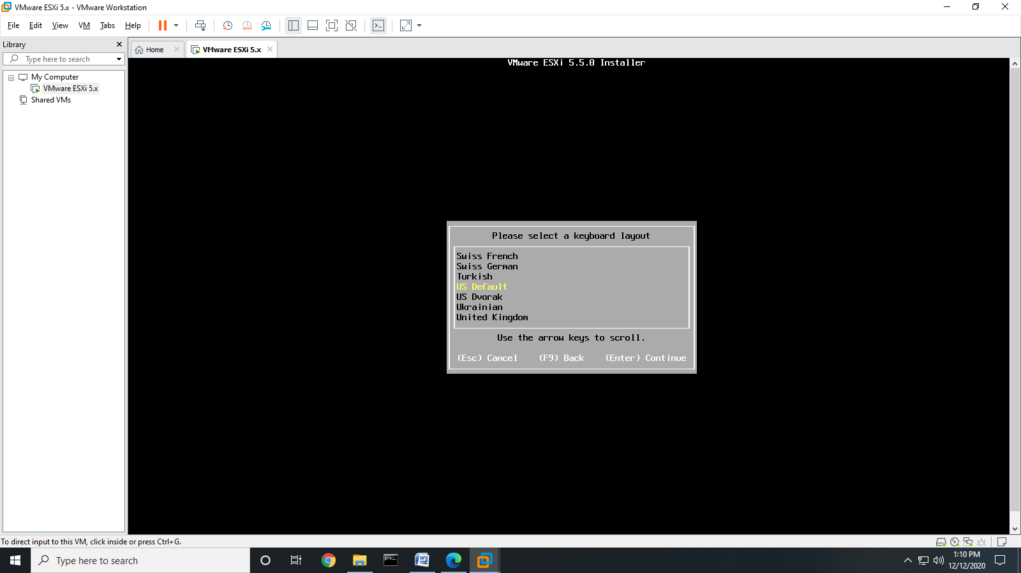

>> Enter the Password “**rjit123**” and press “**Enter**”.

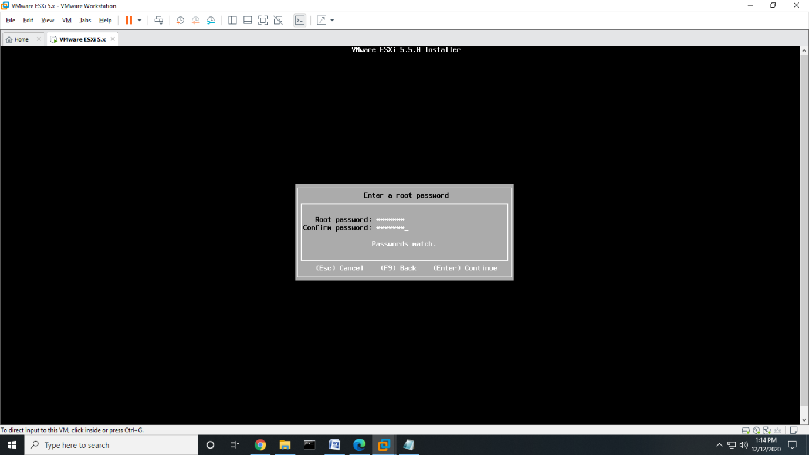

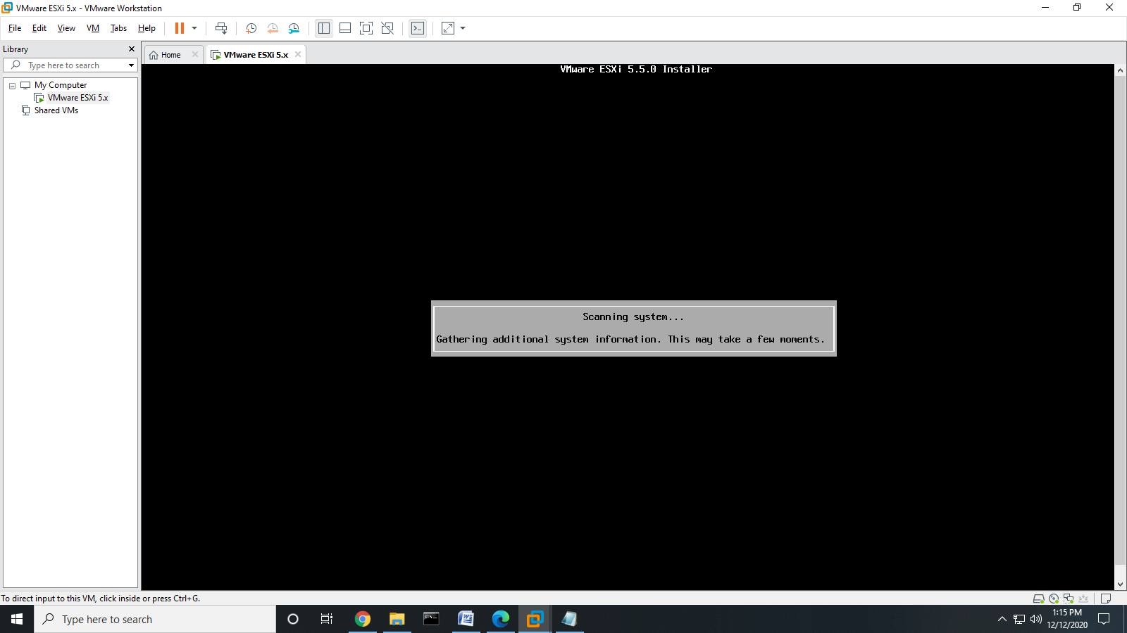

>> Press Function Key 11 “**F11**” to install EX-Si 5.5.8.

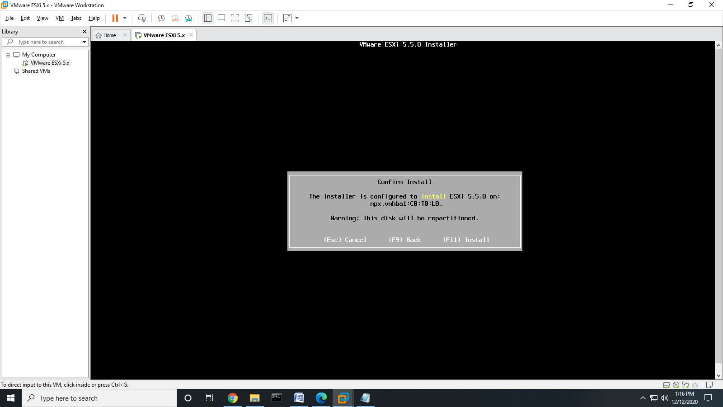

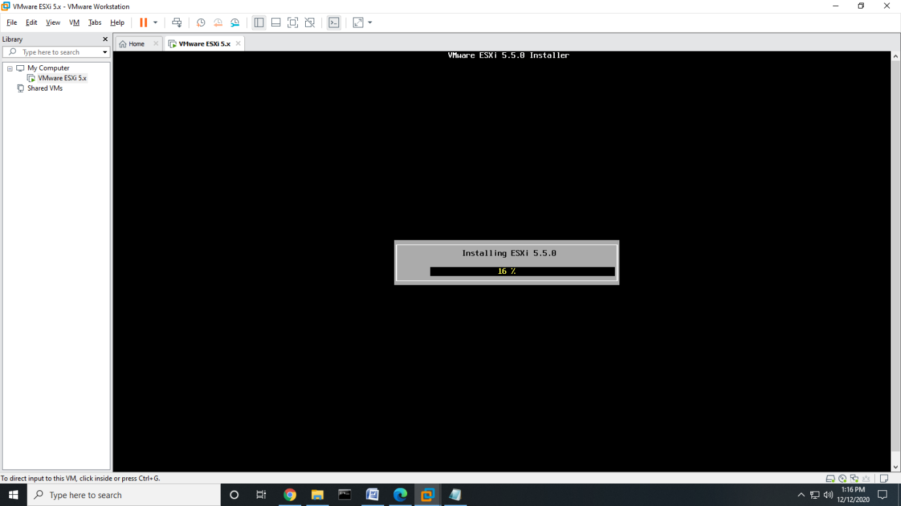

>> Press “**Enter**” to reboot.

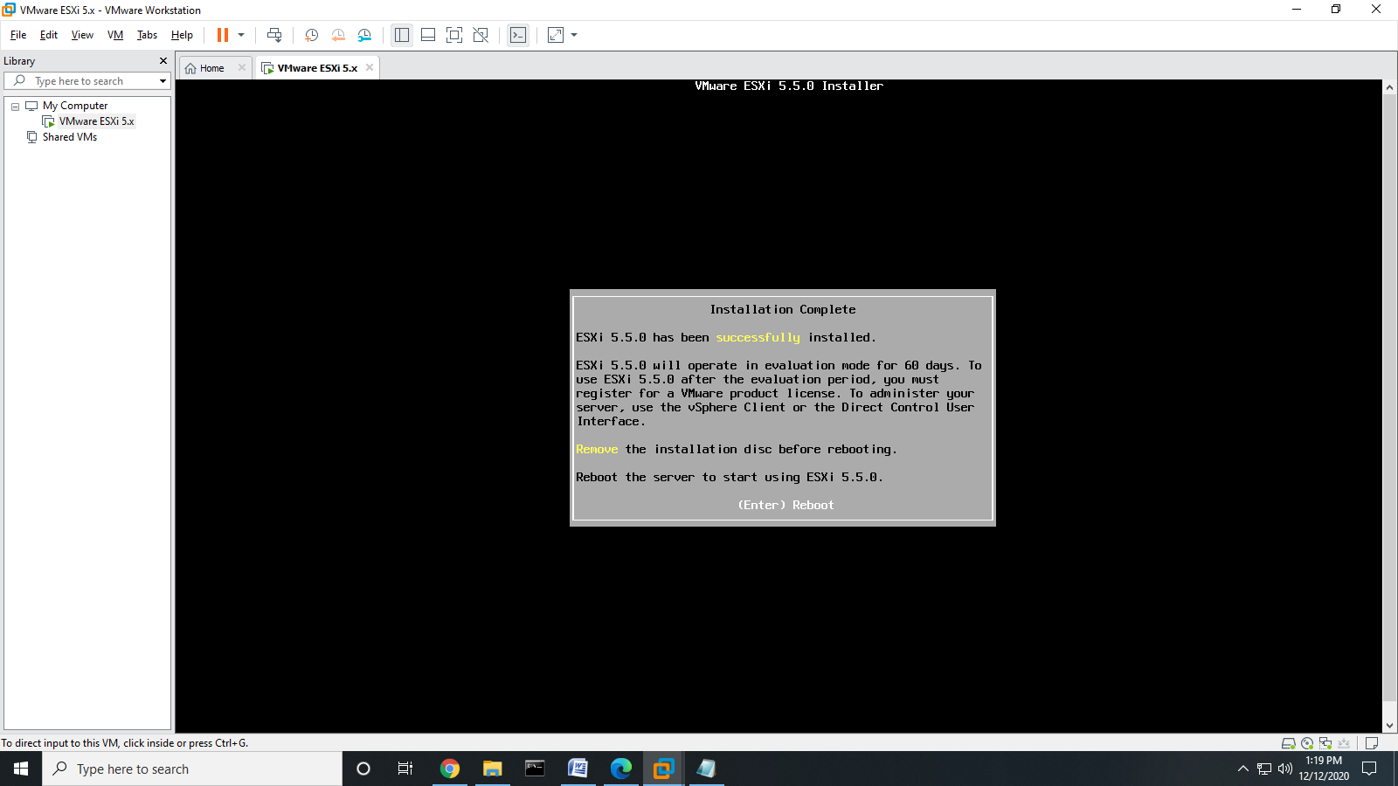

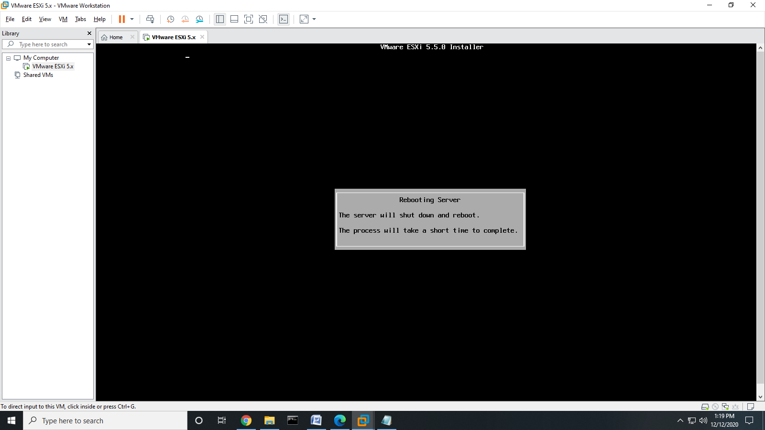

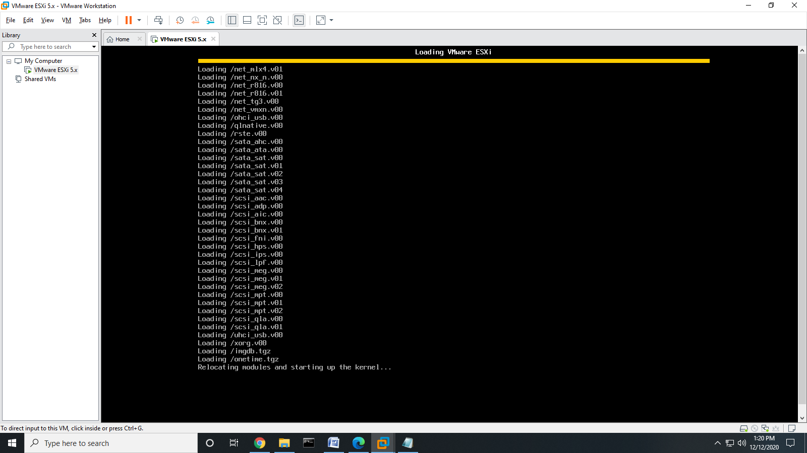

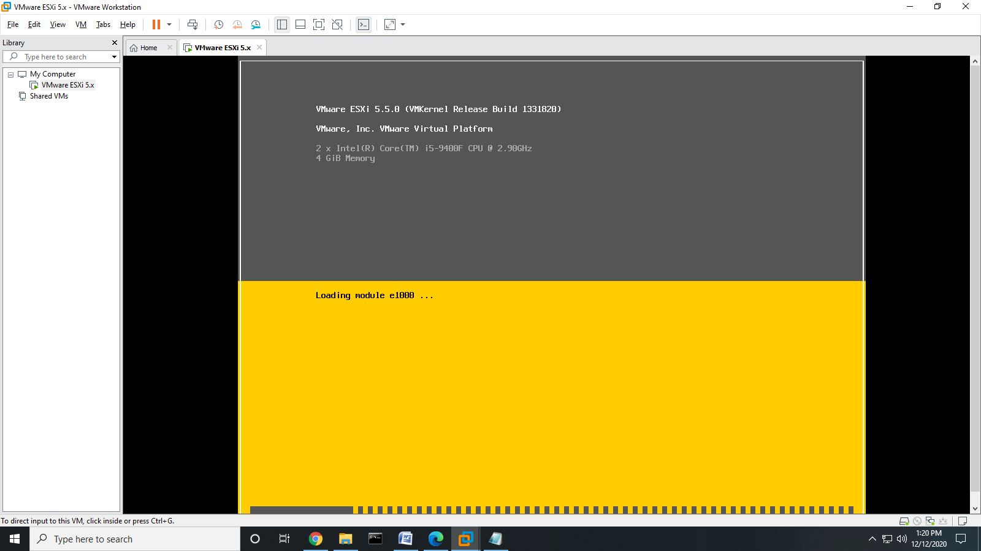

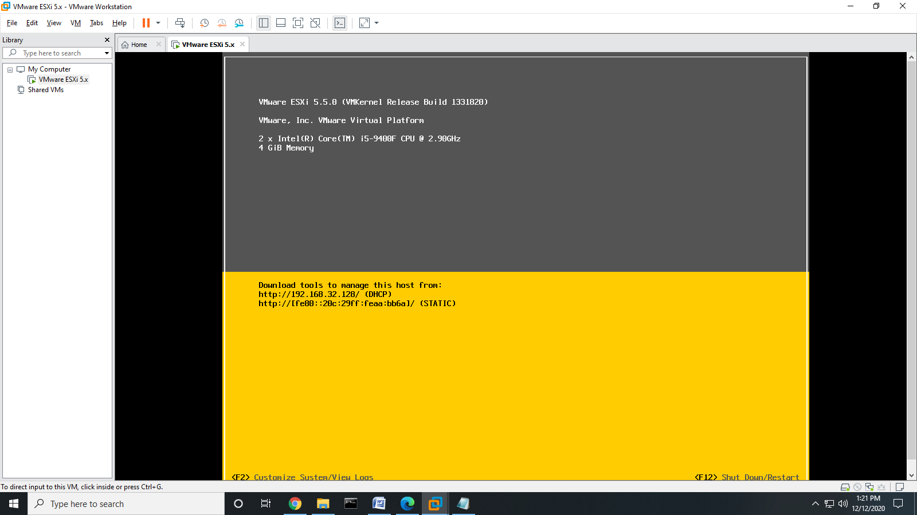

>> Open Browser & type respective IP Address “192.168.32.128”. Click on Advance and Click Proceed to 192.168.32.128.

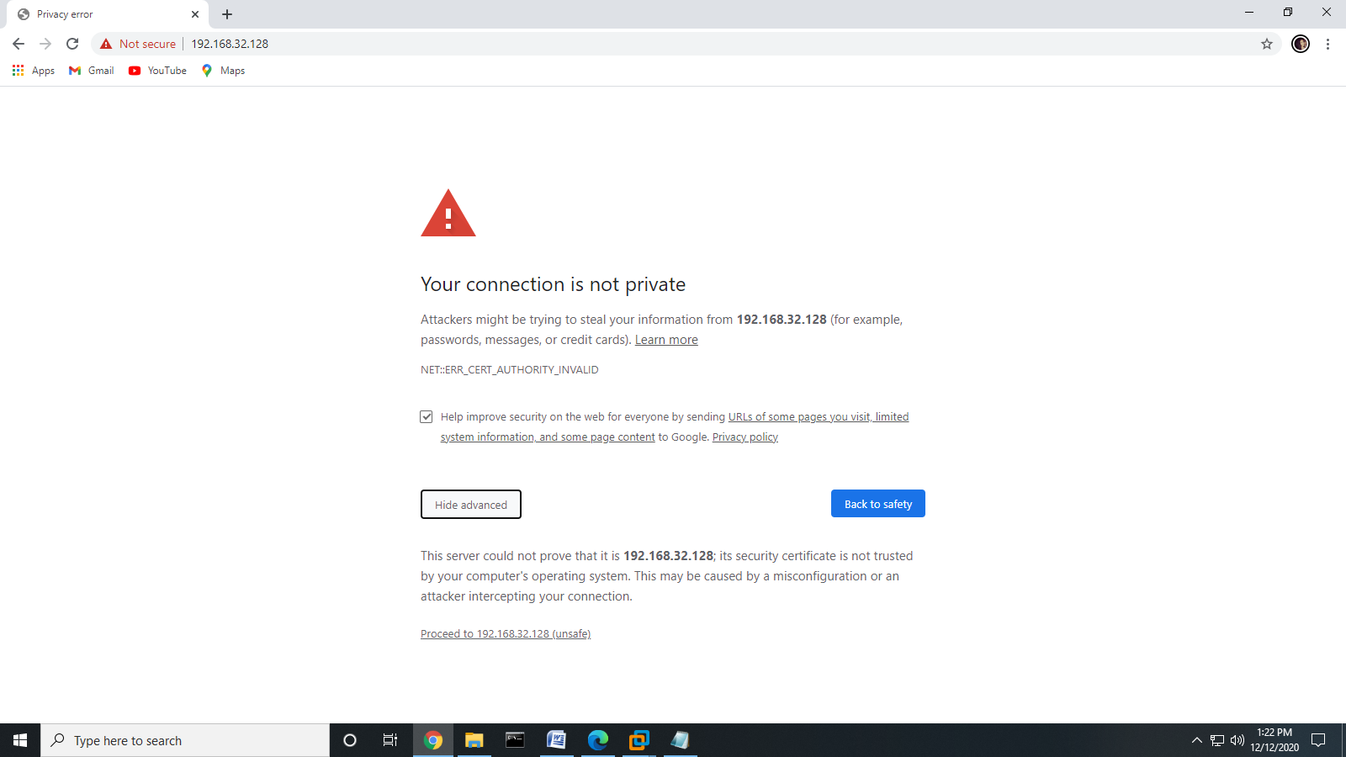

>> Right Click on “**Download vsphere Client**” and select Open in new tab. This will download the file instantly.

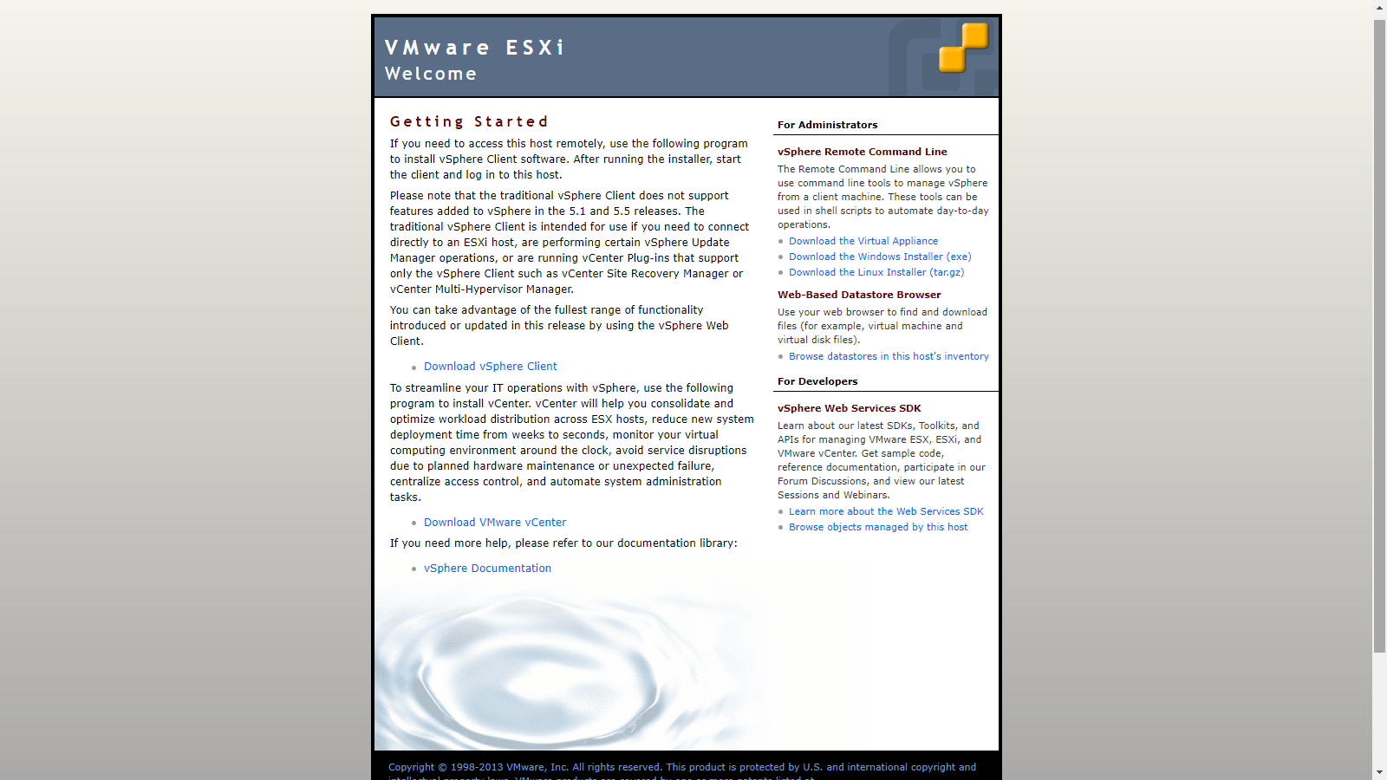

>> Go to downloads Folder and install by selecting run as administrator.

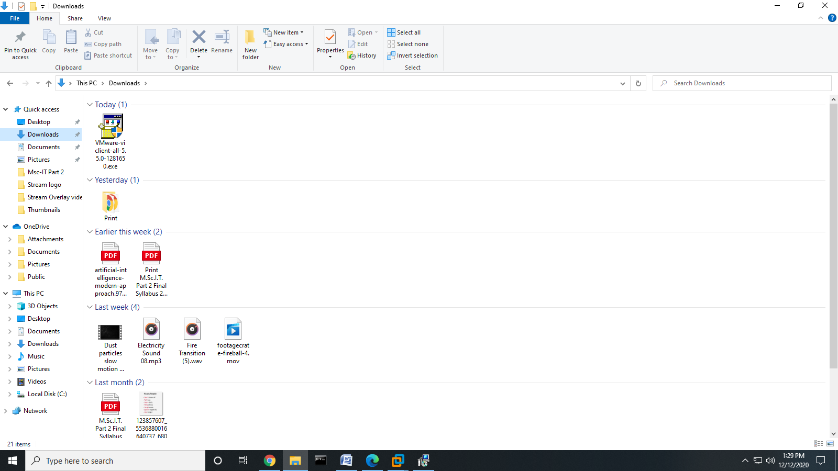

>> Select Language “**English United States**”. Click OK.

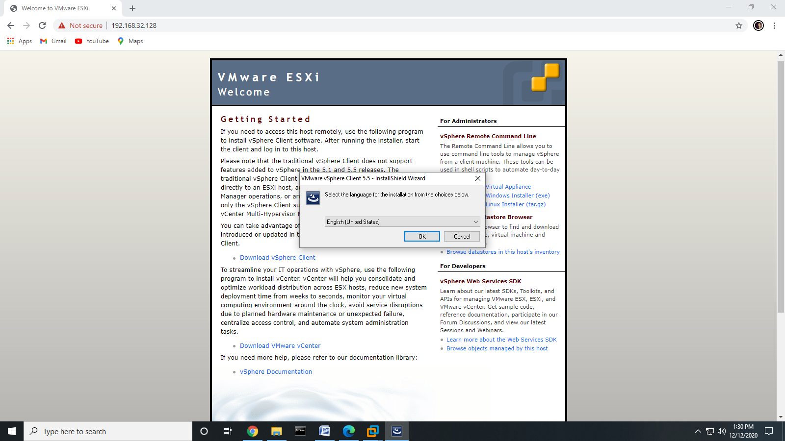

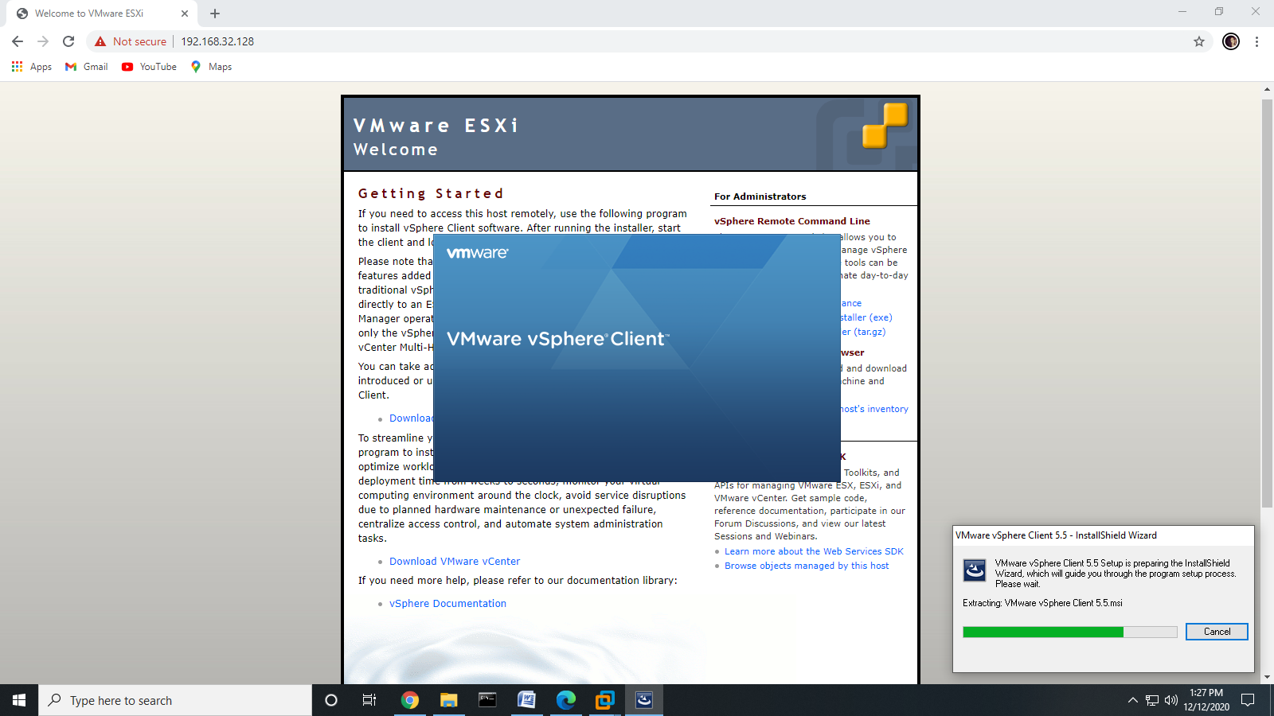

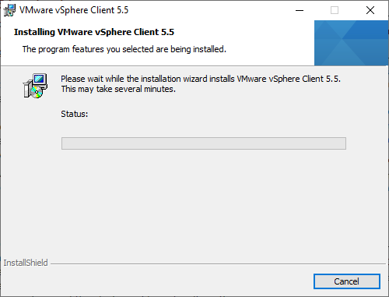

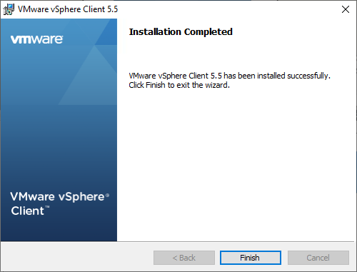

>> Open VMware vSphere Client

* Enter IP address (Which was assigned dynamically) (root)
* Enter Username and Password. (rjit123)

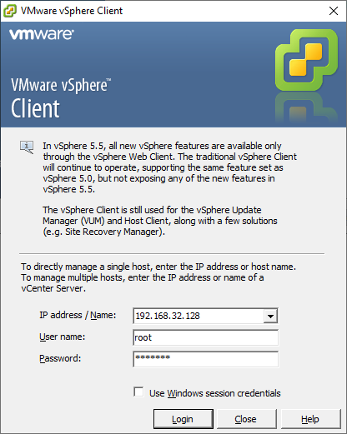

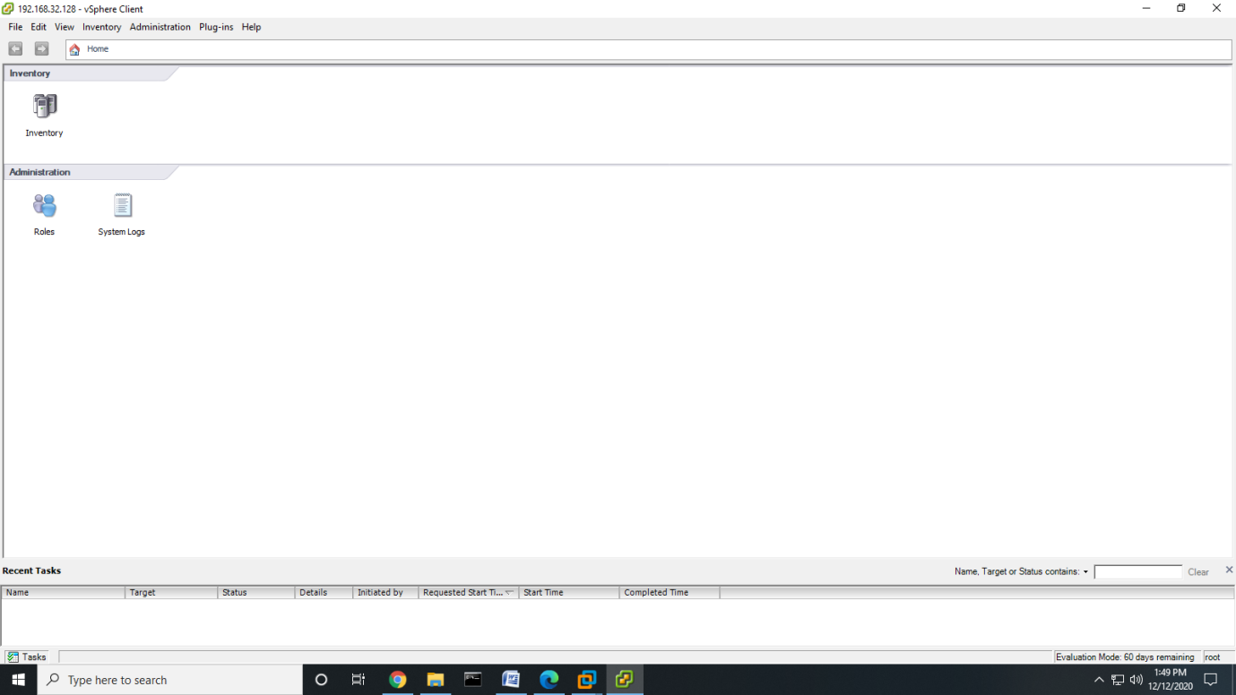

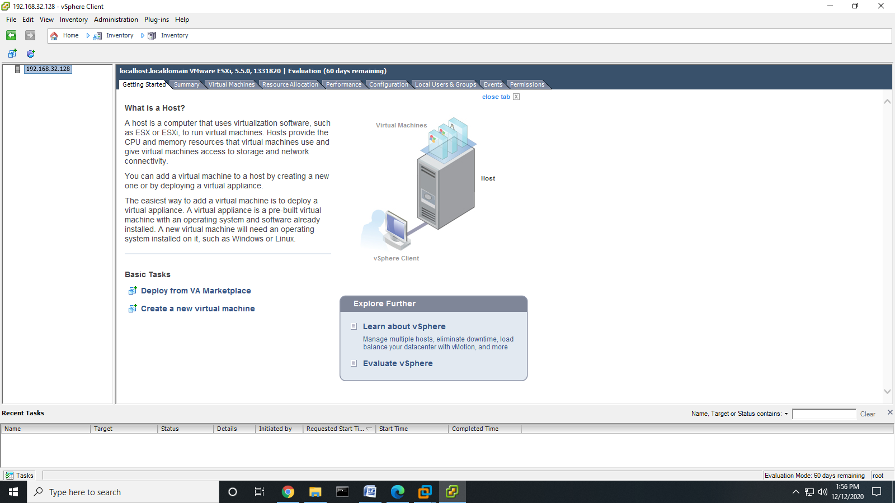

>> Select summary tab.

>> In Storage section, Select on datastore1 and Right-click on Browse Datastore to add iso image of Windows XP in Datastore.

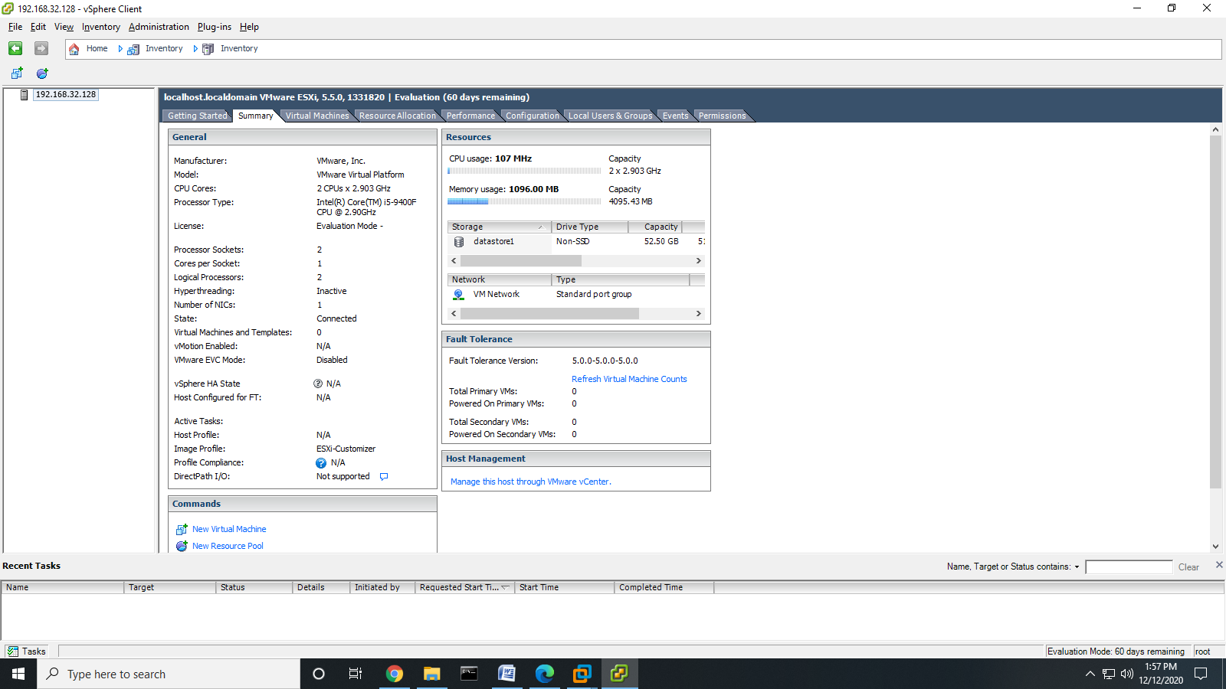

>> Click on Upload Icon and Select Upload File.

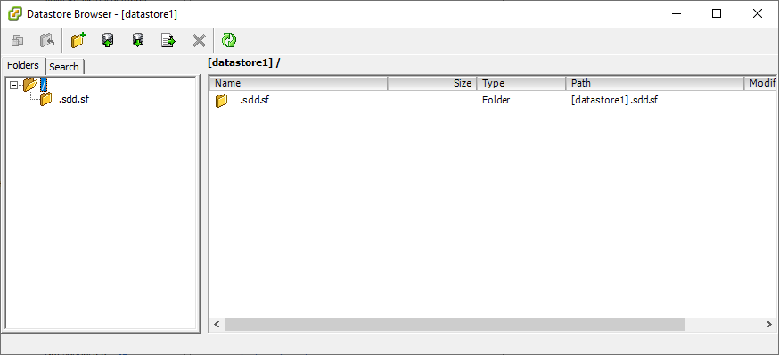

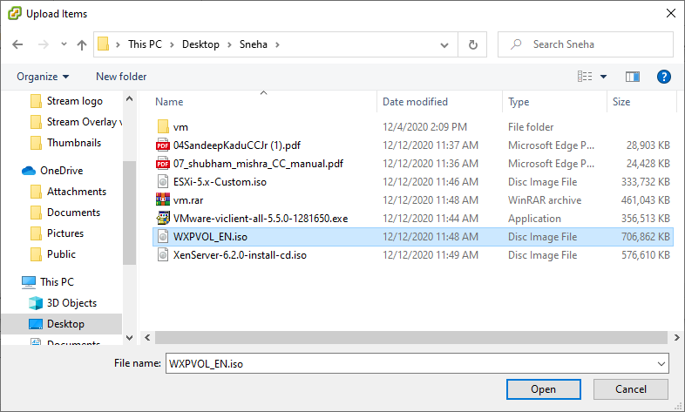

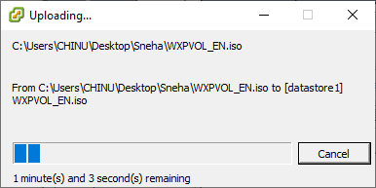

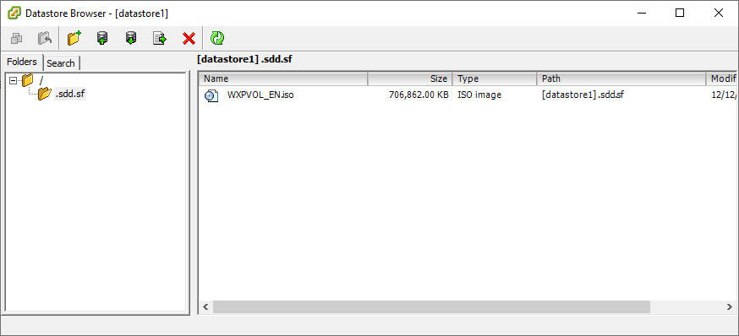

>> Click on File >> New >> Virtual Machine.

>> Configuration : Select Custom configuration.

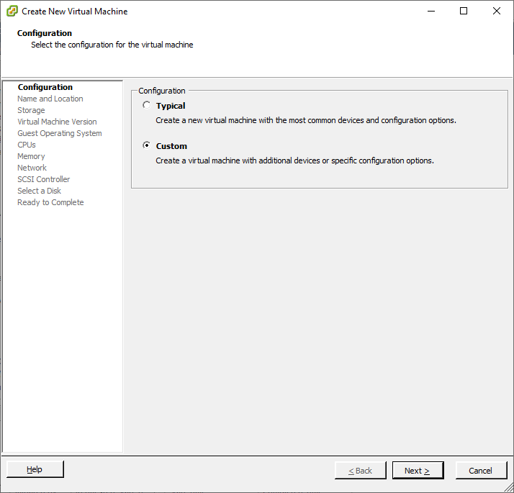

>> Name the file as per Your Requirement. Click Next.

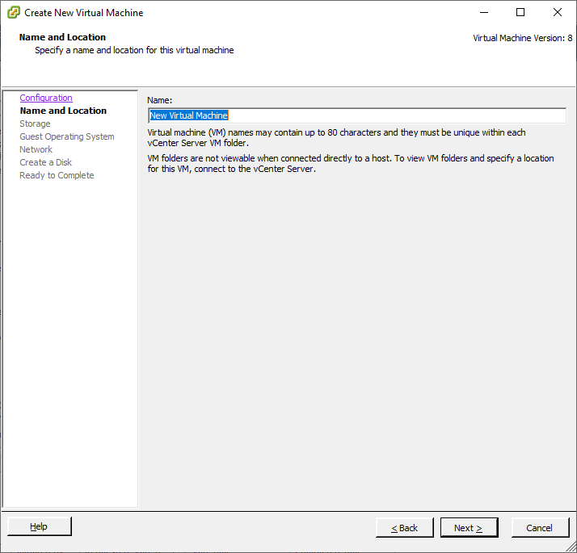

>> Storage: Select datastore1 and click “**Next**”.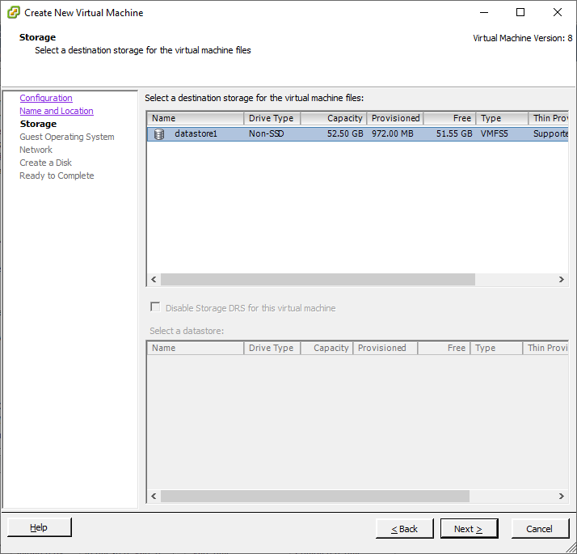

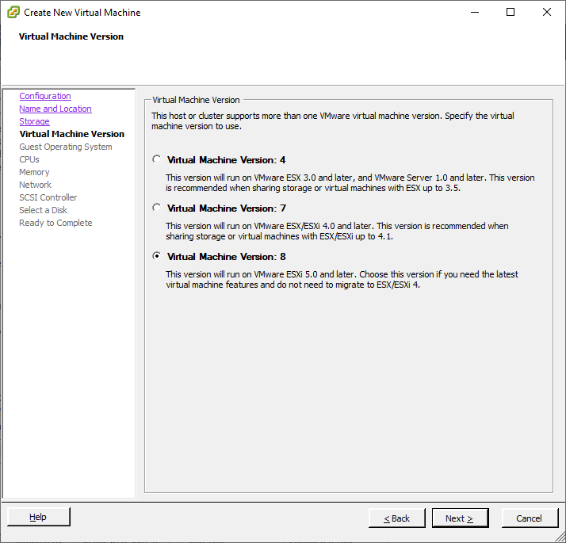

**>> Guest Operating System:** Windows

**Version:** Microsoft windows XP Professional (32-bit)

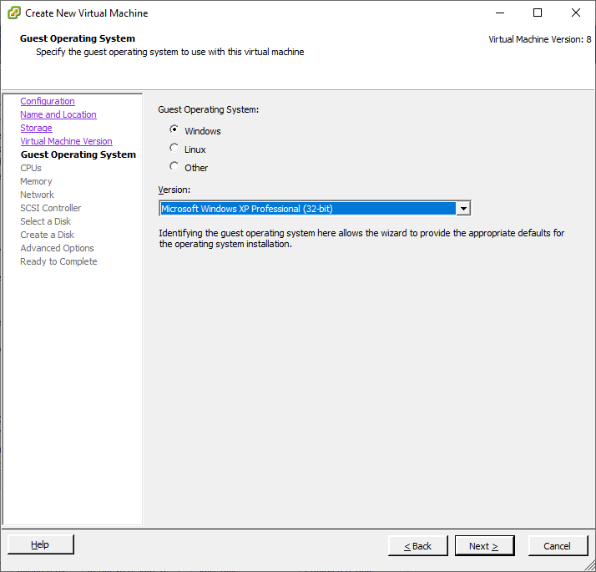

**CPUs:**

>> Number of virtual sockets: 1

Number of cores per virtual socket: 1

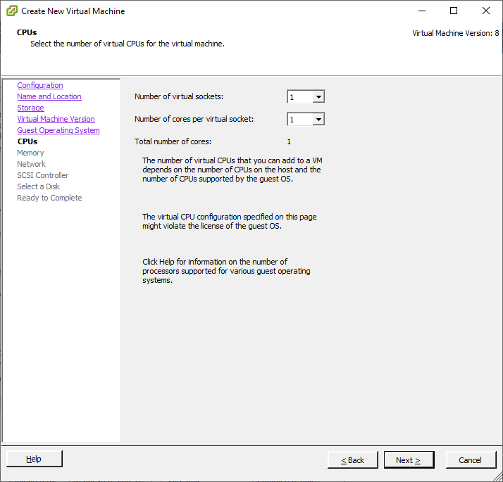

**>> Memory:** 1 GB

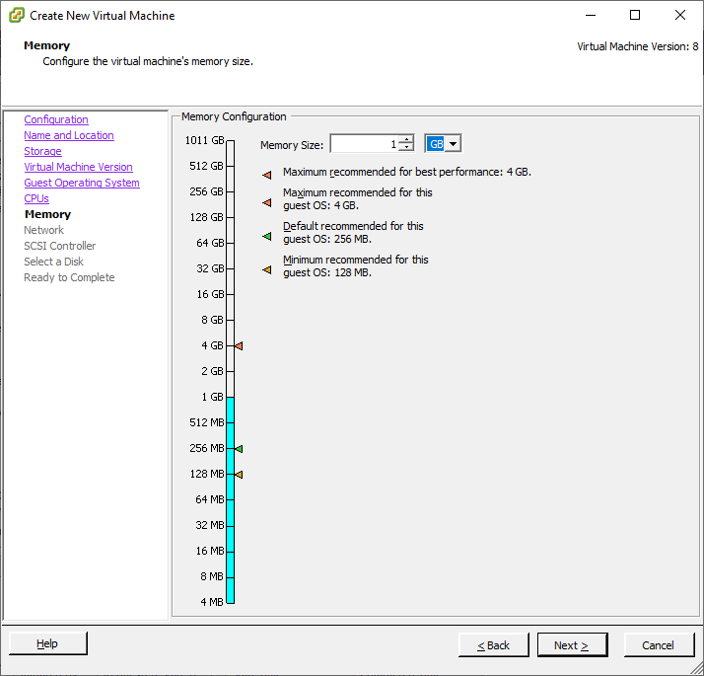

**>> NICs:** Number of NICs : 1

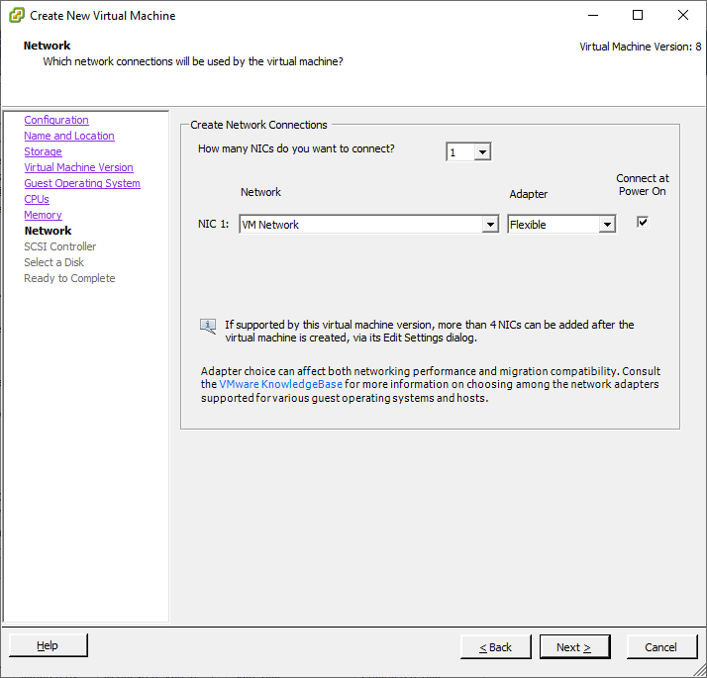

**>> SCSI Controller:** VMware Paravirtual

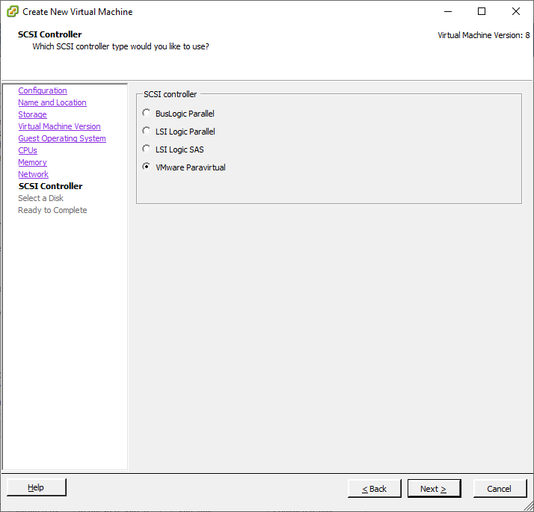

**Select a Disk:** Create a new virtual disk.

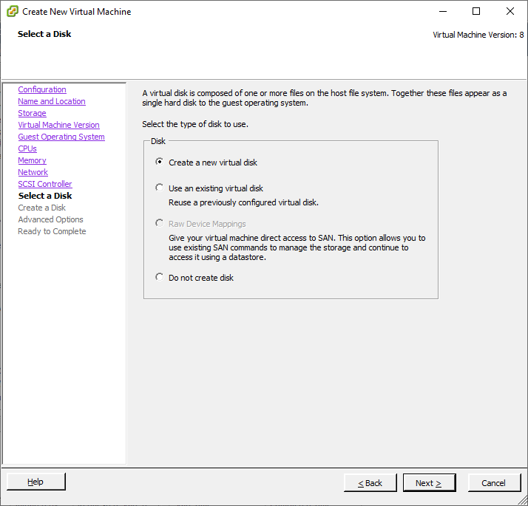

**>> Disk Provisioning:** Select Thin Provision.

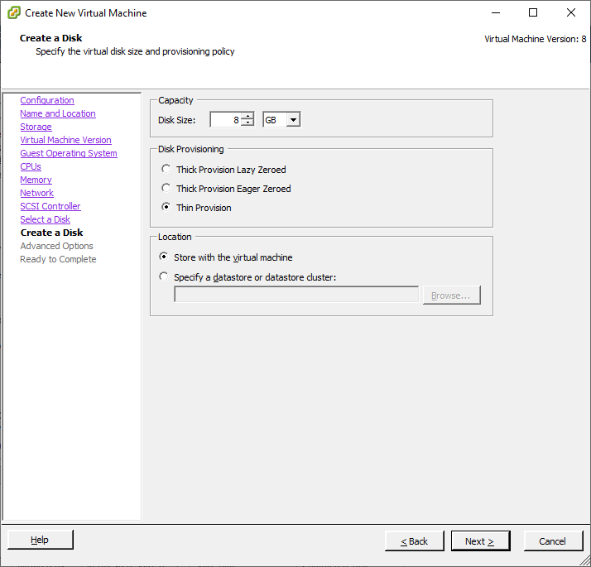

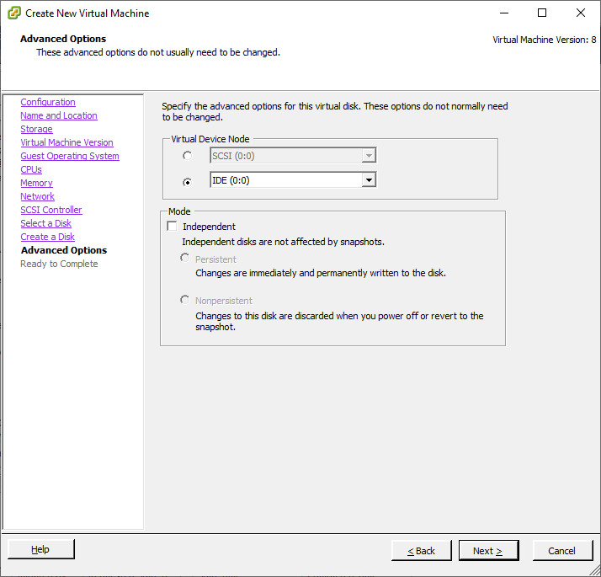

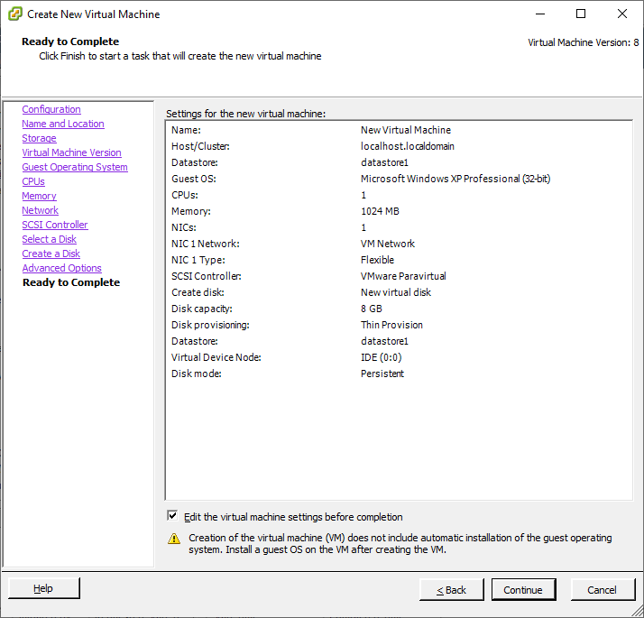

>> Go to New CD/DVD >> Select Datastore ISO File>> Click Browse >> datastore1 >> WXPVOL_EN.iso. Click OK.

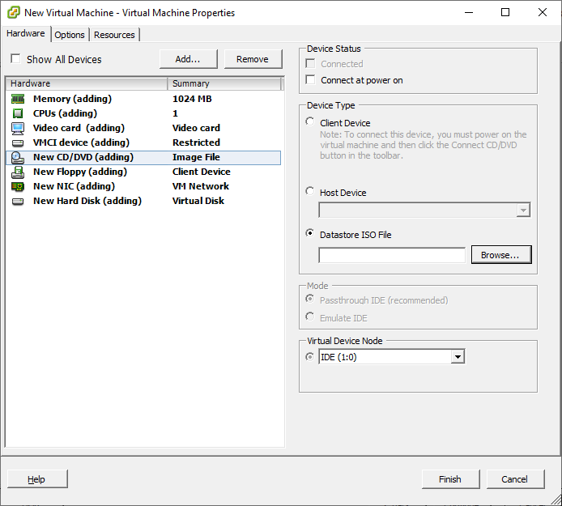

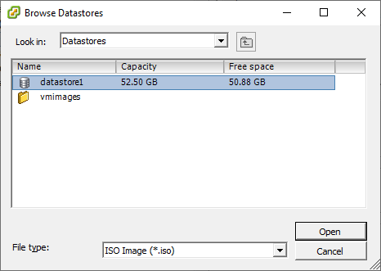

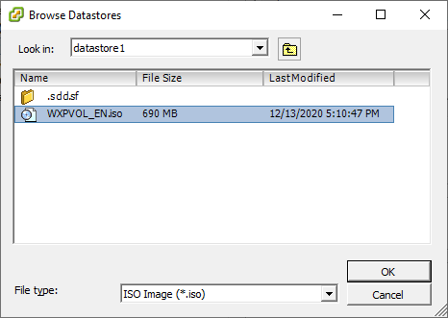

>> Click Check Box Connect at power on.

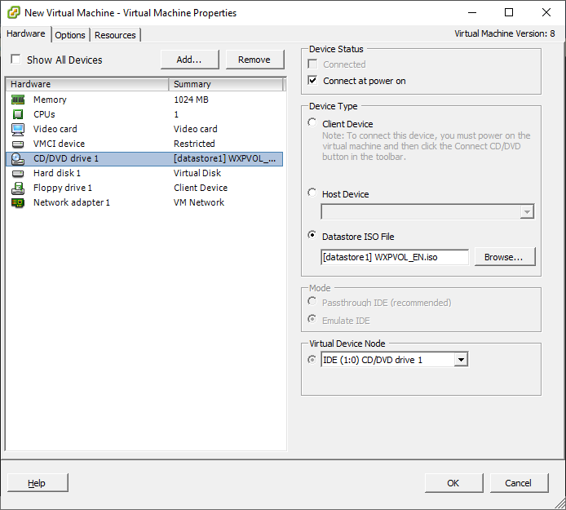

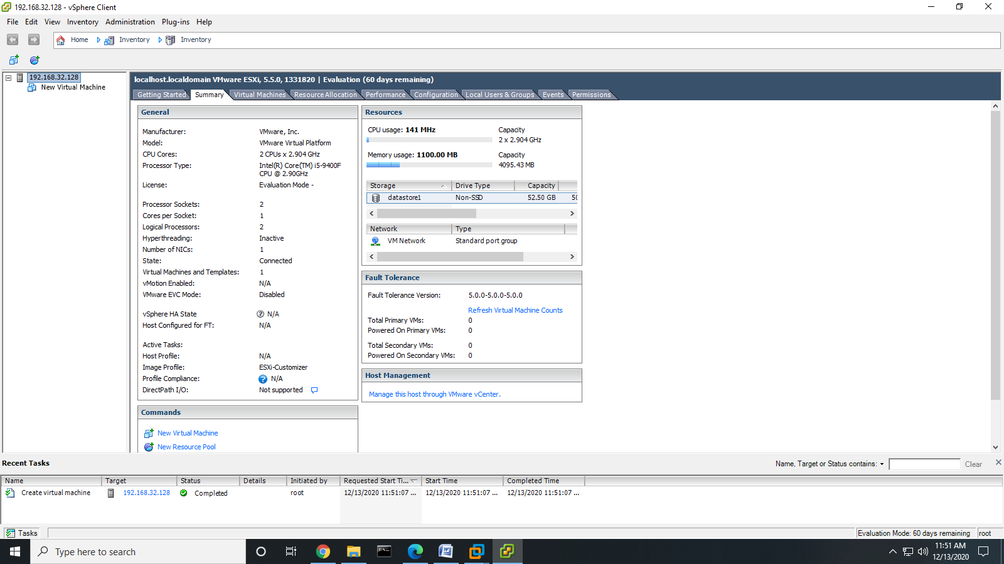

>> Right Click on New Virtual Machine >> Power >> Power On.

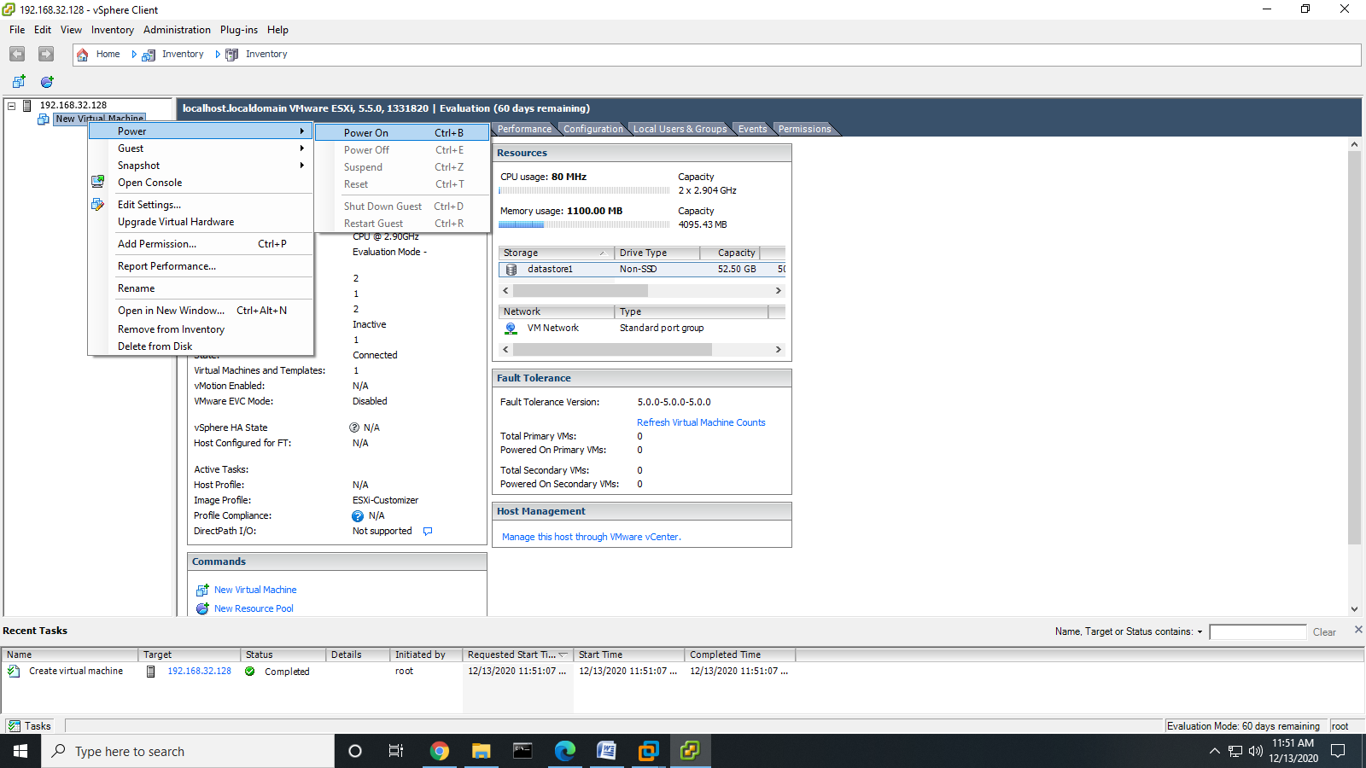

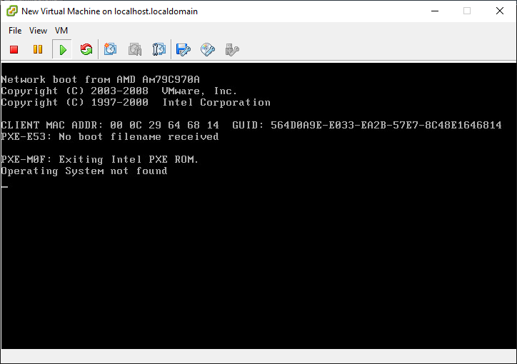

>> If this error occurs then follow the below steps:

>> Solution 1 :

>> Go to connect or disconnect CD/DVD devices of the virtual machine>> CD drive 1>> Connect ISO image file on a database>> Open Database 1>>Select WXPVOL_EN.iso>>Click OK>>Power ON the virtual machine.

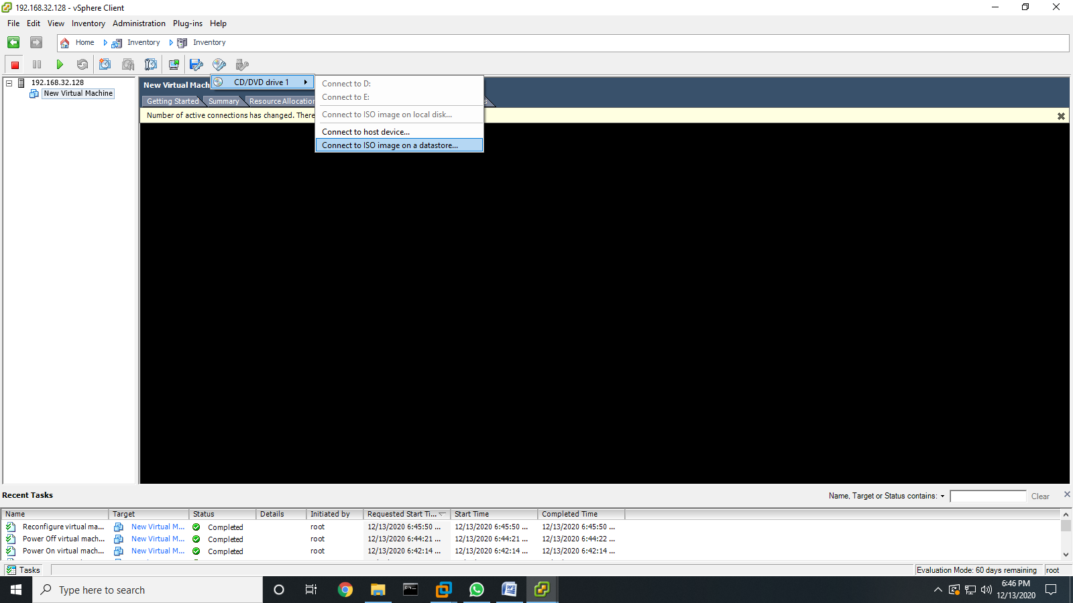

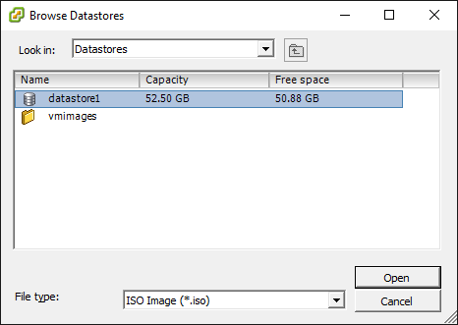

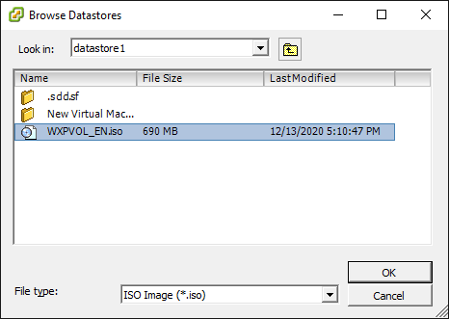

Solution 2 :

>> Perform these steps after Solution 1 doesn’t works.

1. Power off the Virtual Machine.
2. Right Click >> Edit Settings.

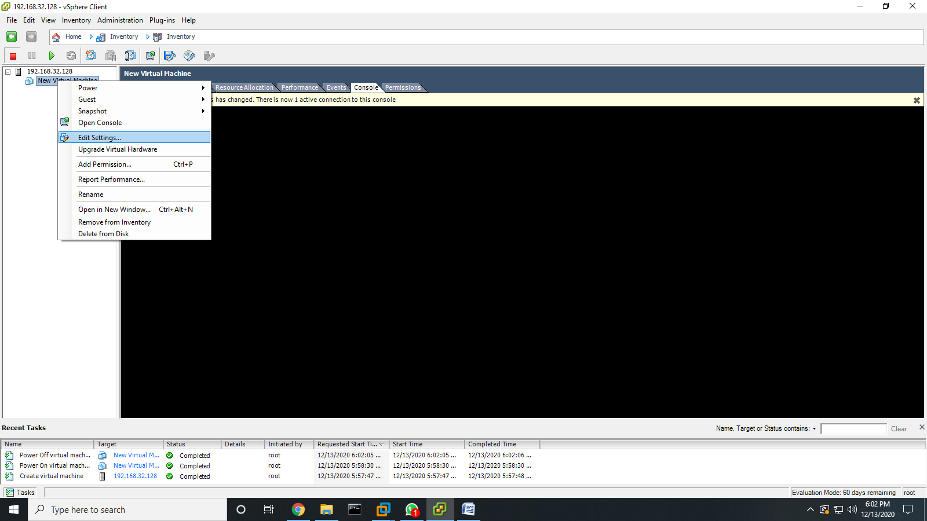

1. Options>>Boot Options.
2. Check The box (✓) Force BIOS Setup and press OK.

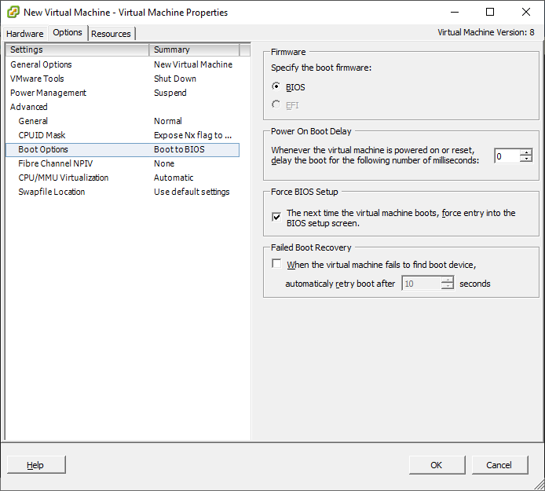

1. Power on the Virtual Machine.
2. Boot Menu will appear.

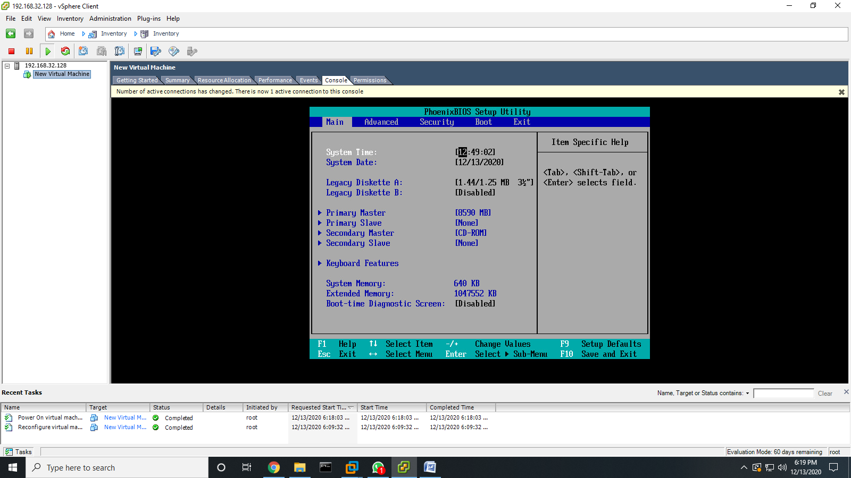

1. Go to Boot option using arrow keys.
2. Go to CD-ROM Drive and click the (+) sign option and move it to the top.

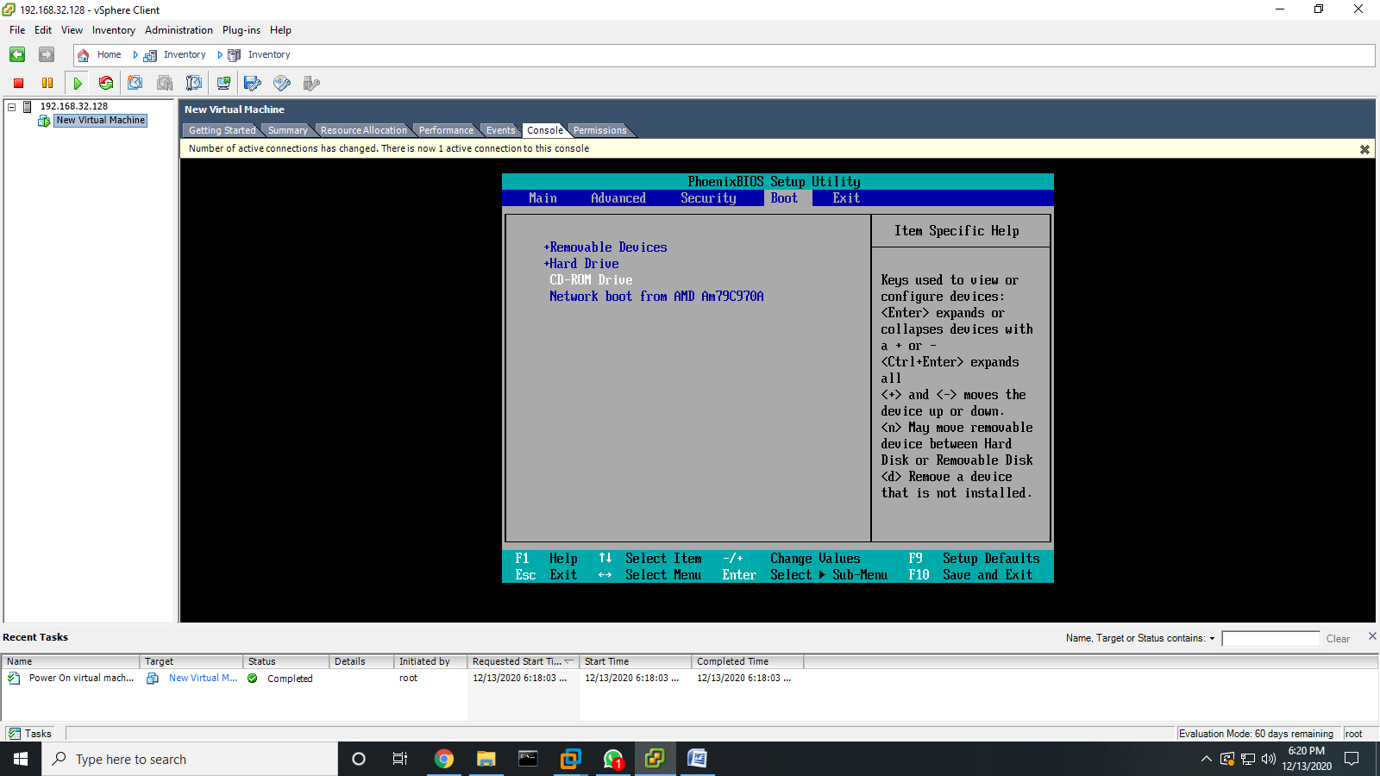

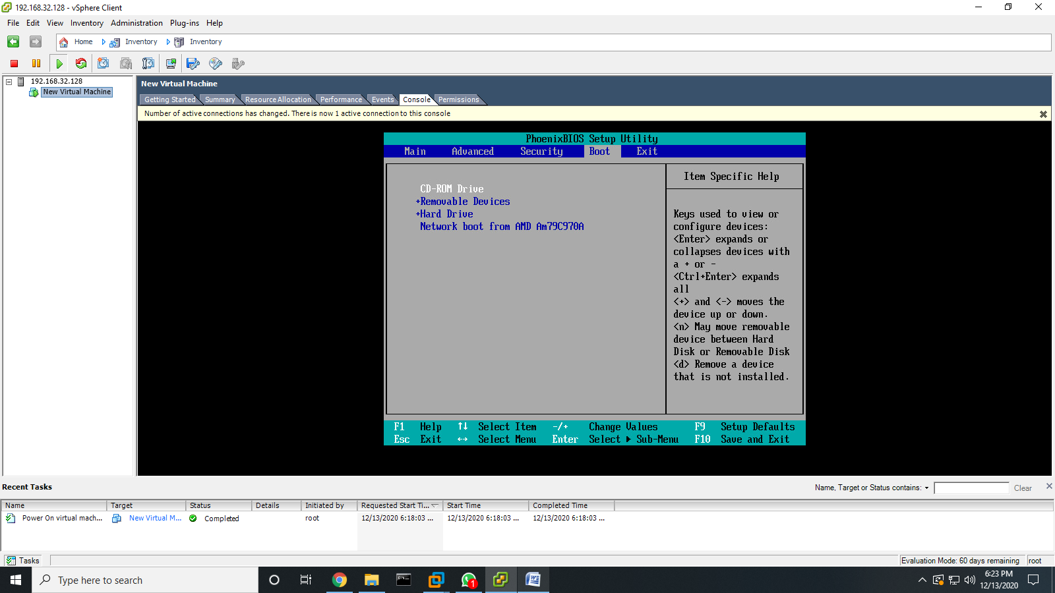

1. Press F10 and Y to save the settings.

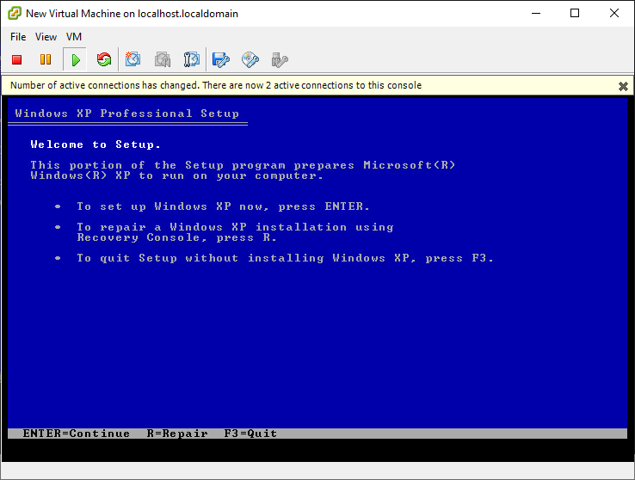

**Practical 6**

**Native Virtualization using Hyper-V**

**What is Hyper - V ?**

**>> Hyper**-**V** is Microsoft's hardware virtualization product. It lets you create and run a software version of a computer, called a virtual machine. **Hyper**-**V** runs each virtual machine in its own isolated space, which means you can run more than one virtual machine on the same hardware at the same time.

**>>** If you have installed VMware workstation or any other virtual machine creator previously and trying to create virtual machine with the help of Hyper-V, you may confront an error - **VMware workstation & Hyper-V are not compatible.**

So, you need to Uninstall VMware workstation or any other virtual machine creator before creating and running virtual machine with the help of Hyper-V and vice versa.

**Steps:**

**>>** Search for **Control Panel** in Windows search bar**.**

**>>** Go to **Programs >> Programs and Features >> Turn Windows Features on or off**

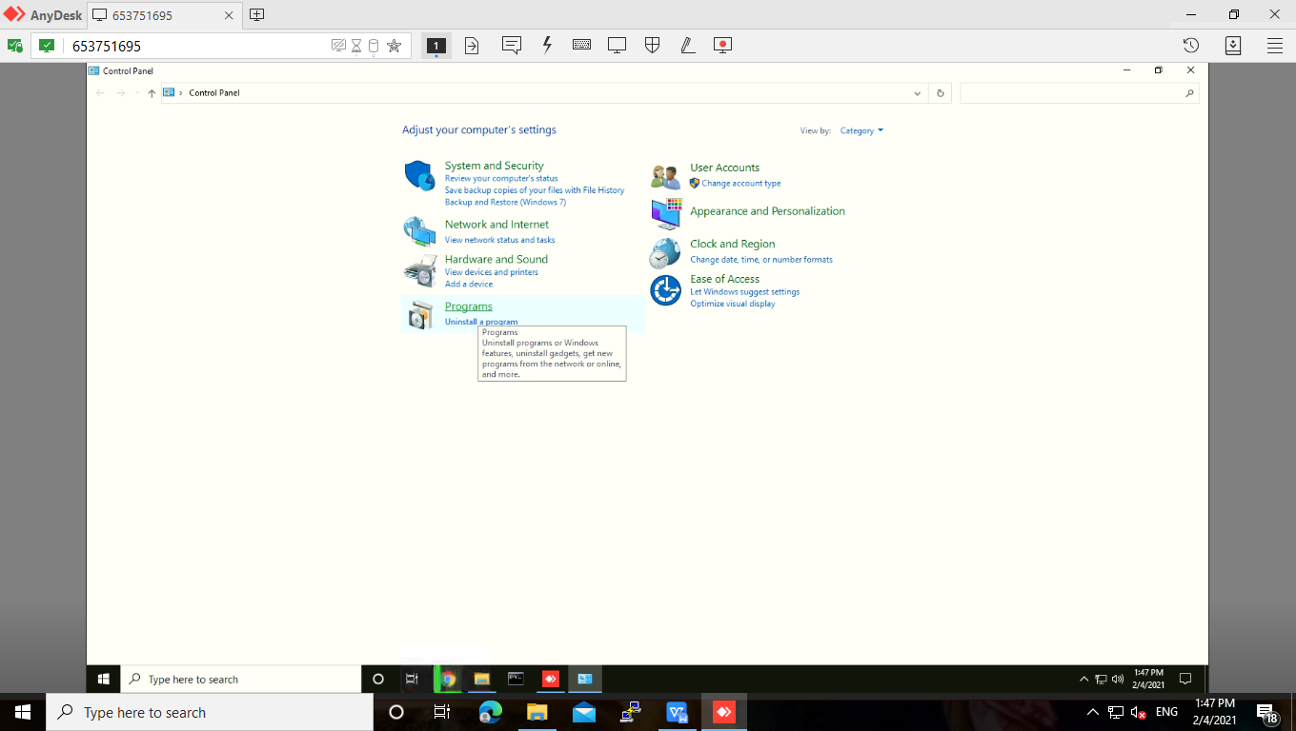

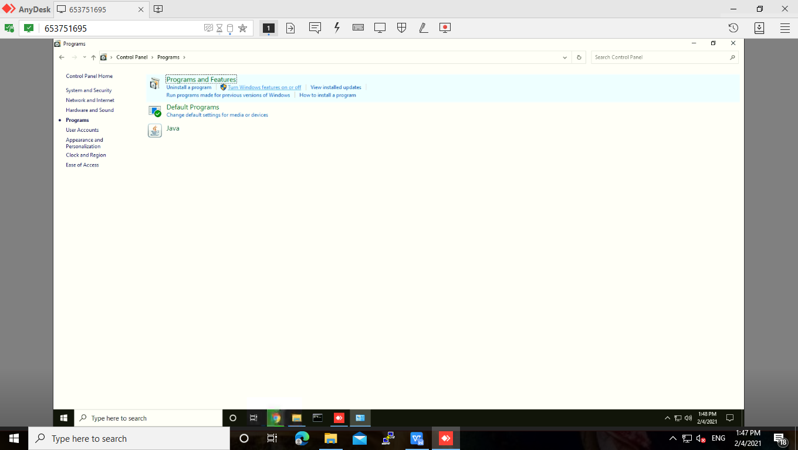

>> Enable the **Hyper-V** option.

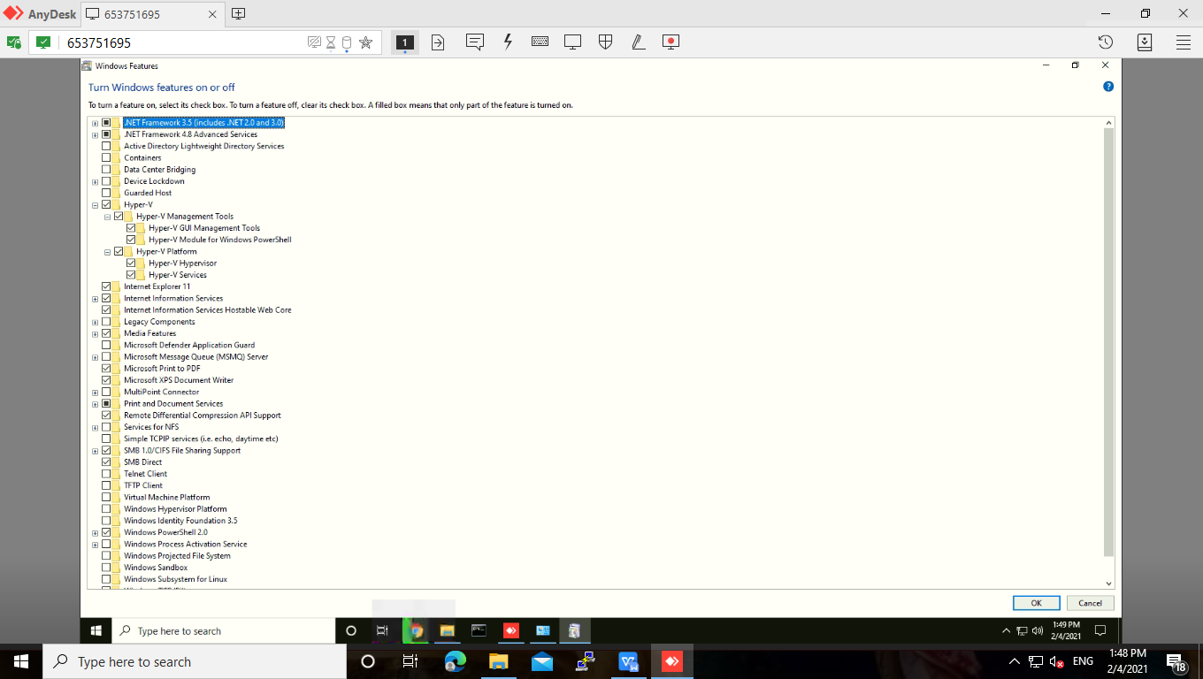

>> Then search for **Hyper-V Manager** in windows search bar. **Run it as an Administrator.**

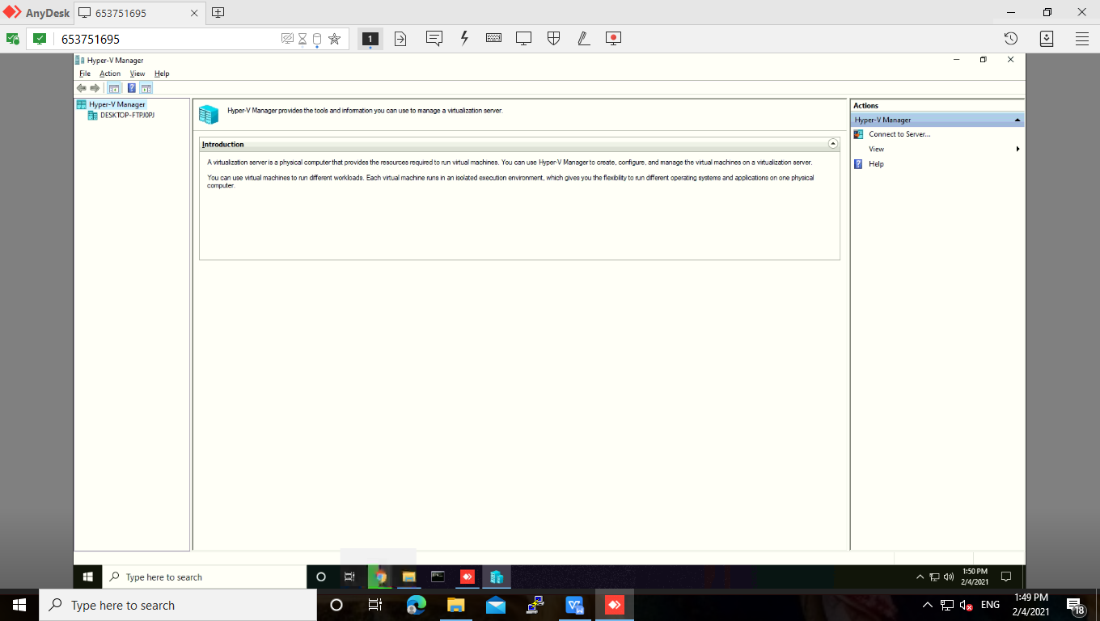

>> For creating virtual machine first we have to create a virtual switch.

>> To create a virtual switch, click on **Virtual Switch Manager.**

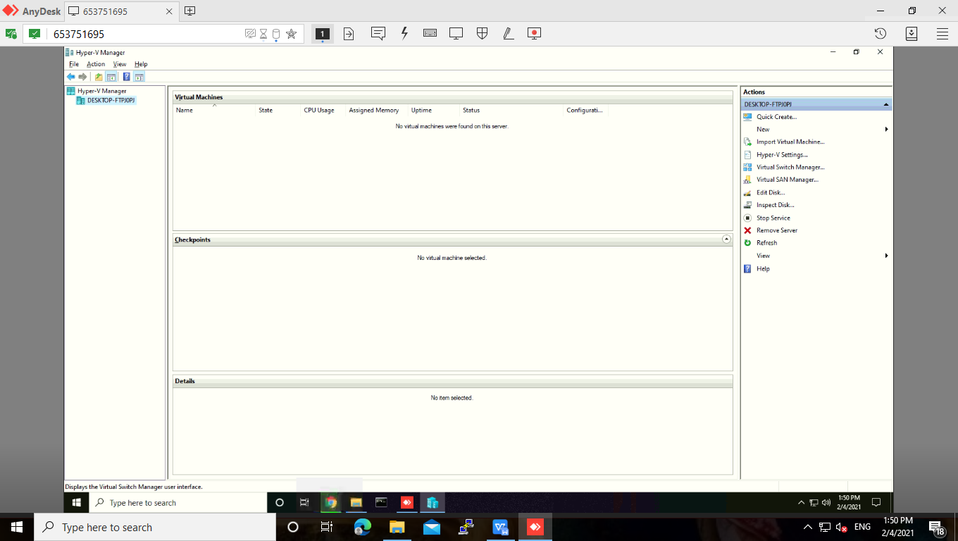

>> Select **External** under **What type of virtual switch do you want to create ?**

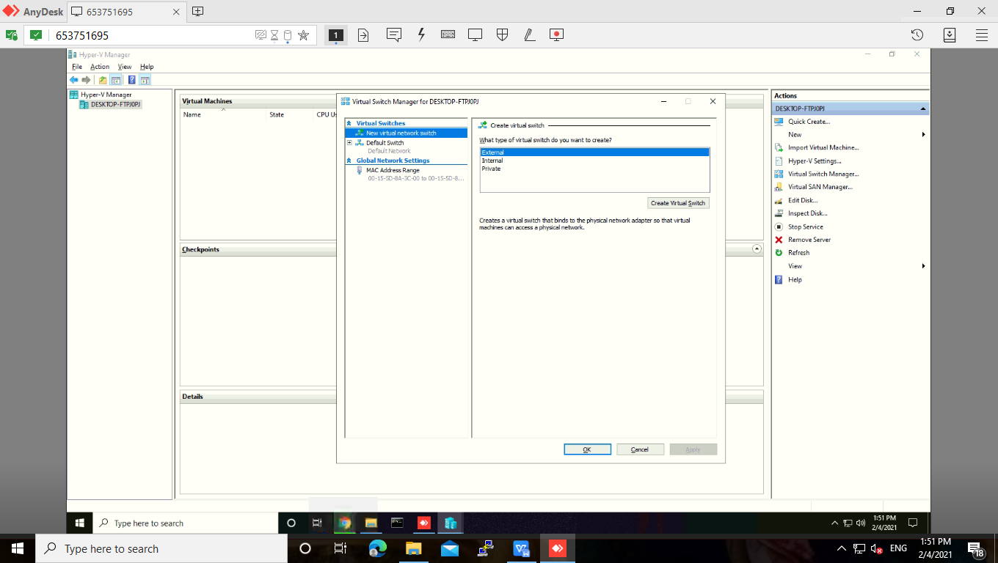

>> Enter name for virtual switch, under virtual switch properties. Then click on **Apply.**

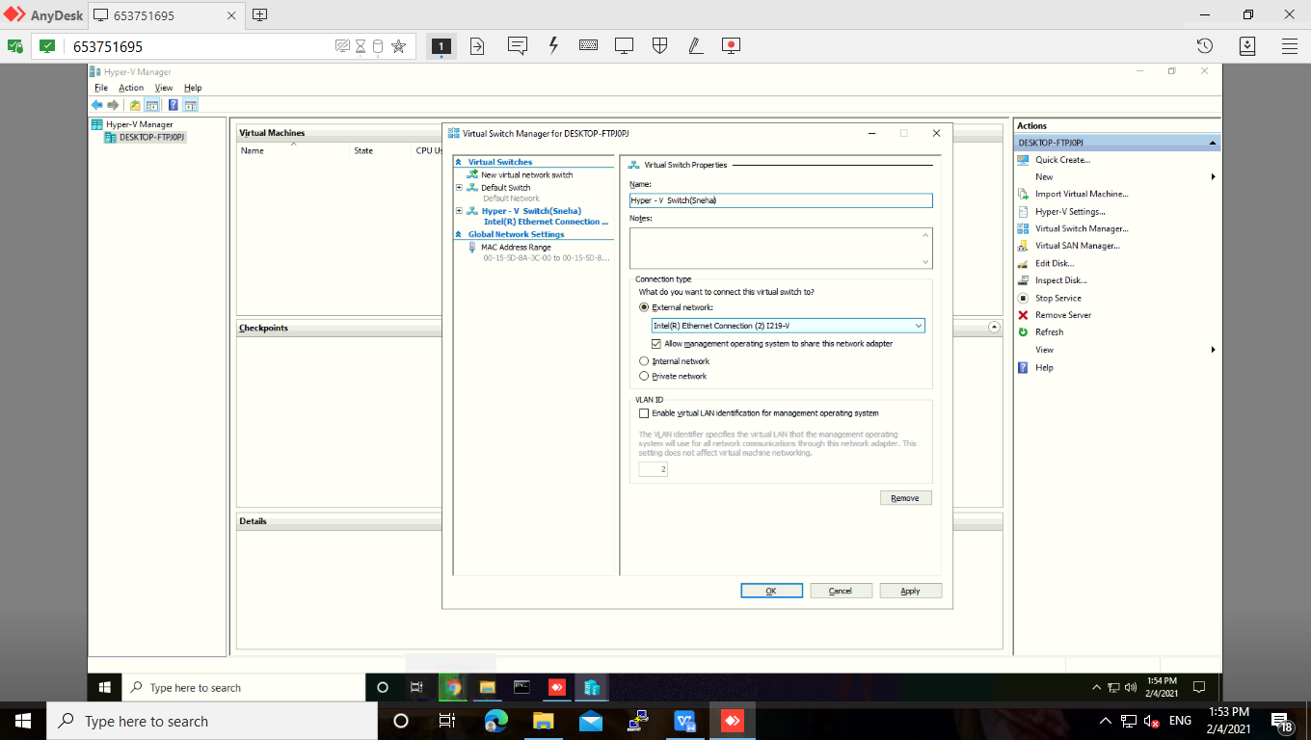

>> The we will get the pop-up as **Apply Networking Changes,** and click on **Yes.**

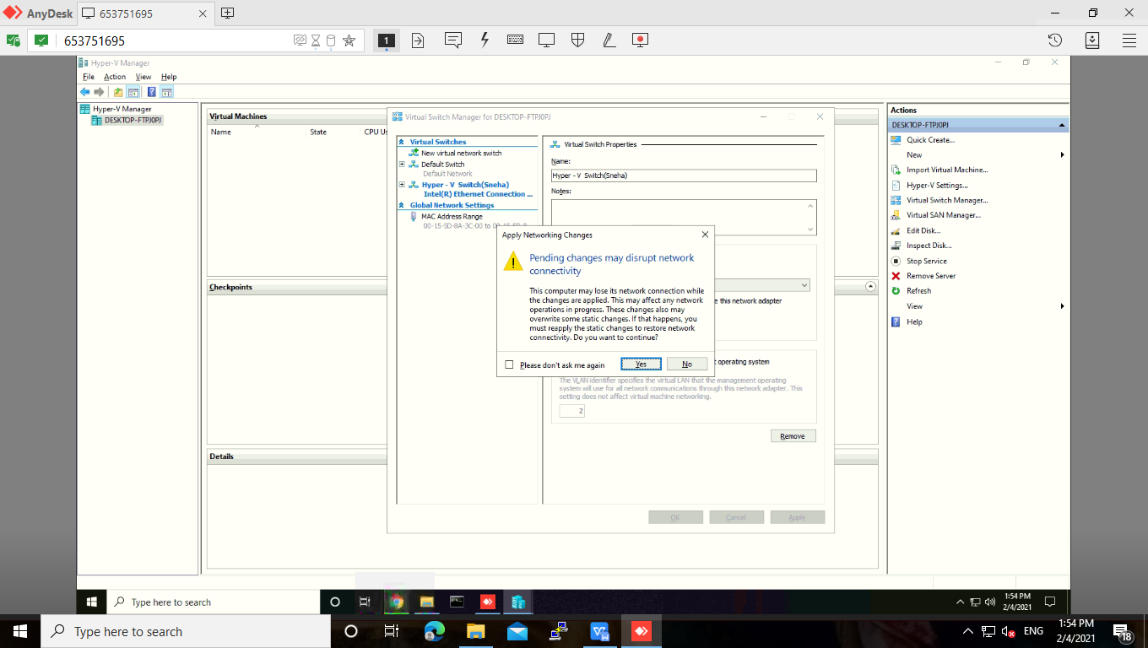

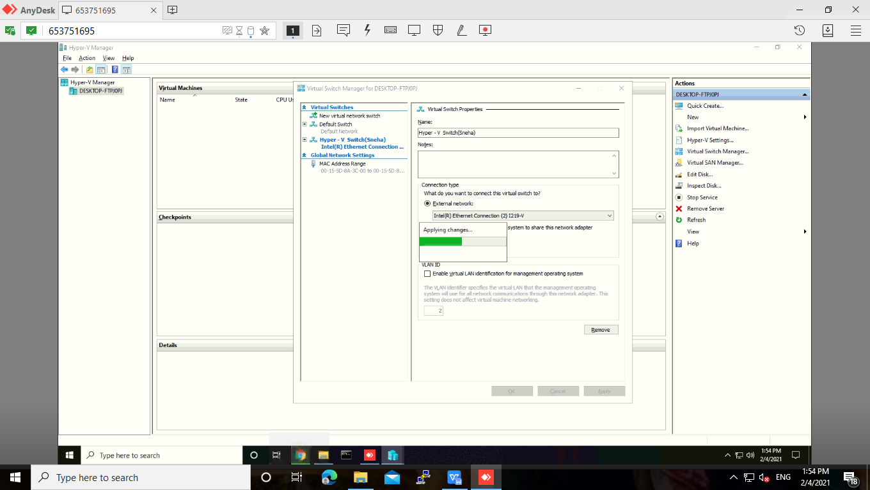

>> Now, right click on Desktop under Hyper-V Manager and select new virtual machine.

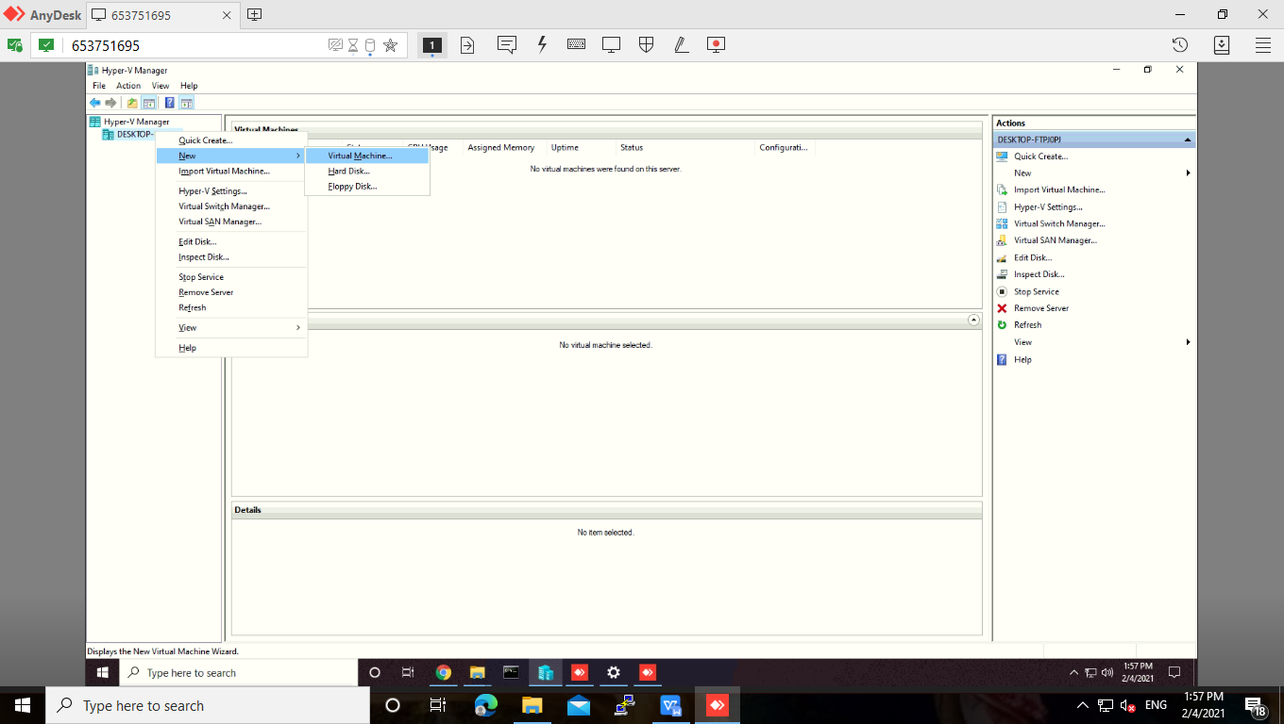

>> Click on **Next.**

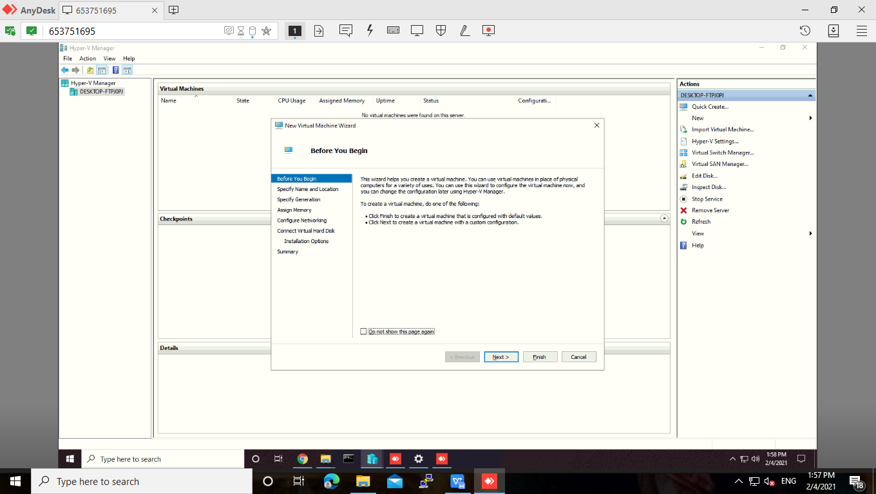

>> Enter a name for virtual machine.

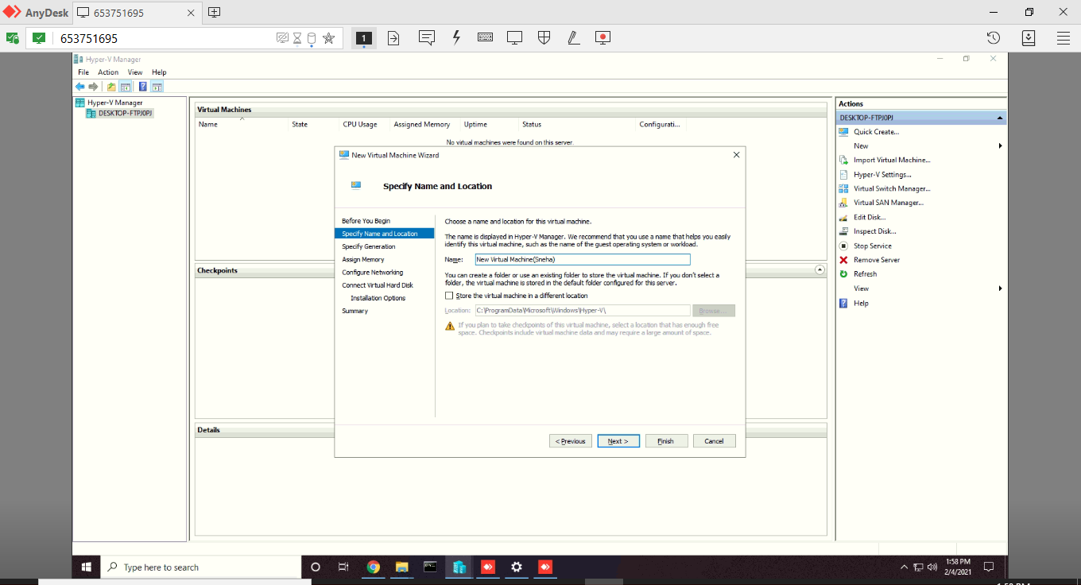

>> Choose the generation of this virtual machine as **Generation 1.**

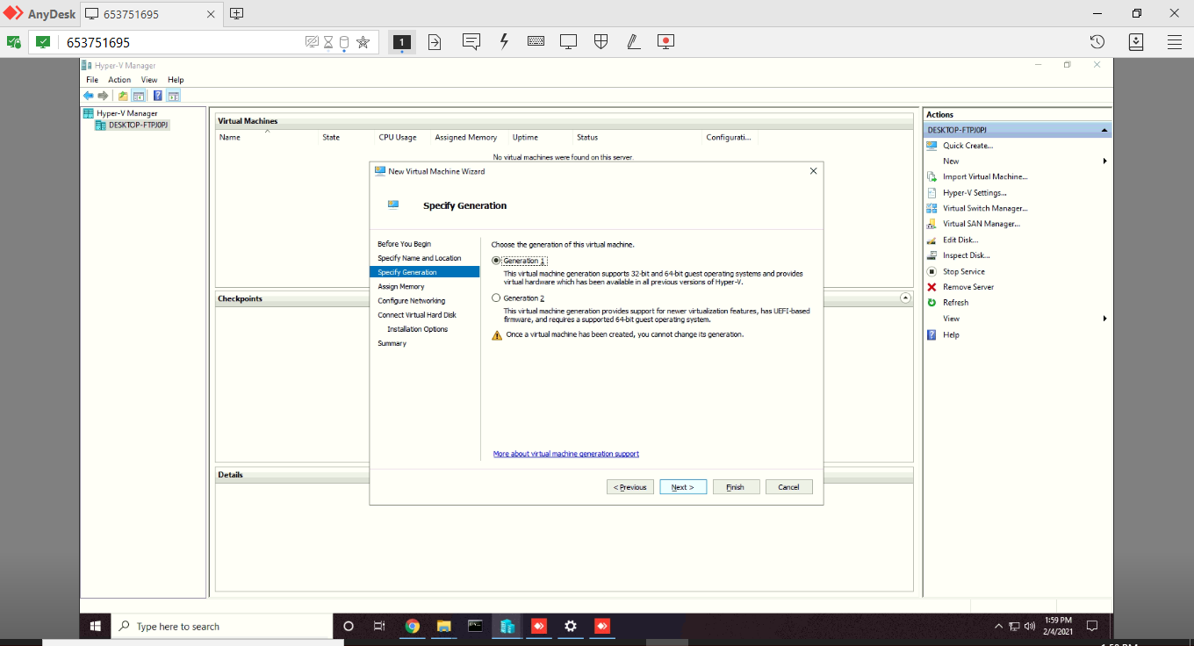

>> Tick on **Use Dynamic Memory for this virtual Machine**, and click on **Next.**

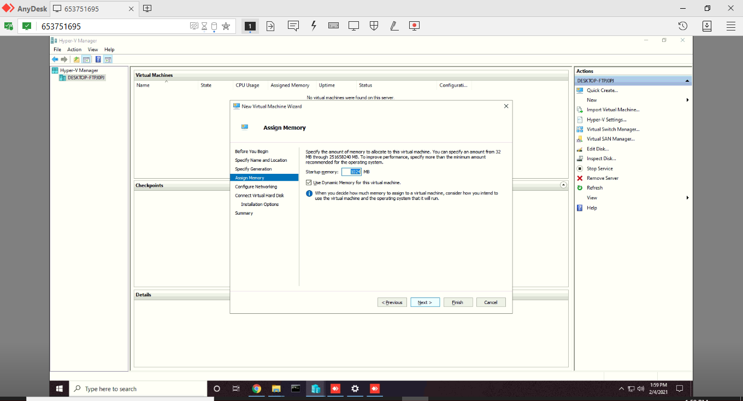

>> Choose the virtual switch that you have created under the Connection dropdown list.

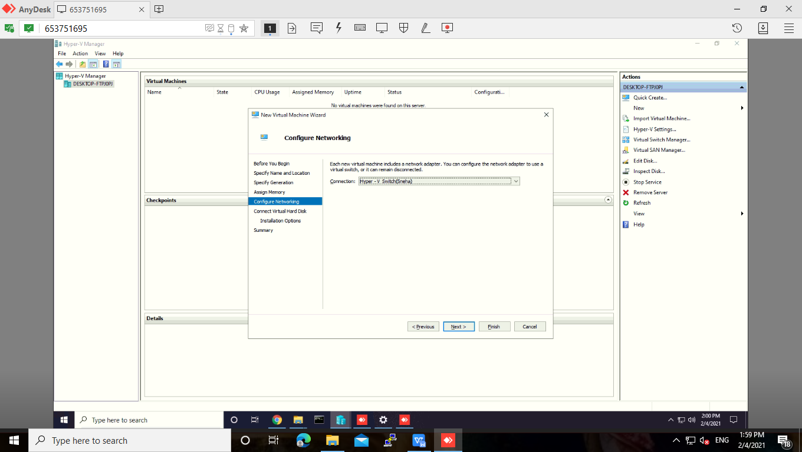

>> Specify the name of virtual machine, location where it will store all virtual machine related files and size required for the virtual machine and click on **Next.**

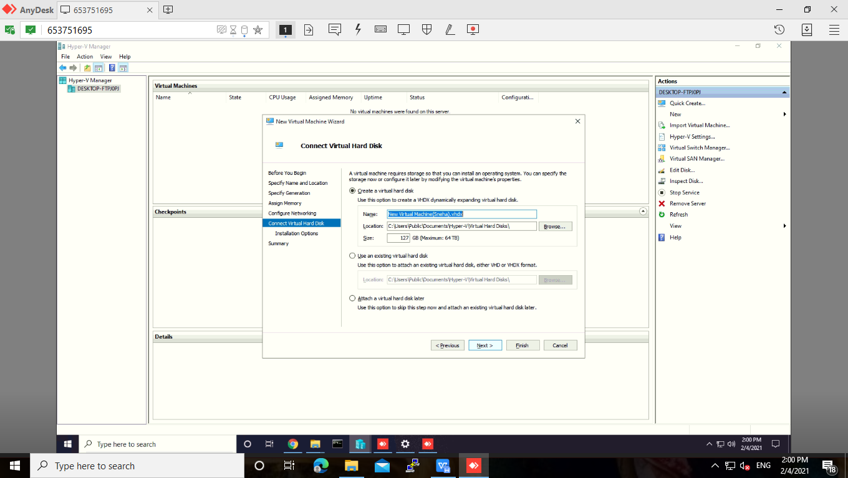

>> Under installation options, select tick on **Install an operating system from a boot CD/DVD-ROM.** and tick on **Image File (.iso)** and browse the

**Windows XP.iso** file location.

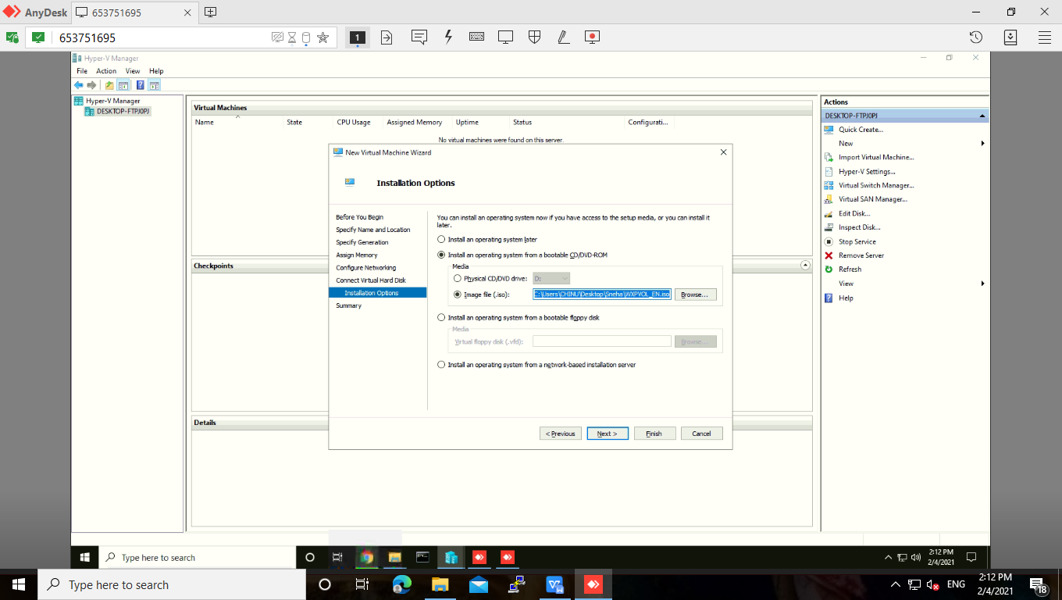

>> Summary report will be generated about virtual machine. Then click on **Finish.**

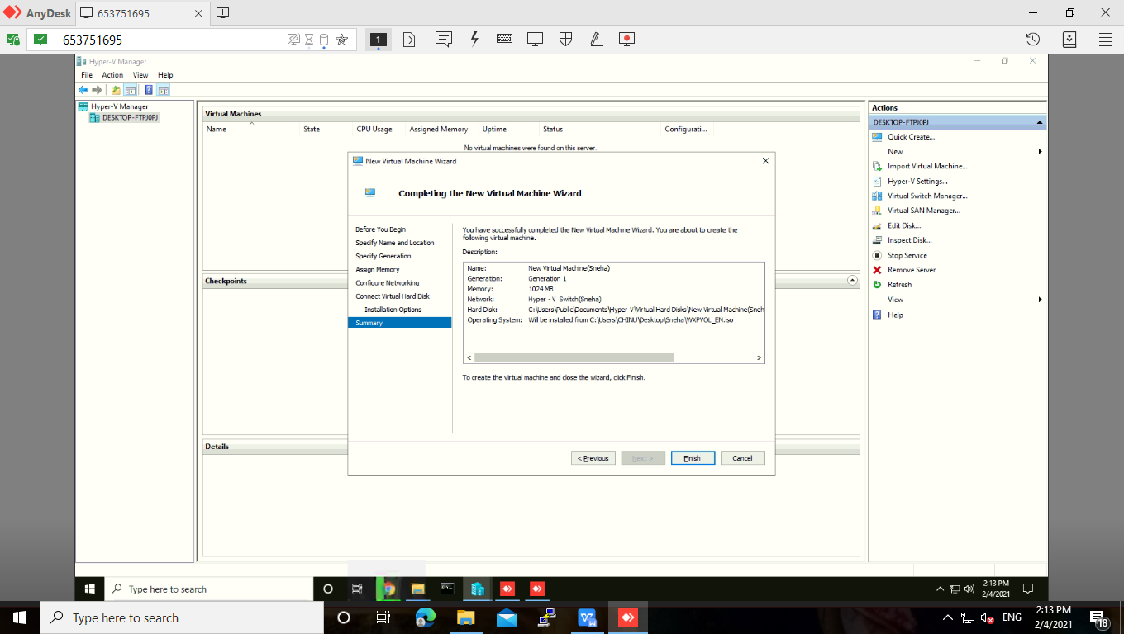

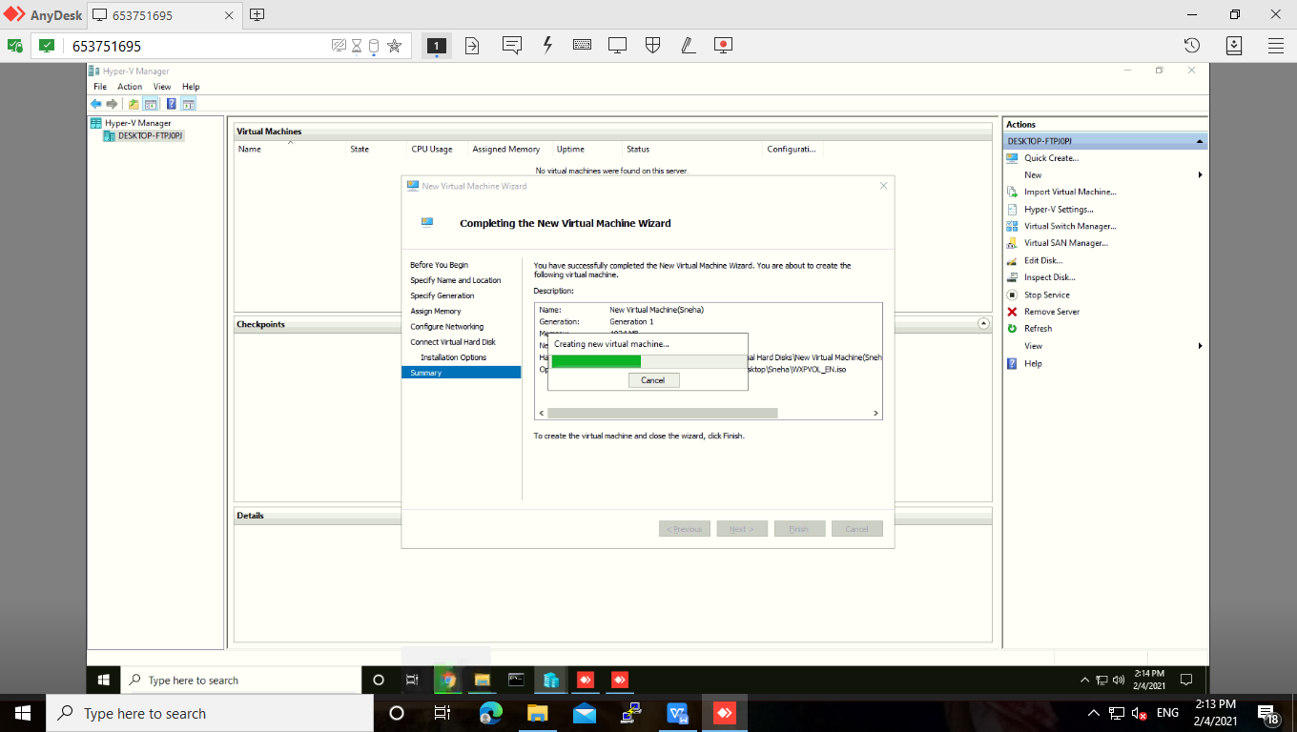

>> In Virtual Machines panel our virtual machine will appear in off state.

>> Right click on virtual machine and click on **Connect option.**

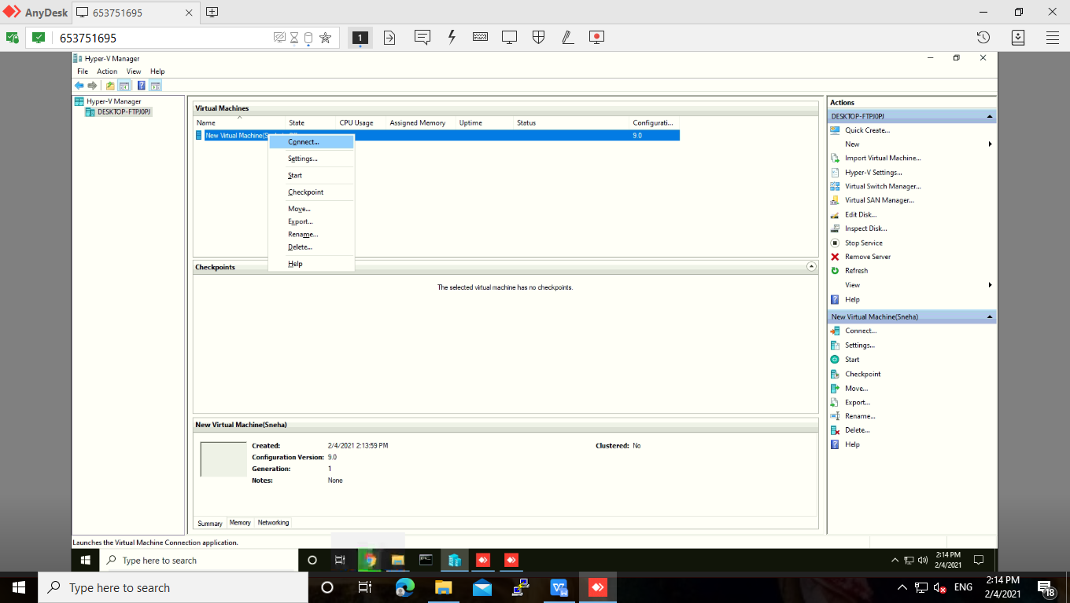

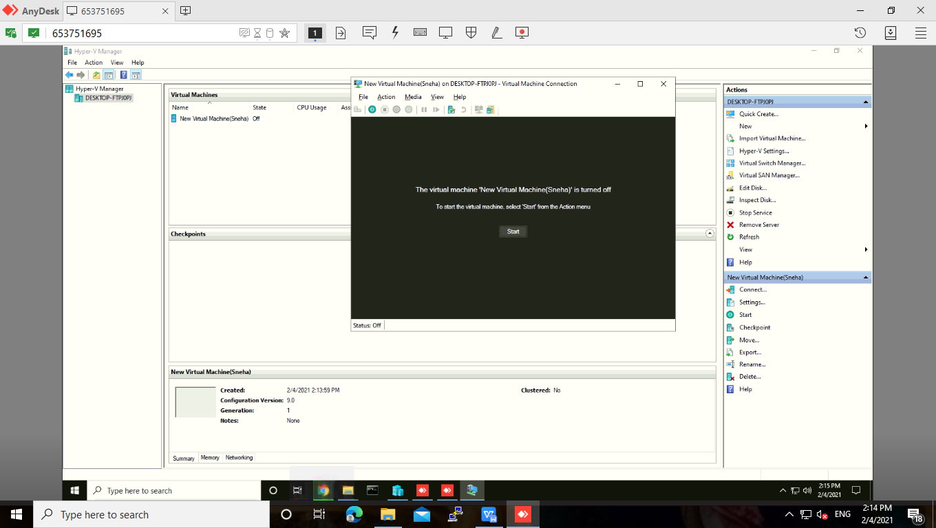

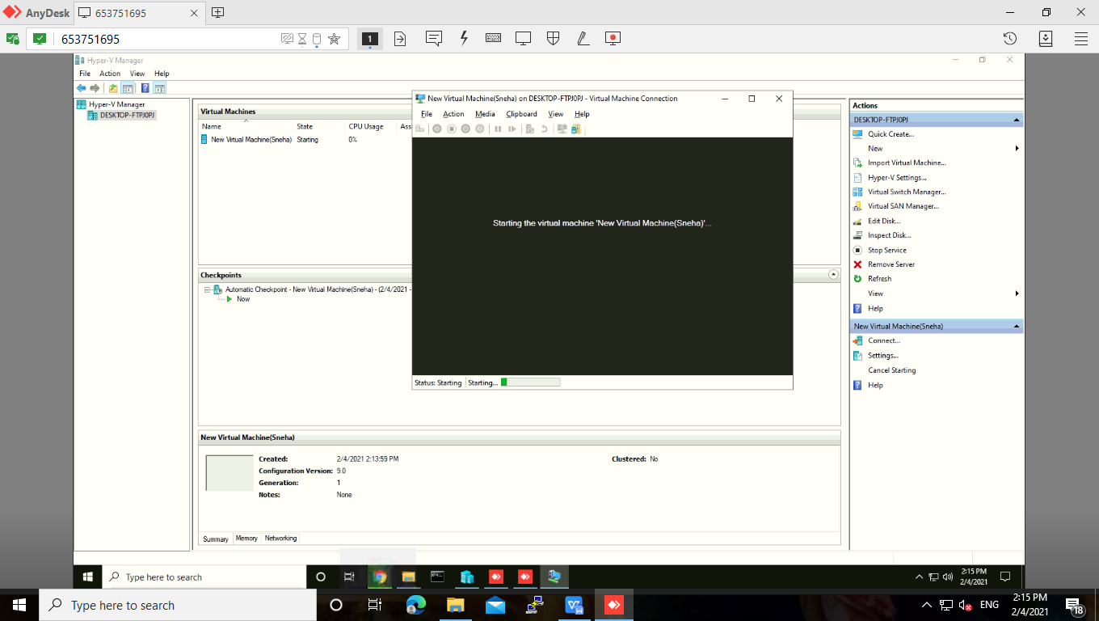

>> Virtual Machine will start with below screen.

